NC-NET Employability Skills Resource Toolkit
Module 8: Entrepreneurship
Overview 2
Presentation Materials 3
Teaching Resources 12
Activity: Business Plan (Part 1)—The Mission Statement 13
Activity: Business Plan (Part 2)—Marketing Research 18
Activity: Business Plan (Part 3)—Products or Services 20
Activity: Business Plan (Part 4)—Marketing and Sales 22
Activity: Business Plan (Part 5)—Financial Projections 24
Activity: Business Plan (Wrap-Up) 29
Activity: Networking 30
Activity: An Essential Guide to Starting Your Own Business 33
Activity: Advertising 34
Assessment Tools/Strategies 35
Rubrics for Instructor Assessment 36
Rubrics for Self-Assessing Entrepreneurship Skills 37
Rubric for Assessing Entrepreneurship Skills 40
Video and Weblinks 43
Video 43
Weblinks 43
Additional Resources 44


Overview
Entrepreneurship is the engine that drives a motivated and productive workplace. We get our word “entrepreneur” from the thirteenth-century French verb entreprendre, which means “to do something” or “to undertake.” From the early use of the word in business circles, we see that entrepreneurs are people who are willing to bear personal financial risk to undertake a business venture. Sometimes the new business succeeds—making a profit, growing, employing workers, expanding to more than one location, and so forth. Other times the business may thrive for a time and then shrink and die due to lack of growth or motivation or leadership, or any number of possible distresses. In our system of capitalism, such successes and failures help to sort through the many ideas that spring forth from creative business minds to yield the vibrant, thriving economy that has made our country great. Business ideas that are efficient and profitable will flourish. But, just as important, ideas that use resources poorly and are intended only to enrich the business owners—without considering public need or demand—are quickly extinguished.
The successful businesses we see today are of the former type. Every one of them began with an idea by an individual—someone not altogether different from the students in your class. In the world of electronics, for example, both Bill Gates and Steve Jobs were willing to risk everything to promote ideas that obviously flourished, proven by the fact that we all have Microsoft and Apple products in our workplaces, schools, homes, pockets, and purses. Similarly, Sam Walton developed innovative ideas in product distribution warehouses and inventory management to create WalMart, the largest retail chain in the world. Many more examples could be offered, but the point to make with students is that it all starts with an idea and the courage to take whatever risks are necessary to bring the idea to fruition. Some of your students may have what it takes to turn an idea into a real business venture. One of them might even be the next Sam Walton.
In the activities that follow, students will discover factors that have contributed to the success of new entrepreneurs, including the process of converting an idea into a plan (specifically, a “business plan”); the importance of family, friends, and business associates in forming a network; and the need for succinctly telling people about your business ideas, in other words, advertising.
In this module we have provided:
- Presentation materials organizing topics for discussion and introducing the activities
- Teaching resources consisting of activities to help students explore aspects of entrepreneurship
- Assessment tools and strategies consisting of rubrics that can be used as observation checklists or for peer or self-evaluation
- Online resources for further exploration of the topic
Presentation Materials
 | SLIDE | TEACHER NOTES
1 | 
2 | 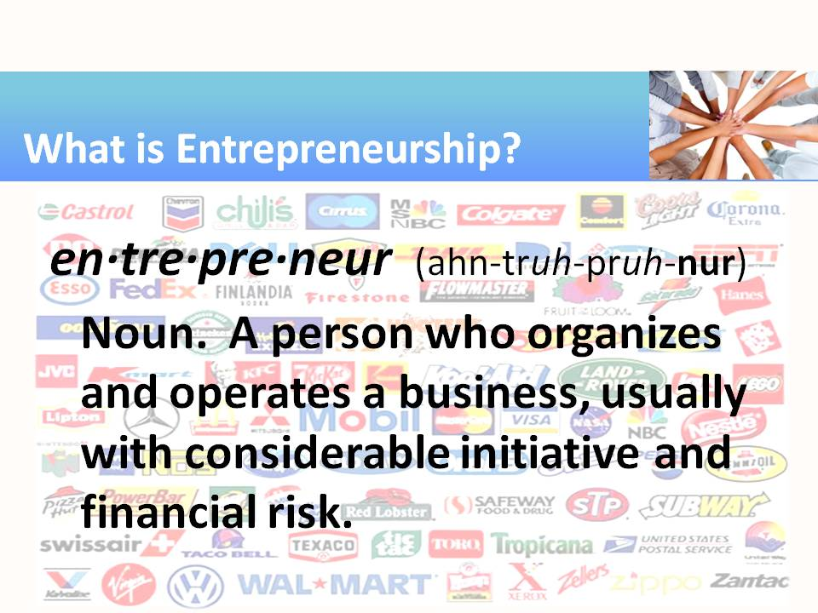 | - We usually think of entrepreneurs as starting a business. Consider some of the businesses represented by the logos (in the background of this slide) that we all recognize. Every one of them had a beginning! Yet, consider where they are today!
3 | 
4 | 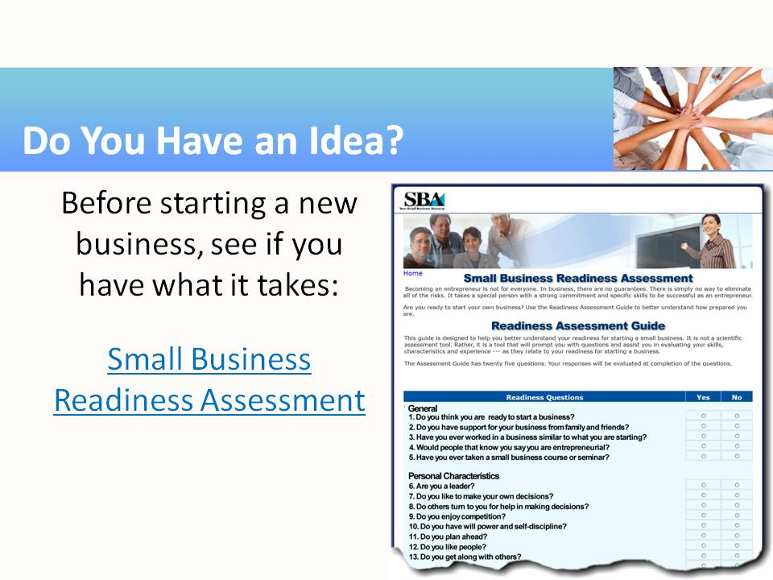 | - Click the link to go to the SBA website for the Readiness Assessment. Each student can do this on his or her own, or, for the sake of this activity, you can simply review the 25 questions (reproduced in the following slides) for their educational value and the whole class can formulate “good answers” to the questions.
5 | 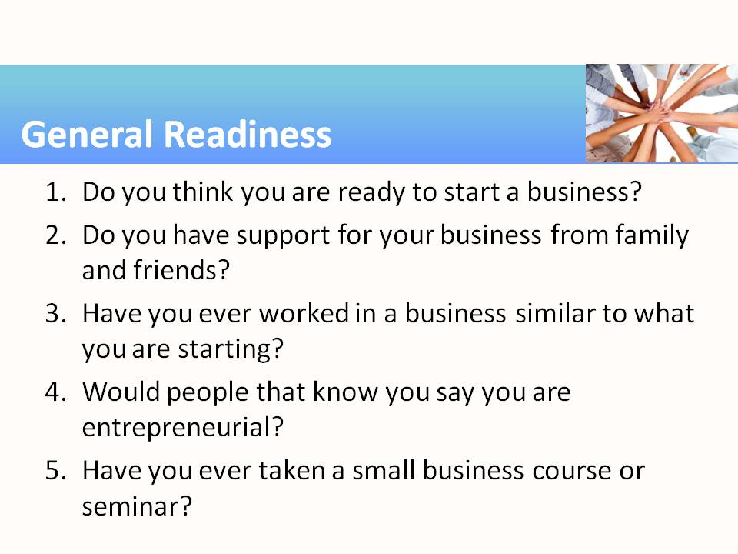 | - Questions are from the Small Business Administration’s SBA Readiness Assessment Tool. An interactive version is available at https://eweb1.sba.gov/cams/training/business_primer/assessment.htm  - You can use the questions on this and the following slides for class discussion. Ask students: Why do you think this question would be important for your consideration before starting a new business?
6 | 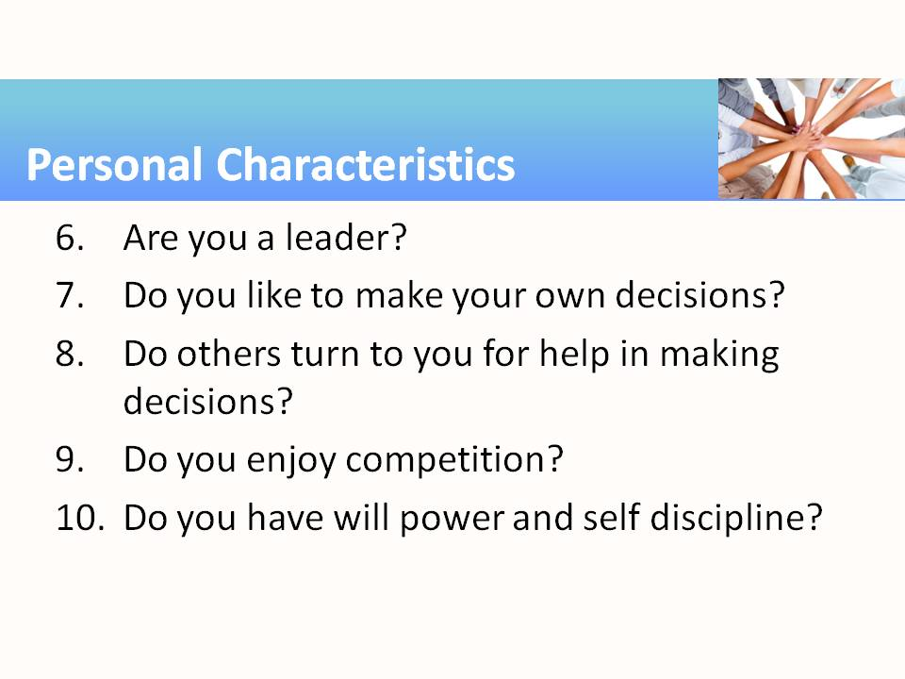 | - Questions from SBA survey
7 | 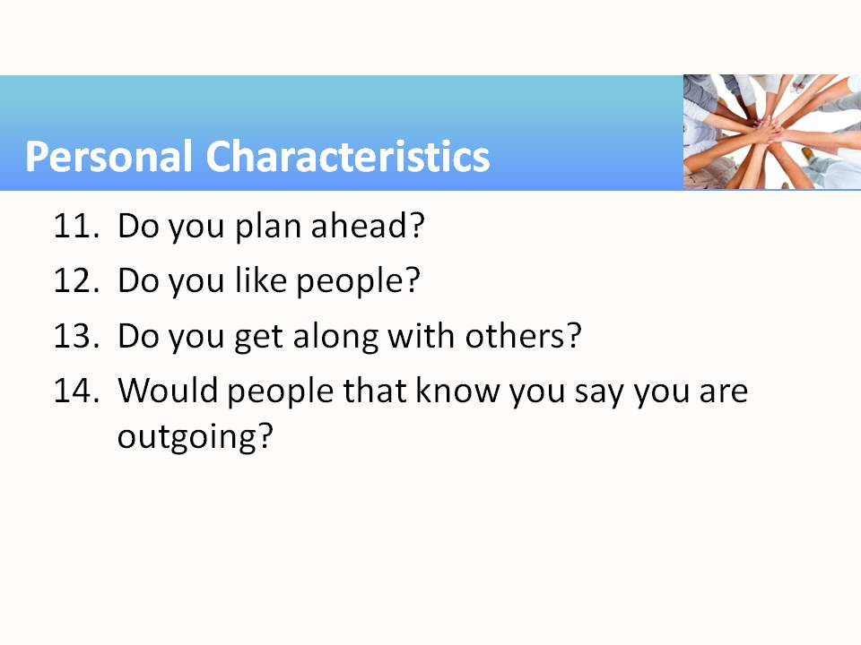 | - Questions from SBA survey
8 | 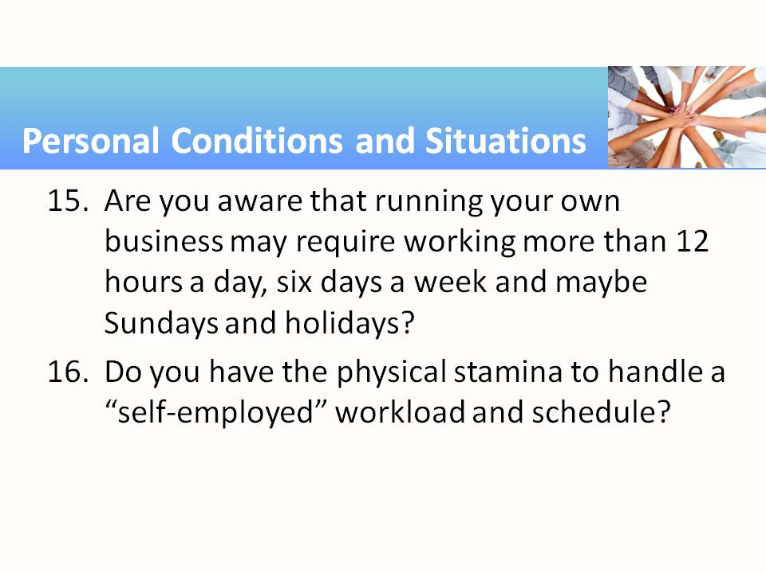 | - Questions from SBA survey
9 | 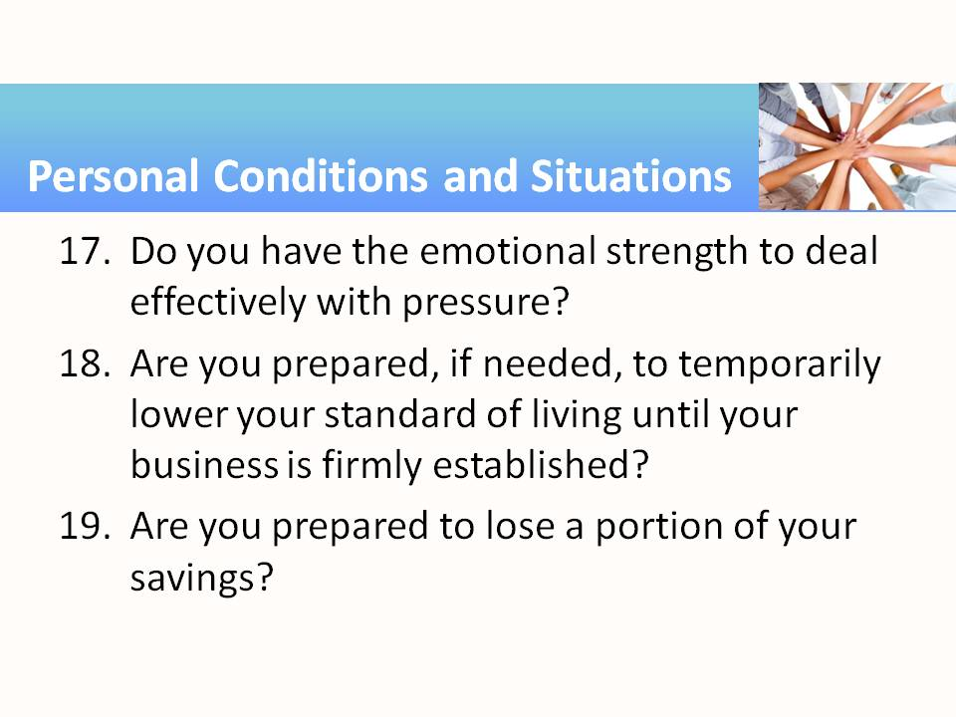 | - Questions from SBA survey
10 | 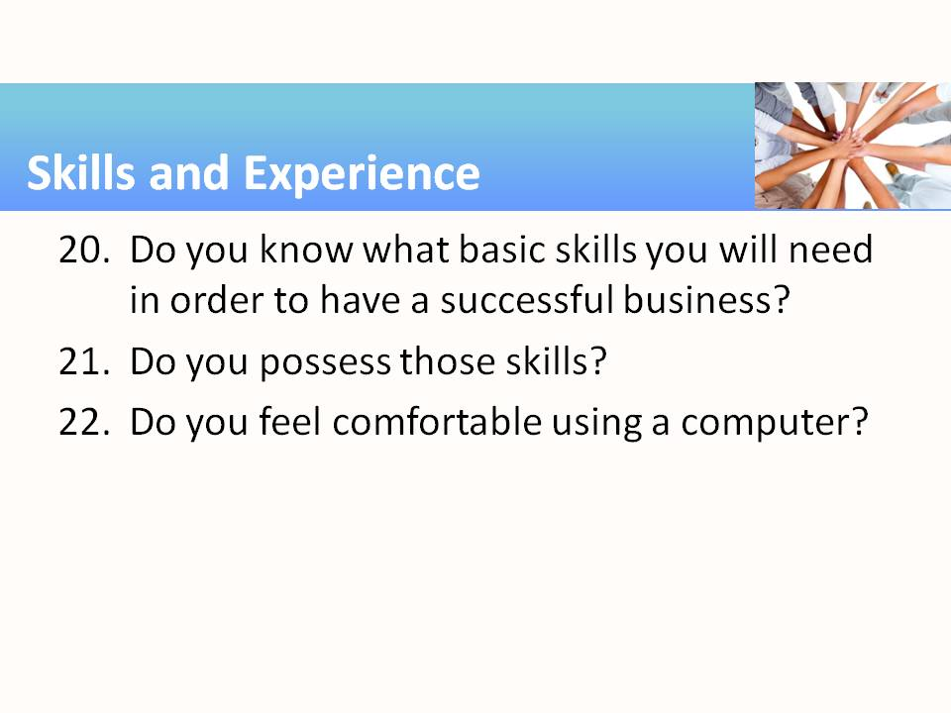 | - Questions from SBA survey
11 | 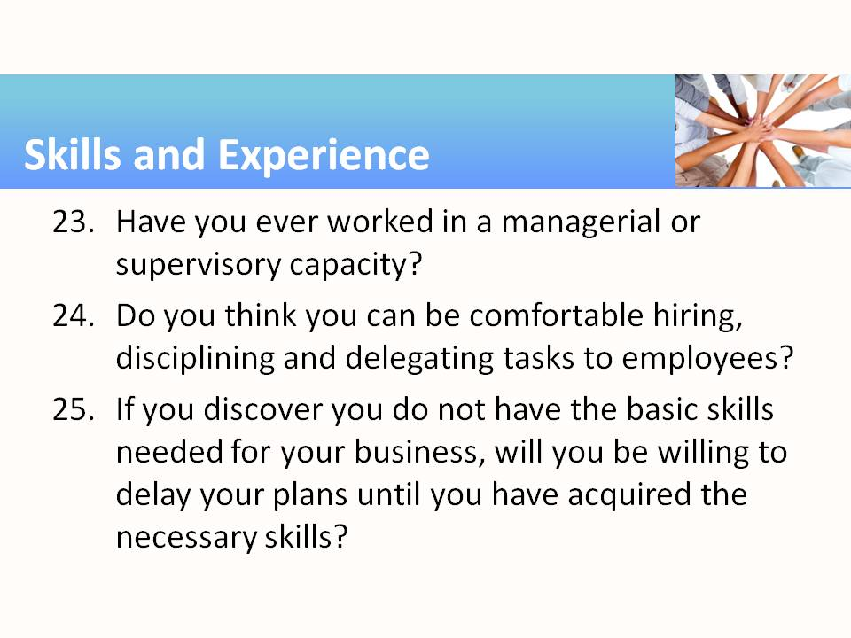 | - Questions from SBA survey
12 | 
13 | 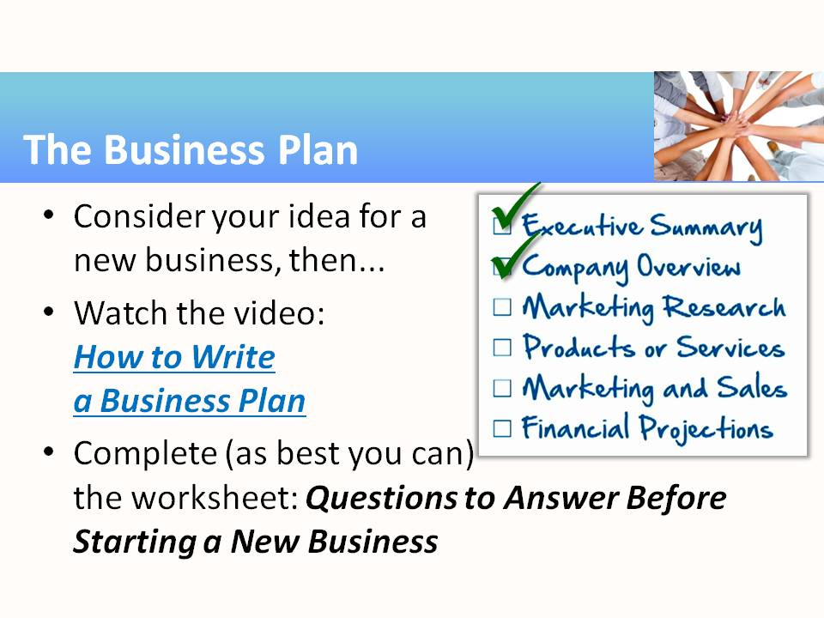 | - Continuing on with the new business idea, we will proceed to develop the business plan. To that end, the class (or student teams) should watch the short video, “How to Write a Business Plan.”  http://www.youtube.com/watch?v=SMr_uLZV-eM (2:27 min)  - Then the team should use the Entrepreneurship module handout, “Questions to Answer Before Drafting a Business Plan,” as a starting point for developing a business plan. Students should write the answers to these questions, as they will be used and revised repeatedly in the module activities that follow.
14 | 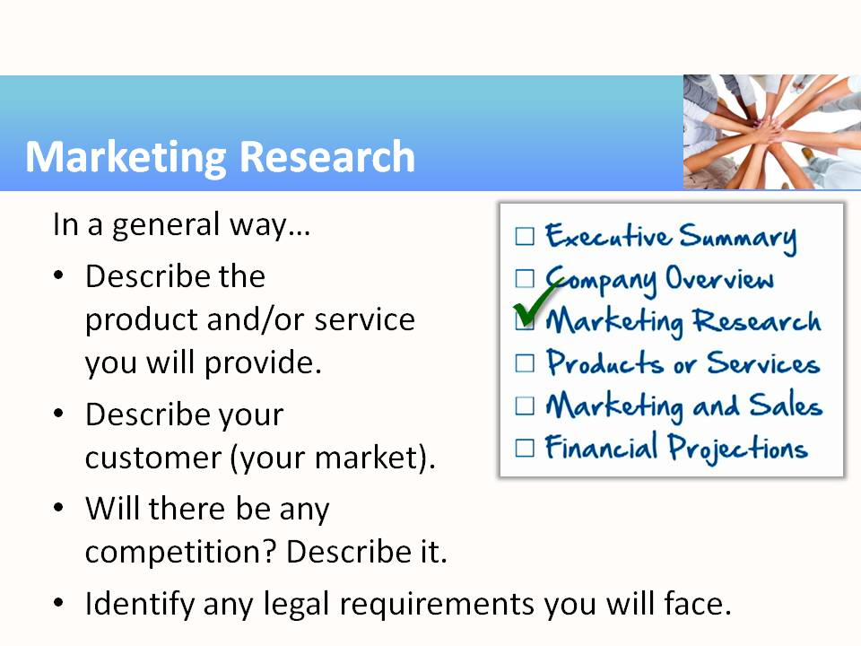 | - As the students formulate a better concept for a new business, the ideas about their product, service, customers, and competition will become clearer. In the first activity, encourage students to have a robust discussion and then conclude by trying to identify and list concrete ideas on paper. The next activity will ask student groups for much more detail about these topics.
15 | 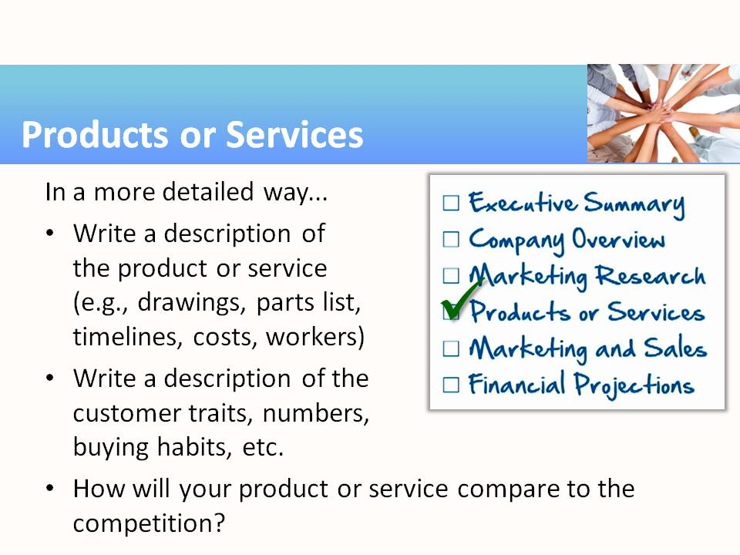 | - This activity is different from the preceding one in that much more detail about the product or service is required. If the business product is pizza, for example, we need to know ingredients for the pizza, sizes available, varieties, pricing, inventory, number of employees needed, and so forth.  - Similarly, considering the customer, students now need to have an idea about the number of customers to expect, different types of customers, and behavior at different seasons.
(Notes for Slide 15 continued)
- Finally, students need to create a detailed comparison with the competition. What other products or services currently fill the niche in the market?
- As before, the enthusiasm of the teams’ discussions should be transcribed into written notes that will be used to compose a business plan document. The more words written in this stage, the easier it will be to produce that document.
- As noted in the activity guidelines, some teams may go so far as to actually develop a prototype product. It would also be constructive to develop a sketch of a brochure or handout describing the product or service, which could also be included in the final business plan.
16 | 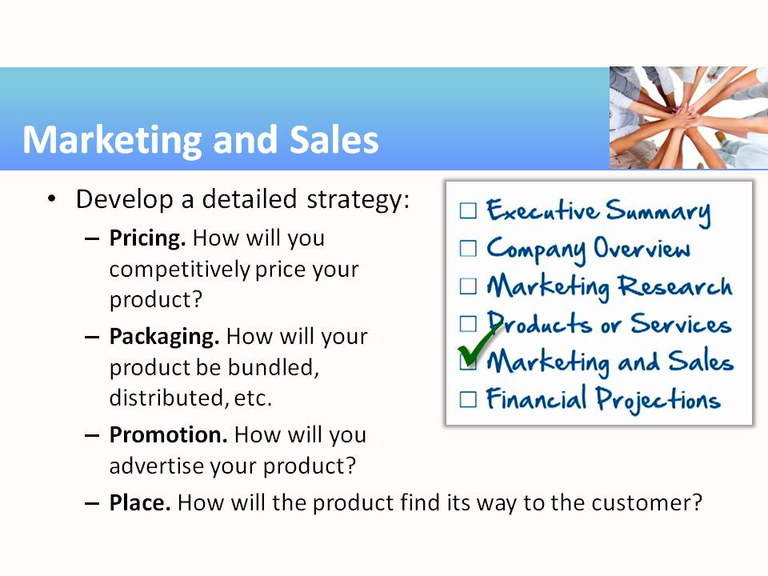 | - The four P’s are a helpful way to remember these four facets of developing a marketing and sales strategy for the new business.  - Pricing. Think of clever ways to price the product and make it more appealing than the competition.  - Packaging. “By the box” or “by the barrel”? “By the gallon” or “by the pound”? Think of the big picture here, for the sake of potential investors.  - Promotion. What marketing methods are appropriate for your type of product? Is a sign on the store front adequate, or do you need flyers? Ads in newspapers and magazines, or will only online advertising bring customers in?  - Place. The location and size of your store is very important. Or maybe there won’t be a store at all, but only an Internet store-front or mail-order catalog.
17 | 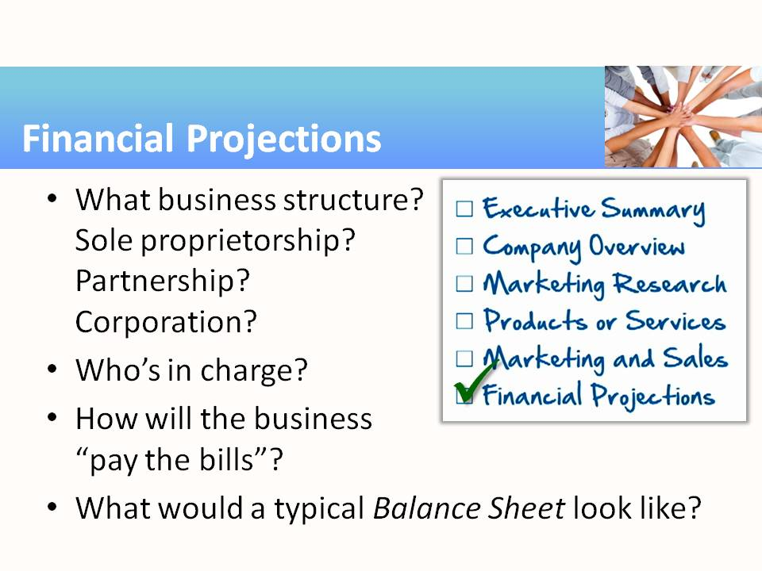 | - In this portion of the activity, students will need to understand some technical terms [sole proprietorships, partnerships, corporations, asset, liability, equity, cash flow, income].The Entrepreneurship module activity guidelines include links on the SBA.gov website that provide concise definitions for these terms.  - Since the teams are (most likely) describing a fictitious business, they are free to use any business structure they like. Organizational structures are described here: https://www.sba.gov/business-guide/launch/choose-business-structure
- Also on the SBA.gov website are sample spreadsheet templates that take into consideration the financial aspects of the business plan, such as assets, liabilities, equity, and income.
- The SBA Business Plan tutorial, https://www.sba.gov/starting-business/write-your-business-plan, covers many of the financial considerations.
18 | 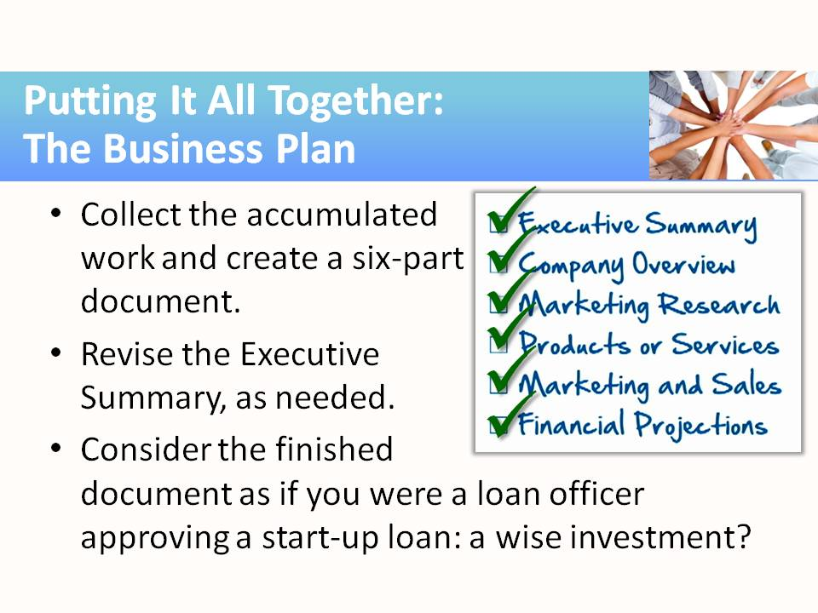 | - Having created the six main parts of the business plan, students can now merge them all into a coherent document.  - The executive summary is written last, after the plan of the new business has been drawn in detail. Students will likely want to revise this paragraph or two to reflect the changes that have evolved through the course of the previous activities.  - Ask student teams to present their business plans to the class. Those listening should analyze the plans as though they were in the role of a loan officer being asked to invest in this business startup. What questions need to be asked in order to feel confident that this business is going to succeed and repay the start-up loan?
19 |  | - Mapping and managing the relations and connections in a business environment allows business owners to better understand and capitalize on the business landscape.
20 | 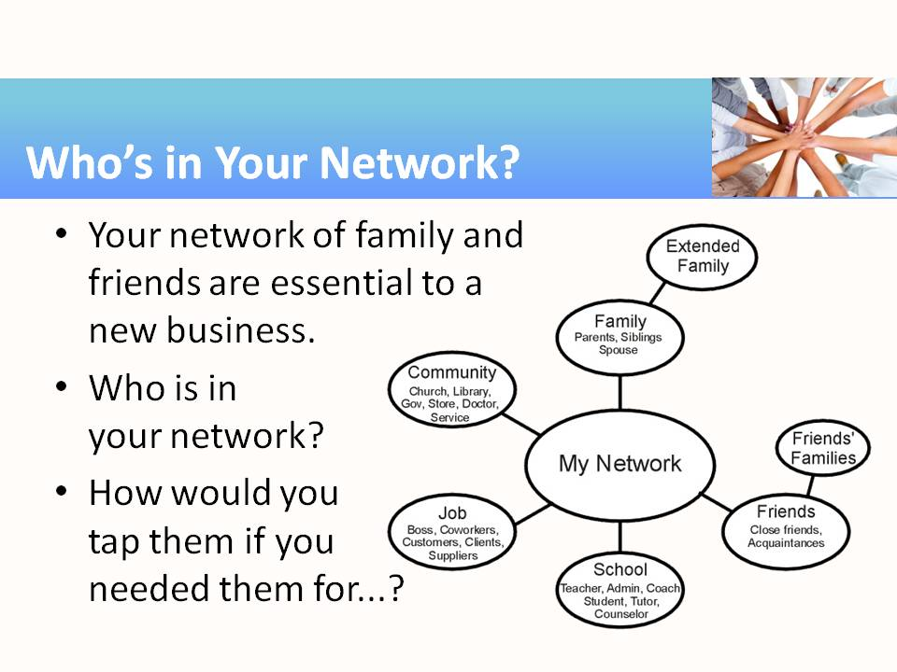 | - This module activity asks students to consider their network of friends and family. Some will have very extensive networks, others minimal (an indication that they would likely struggle as an entrepreneur).  - Students should view the list of life scenarios (or others provided by the instructor) and highlight the members of their networks who would be involved.  - The last bullet is an incomplete question. You can “fill in the blank” with just about anything! But remember: You can’t start a new business all alone! You will need some help!
21 | 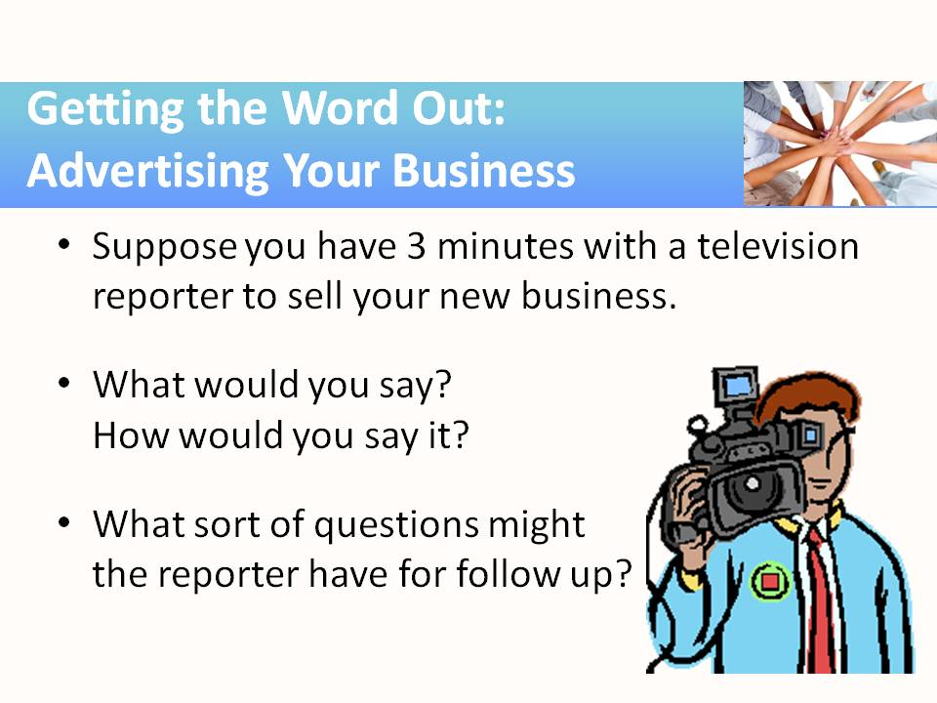 | - This module activity is a twist on the “elevator speech.” Students are asked to prepare for a three-minute interview. That’s a great exercise that requires them to boil down the selling points of their business to the essential facts.  - But then, at the last minute, just as they are wrapping up their preparations, spring on the class the fact that they will really only have 30 seconds with the reporter. Their pitch suddenly MUST be made VERY concise: truly, the elevator speech.
22 | 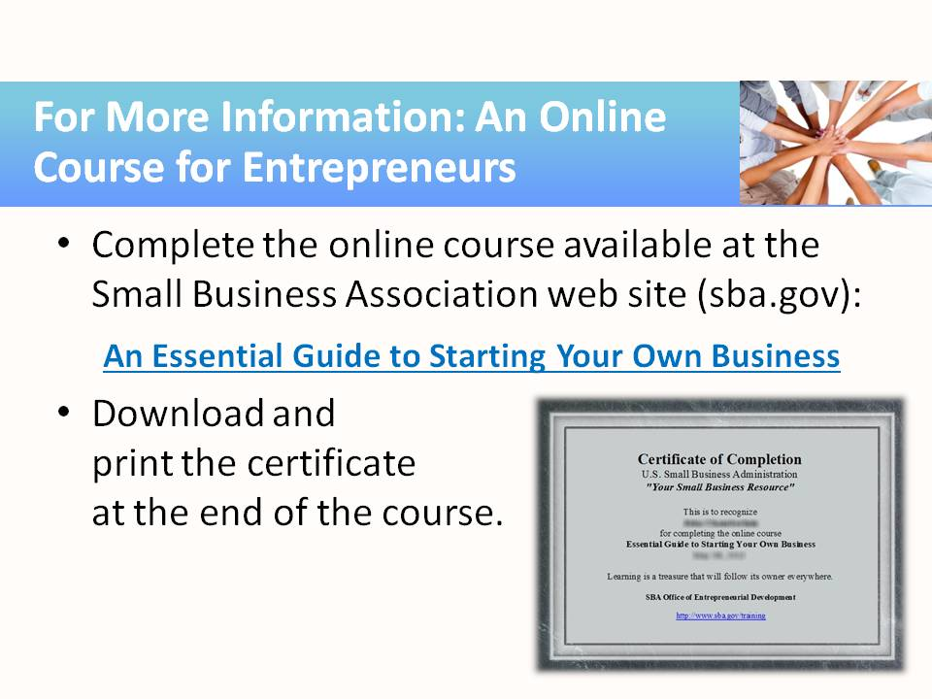 | - This online course (presentation) will take about an hour to complete.
23 | 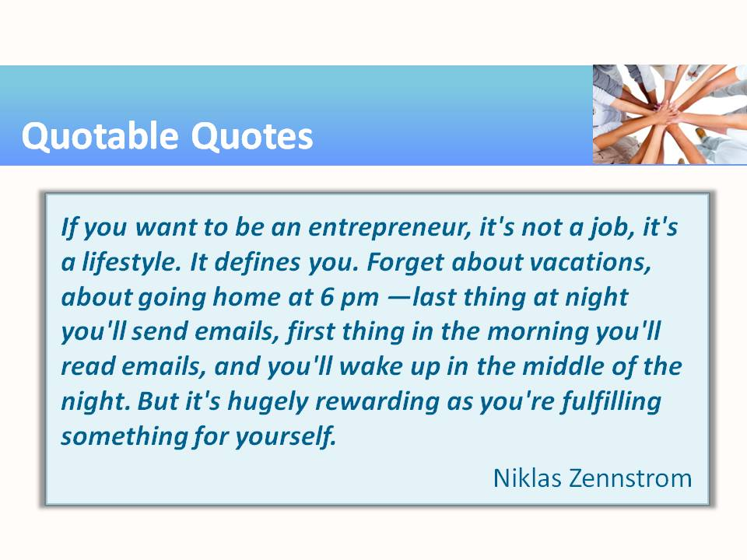 | - http://www.brainyquote.com/quotes/quotes/n/niklaszenn479716.html

Teaching Resources
Activities
The following activities can be completed in class to emphasize, teach, and practice entrepreneurship. This subject is broader than most of the other modules in this series, so it will naturally require a bit more time to infuse into an existing curriculum. For example, writing a business plan is an essential skill for any business. It requires more than a few extra minutes to learn how to describe the many parts of a new business idea and to assemble those into a document. Both the U.S. Small Business Administration, http://sba.gov, and the North Carolina Community College System Small Business Center Network, https://www.ncsbc.net/images/Biz_Plan_Start_Up_Guide.pdf, provide guidance on this process.
This important entrepreneurial tool is covered in a set of connected activities, designed to be conducted in sequence. The final fruit of this effort is a real business plan for a student-proposed business, tailored to your subject areas/career pathway. A few additional subjects related to entrepreneurship (e.g., networking, advertising) are included as optional activities for students interested in starting their own business.

Activity: Business Plan (Part 1)—The Mission Statement
Instructor Preparation
Anyone considering starting a new business must address some basic requirements, usually presented as a set of questions to be answered. Many versions of these questions exist, but the bottom line is: Are you prepared to take the plunge? Simply making an effort to answer each thought-provoking question will clarify the true challenges presented by entrepreneurship. In this activity, students will answer those questions and begin the process of developing a business plan.
The U.S. Small Business Administration website (http://sba.gov) contains a wealth of resources, including several designed to help students understand the importance of the business plan for a new business. Watch the 2½-minute video entitled How to Write a Business Plan at
http://www.youtube.com/watch?v=SMr_uLZV-eM
and the online tutorial, How to Write a Business Plan at
https://www.sba.gov/tools/sba-learning-center/training/how-write-business-plan.
(Printouts of the slides and a transcription of the accompanying narration are provided under “Additional Resources” at the end of this module.) The students will be watching parts of this tutorial as they construct the different parts of their business plan.
Students should work in teams (2–4 students per team). It will be helpful for the team members to share a common interest and for each member to have some experience or knowledge that they can apply to the new small business venture that will be addressed in the activities that follow. For example,
- In the Automotive Technology career area, a student team develops a business plan for a new auto-detailing shop. All the team members own a car and are familiar with auto detailing. One of the team manages an auto-body repair shop during the summer months. Another just finished detailing his own new car with a ground-effects package. And another did part-time work for a car-wash firm that did detail cleaning for customers.
- In the Arts, A/V Technology, and Communications career area, a student team develops a business plan for a drone videography business that would offer its services to wedding planners, real estate agencies, agribusinesses, and others. All of the team members are drone hobbyists. One team member runs a wedding videography business. Another operated unmanned aircraft systems in the military. And another ran the sound system at his church for several years.
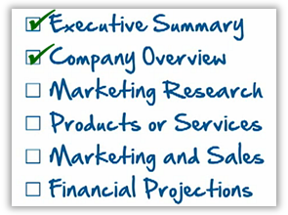
- In the Transportation, Distribution, and Logistics career area, a student team has chosen to start a bicycle courier service operating in the downtown business district. All of the students on the team are members of the local cycling club and are eager to mix their passion for cycling with a money-making business. Two of the students had newspaper routes as youngsters. One worked in advertising sales at a local radio station, and another worked as a clerk in the county courthouse for the justice of the peace. They plan to call their business Pedal Power.
This module includes several small activities that culminate in the creation of a business plan for a new business of the team’s choosing. In this first activity, students will form their teams, select a new business, answer questions to get things started, and try drafting the business mission and vision statements. (They might even be willing to try to write the executive summary, although, as stated in the SBA tutorial, this is normally the last thing written.) This activity will address the first two items in the business plan video—the executive summary and the company overview.
Encourage students to go ahead and write something down to reflect the idea they have today for their new business, knowing they can (and probably will) revise it later. Also reassure students that there will likely be many unanswered questions in their predictions about their business. That’s partially explained by the artificial nature of the activity, planning for a fictitious new business. If this were a real business plan, those holes would be filled with real information. So at this point they can feel free to make up realistic answers and change them as they proceed.
Objectives
Students will:
- Select an idea for a new business and draft an executive summary.
- Assess their readiness to begin their businesses.
Materials
- Folder (for collecting the results of the next several activities) (The students will use this folder in all the activities.)
- Handout—Small Business Ideas
- Handout—Questions to Answer Before Drafting a Business Plan
Activity Guidelines
1. Identify student pairs or teams of three or four who share a common interest that will provide a focus for a new business plan. (See examples given at the start of this activity.)
2. Each team should identify a new business idea that appeals to their skills and interests. If students need help, they can consult the broad (but not exhaustive) list in the handout Small Business Ideas.
3. Show the video How to Write a Business Plan (https://www.youtube.com/watch?v=SMr_uLZV-eM) for an overview. The goal of the next several activities will be to complete the business plan for their new business idea by following the six-part outline given in this video.
4. Using the chosen new business idea, each team should complete the handout Questions to Answer Before Drafting a Business Plan. The answers to these questions will form the basis for the draft of their first business plan. Most of the answers will be “educated guesses,” subject to change, but will help solidify a plan for the company vision and convey to students the type of thinking necessary to plan a new business.
5. Optional: Complete the Small Business Readiness Assessment available at the sba.gov website
(https://eweb1.sba.gov/cams/training/business_primer/assessment.htm). This assessment tool reinforces the Questions handout and also suggests the personality strengths required for jumping into a new small business venture.
6. Introduce students to the tutorial at https://www.sba.gov/tools/sba-learning-center/training/how-write-business-plan.
7. The students of each team should:
- Agree on a name for the new business.
- Draft a short paragraph that describes what the business will do, whom it will serve, and how it will make money.
- Identify where the company will be located, who (and approximately how many) will work in the company, and the key people who will own and manage the company. These facts will play a large role in the organization of the company, to be addressed in a later activity.
- If the team has sufficient enthusiasm, they should draft an executive summary using the above information (knowing that it will likely change).
- Start a file folder to hold the developments for the new business plan, including these first pages of work.
Group Reflection Questions
Give each group 5 minutes to present their business idea and executive summary to the class. Some may even have selected a name for their new business. Engage students in a discussion centered around the following questions:
- Which of the proposed businesses is most likely to succeed? Why?
- On which of the businesses would you like to collaborate as a class? (If the instructor plans to engage the class in a capstone business development activity, the class will need to identify at least one favorite new business idea coming from this activity that will require the combined efforts of the whole class.)

Handout—Small Business Ideas

Air Duct Cleaning
Antique Furniture Sales
Appliance Repair
Aquarium Maintenance
Art and Printing Services
Automobile Detailing
Bakery
Basement Remodeling
Beauty Consultant
Bike Store
Blog Designing
Bookkeeping
Business Consultant
Candle Making
Candy Making
Car Wash Service
Carpenter
Catering Services
Childproofing Expert
Cleaning Services
Cloth Diaper Service
Clothing Design
Composting
Computer Repair/Maintenance
Computer Training
Construction Cleanup
Courier Service
Customer Service Professional
Data Entry Service
Daycare
Delivery Services
Desktop Publishing
Direct Mail Marketing Service
Disaster Planning/Prevention
Dog Training
Dog Waste Remover
Doula (labor coach)
eBay Seller
Energy Conservation Consultant
Event Planning/Consulting
Fitness Center
Florist
Freelance Writer
Furniture Moving
Gardening
Genealogist
Gift Wrapping Service
Grant Writing
Green Consultant
Gutter Cleaning
Hair Salon
Handmade Crafter
Handyman
Hauling Services
Holiday Decorator
Home Decorator
Home Renovations
Home Theater Designing
Home Weatherization
Hot Lunch Delivery
House Painting
Ice Cream Shop Business
Identity Theft Protection
Image Consultant
Ink Cartridge Refilling
Interior Designing
Internet Researching
IT Security Consulting
Jewelry Making
Laundry Service
Lawn & Garden Irrigation
Lawn Care Services
Life Coach
Locksmith
Marketing Copywriter
Martial Arts Training
Massage Therapist
Medical Transcriptionist
Mobile Apps Development
Mobile Phone Repair
Motivational Speaking
Nutritionist
Online Mortgage Brokers
Organic Foods
Organic Hair Care Products
Organic Lawn Care Provider
Party Planning
Patient Advocacy
Personal Chef
Personal Concierge
Personal Training
Pest Control Professional
Pet Couture Designer/Selling
Pet Farewell Services
Pet Grooming
Pet Sitting Service
Photo Restoration Service
Photography
Pizza Parlor
Pool Cleaning and Maintenance
Private Tutor
Professional Organizing
Project Management
Proofreading
Public Relations Agency
Residential Cleaning
Resume Writing
Sales Consultant
Scooter Sales and Repair
Scrapbooking
Senior Care Provider
Senior Transportation Services
SEO Consultant
Sewing and Alteration Services
Snow and Ice Removal Service
Soap Making
Social Media Consultant
Speech Writing
Tax Accountant
Translation Service Provider
Tree Farming
Used Books
Used Car Sales
Video Production/Dubbing
Virtual Assistant
Virtual Call Center
Voice-Over Professional
Website Designer
Wedding Consultant/Planning
Yoga Instructor

Handout—Questions to Answer Before Drafting a Business Plan
Synthesized from sba.gov and other sources

Answer these questions before starting a new business:
- How would I describe the business...in one paragraph (your elevator speech)?
- What products or services will my business provide?
- Who is my competition? How will my business/product/service be different/better?
- Who and about how many will be my customers?
- What will it take to attract new customers and promote the business?
- Where will/should my business be located?
- How many employees and managers will my business need?
- What types of supplies and suppliers do I need?
- How long will it take for my products or services to be available?
- What will be the legal structure of my business initially? In 3 years?
- What will be my approximate operating costs in Year 1, Year 2, Year 3?
- What other expenses will my business have (taxes, insurance, advertising, rent, etc.)?
- What is my potential profit per year for Year 1, Year 2, and Year 3?
- How will profits be handled? How will losses be covered?
- How can the business grow in the future?
- What advice will the new business need and who can provide it?
- How much money will the business need to get started, until making a profit?
- From where/whom will the startup funds come?
Activity: Business Plan (Part 2)—Marketing Research
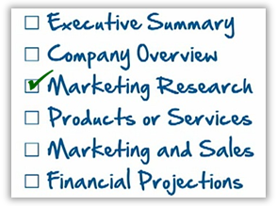
Instructor Preparation
In this activity, each team will continue work on the business plan, agreeing on a preliminary description of the product or service to be provided (the next activity will address this in more detail) and describing the market for the product or service. The work here should also demonstrate an awareness of the competition and any obvious legal requirements that will impact the business planning and operation. As stated in the video (How to Write a Business Plan, http://www.youtube.com/watch?v=SMr_uLZV-eM), this part of the business plan shows that the new business owners have done their homework.
Objectives
Students will:
- Briefly describe the product or service for the new business.
- List the features of the market (customers) for the new business’s product or service.
- Identify other existing or planned businesses that will compete with the new business.
- Identify any obvious legal requirements that will limit or control the new business’s activities.
Activity Guidelines
Each team will:
1. Draft a brief description of the product or service of the new business to enable the discussion to move forward. This is a very preliminary description—subject to change. Don’t spend a lot of time here on the product details.
2. Identify the characteristics that define the typical customers for the business’s products or services. Approximately how many customers can be expected over a given time period (e.g., per year)?
3. How can these customers effectively be reached (e.g., website, email, mail, radio, television, or billboards)? Describe the general marketing strategies here, not details. (Details will come later.)
4. Are there any existing (or planned) businesses that will be competing for the attention of these potential customers?
5. Are there legal requirements under which this new business must operate? Make a general list of those that are known at this point. (Specific details are not necessary for this activity.)
6. Add the notes from this activity to the new business information folder.
Group Reflection Questions
Discuss the following questions with the class. Realistic answers to these questions will determine how profitable the company can expect to be in the coming months and years.
- What is the approximate size of your customer base?
- How broad (geographically) is your customer base?
- Will you be able to reach/serve customers in another city? Out of state? Out of the country?
- Will these customers be motivated to return for more business, or is it likely a once-in-a-lifetime encounter? Realistic answers to these questions will determine how profitable the company can expect to be in the coming months and years.
- After comparing marketing ideas around the room, do you have ideas for updating your marketing plan?
Activity: Business Plan (Part 3)—Products or Services
Instructor Preparation
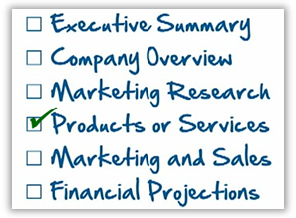
In this activity, students will describe in greater detail the products or services to be provided by the new business, which will have a strong bearing on the proposed costs to be addressed in the next activity. Perhaps a quick prototype or model would be helpful to facilitate the discussion. (Don’t let the creation of a prototype steal an inordinate amount of time, however.)
As students develop the product or service description, they will naturally need to consider customers’ needs. This is a good place to describe the customers who must want the product or service for the business to be successful. And since they must want it more than they do the competition, the plan should demonstrate an awareness of the competition. Who are the competitors? How many are there? How are they positioned in the market? How much does their product cost? Student groups need to think about how the customer will know how their product compares with the competition’s product or service. To answer that, documentation is necessary, such as a brochure, a webpage, or other advertisements.
Objectives
Students will:
- Write a detailed description of the product or service on which the new business is based.
- Identify the customers who will have an interest in the new product or service.
- Compare the new business’s product or service with that of the competition.
- Create a brochure or webpage that gives relevant details about the new business’s product or service.
Activity Guidelines
Ask student teams to:
1. Write a detailed description (or perhaps develop a prototype or model) of the product or service to be sold by the new business. Include drawings, photographs, or even video. For service-oriented businesses, develop a simple brochure or flyer that describes the service being offered.
2. Identify the characteristics of typical customers for the business’s product or service. Describe how customers will benefit from the product or service being offered.
3. Prepare to address the following questions in the marketing piece: How does the product or service compare to the competition? Is it “as good as” or “better”? More or less costly? More or less accessible? Of better quality? Compare as many attributes as is reasonable, as the answers to these questions will inform the marketing strategy.
4. What is it that this business offers? Develop a brochure, webpage, magazine advertisement, or video that communicates to the prospective customer exactly what it is that this business has to offer. Does the business product or service exist now, or must it be designed and perfected before being sold? If the latter, work with the team to decide what sort of timeframe is required. (Realize that any investors or financing agents will want to know this!)
Group Reflection Questions
Allow the class to display their work, then ask them to discuss the following:
- Comparing your team’s work with that of other teams, do any of their product or service ideas make you want to return and revise your proposed description?
Activity: Business Plan (Part 4)—Marketing and Sales
Instructor Preparation
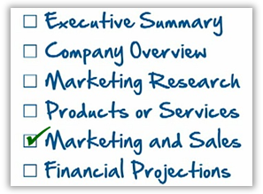
Equipped with a much clearer understanding of the product or service, students are now ready to think about how the new business will successfully deliver the product or service to the customer. The first step is settling on a pricing strategy and packaging method for the product or service. (Customers need to view the product as being a good value for the amount paid.) Next, the customer must be made aware of the product or service and realize that they need or want the product or service. Finally, the marketing and sales plan should show how the product or service will be made available to the customer (e.g., via a traditional brick-and-mortar store, door-to-door sales, mail-order catalog, or online storefront).
Objectives
Students will:
- Develop a strategy for promoting the new business’s product or service.
- Develop a strategy for offering and delivering the new business’s product or service to the customer.
- Develop a competitive pricing strategy for the new business’s product or service.
Activity Guidelines
In this activity students will consider the four P’s of marketing for the new business:
a. Pricing: How will the product or service be priced, including any discount programs?
b. Packaging: How will the product or service be sold or bundled so that customers will want it?
c. Promotion: How will the product or service be advertised or promoted?
d. Place: How will the product or service be made available or delivered to the customer?
Ask student teams to do the following:
1. Develop a strategy for pricing the new business’s product or service. Consider and compare several pricing methods (e.g., bulk discounts, early-bird specials, and so forth) and even innovative schemes that might start a clever marketing trend. Decide which ones are applicable to your product or service, which are efficient and manageable, and which would yield a profit. Tailor price differences to attract customer business, but avoid hard-to-defend disparities among models, brands, styles, etc.
2. Closely related to pricing, develop a strategy for packaging the new business’s product or service. Consider both standard, well-understood methods (e.g., “by the dozen”) as well as other clever bundling ideas (e.g., “buy eleven, get the twelfth one free”). Will this product be sold in bulk (e.g., a pound of customer-selected and weighed tomatoes in a grocery store) or packaged (e.g., a shrink-wrapped carton of four tomatoes)? Will this service be sold as a one-time job or an annual contract?
3. Develop a strategy for promoting the new business’s product or service. Compare several marketing methods, decide which ones are applicable to this product or service, which are affordable, and which would likely be effective. Ignore short-lived, clever promotional gimmicks. Instead, concentrate on just the big picture for the sake of potential investors. It might be helpful to construct a timeline indicating the implementation of different promotion methods now and in the future.
4. Develop a strategy for placing (delivering) the new business’s product or service. Consider and compare several delivery and sales methods, deciding which ones are applicable to this product or service, which are affordable, and which would be most efficient. Consider all the options: traditional brick-and-mortar store, door-to-door sales, mail-order catalog, or online storefront. It may be helpful to consider a timeline, perhaps starting with one method, and growing and expanding to include more methods at a later date.
5. Add the notes from this activity to the new business information folder.
6. Optional: Visit the NCCCS Small Business Center Network’s instructional page on conducting market research, https://www.ncsbc.net/DocumentMaster.aspx?doc=1011.
Group Reflection Questions
Allow the teams to present their completed “four P’s”plans, then ask them to discuss the following:
- Compare your team’s plan with those of other teams. Which of their pricing, packaging, promotion, and placement strategies would also work for your product or service?
Note: This activity is the one most students immediately associate with the business planning, as it deals with all the tangibles: the product, the advertisements, the customer, and the profits. But students will gradually grow to appreciate the necessity of the other details, too, especially when they consider the final activity in this series, where the need for financial backing demands meticulous financial planning.
Activity: Business Plan (Part 5)—Financial Projections
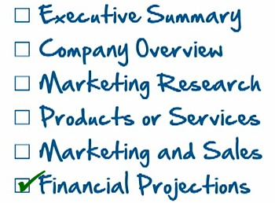
Instructor Preparation
In this activity, students will consider the various accounting documents that must be included in a solid business plan. These will be explored in a superficial way since an in-depth treatment is beyond the scope of this short activity. The SBA tutorial covers these with sufficient detail for our purposes.
A critical decision impacting the financial projection of the company is the organizational and management structure for the new business. The structure answers the questions:
- Who’s in charge?
- How will the business make money?
- Is the business organized as a sole proprietorship, limited partnership, or corporation?
Students will likely need some introduction to these terms, and that can be found at the sba.gov website and the tutorials available there.
The business plan must ultimately convince investors how the new business will meet its financial obligations from month to month and maintain a healthy balance sheet and cash flow. The SBA website has some powerful templates for use by real businesses to achieve this goal, but use of those tools is beyond the scope of this activity. For this activity, students should appreciate that the new business will have to follow accepted accounting standards and documentation.
Objectives
Students will:
- Learn the major features of sole proprietorships, partnerships, and corporations and propose the best structure for their new business.
- Determine the management personnel for the new business.
- Learn business vocabulary: asset, liability, equity.
- Develop a general cash flow model for the new business.
Materials
- Templates available at the SBA website or handouts included here
Activity Guidelines
Students should complete the following activities.
1. Read the six articles on the SBA website that describe the organizational structures available to the new business (https://www.sba.gov/business-guide/launch/choose-business-structure). Create a table in a new document that summarizes and compares the advantages and disadvantages of each structure. (Hint: Copy/paste the items presented in each of the articles on the SBA website.)
2. Select an organizational type for your team’s business and defend how the features of this choice will align with the business.
3. Decide who will manage the business and how it will be managed. Include a short biographical sketch of relevant facts for the major players.
4. Consider the spreadsheet templates provided at the SBA website (and shown in the handouts below). Together, they effectively describe the financial picture of the business: its existing assets, liabilities, and equity, as well as its typical cash flow.
a. The assets should include current assets (cash, accounts receivable, inventory, notes receivable), fixed assets (land, buildings, machinery and equipment, furniture, and improvements to leased property), intangibles (research and development rights, patents and copyrights, market research information, goodwill, and existing organization), and other assets (e.g., miscellaneous accounts, deposits, and notes).
b. The liabilities—financial obligations such as loans, accounts payable, mortgages, deferred revenues and accrued expenses, both current (payable in less than 12 months) and non-current (more than 12 months), and possibly contingent liabilities (e.g., warranties, lawsuits).
c. The equity or net worth is the difference between the assets and the liabilities. This will represent the owner’s share in the financing of all the assets.
d. An income statement shows the profits (e.g., earnings) and losses (e.g., expenses) experienced over a period of time.
5. A new business must be registered with the state, and probably with the city and county taxing entities. A tax identification number is needed if selling a product or service. For the purposes of this activity, you will not actually do those things, but realize that those activities would be required for a real business startup.
6. Add the accumulated notes and artwork from this activity to the new business information folder.
As noted earlier, it is beyond the scope of this brief activity to fully develop an understanding of the financial picture necessary to plan a new business. However, the SBA tutorials and the handouts provided can convey the breadth and depth of content that is involved.
Handout
Template: Income Statement
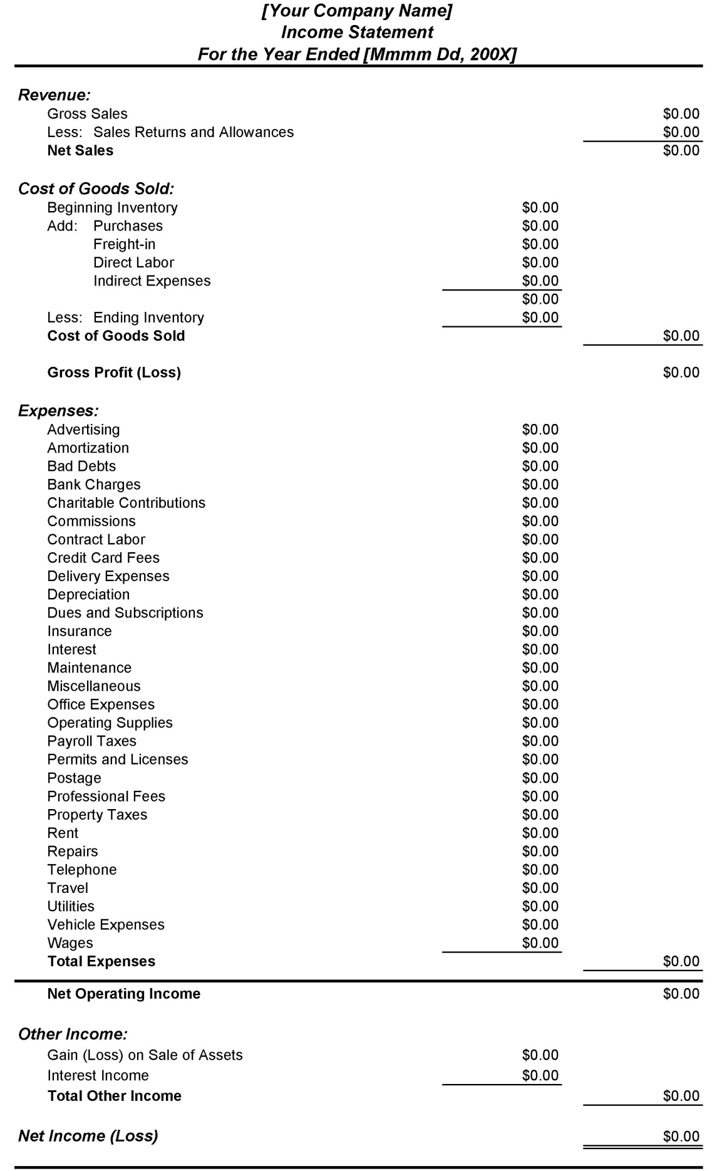
Template: Balance Sheet
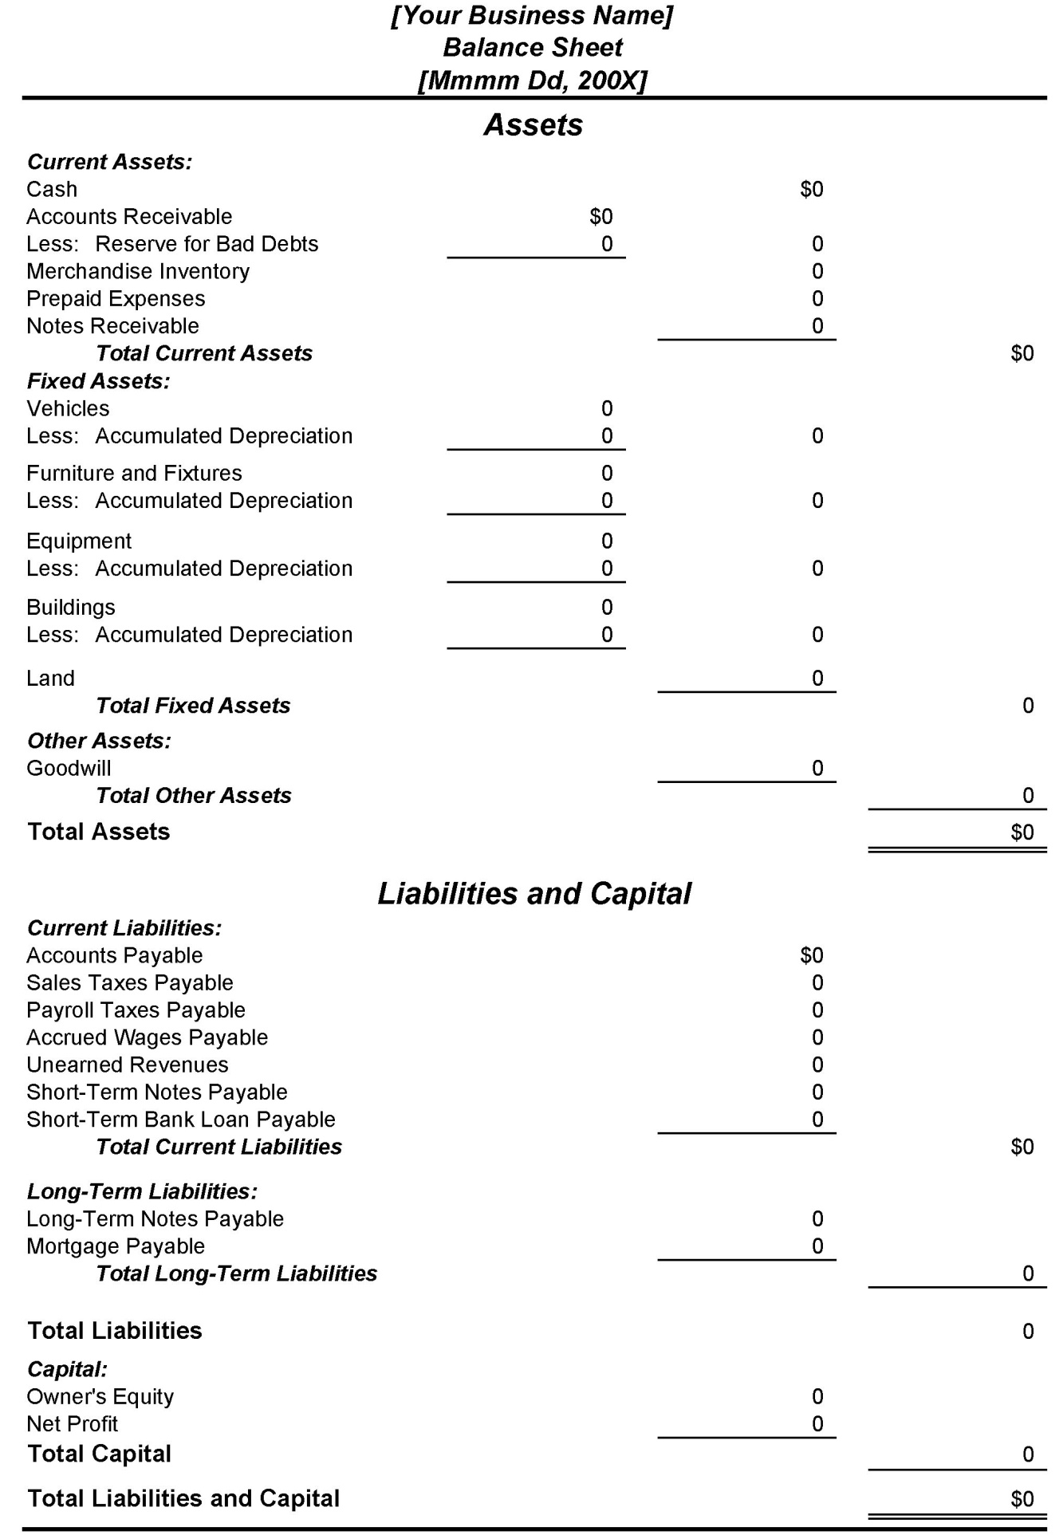
Template: Cash Flow
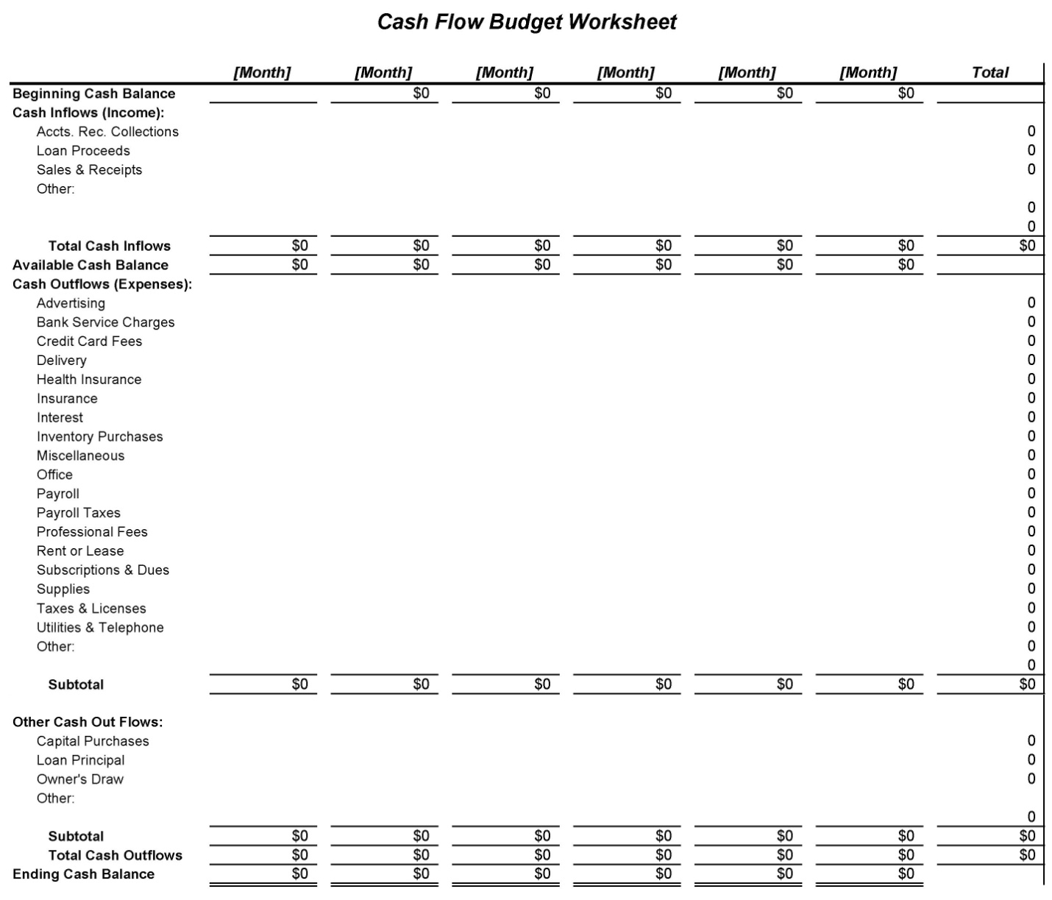

Activity: Business Plan (Wrap-Up)
Instructor Preparation
Now it’s time to collect all the pieces, modify the executive summary if necessary (since it’s quite likely that the big picture has changed), and assemble the whole package. There may be additional details that can be placed in the appendix. Also note that there are several sample business plans available at the SBA website.
Objectives
Students will:
Assemble the business plan for the new business from the several pieces developed earlier.
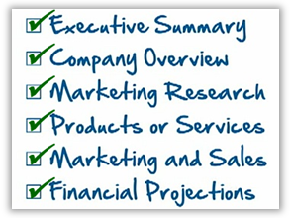
Activity Guidelines
Before asking student teams to assemble all of the pieces of the business plan developed over the preceding several activities, ask them to complete the following tasks.
1. Revise the draft executive summary to incorporate any changes that have been made during preceding activities.
2. Include any attachments and details that will assist the reader in understanding the business plan, such as brochures, list of equipment and other property of the business, photos and graphics showing the business location, important business agreements and contracts, and so forth.
3. Assemble the parts of the business plan that have been accumulated in the team’s folder. Develop a table of contents page to be inserted at the front.
4. Using your executive summary as a guide, present the new business idea to the class in a 3-minute presentation.
Group Reflection Questions
Ask students to present their business plan to the class. As they do so, have the class consider the following questions:
- If you were the bank’s business loan officer, what additional questions would you need answered before feeling confident enough to invest in this new business?
Activity: Networking
Instructor Preparation
A critical component of any business is the array of connections to key personnel with influence. Mapping and managing the relations and connections in a business environment allows business owners to better understand and capitalize on the business landscape. For example, through relationships with others (“contacts”), an owner may be able to reach those who know prospective decision-makers. As a business grows, the network of relations can grow as well. A map of the key influencers will provide students with a graphic illustrating the connections between members of their network.
In this activity, students will map out the relations for a more familiar group—their own network of family and friends. Then, choosing one or more topic areas, they will use the map to propose different ways to find answers to problems.
Objectives
Students will:
- Create a relationship map for one’s own network of family, friends, acquaintances, and co-workers.
- Apply the network map to solving a typical problem.
Materials
- Handout—My Network
Activity Guidelines
1. Distribute the handout My Network to students as a starting point for mapping their own network of friends, family, coworkers, fellow students, and others.
2. Students should make a list of family members, friends, and acquaintances (including co-workers and fellow students) and place them on their new drawings patterned after the handout My Network.
3. Ask students to consider how the members of the network might know each other. If they do, have students show their connections, possibly with a different color.
4. Students should next choose one of the following scenarios (or others provided by the instructor) and highlight the members of the network who would be involved. Imagine that one of your family members is the focus of the effort.
- Joining a little league baseball team  - Fighting traffic  - Adding on a room to your home  - A wedding in your family  - Planning a big vacation  (e.g., a cruise or overseas trip)  - Buying a new car  - Drafting a last will and testament  - Having a major surgery (e.g., appendicitis) | - Recovering from major storm damage  - Accepting teaching role at church or club  - Graduating from college  - Winning a big prize in the lottery  - Being awarded a full university scholarship
Facilitate a discussion among students as they share their network maps with others in the class, especially with others who chose the same scenario.
Group Reflection Questions
- What relationships seem most important for the chosen scenario?
- What relationships might turn out to be surprisingly helpful?
- How many distant relationships actually are likely to be intertwined? How could you facilitate such intertwining and use that to your advantage?
- How many students in the class network electronically, e.g., via Facebook or LinkedIn? How might this lead to business development and growth?
Handout—My Network
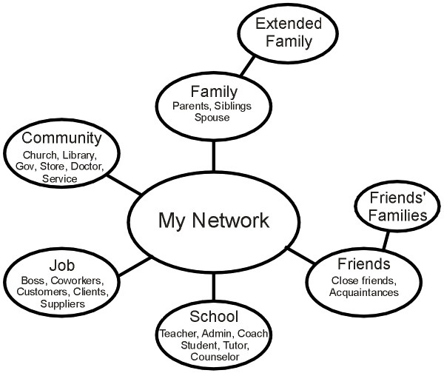
Activity: An Essential Guide to Starting Your Own Business
Instructor Preparation
A free online course is available from the SBA.gov website:
http://www.sba.gov/sba-learning-center/training/364041
Students will need to register and then devote almost an hour to completing the self-paced course. (Screen captures and a transcript of the narration are provided at the end of this module.)
Objectives
Students will:
Complete the online course An Essential Guide to Starting Your Own Business
Activity Guidelines
If time does not permit students to complete the activities in this module, this self-paced course can be used outside of class instead. Students should:
- Sign up and complete the online course.
- Download and print the certificate of completion provided at the end of the course.
Activity: Advertising
Instructor Preparation
Now that students have conceptualized their new business, how can they attract customers? In this activity, students will prepare for a 3-minute interview with a local television reporter. After the students have composed their thoughts, the reporter will inform them that they really only have 30 seconds. In effect, they will have to create an “elevator speech.”
After the recordings are completed, show them to the whole class. You can have everyone vote on the best spot and give an award to the winner.
Objectives
Students will:
Create an informative explanation and sales pitch (30 seconds) for their new business venture.
Materials
- Optional: A video camera, smartphone, or tablet (preferably mountable on a stand) for capturing video of a news-reporter interview
Activity Guidelines
- Assign student teams the task of preparing for a 3-minute interview by a television news crew who will be arriving in 30 minutes.
- After about 30 minutes of work by the teams, spring the news on everyone that you just got a call from the news team that there’s been a change of plan: each interview spot must be trimmed down to 30 seconds! Each team should respond to a prompt like, “Tell our viewers about your new business.”
- If possible, invite a pair of students from the school’s audio-visual department to record each team’s 30-second interview.
Group Reflection Questions
Engage the students in a discussion of how difficult—yet productive—it was to boil down the company description and sales pitch to a 30-second elevator speech. Were all the teams able to do it? Was everyone able to describe their business and their product (or service) and extend an invitation to the public during the allotted 30 seconds?
Assessment Tools/Strategies
This section includes strategies and instruments for assessing students’ knowledge, skills, and attitudes in regard to entrepreneurship.
Rubrics
Rubrics are valuable assessment tools. Students should be provided with the rubric by which they will be assessed before an activity begins so they will understand the performance expectations. When time permits, students can contribute to the rubrics by brainstorming with the instructor about what a quality behavior or product looks like. For example, before assigning a team project to research a topic and prepare a group presentation, ask students to describe how the ideal team would handle the assignment, i.e., how they would assign roles, divide the work, and create and make the presentation. Prompt students with specific components. Then have them describe a poor performance. These will be the descriptions of the characteristics for the highest and lowest ends of the Likert scale for each performance criterion. Instructors should add any required attributes to the rubric if the students do not come up with them on their own. Several entrepreneurship evaluation rubrics have been provided as examples.
- The first rubric for instructor assessment lists desired observable attributes of entrepreneurship and includes blanks where the instructor can adapt the rubric for a specific activity, project, or career field by inserting additional criteria. These first rubrics were intended to be used by the instructor or other observer assessing each student.
- The second entrepreneurship rubric is a self-rating rubric intended for use by the students themselves. The students indicate the degree to which they think they are performing each attribute. They can periodically return to the rubric to reassess and determine whether they are improving those skills.
- The final rubric is the most complex. The student completes a rubric by providing examples of satisfactory or exemplary performance of the tasks/behaviors listed. Then the student meets with the instructor or peer observer and compares his/her reflections with their instructor’s or peers’ observations and formulates an action plan for improving attitudes, behaviors, or skills.
This type of rubric most resembles the type of assessment an employee might receive on the job. It is also the most time-consuming. Ideally, this rubric would be used at least three times during a course:
- At the beginning of the course, to get a baseline and to give students suggestions for specific actions they might take to improve their performance;
- At the midpoint of the course, to check progress and refine the recommendations for improvement; and
- At the end of the course, to assess the progress made over the duration of the course. Additional suggestions can be made for students’ continued growth beyond the end of the course.
Rubrics for Instructor Assessment
Outcomes from Entrepreneurship: In completing this module, students are expected to appreciate the process, requirements, and value of starting a new business. To that end, the activities walk them through the typical process of developing a business plan—the first step in starting a new business. The importance and power of networking is also explored, as well as the ability to distill an informative business description down to a very brief presentation.
Relevant to a new business idea selected by the student, the student is able to:
Select a new business idea as part of a team effort. | 1 2 3 4 5
Complete an executive summary for the new business, as part of a business plan. | 1 2 3 4 5
Complete a description of the product or service of the new business. | 1 2 3 4 5
Describe the market features (i.e., customers) for the product or service of the business. | 1 2 3 4 5
Describe the current market competition for the product or service of the business. | 1 2 3 4 5
Identify the prominent legal requirements for the product or service of the business. | 1 2 3 4 5
Create a brochure or web page to provide an informative advertisement for the product or service of the business. | 1 2 3 4 5
Develop a strategy for promoting the product or service of the business. | 1 2 3 4 5
Develop a strategy for delivering to the customer the product or service of the business. | 1 2 3 4 5
Develop a pricing strategy for the product or service of the business. | 1 2 3 4 5
Identify and defend the choice of structure (i.e., sole proprietorship, partnership, or corporation) for the new business. | 1 2 3 4 5
Describe the general cash flow expected for the new business. | 1 2 3 4 5
Assemble a complete business plan for the new business. | 1 2 3 4 5
Deliver an informative explanation for the new business that lasts 30 seconds or less. | 1 2 3 4 5
Create a relationship map that illustrates the network of family, friends, and acquaintances. | 1 2 3 4 5

5 | Always | Excellent
4 | Most of the Time | Good
3 | Sometimes | Adequate
2 | Occasionally | Fair
1 | Never | Poor or None
Rubrics for Self-Assessing Entrepreneurship Skills
Use a copy of this instrument throughout the course to self-monitor your entrepreneurship skills. Note: It is fairly common to overrate your skills during the initial assessment. You may rate yourself a bit lower as you get feedback from others and discover the complexities of each attribute. By the end of the course you should see improvements in your ratings if you focus on improving the quality of your work and depth of understanding in addition to getting the assigned work completed.
Objective: In the process of developing the idea for a new business, your understanding and confidence about the business will evolve and strengthen. This evolution will occur as a result of research and the help and advice of others.
Essential Attribute | I | II | III | IV
I am able to improve the focus of my new business idea, based on research. | Seldom | Sometimes | Usually | Consistently
I am willing to modify my ideas, based on the input of superiors (supervisors, instructors). | Seldom | Sometimes | Usually | Consistently
I am willing to modify my ideas, based on the input of colleagues (coworkers, fellow students). | Seldom | Occasionally | Often | Consistently
I am willing to share the workload of organizing and running a new business with others. | Seldom | Sometimes | Usually | Consistently
I am willing to share the profits and benefits of a new business with others. | Seldom | Sometimes | Usually | Consistently

Objective: An entrepreneur must invest a great deal of their own time and resources, and take some risk with their own possessions, popularity, and so forth.
Essential Attribute | I | II | III | IV
I devote sufficient time to finish an assignment, even if it means sacrificing my own leisure time. | Seldom | Sometimes | Usually | Consistently
I contribute my resources (time, money, materials, etc.) to completing an assignment. | Seldom | Sometimes | Usually | Consistently
I offer my ideas during brainstorming sessions. | Seldom | Sometimes | Usually | Consistently
I describe and defend my new business idea when given an opportunity, such as an advertisement or interview. | Seldom | Sometimes | Usually | Consistently
 | Seldom | Sometimes | Usually | Consistently

Objective: An entrepreneur must create a business plan, with all the required parts, to have a reasonable chance of obtaining the support needed for a successful venture.
Essential Attribute | I | II | III | IV
I am not intimidated by the task of completing long or difficult assignments. | Seldom | Sometimes | Usually | Consistently
I chart or check-off my progress in completing long and difficult assignments. | Seldom | Sometimes | Usually | Consistently
I am willing to perform the research necessary to complete a difficult assignment. | Seldom | Sometimes | Usually | Consistently
I learn, research, compose, and assemble the parts of a plan for my new business. | Seldom | Sometimes | Usually | Consistently
 | Seldom | Sometimes | Usually | Consistently
Rubric for Assessing Entrepreneurship Skills
Outcome: An entrepreneur must be sensitive to the customer and the market, listening to and responding to feedback and critique.
Performance Criteria
Reflection  Reflect on your actions during class or at a workplace and identify examples of when you: |  | Personal Plan  Based on your examples and the feedback of your peers or instructor, describe the steps you might take to continue or improve in this area.
Listen to your fellow students, and respond in a positive way. | Example:  Peer / instructor review: | Steps:
Use the Internet to find an answer to a question. | Example:  Peer / instructor review: | Steps:
Make a change in your plans as a result of research finding or advice. | Example:  Peer / instructor review: | Steps:
 | Example:  Peer / instructor review: | Steps:

Peer comments and suggestions:
Instructor comments:
Outcome: A successful entrepreneur must be realistic in assessing situations, making wise decisions that reflect reality, not wishful thinking.
Performance Criteria
Reflection  Reflect on your actions during class or at a workplace and identify examples of when you: |  | Personal Plan  Based on your examples and the feedback of your peers or instructor, describe the steps you might take to continue or improve in this area.
Make a realistic cost/sales prediction for your new business. | Example:  Peer / instructor review: | Steps:
Limit yourself or your business in the interest of achieving a higher goal, rather than immediate profit. | Example:  Peer / instructor review: | Steps:
Avoid decisions that incur excessive risk to the business or personnel. | Example:  Peer / instructor review: | Steps:
Consider the investor’s position when making far-reaching decisions about the business (e.g., product addition or alteration). | Example:  Peer / instructor review: | Steps:
 | Example:  Peer / instructor review: | Steps:

Peer comments and suggestions:
Instructor comments:
Video and Weblinks
Video
http://www.youtube.com/watch?v=SMr_uLZV-eM
Instructions on writing a business plan, from the U.S. Small Business Administration.
https://www.youtube.com/watch?v=FY4OGny5vBM
Video tutorial by Tim Berry, Founder and Chairman of Palo Alto Software and business plan expert.
Weblinks
https://www.ncsbc.net/
The North Carolina Community College System Small Business Center Network offers a wide range of services and resources designed to encourage entrepreneurs to be involved in their local communities.
http://www.entre-ed.org/
Consortium for Entrepreneurship Education, a webpage for teachers, instructors, youth leaders, program developers and others who help students of all ages find their own entrepreneurial opportunities. Includes National Content Standards for Entrepreneurship Education and supporting summaries, presentations, examples, and other resources.
http://www.sba.gov/sba-learning-center/training/364041
A free online course: An Essential Guide to Starting Your Own Business (approximately 45 minutes)
http://www.bplans.com/samples/sba.cfm
Hundreds of sample business plans.
Additional Resources
Transcript of SBA course How to Write a Business Plan (4 parts) (https://www.sba.gov/tools/sba-learning-center/training/how-write-business-plan)
1. How to Write a Business Plan
How to Write a Business Plan Overview
Welcome to the How to Write a Business Plan course. The course expands on topics relevant to those individuals who are planning to write a business plan by defining a business plan, as well as appropriate audiences, and its importance to business success, and by explaining in detail the contents of each section within a business plan.

Course Objectives
By the end of this course, you should be able to apply planning principles and design practices when writing a business plan.
To accomplish this objective, you will:
- Define a business plan; and
- Explain the components of a business plan.
Start Your Plan
“By failing to prepare, you are preparing to fail.” - Benjamin Franklin.
Imagine you throwing a surprise party for your favorite relative who is turning 90. Would you plan the food, entertainment, table setup, etc.? Of course, you would. Starting or running a business without proper planning is like throwing a party for 100 people, without a plan.
Planning will help shape the end result and provide the best path to get you there. Planning gives you a roadmap to follow.
If you don’t plan for the success of your business, you will likely fail. It is that simple.
Business Plan Blueprint
Like throwing a party without an agenda, if you’re running a business without a plan, you won’t know in what direction you’re headed.
For businesses, planning is usually presented in the form of a business plan.
As the blueprint for your business, a business plan provides an outline to the framework of your business, declares your visions, and showcases the necessary steps to fulfill the vision you’ve outlined.
It summarizes your business’s history and background and models your core values and mission.
As the roadmap for your business, a good business plan helps you navigate your business towards your strategic direction.
The more thorough you are, the better your blueprint for success will be.
Components of a Plan
To put it into perspective, a business plan explains:
- Who you are
- Why you’re in business
- What you do
- How you do it
- Where you operate
- How you will generate profits
- Who your customers are
- Why your business is important
Your Audience
So who will read your business plan? Who’s your audience?
Business plans are designed to communicate to a specific target audience: internal or external stakeholders. Stakeholders include anyone with a potential vested interest in your business.
Even if you’re not looking for outside funding, a business plan is useful for persons internal to the business: you, employees, management, sales, etc. to know your mission and vision as well as your target market and customer.
However, business plans are often the first thing an outside funder will request; therefore, much of what is in the plan will be directed at an external audience such as potential investors or lenders (government). So, for investors, banks, and loan advisors, business plans are essential.

Tailoring Your Plan
Tailor your plan to your intended audience. And, remember, as your business expands, so will your plan.
When writing for internal stakeholders, focus on the detailed operation of the business. For example, include comprehensive data on the operating budget, market research, competitor analysis, sales lists, product design specifications, etc.
When writing for external stakeholders, focus on the financial aspect of the business. For example, if you’re looking for a traditional loan - you should include the amount you’re looking for, how the funds will be used, what those funds will accomplish, how you plan to repay, and any collateral you have to offer.
If you’re looking for investors, talk about growth; For example, what funds you will need in the short term as well as the long term (up to five years) and how you will use those funds to grow.
Calculate Return on Investment (ROI) estimations and how financial reporting will work. Tell them what percent ownership you’re willing to give to investors, what milestones or conditions you will accept, how you expect them to be involved (board membership, management, etc.), and any proposed investor exit strategy (such as buyback or sale options).
Categories of Business Plans
There are two main categories of business plans: traditional and alternative.
While traditional business plans cover key established business aspects, alternative business plans offer their target audience innovative approaches that emphasize speed, flexibility, and the ability to change direction and adapt.

Traditional Business Plan
Depending on a company’s needs, a traditional business plan can cover key business concepts such as marketing and finances, and/or be used as a tool to effectively operate the business by organizing company goals and objectives.
A traditional business plan can save your business money because its primary function is to manage current and future financial projections. You are better equipped to manage spending since budgets are set within the plan.
In addition, marketing dollars are allocated more effectively because the plan helps pinpoint the characteristics of the company’s target market.
A business plan contains mini-plans to address the different aspects of your business:
Sales and Marketing analysis provides specific information regarding the industry in which the business operates.
Financial information such as accounts payable and receivable, break even projections, and the current financial picture of the business give an accurate depiction of the business’ finances.
Ownership and management structure of the business is also a key element of the business plan, detailing the qualifications and duties of the individuals in charge.

Alternative Business Plan
Alternatives to the traditional business plan provide the target audience with an innovative approach when outlining the business framework.
One Size Does Not Fit All
The first step to outlining a business plan: having an idea for a product or service. The second step is pricing your product or service for customers who need what you are selling. And the third step is making a profit. 1, 2, 3… See, it’s not that hard.
Your business plan is not out to get you. Instead, think of it as a tool to get you where you want to go – a roadmap to success.”

IDEA, PRICE, PROFIT
There are different types of business plans; there isn’t a one-size-fits-all. The trick is finding one that fits YOUR business. And to find out what type of business plan is best for your business, ask yourself: What are you going to need or use to operate your business?

What are you going to need to operate your business?
Owners of startups or businesses in the beginning growth stages will have a different answer than a business that’s been operating for a few years.
So, for startups, your business plan should communicate to investors, partners, and employees about what you’re going to do with your business--your vision, projected strategies, and financial forecasts. Remember, as a startup you may not initially make a profit, but eventually, making a profit is your goal, right?

Communicate business vision; Outline projected strategies; Forecast financial income
A business plan for businesses that have operated for a few years’ maps strategy steps to reach their end goal, whether to be sold or to build the family business for the next generation. Their business plan might outline metrics, list tasks or deadlines, and project sales goals. It might list expenses, capital, and assets/liabilities to manage cash flow. Businesses that have been around for a while have a lot more things to consider, so they may even devote a portion of their business plan to analyzing their projections, expenses and costs.
Bottom line: your business plan will always be a living document because your business will change, and your business plan should be updated to reflect those changes.

Business Plan = Living Document
How it’s presented to your audience also depends on your type of business. Business plans are designed to speak to a specific target audience. While traditional business plans cover key established business aspects, alternative business plans offer their target audience innovative approaches that emphasize speed, flexibility, and the ability to change direction and adapt.

Alternative Business Plans
Okay! Let’s search online for alternative business plans or ideas when you want to impress your investors.
For example, one alternative idea is to give a personal presentation of your business. This adds a human touch into your business plan and encourages questions and answers. Another idea is to boil down your business essentials to a one or two-page blueprint. Focus on the output of the plan, not the description of your business. Consider conveying ideas informally by combining the serious nature of business plans with an easy to read format.
If you not comfortable doing it yourself, there are many services with various solutions to present your plan, so take a few minutes to check them out!
Give a personal demo, Reduce Plan to 1 – 2 pages, Focus on output, Use an informal format
Now you see how one size doesn’t fit all. Your business plan can be written, organized, and presented in different yet acceptable ways, just depends on your answers to the questions we touched on earlier: “What are you going to need to operate your business? And, “What’s the best way to present your business plan?”
Go Traditional or Alternative, whatever aligns best with YOUR business.
Creating Your Plan
When establishing your business, writing your business plan is one of the most important steps you will take because the plan serves as your road map for the early years of your business.
The business plan generally projects 3-5 years ahead and outlines the route a company intends to take to reach its yearly milestones, including revenue projections. A well thought out plan also helps you to step-back and think objectively about the key elements of your business venture and influences your decision-making on a regular basis.
A well-organized business plan is simple, flexible, and manageable. A well-written business plan declares your business’s vision as well as the steps to achieve the vision.
Small business owners or new entrepreneurs are often intimidated when it comes to writing a business plan, thinking it’s complicated or simply unnecessary. Nothing could be further from the truth.
Business Plan Questions
Your business plan should be a living document, constantly revised to match changing markets and business needs. Before you begin writing your business plan, consider these four core questions:
- What service or product does your business provide and what need does it fill?
- Who are the potential customers for your product or service and why will they purchase it from you?
- How will you reach your potential customers? And,
- Where will you get the financial resources to start or grow your business?
Your Company Description
This section provides a general background and description of your company. You should include things like a mission statement, company goals and objectives, and a general overview of your product or service, target market, and industry. You will also go into detail about your company’s management, organizational, and legal structures.
Total suggested page length for this section of the business plan: 3 - 5 pages
Mission Statement: The mission statement is a brief statement about who the company is and what it stands for. Some companies use the mission statement as a marketing slogan. However, the true intent of a mission statement should be to describe the purpose of the business - a futuristic expression of hope inspiration. For example, Google’s mission statement is “Organize the world’s information and make it universally accessible and useful.” Michael and Jennifer’s mission statement might be: “To provide the best service for your pet at an affordable price to foster the collective care and love of our furry friends.” Don’t just write down a mission statement, think about it, get input from others, and carefully develop a statement that is an expression of your business.
Business Goals and Objectives: Your business goals and objectives should be specific and attainable. Remember, goals that are not specific will probably not be achieved. An example could be that your business meets a specific level of customer satisfaction or reaches an annual sales target. If your business is already in operations, describe any major accomplishments or successes.
Products or Services: How is your product or service new and exciting? How are products developed or services provided? Give a brief yet enticing overview of your product or service to include descriptions, pricing explanation, and competitive edge. Keep it short (details come later in the plan). Reference applicable graphics and brochures (in the appendix).
Target Market: This section should briefly describe to whom you will market your products. You will describe this more later, but give a short description of who you think will buy your product and why. To give a frame of reference, include your company’s location and whether you anticipate moving in the future.
Industry: Here briefly describe your industry; you will go into more detail later. What is your industry? Is your industry growing? What changes do you foresee and how does your company plan to take advantage of these changes? How does your company compare to competitors in your industry?
Management Structure: This section should describe the processes that support what your company does. For instance, how is your company’s management organized? Who makes decisions? What are the values that drive your company? How many employees do you have, what do they do, and how are they paid? Do you anticipate this changing?
Organizational Structure: This section should describe the leadership of your company and include an organization chart, if you have one. Who are the principal members of your company and what are their roles? This section of the plan should include a brief resume on each key manager within the company to show that they are qualified to complete this work. If you have a board of directors or outside advisors (such as an attorney or accountant), list them here and describe the relationship. In this section, you should also explain how things get done in the company. Talk about your company’s core competencies.
Legal Structure: What is the legal structure of your business? Here describe what legal requirements your business faces, such as licenses and/or permits your company operates with or needs. It is also an opportunity to highlight special operating achievements or certifications your company has. For instance, your business may have specific security clearances, hold patents, or be quality certified as an ISO 9000 firm. This section should also describe how the company is organized. Specifically, it should explain the legal form of ownership such as the business model. That is, are you organized as a proprietorship, partnership, or corporation and why.
Your Market
Your market is an important part of the business plan. Before you can sell something, you have to know who might buy it and what price they’re willing to pay for it. Research is the foundation to marketing. To conduct market research, you must gather facts and opinions in an orderly, objective way about your target: the industry and your potential customers.
Total suggested page length for this section of the business plan: 9 - 20 pages

Industry
The first step in defining your market should be to describe the industry you operate in, as well as the potential or prospects for your business within that industry. Your industry knowledge as well as the prospects for your business should be clearly illustrated in the plan. For instance, if you are a retail store selling pet care services, describe the general outlook for sales, as well as your potential for capturing a growing segment of the market.
To describe the industry in which you operate, as well as the potential or prospects for your business within that industry, answer these questions within this section of your plan:
- What is your industry?
- What is your industry’s current size and what share of that market will you have? When identifying characteristics of your target market you should also determine the size of your potential market. You can determine the size of your market by examining the number of potential customers in a particular area; reviewing the geographic area they live in; analyzing prior annualized sales and considering market growth. If you don’t know who your customers are, you can’t develop a strategy to reach them. And, if you can’t reach them, you will likely not be effective in selling your products and services.
- Who are your competitors in your industry? Who will be your direct competitors?
- Are there any regulations that apply to your industry?
- What are the trends in your industry, growth, consumer preferences, product development?
- How and where does your company fit in the industry? What advantages or disadvantages do you have over you competitors? Do a competitive analysis to show how you stack up against your direct competitors on things like price, your products, service, etc.
- What are the barriers to entering this industry? (Such as high initial capital costs, unique technology, or customer need for brand recognition)

Customers
The next step in this section of your plan is to identify your target market and profile your customers. Your goal is to find out what people want to buy, not just what you want to sell them.
You should describe your customers’ needs, including information about the degree to which those needs are (or are not) currently being met. Again, if you are selling pet care services, explain why customers will want your services and products. Specifically, what needs are you satisfying with your business.
To determine what needs your business will satisfy, answer these questions within this section of your plan:
- Who are your current or prospective customers? Describe demographic information like age, gender, income level, etc. For businesses that sell to governments or other businesses, describe demographic information such as industry, location, size, and typical purchases.
- What do they buy and why? Can they, and will they, buy my product? What price will they pay? Why might your customers prefer your product over the alternatives? Try to describe how each of your major products or services gives value to the customer.
- And, what market segments or groups are more likely to buy your products?

Market Segment
A market segment or targeted group of customers is a grouping of people sharing one or more characteristics that cause them to have similar product needs. Market segmentation or target marketing is the process of dividing a market into distinct segments that behave the same way or have similar needs. Because each segment is somewhat similar in their needs and attitudes, they will likely respond similarly to a specific marketing strategy. This is an important point and we will discuss marketing to targeted groups later on in this course. However, it is critical that you understand the value of defining your market.
Product Service/Line
In the Product/Service Line section, you will identify and describe all of the products and services your business sells or provides. You should also explain how the items you sell are priced. In addition, and perhaps most importantly, this section should explain how your products and services are competitive.
Keep this section focused, easy to follow and emphasize your competitiveness. It is easy to list your products, but, it is far more worthwhile to explain how you are competitive. Finally, if you have pictures or brochures describing your products, reference them in this section and include them in an appendix to the business plan.
Total suggested page length for this section of the business plan: 4 - 10 pages

Product/Service Line
To provide your audience with a clear understanding of why you are in business, what you sell, and how you compete answer these questions within this section of your plan:
- What product of service will your company provide? For each product describe:
  - What is unique about it? What are its important features?
  - What will it do for the customer? How does it benefit them? Why is it better for the customer when compared to the competition?
- Describe your pricing structure.
- What factors give you a competitive advantage or disadvantage?
- Do you keep inventory? What kind and how much? How is your inventory turnover?
- Who are your suppliers?
- In which lifecycle stage is your product or service?
- What research and development activities are you performing or planning?
- What intellectual property rights do you have for your product or service?
Marketing and Sales Strategy
After you’ve conducted your market research, you can create your marketing and sales strategy to reach your customers.
To develop your marketing and sales strategy, answer these questions within this section of your plan:
- What is your plan to grow your company?
- How will you communicate with your customers?
- How will you sell your product or service?
Total suggested page length for this section of the business plan: 4 - 6 pages
Marketing
Marketing is the process of promoting and selling your products or services. Don’t confuse advertising and marketing as one in the same. Advertising is a component of the entire marketing process; other components are:
- Community involvement
- Customer support
- Distribution
- Market research
- Media planning
- Product pricing
- Public relations
- Sales strategy
In simple terms, marketing activities and strategies result in making products available that satisfy customers while making profits for the companies that offer those products.
Creating a marketing strategy can be difficult. It deals with people and their constantly changing feelings and behaviors, which are influenced by countless subjective factors
A good marketing strategy identifies market segments in which a business can better serve than its competitors.
It also tailors product offerings, prices, distribution, promotional efforts, and services toward those identified segments.
Ideally, the strategy will address unmet customer needs that offer adequate profitability for the business and focus on the target markets it can serve best.
However, both customer needs and the business environment in which you operate are constantly changing. Your marketing strategy needs to consider what changes are taking place, and emerging opportunities and threats.
A marketing strategy will also help you assess how successful you are at meeting your customers' needs, as well as how successful your competitors are.
It may also help you identify new markets that you can successfully target.
A good marketing strategy will be based on your market research to determine what customers want and what they will pay for.
Central to any successful marketing strategy is an understanding of your customers and their needs. The ability to satisfy your customers' needs better than your competitors can help you build customer loyalty and increase sales. Remember, trying to convince people to buy something they don’t want is extremely expensive and seldom successful.

The 4 Ps
A successful marketing strategy will typically mix the 4Ps of marketing - place, price, promotion, and product - to reflect the wants and desires of consumers in the target market.
- Place refers to how the product gets to the customer. Specifically, it refers to the channel by which a product or service is sold or distributed. This is an important piece of information. Are you selling online, in a store, or through sales agents? In your own store or in someone else’s? Is that consistent with what your customers want? Is it convenient, comfortable, or ideal for them? How does your distribution channel compare to your competitors? If you have a physical location, how far are you from your competitors?
- Pricing refers to the process of setting a price for a product, including discounts. You’ll want to discuss how you set prices. How does your price compare with your competition? How sensitive to price are your potential customers? How much of your product do you think you will sell at various price points? Are you going to change your prices often?
- The product aspects of marketing deal with the specifications of the actual goods or services, and how it relates to the end-user's needs and wants. In this section of your business plan, you can talk briefly about where your product fits in the market.
- Promotion includes advertising, sales promotion, and publicity, and refers to the various methods of promoting the product, brand, or company. How do you plan on communicating with customers? What message will you communicate? You’ll want to discuss your promotional plans, the budget for this promotion, and how that budget will change through your business’s life cycle.
Sales Strategy
You will also want to include a sales forecast. Prepare a month by month projection based on historical sales (if available), industry and market research, and the marketing plan described earlier. You may create more than one projection based on multiple scenarios, particularly if this is a new business or new product. Align forecast assumptions with your market research or historical sales. Don’t pull numbers out of thin air. Finally, discuss how these sales will lead to company growth.
Funding Request
In this section, to identify exact (no estimates!) amounts of funding you will need to start your business or have already invested and make sure it ties specifically to your Financial Projections.
If necessary, you can include different funding scenarios, such as best and worst case scenarios, but remember that later, in the Financial Projections section, you must be able to back up these requests and scenarios with corresponding financial statements and projections.
If you are planning to self-fund your business, be aware that while it may not be a required section of your plan, it might be advantageous to know this information for future planning purposes.
If you are seeking funding for your business, include these funding requirements in your business plan.
- Your current and future (5 years) funding requirement. Include time period that each request will cover, type of funding you would like to have (e.g., equity, debt), and the terms that you would like to have applied.
- How you intend to use the funds you receive: Is the funding request for capital expenditures? Working capital? Debt retirement? Acquisitions? Whatever it is, be sure to list it in this section.
- Any strategic financial situational plans for the future, such as: a buyout, being acquired, debt repayment plan, or selling your business. These areas are extremely important to a future creditor, since they will directly impact your ability to repay your loan(s).
Total suggested page length for this section of the business plan: 2 - 4 pages
Financial Projections
As you move to the next section of the business plan (Financial Projections), ensure your financial projections match your funding requests.
All possible credit sources will be on the lookout for inconsistencies and few, if any, will allow you to correct problems they have uncovered. It's much better if you catch mistakes before they do; it can mean the difference between approval and decline.
The financial structure of your business is its foundation; therefore, the Financial Projections section of your business plan is critical to write well.
This important section explains your revenue forecasts, how much money you have and need, and when and how the business expects to make a profit. It also details what your marketing and operational processes and plans will cost.
To clarify your business’s financial situation, the Financial Projection section of the plan includes economic estimates and three financial statements: Projected Balance Sheet, Cash Flow Projection, and Profit and Loss (Income) Projection.
This section of your business plan is considered the most important as it outlines the complete financial situation of your business. Therefore, ensure this section is reviewed by a financial professional, such as your accountant.
Total suggested page length for this section of the business plan: 12 - 25 pages
The financial performance of any business is measured by the interrelationships among six essential elements.
These elements comprise the three financial statements (Projected Balance Sheet, Cash Flow Projection, and Profit and Loss [Income] Projection) and are: revenue, expenses, profits/losses, assets, liabilities, and net worth.
A business will prosper or fail based on the owner’s effectiveness in planning and controlling these components.
The Projected Balance Sheet represents the basic accounting equation: assets minus liabilities, equals net worth.
A balance sheet is made up of assets (items of value), liabilities (debts) and net worth (equity or the difference between a company’s assets and liabilities).
The balance sheet provides a measure of a business’s value at a particular point in time. It is considered a snapshot in time.
The Cash Flow Projection is a valuable tool that monitors and projects the amount of incoming and outgoing cash during a given period (usually monthly) to gauge financial performance.
It helps you determine how much cash your business has on hand at any point in time. If your business has a negative cash position, it means that you have more money going out than coming in and may find paying your bills somewhat challenging.
The Cash Flow Projection shows you if your working capital is adequate and helps you determine how much and when you may need to borrow money. Don’t forget to account for things like selling or buying on credit or irregular expenses.
The Profit and Loss Projection is a measure of how a business’s income has performed over a specific period of time, usually six months or one year.
It measures all income less all expenses to arrive at the amount of profit or loss generated by the business for the period.
The Profit and Loss Projection is also called an income statement or an income and expense statement.
If you’re adding proposed loans into your business plan, include the sources, amounts, and terms in the Financial Projections section of your business plan.
If you have (or plan to get) investors, include how much will be contributed by each investor and what percent ownership they will have.
If you are submitting your business plan to a bank because you are applying for a loan, you should also include a current personal financial statement on each company principal and a copy of your business or individual Federal Tax return for the last three years.
If you are a new business, all of your financial statements should be projected one, two, and three years forward and include accompanying narratives to explain any assumptions. It should also include a Break-Even Analysis. Do your sales projections from the previous section indicate that you will reach your Break-Even Point?
Do your research to accurately determine all of the potential costs and projections. Explain when you expect to become profitable and how you arrived at that conclusion.
If you are an existing business, you should include current and prior Projected Balance Sheets and Profit and Loss (Income) Statements, ideally for the last three years if available. Then, include projections for the next three years.
You should also include a current twelve-month Cash Flow Projection statement that predicts the flow of cash several months’ forward.
Include your business tax documents for the last three years as well, if applicable. If you plan to introduce a new product line or if you will require a large influx of capital up front to grow your business, consider adding a Break-Even Analysis.
Remember to include accompanying narratives to explain any issues or assumptions in your plan.
Break Even Analysis
Another financial analysis you should include is a Break-Even Analysis. A Break-Even Analysis indicates when your business will be able to cover all of its expenses and begin making a profit.
This analysis calculates the minimum amount of sales needed to cover your costs. This is especially critical for startup businesses as it shows the sales threshold that needs to be surpassed before the business becomes profitable.
The quantity of products you will have to sell per month to cover your costs is called the Break-Even Quantity (BEQ) or the Break-Even Point. To determine your Break-Even Point, you will need the following information:
Fixed costs are expenses like monthly rent, salaries, and insurance premiums that are paid at regular intervals. If you pay certain fixed costs only once per year, determine the monthly portion of that cost. Make sure you calculate the monthly cost of each of these items for this analysis.
Variable costs include the costs for producing your product or delivering your service, maintaining your inventory, transporting products, and buying additional equipment. Variable costs change with sales volume. Price is the amount of money your customers pays for a specific product or service.
Optional Appendices
The last section of your plan is an optional appendix. This section can help define your business and highlight your accomplishments by including brochures, resumes, pictures and other important information.
You can use this section to add color and depth to your plan. Examples of things to include are:
- Brochures and advertising materials
- Blueprints or plans
- Maps
- Copies of leases or contracts
- Any press coverage of business
- Industry or Marketing studies
- Any other materials needed to support what you claim in the business plan
Executive Summary
The Executive Summary is a very important part of your business plan. As the name implies, it is a clear, concise snapshot or summary of your business.
As mentioned earlier, the Executive Summary is the first section of a business plan, but it is the last section you will write. And, while it’s the last section you will write, it’s the first section your audience will read. Therefore, the Executive Summary must be engaging, while simultaneously giving solid evidence that your business will succeed.
Total suggested page length for this section of the business plan: 1 - 2 pages

Executive Summary Contents
The Executive Summary should include short descriptive summaries of each section of your business plan:
- Your company
- Products or services you sell or plan to sell
- Mission statement
- Management and organizational structure
- Target market and ideal customer
- Competition
- Future of your business and your industry
- Banking relationships and information regarding current investors
- Financial data and projections
Essentially, the Executive Summary should answer these questions:
- What product or service will your business provide?
- How does it fill a customer need?
- What competitive advantage, if any, does your product/service have?
- Who are your target customers?
- What goals do you have for your company?
Are you asking for money? If so, how much do you need from a loan or an investor and how will you use it?
Finalizing Your Plan
The icing on the cake, so to speak, is to include the cover page and a table of contents.
Cover page: Even though “we shouldn’t judge a book by its cover” - let’s face it, we do. Therefore, every business plan should have a professional-looking cover page that includes your name (and the name of any other owners), your business name, and your contact information (such as street address, telephone, and email). You can also put your logo on the cover page, if you have one.
Table of Contents: A table of contents brings organization and structure to your business plan by listing key sections within the plan and their corresponding order and location (page number). Most importantly, your audience will be able to find specific topics and areas of interest in your plan.

Putting It All Together
Once written, assemble the sections of your business plan in a quality binder (separate the section with tabs) as follows:
- Cover Page
- Executive Summary
- Table of Contents
- Company Description
- Market Research
- Product/Service Line
- Marketing and Sales Strategies
- Funding Request
- Financial Projections
- Appendices (if applicable)

Formatting Best Practices
You’ve got an idea now of the main sections to include in your business plan. Investing the time to properly format your business plan will prove priceless as a well put-together document stands out from a mountain of other papers and documents whose authors did not take the time to format.
Here are a few formatting best practices to follow when writing your business plan:
- Font types recommended: Times New Roman, New Century Schoolbook, Bookman, or Palatino
- Font size 11 or 12 pt
- Single space lines
- Use numerical, bolded headings (slightly larger font size than text).
- Use headers and footers (at minimum - company name in header; page number in footer)
- Do not underline; use italics sparingly.
- Include plenty of white space; use bullets
- Margins should be at least 1”
- Duplex print (both sides of the paper)
- Space once after all punctuation
- Use color sparingly
- DO NOT USE ALL CAPITAL LETTERS; not only are they difficult to read but in today’s world, using all capitals is conveyed as shouting.
- Include tabbed dividers within the binder
And finally, you have probably written, read, reread, rewritten to the point of exhaustion; therefore, hire a reviewer (or two) to read your business plan. You will be amazed at the errors they find and the questions they ask that may require further clarifications to the plan. If reviewers find mistakes, you can bet your end audience will too. It will be money well spent.
To minimize any possible misunderstandings, consider asking the reviewers to sign a confidentiality disclaimer stating the content is confidential and may not be disclosed.
How to Write a Business Plan Worksheets
- Balance Sheet Example
- Cash Flow Statement Example
- How To Write A Business Plan Checklist
- Income Statement Sample
2. Legal Requirements
Determining Your Requirements
The SBA Learning Center presents: Legal Requirements for Small Business, an overview of legal requirements for small businesses and how they can impact you.

Course Objectives
The course has six key objectives:
- Determine federal, state, and local requirements you may have to meet when you start a new business,
- Explain the requirements for hiring, paying, and firing employees,
- Identify federal, state, and local tax collection and reporting requirements for small businesses,
- Describe the importance of zoning ordinances, securities registration, and business permits and occupational/professional licenses,
- List environmental regulations that may impact your business, and
- Examine ways small business owners can manage legal risks.

Course Topics
This course provides an introduction to legal requirements for small businesses. Some of the questions answered in this course are:
- What federal, state, and local requirements may you have to meet when you start a new business?
- What are the requirements for hiring, paying, and firing employees?
- What are the federal, state, and local tax collection and reporting requirements for small businesses?
- How important are zoning ordinances, securities registration, and business permits and occupational/professional licenses?
- What environmental regulations may impact your business?
- How can you manage legal risks?
Let's get started!
Determining Your Requirements
To run your business legally, there are certain federal and state licenses and permits you will need to obtain. There may also be county, city, or other local licenses and permits as well. With so many variables affecting your business choice, the best way is to start by using your favorite search engine to help gather the information you need.
Registering and Licensing
How you register your business will vary based on the business structure you have chosen. However, in general you will need to check on federal, state and local regulations that may impact your business.
You may need to obtain a federal license or permit if your business concerns activities supervised and regulated by a federal agency. For example, you need a federal permit to sell alcohol or firearms. Special permits and licenses are covered later. Federal Employer Identification Numbers (EIN) are discussed later in this course.
You will likely have to register your business with your state's business office. If you are doing business in more than one state, you will have to follow the registration procedures unique to each state in which you plan to operate. And, as with the federal government, many states permits or licenses for certain products or services.
Most localities have business requirements and restrictions. Food and liquor licenses are usually required from the city or county where the business is located, and you will have to register with the city or county treasurer for tax purposes.
DBA
DBA is a popular acronym that means 'Doing Business As.' It is also sometimes called "assumed name" or "fictitious name". It is the legal term used to describe when the trade name or fictitious business name used by a business is not the legal name of the of the actual owner (the individual responsible for it). It is also used when a business is to be operated separately under a parent company or corporation.

Why Use a DBA?
You would need to use a DBA if you do not want to incorporate or do business under your own name. You may also need to use a DBA name if your legal name is already in use by someone else and is unavailable. It is important to remember that a business with a fictitious name does not identify the person or entity legally responsible for its operation. Many states require that you register DBA or fictitious business names in order to protect consumers who do business with you.

How to Get a DBA?
The process to register your DBA name varies depending on the state or region you will be operating in. Typically, you will register your DBA with the local county or city clerk's office, or with the business department of your state government.

Case Study
Andrew Lacona wants to start a new cell phone accessory business and has decided on the name 'Andy's Apps.' He has researched the name and no one else in the state is using it or has it registered. He wants to use this as the legal name for his business instead of his own name.
Andy went to get his business license from the city treasurer's office and found out that he has to register 'Andy's Apps' as a DBA name before he can proceed with his business license.
Andy contacted his state business department and registered 'Andy's Apps' as a legal DBA name. He was then able to complete his city business license application.
Workplace Laws and Standards
There are workplace laws and standards for businesses with employees. You will need to understand federal, state, and local requirements for hiring, paying, and firing employees.

Federal Employment Laws
The first thing you need to do is determine what federal employment laws will apply to your business. The U.S. Department of Labor (DOL) provides a web site called 'elaws - FirstStep Employment Law Advisor'
This site offers a short primer on employment laws, explanations of recordkeeping, notice, and reporting requirements, and links to printable resources such as posters and regulation summaries.

Examples of Federal Employment Laws
You should be familiar with these federal employment laws:
- The Americans with Disabilities Act (ADA) prohibits discrimination against people with disabilities in employment, transportation, public accommodation, communications, and governmental activities. The ADA also establishes requirements for telecommunications relay services.
- The Family and Medical Leave Act (FMLA) entitles eligible employees of covered employers to take unpaid, job-protected leave for specified family and medical reasons with continuation of group health insurance coverage under the same terms and conditions as if the employee had not taken leave.
- The Uniformed Services Employment and Reemployment Rights Act (USERRA) protects service members' reemployment rights when returning from a period of service in the uniformed services, including those called up from the reserves or National Guard, and prohibits employer discrimination based on military service or obligation. The U.S. Department of Labor's (DOL) Veterans' Employment and Training Service (VETS) administers Uniformed Services Employment and Reemployment Rights Act (USERRA).
Federal Identification Number
You must get an employment identification number (EIN) from the U.S. Internal Revenue Service before you hire your first employee. This is the number you will use to report taxes and other documents to the IRS and to state agencies. While not required by the federal government, some banks may require even sole proprietors to obtain an EIN for their business bank account and some state and local authorities may require it for business licenses. You can apply for this number online, by phone, via fax, or mail. There is no payment to acquire an EIN.
To apply for an EIN online, visit the IRS' Online EIN application site.
State Requirements
Labor laws vary by state. You need to determine which local laws apply to your business. The U.S. Department of Labor provides a complete directory of individual state labor offices with contact and web site information.

Local Laws
Although local employee laws are usually modeled after federal and state laws, they sometimes extend certain rights and protections beyond what the federal and state laws require. Unlike some federal and state labor laws, local labor laws often apply to smaller employers as well.
Make sure that you check with your city or county business office to find out what local legal requirements you need to be aware of.
Federal Taxes
Your responsibilities for federal taxes depend on the structure and size of your business.
- Income Tax: Unless you have a business partnership, you will have to file an annual income tax return with the Internal Revenue Service. The type of return you file depends on the business structure you have selected.
- Estimated Tax: This is the tax you expect to owe the federal government based on projected earnings of your business and is usually in the form of regular payments through the year.
- Self-Employment Tax: If you are a sole proprietor of your business, you will need to pay self-employment tax, which covers your required contributions to social security and Medicare.
- Employment Tax: If you will have employees working for you, you will be responsible for specific taxes and forms. These include withholding income tax, social security and Medicare taxes, and Federal unemployment tax.
- Excise Tax: Certain manufacturing businesses and service providers must pay excise taxes. Some examples include the operation of large vehicles or accepting wagers.
- More Information: You can get more detailed information on federal tax requirements for businesses at the IRS' Business Tax website.
State and Local Sales Tax
Sales taxes are typically required by both state and local governments for both products and services (labor).
- Sales tax is a point-of-purchase state and/or local tax paid by the purchaser for retail goods and services.
- You are required to determine applicable sales tax for any products or services you provide, collect the tax from consumers, and pass tax revenue on to the responsible state and local authorities. Note that regulations and requirements for sales tax vary by state, which can become complicated if you sell to consumers in multiple states.
- Your state or local government may require you to obtain a sales tax permit in order to collect tax revenue from consumers. This revenue is typically paid monthly or quarterly and requires that you complete returns and reports to the responsible government entities.
Income Tax
Business income taxes are collected by most states, and depend on the legal structure of your business.
In some cases, a Limited Liability Company (LLC) is taxed separately from the owner, who will also file an individual income tax return. However, this is not always the case. LLC rules vary by state, so check with your accountant or legal advisor to discuss your options.
If you are the sole proprietor for your business, you will use the same form to report your personal and business income taxes.
You can find out specific business income tax information for your state by reading SBA's article, Determine Your State Tax Obligations, on their web site.
Zoning Ordinances
You need to check the location you plan to use for your business to make sure that the property is zoned correctly. You can find this out by contacting your local planning agency. The types of restrictions you are likely to encounter depend on if you are planning a home-based or separate (brick and mortar) business.
Residential areas tend to be much more restrictive than business areas. Be sure to check for any local zoning restrictions for your property. Some of the typical restrictions include:
- Changes to the physical appearance of your home, such as outside displays or parking commercial vehicles,
- Impact on local traffic limiting the number of customers or employees, and
- Noise or nuisance, such as storage of hazardous chemicals or unusual odors.
Brick and Mortar is a traditional physical building specifically used for your business or operation. A brick and mortar business will normally be located in a commercial zone, which typically has fewer restrictions than a residential area. However, there are different types of commercial zones. Make sure your business fits into the property limitations. Brick and mortar businesses fall under two general zoning classifications: commercial and industrial.
Commercial Zoning - Commercial business zones are typically used for retail sales and service operations. Restrictions common to commercial areas often relate to the availability of parking or the proximity of certain types of businesses to others. As an example, many communities prohibit or restrict the locations of bars or dance clubs.
Industrial Zoning - If your business involves manufacturing or bulk storage, you are likely to fall under industrial zoning requirements. Typical restrictions in industrial areas include the amount of lot coverage and setback from property boundaries, as well as environmental factors such as noise and pollution.

Case Study
Karla Hall wants to start a home-based mobile car repair service where she does minor repairs to vehicles at the owner's home or place of business. Because she depends on advertising and word-of mouth, she plans to have her work van painted up as a rolling billboard. However, her neighborhood is zoned residential R-1 and does not allow commercial vehicles to be parked on the street or front driveway. Also, one neighbor has objected to the possibility that she may be parking inoperable vehicles on her property.
Karla went to the city planning commission to request a zoning variance, noting that her van is a converted standard passenger model no bigger than many passenger vehicles used by her neighbors. She does not plan to repair any vehicles at her home.
Karla agrees to erect a privacy fence around her back yard and park her vehicle behind the fence at night. The planning commission approves a conditional variance and both Karla and the neighbors are satisfied.
Securities Registration
Any time a small business offers or sells securities, even to just one person, the offer and sale must either be registered with the U.S. Securities and Exchange Commission (SEC) or qualify for the one of the registration exemptions provided under the Securities Act. Registration is usually necessary if you advertise for investors in any way.
Note that public offerings are not recommended for new businesses because the time and cost involved, and they lack the prior performance needed to generate sales.
Permits and Licenses
You will need to check for any special permits or licenses your business requires, including possible workplace inspection and approval by the Occupational Safety and Health Administration (OSHA).
- Business Permits: Federal, state, and local governments may require special business permits for your business. Examples include a seller's permit for reselling wholesale merchandise or a health permit for food preparation businesses.
- Professional Licenses: Certain businesses or services may be required by state or local agencies to have professional/occupational licenses. Examples include real estate sales and operation of childcare facilities.
- OSHA: As an employer, you are required to provide your employees with a safe and healthy workplace. The U.S. Department of Labor's Occupational Safety and Health Administration (OSHA) provides an on-line Small Business Handbook that will help you understand and meet the legal requirements and recommendations so that you can achieve an 'In-Compliance' status before an OSHA inspection. For more information refer to the OSHA Small Business Handbook.
Environmental Regulations
If your business operation has any impact on the local environment, you will need to check with the U.S. Environmental Protection Agency (EPA) and state environmental agencies. Many environmental regulations apply to small businesses, and the EPA and other agencies will work with you to explain specific requirements. Commonly required environmental permits involve the Clean Air Act, risks to endangered species, and use of wetlands.
You can get specific information on environmental issues and regulations that may affect your business from the EPA by visiting their Compliance web site.
Risk Management
You will face a variety of legal risks with the operation of your small business, both internal and external. While it is not possible to be prepared for all issues that could come up, you should analyze your business operation and take steps to minimize potential risks.
In the small business world, Law of Agency typically describes a legal situation where an employer authorizes an employee to deal with a customer and the employee causes a legal issue that results in a lawsuit against the employee and employer. As an example, a new employee of a tree removal service accidentally drops a branch on a customer's car and causes severe damage. The customer then sues both the employee and the tree removal company for damages. The best way to mitigate this risk is to ensure that your employees only undertake tasks they are qualified for and to be as explicit as possible when defining the authority and responsibilities with someone who may act as an agent of your business.
Direct customer legal action: There are some simple steps you can take to limit the possibility of a lawsuit against your company:
- Avoid conflicts of interest.
- Be careful of what you say and do
- Have a good lawyer available to help with decisions before they cause problems
- Separate your personal assets from the business
- Make sure you have adequate liability insurance
- Make sure your critical data is protected and backed up.
Disputes with partners, employees, and suppliers can arise over a wide range of issues such as debts and contractual obligations. These disputes represent a risk of disruption of services or sales to your customers, which may result in legal action. You can mitigate the risk of these disputes by following these guidelines:
- Document all agreements
- Be alert for signs of trouble
Legal Requirements Conclusion
We have looked at some of the main legal requirements you may need to understand and deal with as you start your small business, such as:
- Determining federal, state, and local requirements,
- Explaining the requirements for hiring, paying, and firing employees,
- Identifying tax collection and reporting requirements,
- Understanding the importance of zoning ordinances, securities registration, business permits and occupational/professional licenses.
- We also briefly described environmental regulations that may impact your business, and
- Examined ways small business owners can manage legal risks.
Remember that this has just been an overview of requirements - detailed information is available from the sites and sources identified within the lesson. You can also find a wide variety of information and help at the SBA website.
3. Buying a Business
Buying a Business Overview
Welcome to SBA's online training course: Buying a Business, an overview of how to buy a business, and of the resources available to help you buy a business.

Course Objectives
The course has three key objectives:
- Identify the advantages and disadvantages of buying a business.
- Describe the steps involved in buying a business.
- Identify the resources available in buying a business.

Course Topics
This course covers areas such as:
- How and what to research about a business that you are interested in purchasing
- How to determine the value of a business, and
- How to transfer ownership of a business
Let’s get started!

Buying an Existing Business
Buying an existing business can be less risky than starting a new business from scratch because the existing business is already generating cash flow and has established customers, reputation, and employees. However, it is important that you ensure that you are making the right choice in your new venture.
Even though there are steps you can take to help make the best decision, only you can determine the right business for your needs.
Deciding to Buy a Business
The first step is to decide whether buying a business is the best option for you.
Let's look at the advantages and disadvantages of buying a business. It helps you choose the option that works best for you.
One of the advantages is that you may be able to acquire legal rights to patents and trademarks, which may increase profitability. In addition, buying a business involves reduced startup costs and immediate cash flow and inventory.
However, the downside is that the purchasing cost may be considerably higher than the cost of starting a new business. This could be the case because of the initial business concept, customer base, brand, and other fundamental work that has already been completed.
There could also be existing problems associated with the business - such as debts that you may inherit.
Beginning the Buying Process
Here are the steps to start with when you decide to buy a business:
- Pick an industry that you are familiar with and understand.
- Consider your interests, skills, and experience to help you eliminate unrealistic business ventures.
- List your conditions of purchase, such as location, size, and time commitment. It is also important that you find answers to questions like “Are you willing to buy a business with multiple locations?”
- After you have considered these factors, look for businesses in your preferred location that meet your requirements.
- Hire a business broker who finds buyers and helps you negotiate deals, prescreens businesses for you, helps you pinpoint your interest, and assists with paperwork.
Due Diligence
The next step in buying a business is to put together an Acquisition team consisting of lawyers, bankers, and accountants. The Acquisition team will be able to advise and help you address specific items before you enter into a business agreement or transaction. This process is called due diligence.
After due diligence is completed, you will know what you are buying and from whom.

Initial Research
Due diligence begins with an initial research of the business that you are interested in buying.
Your Acquisition team would be able to help you find answers to questions like:
- Why is the business for sale?
- How is the business perceived?
- What is the future of the business?
- Will the business stay profitable?
- And how has the company evolved over time?
Then reach out to business associations and organizations to ensure that there are no complaints filed against the business you are buying. You should also speak to customers and suppliers about their relationship with the company.
If you are satisfied with the results of your initial research, then the next step would be for your Acquisition team to inquire about an asking price.
Determining the Value of a Business
You should refer back to your initial research while determining the value of a business. Take into consideration factors like inventory, office equipment and property, liabilities, debts, accounts receivable, market history and reputation, and location.
There are a number of different methods that help you determine a fair and equitable price for the purchase of a business.
Among these methods are Asset-based Approach, Market-based Approach, and Income-based Approach.
In Asset-based Approach, the value of the business is determined based on the costs to replace the tangible assets. If the earnings will not support a value greater than the assets, then at best, the value of a business is the value of its tangible assets.
The Market-based Approach forms an indication of value using ratios or factors. These ratios or factors are derived from the earnings, sales, and/or assets of past transactions of similar businesses. They are then applied to the subject company's sales, earnings, and/or assets to derive an indication of value.
The third method, Income-based Approach, derives indications of value by converting some level of earnings into a value using a capitalization rate, discount rate, or a multiple thereof.
For more information, refer to SCORE’s article on How to Value Your Business.
Purchasing Options
Business owners have several options when it comes to transferring ownership rights to another person or entity. These options are outright sale, gradual sale, and lease agreement.

Outright Sale
Outright sale involves buying a business in full. In outright sale:
- The ownership is transferred immediately
- Payment is expected right away

Gradual Sale
Gradual sale is a flexible option in transferring a business which often benefits individuals who cannot afford to purchase a business through an outright sale, but are instead able to finance a long-term payment plan

Lease Agreement
When you agree to a business ownership through a lease, you will commit to a contract that details the conditions and payments you will make for the temporary rights to the business.
Sales Agreement
To buy a business officially, you need to prepare a sales agreement.
The sales agreement is the key document in buying the business assets or finalizing the purchase of the business. This agreement defines everything that you intend to purchase, including business assets, customer lists, intellectual property, and goodwill. It is important that you have a lawyer who can help you draft the terms of the sales agreement and review it before you sign it.
Checklist for Closing
The final step to buying a business is the closing.
You need to follow a checklist for closing on a business. It is important that you address all of the items listed on the checklist at the time of closing.

Checklist for Closing on a Business:
- Adjusted Purchase Price: This will include prorated items such as rent, utilities, and inventory up to the time of closing.
- Review of Required Documents: The documents that you need to review include a corporate resolution approving the sale, evidence that the corporation is in good standing, or any tax releases that may have been promised by the seller. You may check with your local department of corporations, state corporation commission, or Secretary of State for more information.
- Signing Promissory Note: In cases where the seller has back-financing, have an attorney to review any note documentation.
- Security Agreements: This lists the assets that will be used for security as a promise for payment of the loan.
- UCC Financing Statements (UCC): Uniform Commercial Code documents are recorded with the Secretary of State, in the state in which you will be purchasing your business.
- Lease: If you agree to take over the lease, make sure that you have the owner's concurrence. If you are negotiating a new lease with the owner, make sure both parties are in agreement about the terms of the new lease.
- Vehicles: If the purchase of the business includes vehicles, complete the transfer of documents for the vehicles. Check with your local Department of Motor Vehicles to determine the correct procedure and necessary forms.
- Bill of Sale: The bill of sale proves the sale of business. It also explicitly transfers ownership of tangible business assets.
- Patents, Trademarks, and Copyrights: If there are any patents, trademarks, and copyrights associated with the business, complete the necessary forms to acquire them as part of the transaction.
- Franchise: If the business is a franchise, you may need to complete franchise documents. See the FTC's Consumer Guide to Buying a Franchise for more information.
- Closing or Settlement Sheet: The closing or settlement sheet will list all financial aspects of the transaction. Everything listed on the settlement should have been negotiated prior to the closing.
- Covenant Not To Compete: It is a good idea to have the seller sign an agreement not to compete against the business. This will help prevent any interference from the previous owner.
- Consultation/Employment Agreement: If the seller is agreeing to remain on for a specified amount of time, this documentation is necessary for legal reasons.
- Complete IRS Form 8594 (Asset Acquisition Statement): This document will indicate how the purchase is allocated and the amount of assets, which are important for your tax returns.
- Bulk Sale Laws: Make sure that you comply with bulk sale laws, which govern the sale of business inventory.
Transitioning
The transition process starts before the deal is complete.
At this stage, you should make sure the owner feels good about what is going to happen to the business after he or she leaves.
You may talk to key employees, customers, and suppliers before you take over the business. Inform them of your future plans and goals for the business and make the transition easier for them (and you) by getting them involved.
Finally, ensure that the seller provides business operations training. It is important to include a training plan in your contract and confirm whether the seller is open to consultations on an "as-needed" basis.
Buying a Business Conclusion
We are at the end of this course. Here are some key points to remember:
- Before you buy a business, the first step is to decide whether buying a business is the best option for you.
- Pick an industry that you are familiar with and understand.
- Put together an Acquisition team to advise and help you address specific items before you enter into a business agreement or transaction.
- Start the transition process before the deal is made by ensuring that the owner feels good about what is going to happen to the business after he or she leaves.

Next Steps
Now what should you do? Follow these steps to begin applying your knowledge of buying an existing business.
- Identify the industry in which you would like to purchase a business
- Consult with a business mentor, coach, or other seasoned business advisor, and
- Use the gathered information to begin the proccess of buying a business
4. Young Entrepreneurs
Young Entrepreneurs Overview
Welcome to SBA’s online training course, Young Entrepreneurs, an overview of the opportunities for and unique challenges of young entrepreneurs, it also outlines the essential steps you need to take to get started and be successful.

Course Objectives
Entrepreneurship can be an exciting adventure, and if you’re young it might be easier than you think. This course has four key objectives:
- Describe the fundamentals of entrepreneurship
- Identify the options for doing business that are ideal for young entrepreneurs
- Explain the first steps to starting your business
- Give examples of entrepreneurial support resources

Course Topics
The topics discussed in this course include:
- Developing a business idea
- Conducting market research
- Running an online business
- Working from home
- Freelancing
- Franchising
- Developing a business plan
- Understanding finance options
- Identifying business structures
- Summarizing business registration
- Finding entrepreneurial support resources
Let’s get started!
Fundamentals of Entrepreneurship
Starting your own business can be an exciting and rewarding experience. It offers numerous advantages like being your own boss, setting your own schedule, and making a living doing something you enjoy.
But entrepreneurship also brings with it a variety of challenges. In this first objective we will discuss:
- The characteristics of an entrepreneur,
- Coming up with a business idea, and
- Assessing the market opportunity
Characteristics of Entrepreneurship
Becoming a successful entrepreneur requires sound planning, creativity and hard work, and it also involves taking risks, because all businesses require some form of investment, usually time or money.
To begin evaluating whether launching your own business is right for you, consider some of the following common characteristics that are typical of successful small business owners:
Innovation and Creativity: The first step to starting a business is to come up with an idea or concept. It takes innovation to develop a product or service that brings value to customers that they can’t get elsewhere. Additionally, entrepreneurs often have to find creative ways to tackle everyday business problems like suppliers shipping inventory late and ineffective marketing plans.
Persistence and Resiliency: Businesses, like all things, take time to grow. Very few people will produce mass amounts of profit within just weeks or even months of being in business. There will be things that you fail at, even if your business is successful. Inevitably, some projects fail for a variety of reasons--poor planning, competitors offering better options, market timing or other factors. To be a successful entrepreneur you need to learn and grow from your mistakes to move forward. You must be able to live with uncertainty and overcome obstacles that you didn’t anticipate.
Flexibility: Even the most well thought out business plans will change along the way. Changes in the market, technology, and customer tastes are going to happen and they’re out of your control. Your ability to be flexible and respond to these changes will be the key to your business’s survival.
Passion: As you’ve probably realized, entrepreneurship is not easy. If you are not passionate about what you’re doing, it will be much harder to persist through all of the challenges that come your way. Your customers will also notice, it’s harder to sell something you’re not passionate about yourself. Mollie Breault-Binaghi, who was named Vermont’s Young Entrepreneur of the Year in 2011 by the SBA, said it best: “You have to be passionate about it. Otherwise it’s not worth doing. Owning your own business is not easy and it’s not going to make you rich quick. You’re going to be in it for the long haul so it’s got to be something you love.”
Other characteristics that are helpful to an entrepreneur are persuasiveness, self-confidence, and being visionary. While it’s not essential you have all of these qualities, it’s a good idea to think about them and determine if entrepreneurship is really right for you.
Your Business Idea
Do you already have a business idea? Coming up with your idea is the first step to entrepreneurship. Consider these questions:

What are you interested in?
Often times the best ideas come from doing what you enjoy most - which is why personal passions or hobbies often lead to rewarding businesses. Do you have a special talent or skill that could be an idea generator? Even minor interests can lead to innovation.

What do you have to offer?
In addition to doing what you enjoy, ask yourself what aspects of your work do you do well and what you don't do so well. Knowing what you can offer and in which areas you excel are essential to building a business.

What do you want?
One of the most important considerations when planning a business is pinpointing what you want to get out of it. Whether it's making money, working with and creating something you’re passionate about, or just being your own boss - it’s important to know whether your business idea will give you the life you want.

What are current market and consumer trends?
Successful entrepreneurs are always on the lookout for new opportunities in the market. While these ideas don't always have to stem from what you already do, it certainly helps if you can combine what's hot with your existing know-how, expertise, or passion in life.
Assess the Market Opportunity
If you’ve determined what your idea will be and you’d like to move forward with the entrepreneurial process, you’ll need to do some preliminary market research to assess the viability of your idea. To run a successful business, you need to do some market research to learn about your customers, your competitors, and your industry. Market research is the process of analyzing data to help you understand which products and services are in demand, and how to be competitive.
Some tips to get you started on assessing your competition and your market:

Determine Your Target Market and Understand Your Customer
A common mistake with new business owners is assuming that if the business owner would buy the product, everyone else will as well. You need to know what potential customers want, what price they are willing to pay, how they decide what to buy, and where they buy it. Think seriously about who your potential customers are and start defining their demographics, including age, education level, geographic location, and income level.
Use customer reviews on sites such as Yelp, Amazon.com, and ConsumerReports.org to take a look at the customer reviews posted about businesses or products similar to your idea. This information can provide valuable insight into why a customer chooses one business or product over another. Don’t forget to research complimentary and substitute products. These are products that are normally sold with (complimentary) or instead of (substitute) your product.
As you develop your business idea, don’t forget to talk directly to potential customers; these can be family, friends, and complete strangers. See how they react to your idea. Would they buy your product? Ask them what elements are important to them, whether it’s price, quality, reputation in the industry, or something else.

Get to Know Your Competition
It's very rare that any two businesses are exactly the same, which makes it a good idea to get to know, and even network with, your competition in person. The rewards can include referrals (if you offer something that they do not) or if they are unable to take on additional customers, or even a joint venture.
Use the web to conduct a search on popular business listings in your market. Assess how your offerings compare to your competitors. What do you offer that is unique? How can you work that into your marketing plan to set you apart from the competition? Is your competition only local (for example, with an auto repair shop) or is it global (any products that can be shipped or services that can be done remotely can get to your customers from anywhere in the world)?

Understand Your Industry
You will need to know what others in your industry are doing, even if they are not your direct competitors. Trade Associations, the U.S. Securities and Exchange Commission filings, and your local Chamber of Commerce are good places to start. Look up the North American Industry Classification System code for your industry and use that to focus your search. Use the Internet to find reports and analysis of your industry. This will help you see if experts are predicting a downward or upward trend, any new laws and regulations that you have to conform to, and ascertain the general feelings toward your industry.
There are several free government resources that can help you conduct marketing research. The US Census Bureau, FedStats.gov, and the Bureau of Labor Statistics are good places to get started. Remember, there is no one market research source that will answer all of your questions, so you’ll need to get information from multiple sources. Additionally, market research is essential to the ongoing success of your business even after you start. You should never stop learning about your customers, competition, or industry; they are constantly changing.
Understand Your Options
Understand different options for doing business that are ideal for young entrepreneurs. Once you have your idea finalized, you will need to consider what business type is best for your goals and your idea.
There are several options for young entrepreneurs who are just getting started, have little or no capital, or who may not be able to dedicate themselves to their business full time.
In this objective, we'll explore some lower-risk choices to help young entrepreneurs decide on a business type, such as:
- Running an online business,
- Working from home,
- Freelancing, and
- Franchising.
Online Business
Doing business online is a relatively low-cost way of starting your business and one that could potentially be done part time. Whether it’s selling online on sites like eBay, Amazon or Etsy, providing online services (such as website design), or delivering goods and services via your own e-commerce site, online businesses can take many forms.
Online business benefits include a low cost of entry, low overhead cost, and can be lower risk than other business options. Additionally, you can usually start the business in a very short time, as you do not need to find a physical space.
There are some challenges to online businesses. Generating site traffic is essential to sales so you’ll have to invest in search engine optimization and social media practices to drive traffic as well as non-traditional marketing. You will not have a lot of face-to-face customer contact so it is more difficult to gauge opinions and build relationships with your customers. Online businesses also must comply with laws unique to conducting business over the internet.
Home-based Business
Another lower risk option for starting a business is to do it from your home. A growing number of people choose to launch their business out of their home as opposed to investing in property. Some of the benefits to a home-based business are similar to those of an online business.
However, home-based businesses also have challenges. It can be difficult to maintain a work and life balance, and you’ll experience a lack of social interaction on the job. Home-based businesses can look unprofessional if, for example, you need to hold business meetings but lack a “professional looking” meeting space. There are also limitations as to what types of businesses you can run from a home. For example, catering or food production cannot be done from a domestic kitchen, and zoning laws and Home Owners’ Associations put restrictions on certain businesses.
Freelancing
Freelancing allows you to be your own boss while doing what you enjoy. Often times, service-based professions like graphic design, writing, photography, and pet-care can be done on a freelance basis. You can usually start with little to no investment, are able to do it part-time, and do not normally need a physical office or storefront. Websites such as oDesk, Elance, and Freelancer can be great places to explore opportunities for freelancers.
However, it’s also important to consider the challenges of freelancing:
It can get lonely and may be hard to gain enough business to support yourself by freelancing alone. Don’t forget, freelancers are still subject to business laws, so be sure to do your research regarding taxes, registration, and licensing just as you would any other business venture.
Franchising
Franchising is also a popular and relatively low risk business opportunity for young entrepreneurs; however, many require a greater commitment and investment than the other business types we’ve talked about so far.
A franchise is a right granted to an individual or group to market a company's goods or services within a certain territory or location. Some examples of today's popular franchises are McDonald's, Subway, and Dunkin’ Donuts. There are many different types of franchises spanning many different industries, business types, and investment levels.
Franchising can be a relatively low-risk entry into business since you benefit from the training and advisory services of the franchisor as you go about starting your business. You will also typically receive marketing support and benefit from the power of an already-established brand.
It’s important to note that franchising also brings with it franchise fees and monthly costs that can be a drain on your profits. Contracts can be lengthy and you might also feel like you have less control over your business.
Implement Your Idea
So you’re ready to get started with your idea? The next part of the course will help de-mystify what it takes to start a business and provide you with a series of actions that you can take to get your business up and running.
- First we'll look at how you can create a business plan
- Then, we'll help explain a few common financing options
- Finally, we share several ideas about structuring and registering your business
Create a Business Plan
Many new entrepreneurs are intimidated by the formality of a business plan or put off the process until they need a loan. However, many business-planning experts will stress that you don’t need a lengthy plan to launch your business.
Instead, try developing your business plan as a succinct, living document that you revisit and update as the market and business conditions and opportunities evolve.
Some helpful tips to consider as you create your business plan:
Define success: All business planning should keep real goals in mind. It's about achieving what you want.
Focus: You can't do everything and you're not credible when you promise everything to everybody. Focus on a well-defined target market, and understand who isn't in your market. Also, concentrate on a well-defined product offering.
Create meaningful steps: Strategy without implementation means nothing. Make it real with dates, deadlines, tasks, and measurements you can track.
Manage the planning process: The initial plan is just the beginning. What makes the real difference for your business is managing the implementation of the plan, keeping the planning process alive, reviewing progress towards goals, watching for changing assumptions, and revising your approach.
Break up your plan into mini-plans: In addition to your overall business plan, try creating mini-plans for areas of your business such as sales, marketing, and technology. Re-visit these plans monthly, if not weekly. Keeping it simple not only makes the planning process easier, it makes it more likely that you will stay true to your plan in the year ahead.
Finance Your Venture
It’s possible to start your business without a lot of capital, particularly if you are freelancing, working from home, or doing business online.
However, it is important to assess your funding needs, including assets like a laptop, software, or inventory - as well as the amount of cash flow you will need to keep you afloat until your business is making a profit. Remember, small businesses can get started without a lot of assets and inventory. You don’t need to buy everything you want at the very beginning. Find a way to start as low cost as possible - think of using garage space to store inventory instead of paying for a warehouse or using social media to make the most of low-cost marketing - until you get some cash flowing. Consider working part-time when you launch your company. This will give time to build your business with less risk and provide you with a steady cash flow from another source. Once you’ve established a base, then transition to full time business ownership.
It is also important for you to have fully developed and tested your product or service. Ensure your product or service is as complete and ready-for-market as it can be before marketing it or seeking financing.
Bootstrapping
Bootstrapping: Instead of seeking external investors, entrepreneurs with very limited capital can find the funds to startup by reaching into their pockets and pinching together a mixture of supplemental income, savings, credit cards, and stock investments. As with any financing option, bootstrapping your business has its pros and cons:
Pros: Many entrepreneurs choose this route because they do not want their business to be defined by the demands of external investors
Cons: At the same time, bootstrapping is risky - your personal savings, stock portfolio, and debts may be at risk. If you are thinking about bootstrapping, consider consulting with a trusted financial advisor who specializes in small businesses.
Crowdfunding
Crowdfunding is a term used to describe a network of people who pool their money and resources together, usually via the Internet, to support efforts initiated by businesses. You are probably familiar with popular rewards crowdfunding sites such as Kickstarter and Indiegogo. This is probably the easiest way to get started in crowdfunding and can be a good tool to gauge customer interest as well.
However, there are actually four different types of crowdfunding and the rules can be confusing. The other types of crowdfunding that may be useful to your business are debt crowdfunding (also called peer-to-peer lending) and equity crowdfunding (where your funders actually take a stake in your company and its profits). Some of the rules regarding equity crowdfunding are still being decided by the government. If you plan on using crowdfunding, be sure you understand all of the rules and costs. Crowdfunding also has its pros and cons.
Pros:
- Relatively quick and simple to set up
- Can help you gauge interest in your business idea, particularly if it’s a unique idea
- Can be a very cheap form of financing
Cons:
- Rules can be confusing
- Can be difficult to achieve fundraising goals
- Often, if you don’t reach your goal, you see nothing in return for your work
Microloans
Microloans are small, short-term loans for small businesses.
Pros: These may be available through your bank’s own loan programs or you might be eligible for a loan that is guaranteed by the SBA. SBA loans are designed to help small businesses get started - the SBA guarantees the loans on behalf of the lender or bank, which reduces the risk involved in lending to new business owners. Microloans are typically made up to $50,000.
Cons: While microloans are an option, they can be difficult to secure for someone with poor or no credit history. Additionally, microloan programs are not available everywhere, it may be difficult to find a lender with a microloan program.
Decide on a Structure
In the previous topic, you figured out what needs you have in terms of cash flow. Then, you figured out the best way to get financing for your business. Now, as you near the point of starting and registering your business, one of the first decisions you have to make is how to legally structure your business. Common options for small businesses are a sole proprietorship, a partnership, or a limited liability company. It’s important to understand each business type and select the one that is best suited for your situation and objectives.
This decision is important, because the type of business you create determines the types of applications you’ll need to submit. It will also affect the liability you have as a business owner and the taxes you will need to pay.
We will cover the most common three business structures for small businesses: sole proprietorship, partnership, and Limited Liability Company (or LLC).

Common Small Business Structures
Sole Proprietorship
A sole proprietorship is the simplest and most common structure chosen to start a business. It is an unincorporated business owned and run by one individual with no legal distinction between the business and you, the owner. You are entitled to all profits and are responsible for all your business’s debts, losses and liabilities. Because you and your business are one and the same, the business itself is not taxed separately-the sole proprietorship income is your income.
You do not have to take any formal action to form a sole proprietorship. As long as you are the only owner, this status automatically comes from your business activities. In fact, you may already own one without knowing it. If you are a freelance writer, for example, you are a sole proprietor. However, like all businesses, you will still need to register your business with federal and state authorities, and obtain the right licenses and permits.
Partnership
A partnership is a single business where two or more people share ownership. In general, each partner contributes to all aspects of the business including money, property, and labor or skill. In return, each partner shares in the profits and losses of the business.
Because partnerships entail more than one person in the decision-making process, it’s important to discuss a wide variety of issues up front and develop a legal partnership agreement. This agreement should document how future business decisions will be made, including how the partners will divide profits, resolve disputes, change ownership (bring in new partners or buy out current partners) and how to dissolve the partnership.
Limited Liability Company (a.k.a., LLC)
A Limited Liability Company (LLC) is a flexible form of enterprise that blends elements of partnership and corporate structures. It is a legal form of company that provides limited liability to its owners in the vast majority of United States jurisdictions.
The "owners" of an LLC are referred to as "members." Depending on the state, the members can consist of a single individual (one owner), two or more individuals, corporations, other LLCs, and even other entities.
Unlike shareholders in a corporation, LLCs are not taxed as a separate business entity. Instead, all profits and losses are "passed through" the business to each member of the LLC. LLC members report profits and losses on their personal federal tax returns, just like the owners of a partnership would.
Other
Other legal business entities include corporations, non-profits, and cooperatives.
If you are unsure which business structure is best for your business, seek advice from a lawyer who specializes in business structures.
Register Your Business
Next, you’ll need to ensure you register your business with the right authorities.
Business registration essentially encompasses a 4-step process, and applies to all businesses whether you are a freelancer, a home-based or online business, or a franchise, regardless of whether you are incorporated or not.
The four steps are:
- Register Your “Doing Business As” Name: This is a fictitious name, assumed name, or trade name, and is usually referred to as “DBA.” It is different from your personal name, the names of your partners, or the officially registered name of your LLC or corporation. An example is John Doe’s sole proprietorship doing business as “Doe’s Lawn Mowing Service.” Registering your DBA is done either with your county clerk’s office or with your state government, depending on where your business is located. There are a few states that do not require the registering of fictitious business names.
- Register for State and Local Tax Purposes: State taxes include income tax, sales tax and unemployment insurance tax (for employers only), while local authorities such as your city or county government oversee business property tax, permits, and licenses. Are you selling products? If you plan to sell products and you are required to collect sales taxes, you may need a Sales Tax Permit or Vendor's License from your state or local government (or both).
To register your business with your state tax agency, and to understand what you need to do based on your business type, visit your state website. Similarly, to register your business with your city or county tax department, visit your city or county website.
- Register for Permits and Licenses: These vary by business type and location, but every business needs a basic operating license or permit - even if you are home-based. Most of these permits and licenses come from your local or state government. If your business is involved in activities supervised and regulated by a federal agency - such as selling alcohol, firearms, commercial fishing, etc. - then you may need to obtain a federal license or permit.
- Register for a Tax Identification Number from the IRS: Most entrepreneurs use their own social security number to pay business taxes, however if you have employees you’ll also need to apply for an Employer Identification Number (EIN). Employers with employees, business partnerships, and corporations and other types of organizations, must apply for an EIN Online.
A good place to get started learning about the registration process, what permits and licenses you may need, and registering for an EIN is the Licenses and Permits tool on SBA.gov. http://www.sba.gov/licenses-and-permits
How To Get Help
While this course is a great start to understanding what it takes to launch your own business, you probably have more questions. Throughout the process of starting a business, from thinking of an idea to actually opening your doors for business, seek out help to ensure your success! You might be surprised, but the government offers a great deal of free resources such as mentoring, workshops, and training, both online and locally.
Let’s talk about three ways to find advice and help through your business’s life: Finding a mentor, using online resources, and finding in-person assistance.
- Mentors
- Online resources
- Resources within your community
Find a Mentor
During the first few years of your business’ life, you will need a mentor…someone to turn to for advice and support.
A mentor is someone who has been there before…they are experienced, successful, and can provide critical guidance to help you make an informed decision with your business. Below are some ideas on finding and working with a mentor for your small business:
- Try utilizing free business mentor organizations such as SCORE, a nationwide network of business mentors who provide free and confidential counseling, mentoring, and advice to small business owners. SCORE offers in-person and online mentoring, hosts online and in-person training, and offers free business related templates and worksheets on their website, www.score.org
- Mentors can be successful family members or members of the business community you admire or aspire to become. Look within your network - whether you have admired a business owner from afar, or know someone in your previous employment that you respect and value for their business insight; you have nothing to lose in approaching and asking these individuals if they would consider being your mentor.
- A mentoring relationship is unique and can be a valuable resource for you and your business. There are no specific rules for developing a mentoring relationship; however, you should respect each other’s contribution to the mentoring relationship, and recognize when you need to change the relationship, move on, or step it up.
- Mentoring requires communication, so try to find a balance between being too shy and too aggressive and demanding with your mentor.
Online Resources
There are many resources on the Internet to help small businesses succeed. You can use a search engine to find online business advice, training, or mentoring for general business topics or based on your business’ geographic location or industry.
Young Entrepreneurs Conclusion
That was a lot of information. Becoming a young entrepreneur can seem daunting, but the information presented should help you succeed.
In this course, we:
- Described the fundamentals of entrepreneurship, including the characteristics that are typical of successful small business owners, how to come up with your business idea, and how to assess the market for your idea.
- We also identified different options for doing business that are ideal for young entrepreneurs, such as online businesses, working from home, freelancing, and franchising.
- We provided the first steps to starting your business by stressing the importance of defining success and creating meaningful steps in your business plan. We provided ideas about how to finance your venture, including possible financing options depending on your situation. We defined the three common small business structures your business may fit under. We finished up by giving you the four-steps required to register your business.
- Finally, we provided information about accessing entrepreneurial support resources such as finding and working with a mentor; or accessing free online training and information. We also described various in-person resources available from the Small Business Administration and its resource partners all over the United States and its territories.

Next Steps
Read SBA’s article, “10 Steps to Starting a Business” (https://www.sba.gov/business-guide/10-steps-start-your-business) for more guidance on those first critical steps.

