NC-NET Employability Skills Resource Toolkit
Module 5: Initiative and Dependability
Overview 2
Presentation Materials 3
Teaching Resources 10
Activity: Initiative and Dependability at School or Work 11
Activity: Where Does the Time Go? 14
Activity: Using Time Wisely 22
Activity: Creating Schedules to Complete Projects on Time 28
Activity: Goal Setting 31
Activity: Maintaining Your Workspace and Equipment 34
Activity: Fitting Into an Organization 36
Assessment Tools/Strategies 90
Rubric for Scheduling 91
Rubric for General Housekeeping 92
Rubric for Positive Attitudes Personally and Professionally 93
Rubric for Role of Awareness of Abilities and Skills 95
Rubric for Successful Job Performance 97
Rubric for Job-Keeping Skills 100
Rubric for Work Ethic 104
Rubric for Self-Management 106
Videos and Weblinks 109
Videos 109
Weblinks 109


Overview
Initiative and dependability are the cornerstones of what is commonly referred to as the work ethic.
According to the Pew Research Center, while Americans place considerable stock in the value of college, they see character traits, not education, as the most important determinants of success in life. 96% of parents say a good work ethic is extremely or very important; 90% say the same about work skills learned on the job. Just 77% of people say that a college education is extremely or very important. - WorkEthic.org
Employers need employees who can be trusted to show up on time and complete their full shifts and who give their full effort to every task put before them. They need employees who show initiative and can act responsibly without constant supervision.
This module, like others in the series, explores characteristics that contribute to a good work ethic. It focuses specifically on time management, goal setting, taking responsibility for maintaining equipment and workspaces for safety, and learning how an organization is a system. The board game helps students recognize that every job within a business system has consequences for the organization as a whole.
A variety of rubrics are provided to help instructors evaluate aspects of work ethic throughout any course.
Presentation Materials
 | SLIDE | TEACHER NOTES
1 | 
2 |  | - Every employer requires certain technical skills of employees, but students should realize that many “soft skills” are essential to hiring and continued employment. Soft skills are also commonly referred to as employability skills, 21st-century skills, SCANS skills, or essential skills. They are all central to the main focus of this module: dependability.
3 | 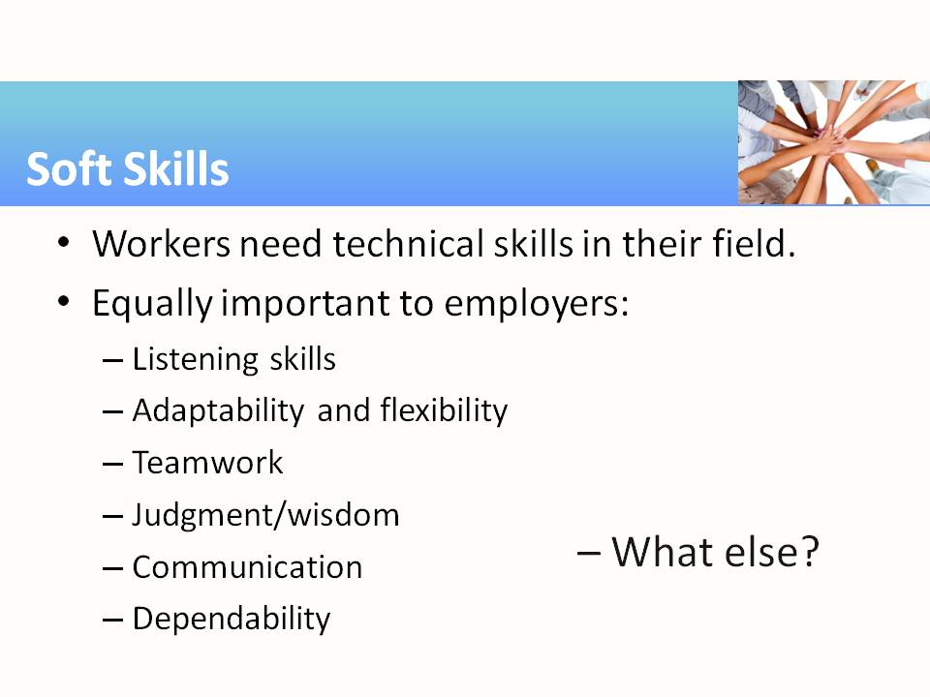 | - One of the activities in this module encourages students to brainstorm a list of good work habits and attitudes. This slide can be a starter for that activity.  Some possible discussion points:  - Listening skills: You must listen to be able to follow directions and learn new information that comes with any job.  - Adaptability and flexibility: We live in a changing world, with changing demands and requirements. We will encounter new coworkers with whom we must get along and new work environments in which we must function.
(Notes for Slide 3 continued)
- Teamwork: When we hear “team,” we think of sports. Most jobs require a team effort to reach the goal, just as in every team sport. As a team player, you must do your assigned tasks in order for the whole team (system) to succeed.
- Judgment/wisdom: Are you able to apply the fruits of past experiences to today’s problems? Can you restrain your emotions and be discrete on social media? If so, then you may have more judgment and wisdom than you think. Making sound decisions in the workplace begins with the ability to make wise, well-reasoned choices.
- Communication: This is probably the first soft skill on which you’ll be judged during your job application and interview. In the workplace, you must be able to engage colleagues in two-way exchanges of information in person, over the phone, via email, and probably with written documents. We must practice these skills to be good communicators.
- Dependability: Do you do what you say you will? Show up where you promise to be? Deliver what you are asked to produce? Complete tasks on time?
What other soft skills can you (or your students) suggest that are equally important?
4 | 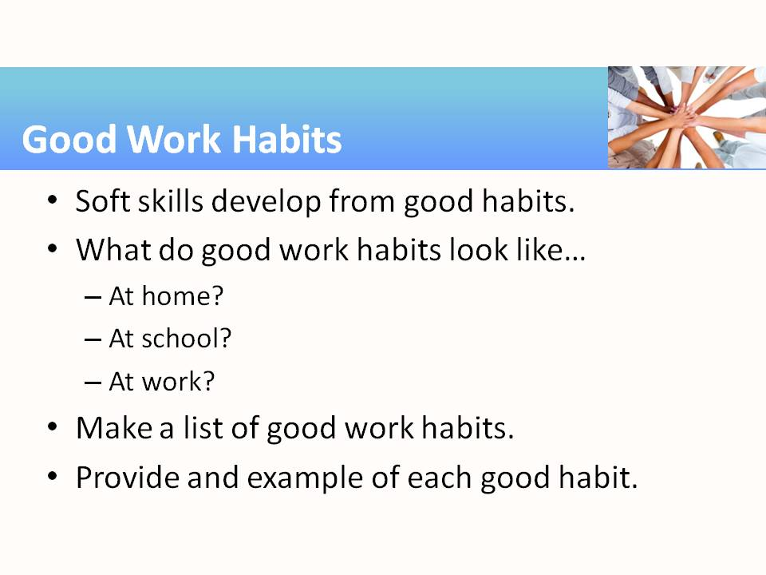 | - One of the activities of this module encourages students to brainstorm to form a list of good work habits. You can move the conversation forward by seeking volunteers to describe a few good habits that are respected at home, school, and work.  - As students expand the list, seek examples. For the good work habit of being self-directed, for example, one might clean up a small spill, rather than expecting someone else to do it. Use this as an opportunity for students to “brag on themselves”—to use themselves as positive examples.
5 |  | - Many people devote time and energy to inconsequential tasks and then are left with little time for accomplishing important objectives. Students need to develop a system (and follow it) for planning their effective use of time.
6 | 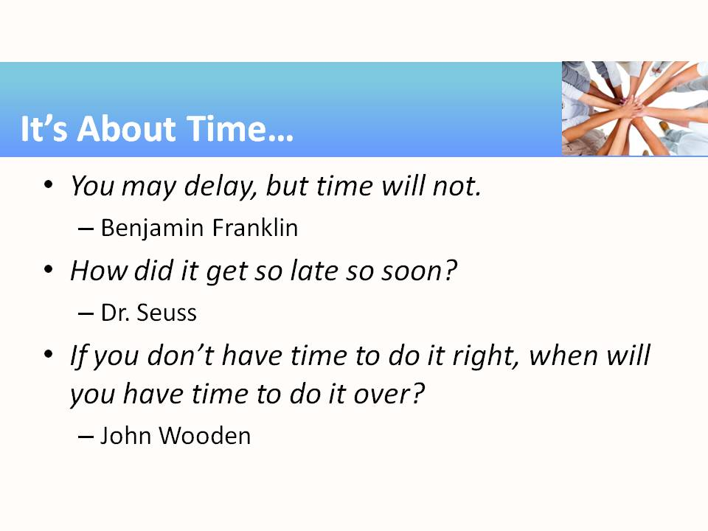 | - See Handout 1 for a list of quotable quotes, like:  “Time is what we want most, but what we use worst.” ― William Penn  “You will never find time for anything. If you want time, you must make it.” ―Charles Buxton
7 | 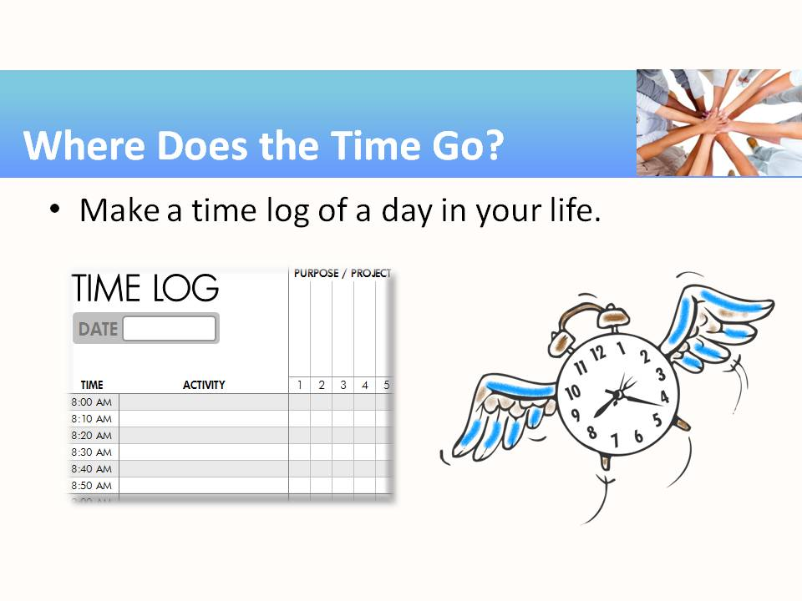 | - Most people have no idea how much time they spend on various tasks throughout a day or week. Keeping a time log can help students recognize where they are spending time and find time that could be reallocated to reaching personal and professional goals, e.g., a professional certificate or degree.  - See Handout 2 for a Time Log master.
8 | 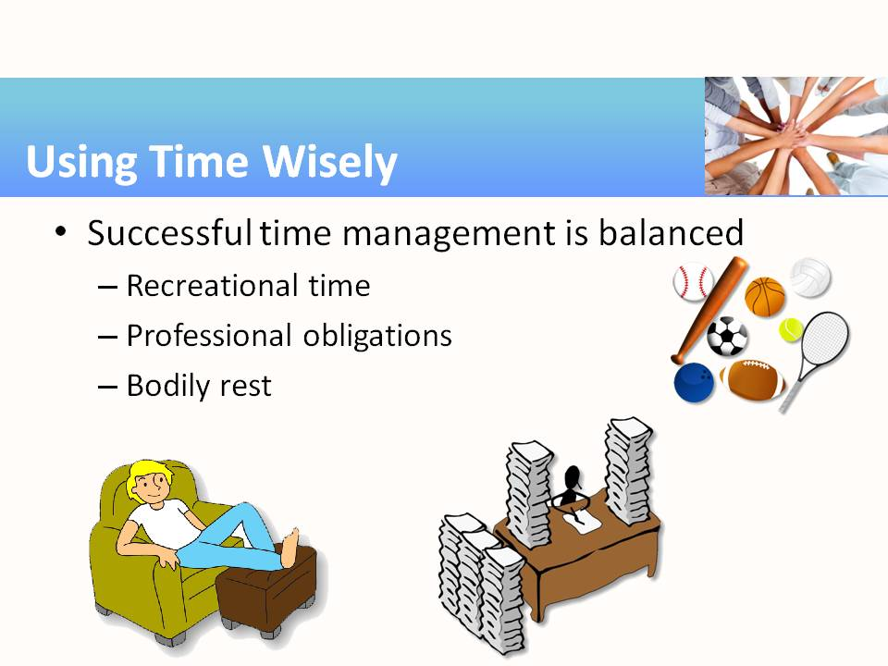 | - This list is not comprehensive. Students may wish to add family time (a large component for many students) and spiritual time (e.g., church attendance, prayer, meditation).
9 | 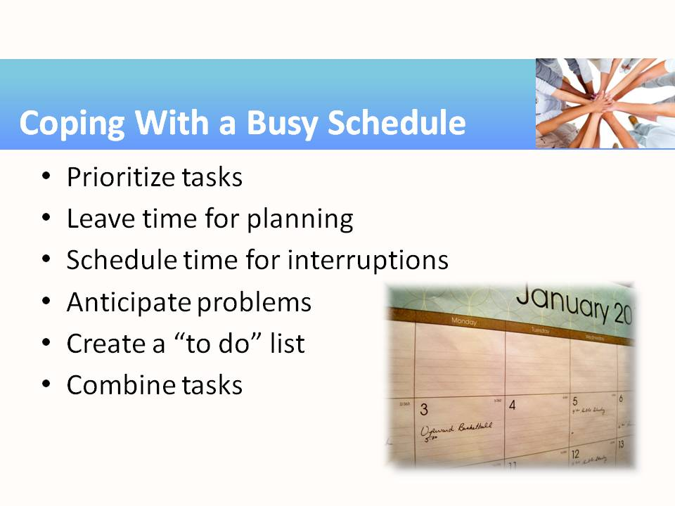 | - How many students use a planner of some sort?
10 | 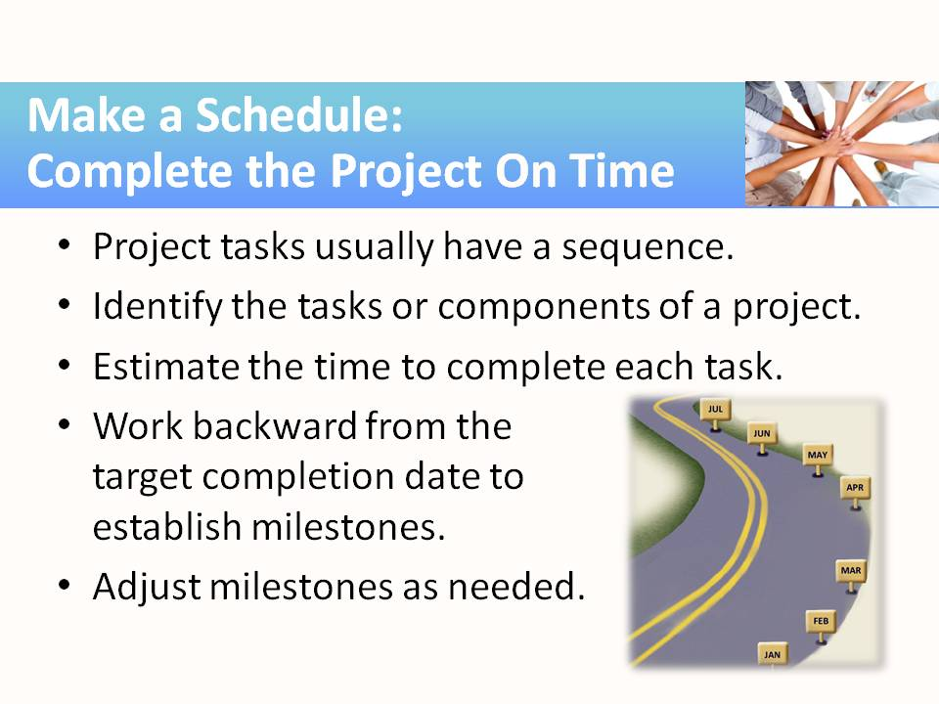 | - Many project management tools and programs exist. You may be able to keep all the steps and plans in your head for a small project, like building a bird house, but when tackling a project that is too big to remember all the pieces and parts and players, it’s time to sit down and “manage the project” more professionally.
11 |  | - To succeed, students need to create realistic, reachable goals. They must be measureable (how will you know when you’ve accomplished this goal?) and have a timeframe or date for achievement.
12 | 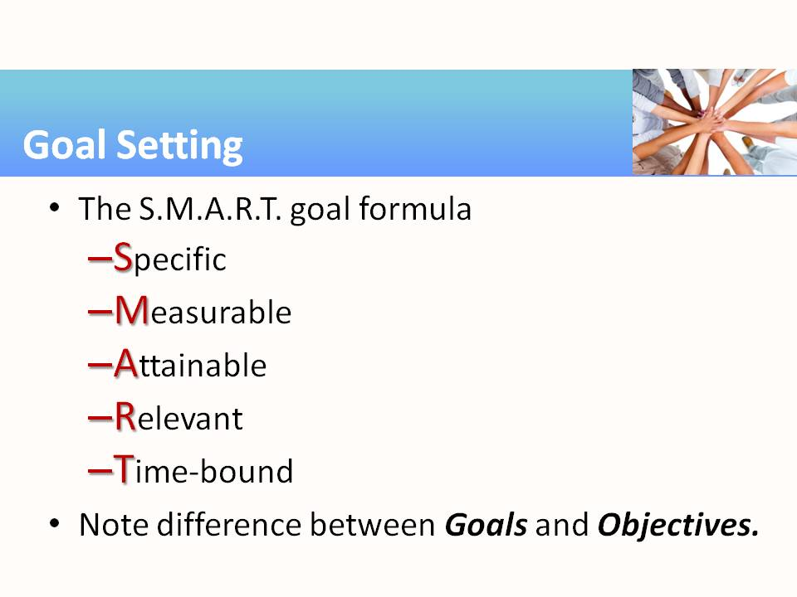 | - The SMART goal formula has been around for many years. Here is one of the most widely accepted interpretations of the acronym.  - The goal is the larger accomplishment; the objectives are the subtasks that lead to reaching the ultimate goal.
13 | 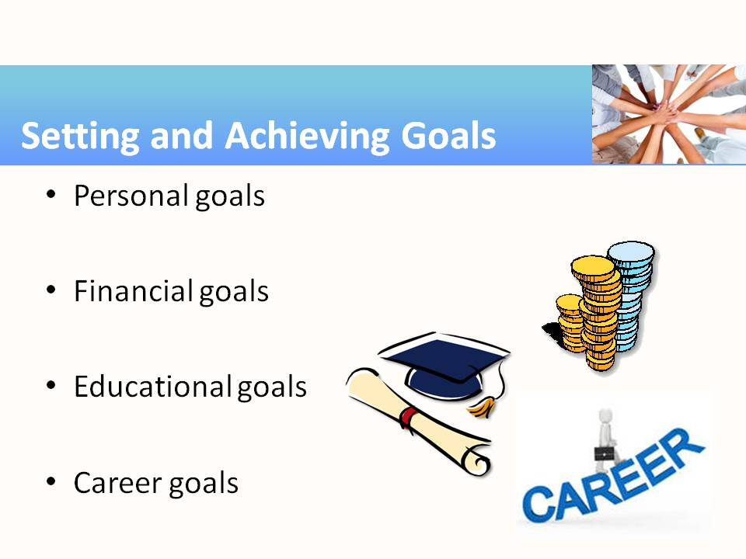 | - As the old saying goes: “If you never set a goal for yourself, you’re certain to never achieve it.” Encourage students to set goals for themselves in all four of these areas of their lives.
14 |  | - Maintaining a safe, orderly, and clean work environment is important. Different workplaces may have different standards for safety and cleanliness. Ask students to discuss the following workplaces and the maintenance required:  - Surgery room  - Hotel  - Restaurant  - Office  - Auto repair shop  - Soda bottling plant  - Manufacturing facility  - Construction site  - Beauty salon
15 | 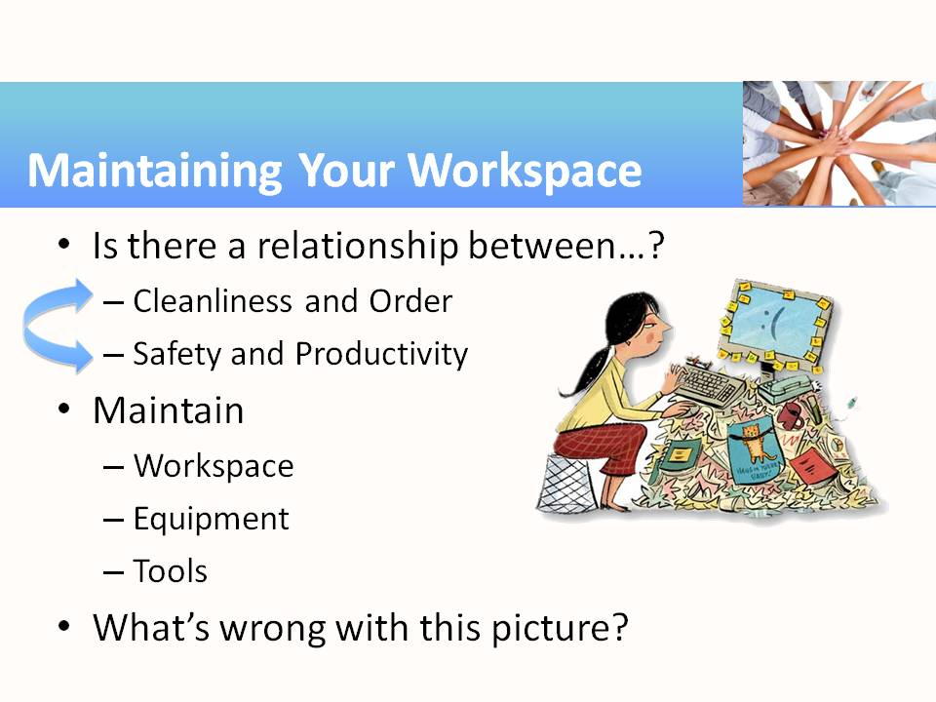 | - Considering a photograph of a workplace, students can play “What’s wrong with this picture?” It’s fairly easy to locate “messy desk” photos on the web and, with today’s phone cameras, it’s not hard for students to take photos and share them.
16 | 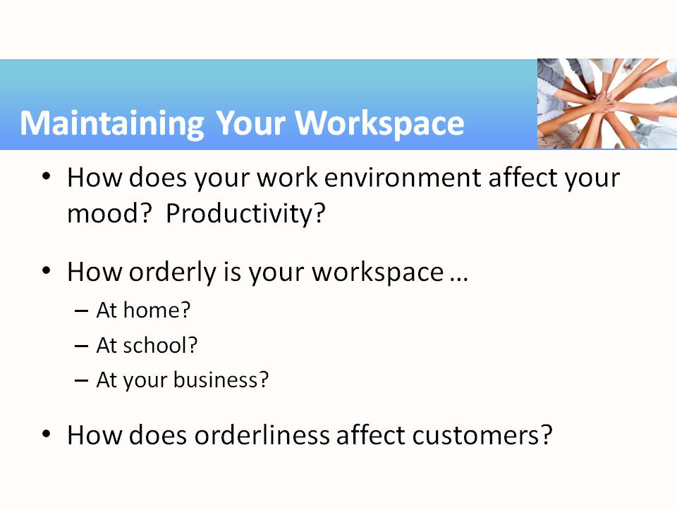 | - How does your bedroom appear? Your desk? Your kitchen? Your classroom? Your lab closet? Or, if you’re running a business, what do the customers think about orderliness?  - Ask students if they’ve ever visited a flea market, where the space is littered with a large assortment of “stuff.” How does your attitude about the flea market display compare to the local department store with its neatly arranged goods on shelves? How could the flea market atmosphere be improved in this regard? Suppose your booth at a flea market was different (neater!) than all the others…how might this affect your success?
17 |  | - Many people go through life thinking that their actions don’t impact others. This is not the case. A stock picker or phone receptionist for a large company may think that his or her position isn’t important, but when that job is not done or not done well, it could cost the company financially and tarnish its reputation. Students need to know that a company is an interdependent system. What happens in one area impacts other areas.
18 | 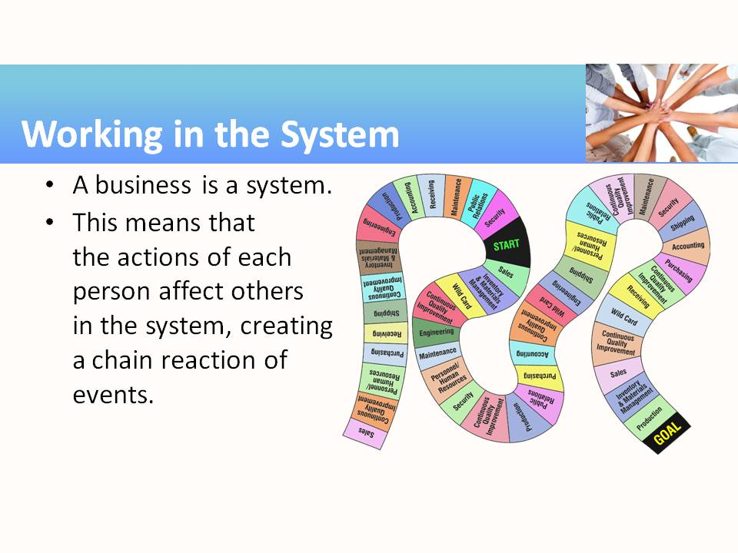 | - This slide can be used to introduce the “Working in the System” board game. This activity is a simple board game designed to demonstrate how actions and events within each department of an organization can affect the whole organization: that is, if one department drops the ball, the whole organization’s mission suffers.  - By playing the game, students will gain an understanding of the concepts of: working within a system, business organizational structure, and communication within a company hierarchy.  - The objective of the game is for all team members to reach the goal, and the game is not over until all players reach the goal. There is no reward for reaching the goal first.
19 | 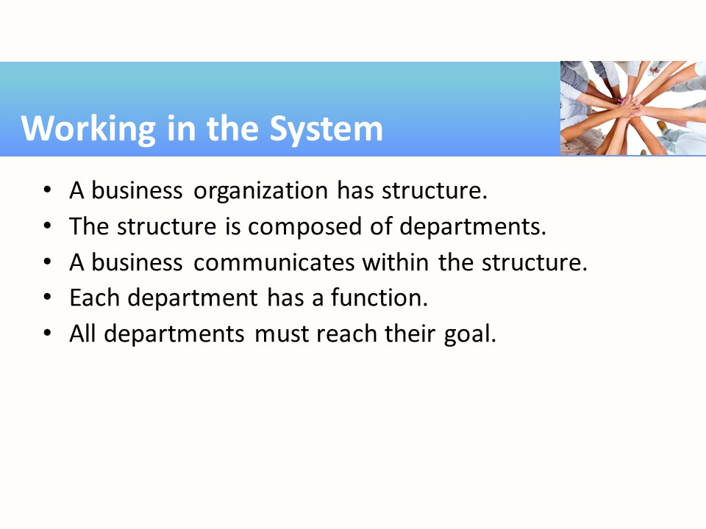 | Key points:  - Departments within a business are interdependent; nothing happens in a vacuum.  - Typical departments include: sales, personnel/human resources, purchasing, receiving, shipping, inventory/materials management, production, accounting, engineering, quality assurance, public relations, maintenance, and security. Ask students to describe, based on their work experience, departments that are not mentioned in this list and also departmental functions that may have been combined in smaller businesses.

Teaching Resources
Activities
The following activities are examples of activities that can be completed in class to emphasize specific aspects of initiative and dependability. The activities found in this resource can be used “as-is” or they can be tailored to fit a specific course. Suggestions for adaptation precede each activity, with examples from several different subject areas/career pathways. The suggested modifications provide instructors with ideas for adapting the activity to fit content they are already teaching. Modifying the activities allows employability skills to be infused into subject area content more easily.
The instructor must emphasize the importance of time management in the classroom and the workplace throughout the course. Work with local employers to find out how much absenteeism and tardiness costs them each year. Obtain copies of workplace policies that show the consequences of absenteeism and tardiness. In the syllabus, spell out all policies concerning tardiness, absenteeism, and failure to turn in work on time. Include a policy for notifying you of absences via phone, text, e-mail, or other means and define excused absences. But most importantly, enforce those policies. It is better not to have a policy than to have one and not enforce it. The only way students learn to meet deadlines is if instructors show that they value them.
Activity: Initiative and Dependability at School or Work
Instructor Preparation
It is recommended that this activity be done as early as possible in the course. It is a relatively simple activity but can help students understand from the beginning the types of behaviors that are desired at school and in the workplace. Explain that while technical skills may help them get jobs, soft skills, i.e., good work habits and attitudes, will help them keep their jobs.
The instructor could ask for local business/industry representatives to either come and discuss with the class the importance of “soft skills” or send responses by email so student groups can review and discuss them.
As students work through their lists of desirable work habits and attitudes, have them discuss what those habits would look like both in class and on the job. In some cases, there will be no difference, for example, punctuality. Being on time for class would look the same as being on time at work. Others may be different, such as productivity, for example. A student in class would not be expected to repair body damage on a car as fast as someone who has years of experience in collision repair. They would both be expected to do quality work, but the student might take twice as long to complete a similar job.
As each work habit or attitude is discussed, have students identify careers where that particular trait would be especially desirable. Helpfulness (the willingness to pitch in and help others), for example, might be particularly useful in a customer service position such as concierge in a hotel or at a help/information desk at an airport. Loyalty and ethical behavior would be especially prized in jobs where people work with secure information (e.g., as a medical records technician) or intellectual property that must be protected (e.g., by engineering technicians and product developers at large companies). All employers value dependability and reliability.
Discuss penalties at work and at school for failing to exhibit desired traits. For example, failure to comply with safety regulations can result in a worker getting fired. For safety issues and any other behaviors considered essential to good class performance, clearly explain the consequences up front and always enforce them. If you are trying to teach punctuality, for example, have policies that promote punctuality such as points off for late work and/or cutoffs for when you will no longer accept late work. For long-term assignments that are completed over a period of several weeks, you might give bonus points if the project is turned in early.
Objectives
Students will:
- Identify good work habits.
- Describe what good work habits look like in school and at work.
- Create a work habit evaluation sheet.
Materials
- White board or flip charts and markers for recording student responses
Activity Guidelines
      - Have students brainstorm aloud what a good work habit includes. Ask them to list work habits they would want to see in someone they hired to do work for them. Ask them to describe examples of good and bad work habits they may have seen or experienced. As appropriate, invite guest speakers to give examples of the good work habits that their employer expects from employees, or provide articles or other sources of employer responses.
      - Make a class list of good work habits and attitudes. The list should include things such as:
Assertiveness  Attendance  Care of equipment  Cheerfulness  Commitment  Cooperativeness  Creativity  Dependability  Efficiency  Enjoying challenges  Enthusiasm  Ethical behavior  Good judgment  Helpfulness  Honesty  Initiative  Interest  Loyalty  Mastery  Maturity | Overcoming failure  Perseverance  Persistence  Planning and organization  Political awareness of the workplace  Problem solving  Productivity  Punctuality  Quality of work  Reliability  Responsibility  Risk-taking  Safety consciousness  Self-directed  Self-management  Unselfishness  Willingness to follow directions  Willingness to learn  Willingness to take on more responsibility
      - Prioritize those that emphasize initiative and dependability.
      - Have each student choose an accountability partner. They should work with their partners to identify ten traits in which they see room for personal improvement.
      - After students have chosen the top 10 traits to work on during this course, have them describe what good behaviors and bad behaviors would look like. Have the pairs create a work habit evaluation sheet that will make it easy to observe each partner for the top 10 traits selected.
      - Ask students to make notes on when they think they have exhibited good behaviors or bad behaviors.
      - Students should also observe their accountability partners and make written notes on their good and bad behaviors. Remind students occasionally to be sure they are observing and making notes on their accountability partners’ behaviors.
      - Once or twice every month have students meet together and give each other feedback on what they have observed over that time period.
Group Reflection Questions
After the first one or two meetings between accountability partners, have a class discussion. Ask the following questions:
      - Did having an accountability partner change your behavior?
      - How did thinking about behaviors that produce desired results change the way you value specific work habits?
      - Which was harder, observing your own behaviors or observing your partner’s behaviors?
      - For those who showed improvements in one or more of their behaviors, ask them to share tips on how they were able to accomplish those changes.
      - Can good work habits/attitudes ever become detrimental? Let students discuss the issue and see if they can give specific examples. If students have trouble thinking of examples, ask about medical professionals who empathize so much with a patient’s suffering that they act on their own as “angels of death.” Also, while initiative is good, unless you have full understanding of a process and the reasons things are done according to a specific protocol, you shouldn’t take it upon yourself to change the way things are done. A biotech firm had to throw out data from several weeks of experiments because the new lab tech, taking initiative to save time in cleaning glassware, decided that instead of a 15-minute distilled water rinse between washes of different solutions, he would just use one longer distilled water rinse at the end. Since he didn’t check with his supervisor, the data collected using the improperly cleaned equipment had to be thrown out.
      - They say “hindsight is always 20/20.” In hindsight, what work habits/attitudes would you change if you were able to go back and do things over in school or on the job? Note: Some students may not wish to discuss this question in class, so you may want to let them reflect on this outside of class.
Activity: Where Does the Time Go?
Instructor Preparation
Time management is an important skill. The ability to get a task done in an allotted amount of time without falling behind in other areas is a highly prized skill to employers. Some people seem to have a natural ability to manage time well. For others, it is a skill that can be learned.
In some careers, tracking of time spent on different projects is a necessity so that various clients can be billed appropriately. Lawyers and paralegals, for example, must track how much time is spent working on each of the cases they are assigned. Sales reps must track travel time and mileage as well as the amount of time spent with each potential client. Contractors need to know how long each subcontractor spends on specific jobs so the work can be billed appropriately.
This activity will help students become aware of how they spend their time. They will keep a time log for two days and then bring them to class to analyze. Students will probably be surprised to see how their time was spent. As you wrap up this activity, lead students to examine how they could spend time differently to accomplish personal goals. The following activity, Using Time Wisely, provides students with tools and strategies for managing their time more effectively.
Objectives
Students will:
- Examine some of the ways people relate to time through reading quotations from famous people.
- Keep a time log.
- Analyze how they spend their time.
Materials
- Handout 1—Quotes about Time
- Handout 2—Time Log Blanks (2 per student)
- Handout 3—Instructions for Completing Time Log
Activity Guidelines
      - Begin the session by asking students the following questions:
- Do you know anyone who is always late, rushes around, and regularly misses appointments, dates, or other engagements because they “just ran out of time” or time just “got away” from them?
- Do you know anyone who seems to always have it together, finishes work and projects on time or even early, but still has time for volunteer work and never seems to be rushed or flustered?
- Everyone has the same number of hours in a day. What do you think is different about how each of those people relate to time?
      - Have students look at Student Handout 1: Quotes about Time. Ask them to choose one or more of the quotes that resonate with the way they look at time. Have them write a short paragraph or two describing why and/or participate in a class discussion about the quotes. There is no right or wrong answer. An Internet search of “quotes about time” will lead you to numerous sites if you wish your students to pursue this activity further.
      - The next part of this activity will take place over several days. Students should be asked to keep a time log showing how they spend their allotted 24 hours a day. Ideally students would keep a log for an entire week, but that quickly becomes burdensome. Instead, have them look at their normal week and pick one weekday and one weekend day that best reflect their typical schedule. They should not pick a day when they are on vacation, are sick, or have some other rare event that doesn’t usually recur. Students need two copies of the time log and a copy of the instructions for keeping a time log included in the handouts. Tell students they are welcome to record their time log using whatever means is most convenient for them. Some may choose to use smart phones, tablets, or other electronic devices while some may prefer a small memo pad. Others may choose to record directly on the log sheets.
      - Optional: Have students estimate the percent of time they spend each day on broad categories such as sleeping, eating, travel, school work, leisure, socializing, work, family, chores, and online. Students can then compare their estimates to actual time spent in each category at the end of the activity.
      - After the time logs have been recorded, bring the class together and ask them to come up with broad categories for how they actually spent their time such as sleeping, eating, travel, school work, leisure, socializing, school, work, family, chores, and online. Then allow students to categorize each of their entries on their logs using the categories determined by the class and total the time spent in each. To make it more visual, have them create a pie chart showing how they spent each of their days.
Group Reflection Questions
Discuss the time logs and time distribution pie charts with students. Ask them the following questions:
      - How many of you found yourself forgetting to log your time and then trying to reconstruct the last hour or so at one time? Did you notice how easy it was to forget some of the activities that you had just completed?
      - If you estimated the amount of time you spent in each category beforehand, how close were your estimates to the actual amounts of time you spent in each category?
      - What was most surprising to you about the way you spend your time?
      - How much time was spent on important tasks vs. unimportant tasks or routine tasks?
      - How much time was spent on unimportant and non-urgent tasks?
      - Did keeping the time log have any impact on how you were spending your time while you were keeping the time log?
      - How do you think periodically keeping a time log might help you to become a better manager of your time?
Remind students to keep their time logs and time distribution pie charts for use in later activities.
Handout 1—Quotes about Time
“You may delay, but time will not.”
― Benjamin Franklin
“Time you enjoy wasting is not wasted time.”
― Marthe Troly-Curtin, Phrynette Married
“How did it get so late so soon?”
― Dr. Seuss
“Yesterday is gone. Tomorrow has not yet come. We have only today. Let us begin.”
― Mother Teresa
“Don't spend time beating on a wall, hoping to transform it into a door.”
― Coco Chanel
“Time is what we want most, but what we use worst.”
― William Penn
“There's never enough time to do all the nothing you want.”
― Bill Watterson
“Unfortunately, the clock is ticking, the hours are going by. The past increases, the future recedes. Possibilities decreasing, regrets mounting.”
― Haruki Murakami, Dance Dance Dance
“Time is a created thing. To say ‘I don’t have time,’ is like saying, ‘I don't want to.’”
― Lao Tzu
“I don't understand people who say they need more ‘Me Time.’ What other time is there? Do these people spend part of their day in someone else’s body?”
― Jarod Kintz, This Book is Not for Sale
“If you only had 48 hours left to live, would you spend it like you normally spend your weekends? If not, why spend 2/7th of your life wasting your free time? After all, free time isn’t free. Free time is the most expensive time you have, because nobody pays for it but you. But that also makes it the most valuable time you have, as you alone stand to reap the profits from spending it wisely.”
― Jarod Kintz, I Should Have Renamed This
“You will never find time for anything. If you want time, you must make it.”
― Charles Buxton
“Time is an equal opportunity employer. Each human being has exactly the same number of hours and minutes every day. Rich people can’t buy more hours. Scientists can’t invent new minutes. And you can’t save time to spend it on another day. Even so, time is amazingly fair and forgiving. No matter how much time you’ve wasted in the past, you still have an entire tomorrow.”
― Denis Waitley
“It is the time you have wasted for your rose that makes your rose so important.”
― Antoine de Saint-Exupéry, The Little Prince
“Determine never to be idle. No person will have occasion to complain of the want of time, who never loses any. It is wonderful how much may be done, if we are always doing.”
― Thomas Jefferson
“Until you value yourself, you won’t value your time. Until you value your time, you will not do anything with it.”
― M. Scott Peck
“Everything changed the day she figured out there was exactly enough time for the important things in her life.”
― Brian Andreas
“If you don’t have time to do it right, when will you have time to do it over?”
― John Wooden
“Time is money.”
― Benjamin Franklin
The quotes above were collected from the following websites:
http://www.brainyquote.com/quotes/topics/topic_time.html
http://www.goodreads.com/quotes/tag/time
Handout 2—Daily Time Log for (M TU W TH F SAT SUN) ____________________ (date)
Instructions: By each time interval record the activity(ies) you were engaged in during that interval. In the Category column mark the type of activity from the class list and/or priority of that activity. Leave the comment column blank for later analysis.
Time | Activity | Category | Comment
midnight
12:30
1:00
1:30
2:00
2:30
3:00
3:30
4:00
4:30
5:00
5:30
6:00
6:30
7:00
7:30
8:00
8:30
9:00
9:30
10:00
10:30
11:00
11:30
Noon
12:30
1:00
1:30
2:00
2:30
3:00
3:30
4:00
4:30
5:00
5:30
6:00
6:30
7:00
7:30
8:00
8:30
9:00
9:30
10:00
10:30
11:00
11:30
Handout 3—Instructions for Keeping a Time Log
Time logs are a good way to determine how you are spending your time and if you are spending it as effectively as you could. Effective here means different things to different people. For example, to someone who has had bypass surgery or suffers from diabetes, a 30-minute walk each day may be very important. To another person a 30-minute walk is the quickest way to get from one place to another, while to another person it is a way to enjoy socializing with friends. To someone looking in from the outside, the 30-minute walk might be perceived as a total waste of time that could have been spent doing something “productive.” Since a time log is a personal tool, you get to define effective use of time by your values and goals for the day.
Keeping a time log may seem like busy work, especially after the first couple of hours of recording what you are doing. However, it has been shown repeatedly that the vast majority of people have no idea of how much time they spend on different tasks on different days, and most cannot give you an accurate estimate of how much time it will take them to do any given task. It is important to see where your time goes so that you can find time that you can use to work on your goals.
For this activity you will keep a record for two days, one weekday and one weekend day. You will record what you do from the time you get up to the time you go to bed. Try to pick days where your schedule for the day is typical for that day of the week. Don’t pick a day when you are on vacation, are sick, or have some other rare event that doesn’t usually occur.
Your instructor will give you blank time log sheets to use. You are welcome to record your time log using whatever means is most convenient for you. If you constantly have a smart phone, tablet, or other electronic device with you, you may wish to record the data electronically. You might find it easier to use a small memo pad you can carry in a pocket or purse. Of course, you may choose to record directly on the log sheets. Just make sure to record all of your information and bring it to class as instructed.
- The first column gives the starting time of each 15-minute interval.
- The second column is where you describe what you were doing during each 15-minute interval. Sometimes you may do more than one thing at a time, so you should note concurrent activities. For example, eating lunch with friends to socialize would be different than eating lunch with a partner to discuss the class project you are working on together. Note: If you work or go to school, don’t simply block that time as work or school. Write down tasks or specific activities you are involved in at the time.
- The third column is for category and/or priority. As a class you will look at categorizing activities such as sleeping, eating, travel, school, and work. Once the list is completed you will determine the broad category that best describes your activity in that block of time.
Priority is a rating system that you can use to assess the value of the time spent to you and your goals. You will rate each item according to the following scale: 1=Important and Urgent, 2=Important and NOT Urgent, 3=Urgent and NOT Important, and 4=Routine. To do this you need to understand the difference between important and urgent. Important can be defined as significant, weighty, and having long-term consequences. Urgent means pressing and requiring immediate action, but probably not of long-term importance.
Activity: Using Time Wisely
Instructor Preparation
Too many people today devote needless time and energy to inconsequential tasks only to discover they have insufficient time to devote to important matters. Students need to develop a system, compatible with their personalities and responsibilities, enabling them to discharge those responsibilities in sufficient time to meet deadlines while preserving their enjoyment of the job.
Successful time management allows for recreational time as well as for professional obligations. It allows you to lead a well-balanced life, spending your time efficiently so you have time to do the things that are important to you.
This is the second of two activities on time management. In the first lesson students analyzed how they spent their time on a typical weekday and weekend day by keeping a time log. In this activity students look at ways they can use time more effectively, establish priorities, and avoid time wasters. They will explore tools such as calendars, to-do lists, and day planners. Students should be free to use printed or electronic versions of these tools based on their lifestyles.
Be sure to discuss with students that some careers require more flexibility in time management than others. For example, farmers must schedule tasks around actual and predicted weather conditions. Ranchers need to be available to deal with livestock breeding or birthing whenever it may occur. Physicians may have scheduled office hours, but they also must respond to emergencies when they are on call. Other jobs such as those in manufacturing may require workers to work rotating shifts, while others such as nurses in a hospital will have permanent shifts. Store employees may have regular hours most of the time with additional hours required for inventory or during holiday shopping seasons. Some jobs are seasonal and workers must find alternative sources of income. An example might be a lawn care business in the north. During the warmer months they may be busy mowing lawns, landscaping, and so forth, but in the winter they may need to diversify to include snow removal, hanging holiday decorations, and removing trees damaged by ice storms. They need to choose careers where they can adapt to the hours they will be required to work.
Objectives
Students will:
- Examine strategies for more effective use of time.
- Identify strategies that are compatible with their personalities and responsibilities.
Materials
- Calendar or calendar handout
- Things to Do This Week handout or task list app
- Plan Your Day handout
- Completed time logs from the activity Where Does the Time Go? (It is not necessary to have completed the previous activity, but it will give students a better feel for how they are currently spending time and where they might be able to prioritize the time differently to accomplish more.)
Tell students ahead of time to bring whatever calendars, assignment books, day planners (printed or electronic) they use or have tried to use to class on the day they will do this activity.
Activity Guidelines
      - Ask students how they feel when they suddenly realize that they have a major project or test the next day but haven’t adequately prepared. Have them discuss possible reasons people procrastinate.
      - Ask students if they regularly keep a calendar, to-do list, or day planner to keep track of their time. Any student who does can be a resource to help students who have not used these tools or have not succeeded in using them.
      - Distribute copies of the handouts. Let students know they can use a calendar or electronic version as long as they can keep it with them to refer to as needed. The idea is to make time management fit their personality so it becomes a habit and not just another task that takes up time in an already busy schedule.
      - Have students create a to-do list for the month and use the monthly calendar to enter their individual schedules for the month. Have them list all activities (e.g., club meetings, parties, family events, sports events, choir practice) and obligations (school projects, tests, jobs, family responsibilities, and so forth) that will be occurring in the next month.
      - Have students indicate which activities on their calendars are events that only require that the students be there at a certain time (a dentist appointment, for example), and which are deadlines. Deadlines are the endpoints for processes or activities. A deadline implies that time is required to complete the assignment or prepare for a test. For any deadlines, students should schedule time throughout the days prior to the event to prepare for and accomplish the task. They should indicate how much time they want to spend on the task each day.
      - After students have had several minutes to create their calendar entries, ask if any of them have conflicts on any days of their schedules. Do they see particularly busy periods of time or periods of time where they don’t currently have many obligations? Ask them how they might cope with busy times when they have too many things going on at the same time. How could you manage your time more effectively? Record answers on the board. Ideas should include the following:
- Prioritize tasks (Point out that priorities will differ from person to person.)
- Leave time for planning
- Schedule time for interruptions
- Anticipate problems and plan how to handle them
- Make a daily “to do” list
- Identify and reduce time-wasters
- Learn to say no
- Try to combine satisfactions (study with friends, study while traveling to school, etc.)
Suggest that students avoid the illusory satisfaction of doing easy but low-priority tasks while procrastinating on larger, more demanding tasks. Remind them of a technique for attacking a large task in small sections, doing a little bit at a time.
      - Finally, have students choose a particularly busy day from their calendar and create a plan to accomplish those activities during that day.
      - Have students work in small groups to identify their biggest time-wasters. Ask them to brainstorm ways they might control the amount of time spent on each of these. Let each group share what they discussed with the rest of the class. For example, many business managers say that one of their biggest time-wasters is answering e-mail. One solution that has been used by managers is to set two or three specific times throughout the day to answer e-mail. Also, in businesses where much of the e-mail correspondence was routine, they created a library of responses for frequently asked questions that they could plug in as needed without having to recreate the answers over and over. Ask students to practice using time management tools throughout the course.
Group Reflection Questions
      - Why is it important to realize that you can manage your time?
      - What tool(s) do you find most useful in managing your time? Why?
      - What were the hours you have worked on jobs you may have held? Were you able to adapt to those hours? Would you want to work those hours in the future?
      - Can you think of reasons you might consider working a shift other than your desired shift for some time period? For example, some people might agree to start work on the night shift so that when an opening became available on a different shift they have a better chance of getting the position than someone from the outside. Or, if a couple has young children, one parent might work days and one nights so that there was always a parent available to watch the children, take them to school in the morning, and pick them up in the afternoon.
Handout—Calendar
Month ________________ Year________
SUNDAY | MONDAY | TUESDAY | WEDNESDAY | THURSDAY | FRIDAY | SATURDAY

Handout—This Week … Things to Do
Date _______________________________ | Completed  (Check when done.)
1.
2.
3.
4.
5.
6.
7.
8.
9.
10.
11.
12.
13.
14.
15.

Handout—Plan Your Day
Date ____________________________

Top priorities  (call, do, get, write, etc.) |  |  | Who/Where/When
 |  | 6 A.M.
 |  | 7 A.M.
 |  | 8 A.M.
 |  | 9 A.M.
 |  | 10 A.M.
 |  | 11 A.M.
 |  | 12 A.M.
 |  | 1 PM
 |  | 2 PM
 |  | 3 PM
 |  | 4 PM
 |  | 5 PM
 |  | 6 PM
 |  | 7 PM
 |  | 8 PM
 |  | 9 PM
 |  | 10 PM

Activity: Creating Schedules to Complete Projects on Time
Instructor Preparation
Employers need workers who can manage their time wisely and complete project tasks in a timely manner. Begin by asking students if they have watched shows such as Undercover Boss where the president or CEO of a major company goes undercover in his/her own business to see how things are being run throughout the business. Generally there are segments where the boss is assigned tasks where he/she cannot keep up with the workers in doing their jobs. As a result, production or service is slowed down and quotas are not met. While the boss may not have been trained to do a particular job, workers who are hired to do the job are expected to complete assignments in a timely manner.
Often employees are part of a team with a deadline. Managers plan how to accomplish the job by breaking the job down into smaller tasks and assigning completion dates by which tasks must be finished to keep the whole project on schedule. As part of the plan, the manager will assign the tasks to specific departments or employees. Whenever milestones are missed, the entire project is in jeopardy of falling behind. Impress on students the need for them as future employees to be able to stick to schedules to accomplish their work in a timely manner. Discuss also the need to keep their supervisors informed if they encounter problems that might cause delays. The sooner a manager knows that there is a problem, the sooner he/she can make adjustments to the plan and reallocate resources to try and maintain the schedule.
Have students list tasks that might be involved in getting a magazine published, preparing for a football game, preparing for a theatre production, and making an arrest in a crime. Who would be involved in these activities? Possible answers might include:
Publishing a magazine: Editor-in-chief would determine theme of the magazine; various other editors make assignment in their departments; reporters and feature writers would research their articles and conduct interviews; photographers would take and edit pictures; drafts would be turned in, editors would edit articles; advertising department would solicit ads and work with advertisers to design them; pages would be laid out; proofreaders would copyedit all written materials and check facts; magazine would go to press; copies would be distributed to subscribers and stores.
Preparing for a football game: Coaches would study video of the opposing team and plan strategies for both offense and defense; coaches would review video with players and explain strategies; players would practice plays; athletes would follow conditioning and dietary programs to maintain fitness levels; team and staff travel to the game; pregame practice/warm-ups; play game; make adjustments during game.
Preparing for a theatre production: Select play; determine venue; get backers; set dates; hold auditions, select cast and understudies for parts; advertise and sell tickets; create sets, obtain props and costumes; memorize lines; fit costumes; rehearse scenes; make changes to script as director indicates; prepare makeup; hold dress rehearsal; perform play. These tasks would be completed by directors, set managers, props managers, public relations, actors, makeup artists, costumers, and others.
Making an arrest: Respond to report of a crime; collect evidence; analyze evidence; canvass neighborhood for people who might have witnessed something; establish timeline; evaluate evidence; identify suspects; question suspects; check alibis; determine motive, means, and opportunity; make an arrest, read Miranda rights; take to jail; follow booking procedures, and so forth. Depending on the crime and the size of the police force you would have police officers, detectives, crime scene investigators, crime lab technicians, booking officers, and so forth.
Point out that in each of these scenarios some of the tasks are dependent on others. They cannot occur until another task is completed, while some tasks are concurrent and can occur at the same time as other tasks.
This activity is a natural follow-up to the previous activities “Where Does the Time Go?” and “Using Time Wisely.” Students will look at a project, and working with all who are involved, create a schedule to complete the project on time. Ideally students will create a Gantt chart so that they can see the flow of the project. The instructor should review the key points of a Gantt chart and talk about dependent tasks, i.e., tasks that must be completed before another task begins. In the case of a field study, data must be collected and tabulated before any conclusions can be drawn.
There are free programs and templates available online that students can use to create their Gantt charts. Google Sheets provides a Gantt chart template, and several are available for Microsoft Excel. These can be accessed through Excel by clicking New and then entering “Gantt” in the search window. See also https://www.smartsheet.com/s/gantt-chart-excel. Several Gantt chart apps are also available.
Point out to students that this process can be revisited any time there is a project that will take more than a day or two. They can also use it to prepare for major exams or tests to avoid last-minute cram sessions. Emphasize that the more students use tools such as this, the better they will become at estimating and scheduling the time needed for accomplishing their work by its due date.
Objectives
Students will:
- Break a project into components.
- Estimate the time to complete each component of a project.
- Work backward from the project due date to establish milestones in a schedule.
- Make adjustments in a schedule as necessary to reach goal.
Materials
- Calendar and/or day planner
Activity Guidelines
      - Discuss as a class the importance of being able to schedule time and stick to a schedule.
      - Have students work in the small groups. Provide them with the due date for the project and all the details of a long-term assignment.
      - Students should work together to break the project up into smaller tasks and estimate the time it will take to accomplish each task. For example, if the project is a group research project, sub-tasks might be to research the topic, create an outline, create a draft, edit the draft, format the draft, and submit a final draft. If the project also includes a class presentation with PowerPoint slides or other media, there would be similar steps. Both the paper and the presentation would have the same final due date.
      - Students should determine who will be working on each task of the project.
      - Working backward from the final due date, students should create milestone dates by which each piece must be completed. Students may start by using their time estimates to see if they can achieve the goal in the allotted time. Students might be surprised to see they overestimated or underestimated the time required to complete a task. Have them create a Gantt chart either by hand or using an app or program specifically designed for that purpose. At this point, the simpler the program or app, the better. Students shouldn’t have to spend more time learning a program than it takes them to do the project.
      - As students work to develop their schedule, remind them that when making assignments and setting deadlines, they need to take into account each individual’s schedule and the fact that this project is not the only thing that they will be working on during the given timeframe. They may need to reassign tasks or share them to complete the project by the deadline. If students are maintaining personal schedules from the previous activity, they can easily identify possible conflicts and include those in their planning.
      - As students work on their projects, they should remember to update the Gantt chart as they go to keep track of how they are progressing and make further adjustments as needed.
Group Reflection Questions
      - How did the preplanning of your project affect the way you were able to complete the project?
      - Were the individual assignments and milestones useful in meeting the project deadline?
      - Was your group able to stick to its initial project plan, or did it have to be adjusted during the completion of the project? Give examples of changes made to the plan.
      - How did knowing that completing your assigned task on time would affect the outcome for the entire project team help you determine the way you prioritized this project in your daily plans?
      - This project took place over a relatively short time span. In business, projects are often planned out several years at a time. How important do you think Gantt charts or other project management tools are in meeting deadlines for those projects? For example, think of NASA preparing for a mission to Mars or the development and launch of the international space station.
Activity: Goal Setting
Instructor Preparation
There is a book by David P. Campbell titled If You Don’t Know Where You’re Going, You’ll Probably End Up Somewhere Else. The premise of the book is that if you don’t set goals that take into account things that interest you and things you can do well and work to reach those goals, over time you will lose the options to do those things. In this activity students will begin to look at how to set and achieve goals.
If we are to have a chance to succeed, we must be realistic in the goals we establish. The goal must be reachable and, hopefully, measurable in both the amount of time needed to achieve it and quality of the end result. For this reason, we will use the SMART goal formula for writing goal statements. SMART goals have been around for many years, and authorities differ on who was the first to use the acronym. The following seems to be one of the most widely accepted uses of the acronym:
S = Specific M = Measurable A = Attainable R = Relevant T = Time-bound
SMART goals are used in all areas of business today as well as for personal goals of all types. Some plans might substitute the word significant for specific or trackable for time-bound.
The following are examples of goals turned into SMART goals in different areas.
Education—Original goal: Every student will show evidence of one year of growth in mathematics each year in attendance. SMART goal: During the 2020–21 school year, all students will improve their math problem-solving skills as measured by a 1.0 year gain in national grade equivalent growth from the 2019–20 to the 2020–21 ITBS mathematics subtest.
Personal—Original goal: I want to lose weight and get into shape this year. SMART goal: At the end of 2021, I weigh no more than 180 pounds; I eat a salad every day and exercise four times a week.
Entrepreneur—Original goal: I want to start a successful business. SMART goal: I have set up a bank account for my new business, deposited $2000 in sales, and generated $500 profit all by Dec 2021.
Note that the last two SMART goals are written in present tense. Psychologically using the present tense makes it easier to visualize success and makes the goal seem more easily attainable.
You will need to guide students through the goal-setting process. Discuss the difference in a goal and an objective. Objectives are subgoals or steps that are required to reach the ultimate goal. Let students know that this is like breaking down a large task into smaller tasks. People are often taught to develop lifetime goals first, then to develop goals and objectives with shorter and shorter time frames—5-year goals, 1-year goals, monthly goals, weekly goals, and daily objectives. If time allows, have your students search the Internet for information on goal setting.
Objectives
Students will:
- Differentiate between a “goal” and an “objective.”
- Write four SMART goals for different aspects of their lives.
- Look at strategies for achieving goals.
Materials
- Handout—Setting and Achieving Goals
Activity Guidelines
      - The instructor should begin this activity by discussing the importance of goals and the consequences of not having them. Point out that even if students have not determined what exactly they want to do as a career, it is possible to set goals that will allow them to keep options open while still moving forward toward a satisfying career. If students don’t do anything toward obtaining a satisfying career, they may end up in the position of taking whatever low-paying jobs they can find because they don’t have skills or knowledge to qualify them for better jobs. They may have to work two or more jobs to make ends meet, leaving them no time to go to school to obtain the skills and knowledge for more satisfying careers.
      - Review how to create a SMART goal with your students. The Indeed.com website (https://www.indeed.com/career-advice/career-development/smart-goals) provides a good article on the subject. See also https://www.edutopia.org/blog/smart-goal-setting-with-students-maurice-elias and https://www.lifehack.org/864427/examples-of-personal-smart-goals.
      - Have students complete the “goal” and” reach by date” for each section of the handout Setting and Achieving Goals by writing a SMART goal for each of the four areas: Personal, Financial, Educational, and Career-related. Then pair students and have them review each other’s goals to see if they are specific, measurable, achievable, relevant, and time-bound. The pair should rework each goal until it meets the criteria.
      - Students should write objectives for each goal. Ask students to come up with one thing they could do in the next week that would move them closer to each goal.
Group Reflection Questions
Discuss the following questions with students. Don’t call on students to discuss their personal goals, as they may not be willing to share. Instead ask about goals in the other categories.
      - Why is goal setting important?
      - Share one of your goals and describe how it meets the SMART requirements.
      - Why is it necessary to create objectives?
      - Do you think you will achieve your goal? Why? Note: If students don’t think that they will achieve their goal, ask them if it is attainable. Open a discussion about what might hold someone back from attaining their goal.
      - How difficult was it to think of something that could be done within a week that would get them closer to each goal?
      - Discuss the fact that goals must be reviewed and revised periodically. Changes in circumstances may require that some goals be altered or dropped altogether. Ask students to describe when they might want to drop or change a goal.
Handout—Setting and Achieving Goals
Set one SMART goal for yourself in each of the four categories below. Indicate the date you can realistically aim for to achieve the goal. Then identify the main objectives you will meet to attain the goal. Remember that SMART indicates goals that are:
S = Specific
M = Measurable
A = Attainable
R = Relevant
T = Time-bound
Personal Goal:
Reach by date:
Objective:
Objective:
Objective:
Financial Goal:
Reach by date:
Objective:
Objective:
Objective:
Educational Goal:
Reach by date:
Objective:
Objective:
Objective:
Career-Related Goal:
Reach by date:
Objective:
Objective:
Objective:
Activity: Maintaining Your Workspace and Equipment
Instructor Preparation
Maintaining a workspace and equipment are habits that should be developed throughout a course. This activity is most appropriate for courses with a laboratory, shop, or studio component.
Maintaining a clean, orderly, and safe work environment is important in all types of work, even when the work itself is a dirty or grimy operation. Begin the activity by talking about various work environments (e.g., clean rooms, surgery suites, hotels, restaurants, offices, dairy operations, manufacturing facilities, auto repair shops, construction sites, hair salons) and what the standards of cleanliness and order is for those areas. Focus on work environments students may be familiar with and in which students may someday be employed. Be sure to discuss the tools and equipment found in each type of environment. Discuss why there are requirements for order and cleanliness in each situation and how cleanliness and order impact safety and productivity.
Next have students tour the class lab or shop area and identify common areas as well as specific lab stations. Point out where and how class equipment, tools, and supplies are stored. If there are personal spaces or stations assigned to students, point those out as well. Review the lab or shop guidelines for cleanliness and order as well as safety issues that must be observed. Go over your expectations of how students will behave while working in the lab or shop and requirements for how the area should be left at the end of each class. With each new project or lab activity, remind students of any special requirements for maintaining their area and any special care of tools and equipment used for the first time.
Throughout the course, instructors should point out problems and ask students to correct them when students are not maintaining their work areas properly. For repeat offenders, instructors may want to enact penalties such as points off daily grades.
Objectives
Students will:
- Describe the relationship between cleanliness and order and safety and productivity.
- Maintain their work area in the lab, shop, or studio in an orderly manner according to class rules and safety regulations.
- Maintain tools and equipment.
Materials
This lab requires no additional equipment and supplies other than what is required for projects and lab activities that the instructor normally does in class. If there are lab or shop rules regarding maintaining work areas and equipment, the instructor should post them prominently in the appropriate areas and provide students with personal copies of those instructions.
Activity Guidelines
      - Discuss the role of a clean and orderly workplace in safety and productivity. Describe the level of cleanliness/order required in a variety of different workplaces and the reasons for different levels in those workplaces.
      - Ask students to review the workspaces they use at school. What are their responsibilities in maintaining them?
      - Divide students into groups of 3–4 and have them create a “What’s wrong with this picture?” skit or photograph of a workplace scene that includes at least five errors. Each group should write down the errors they have included. Have the rest of the class identify the errors. Did the class identify all of your errors? If not, you should identify an error and tell why it was problematic. Did the class identify any errors that you did not write down? Have them explain why the error is problematic. The instructor will have the final say on any debatable calls.
Group Reflection Questions
      - How does your work environment affect you, your mood, and your productivity?
      - Do you have an area at home set aside for working on school assignments, personal finances, and/or hobbies? What are the characteristics of your workspace? Did completing this lesson give you any ideas or organizing your space?
      - Are you currently employed? Describe your workspace. Describe the workspace of those around you. What level of cleanliness/orderliness is expected at your place of work?
      - How does the neatness and organization of a business’ workspace impact customers?
      - What are your expectations as a customer of a business for cleanliness and neatness? Have you had an experience where you went to a business and were “turned-off” or repulsed by the lack of cleanliness and order? Describe the situation. Try to be as specific as possible about what gave you that feeling. Did the environment influence your dealings with the business?
Activity: Fitting Into an Organization
Instructor Preparation
Many people go through life thinking that their actions don’t impact others. This is not the case. A stock picker or phone receptionist for a large company may think that his or her position isn’t important, but when that job is not done or not done well, it could cost the company financially and tarnish its reputation. Students should be shown that a company is a system. What happens in one area impacts other areas.
In this activity students will play a game, “Working in the System,” to gain an understanding of the concepts of working within a system, business organizational structure, and communication within a company hierarchy. The objective of the game is for all team members to reach the goal, and the game is not over until all players reach the goal. There is no reward for reaching the goal first.
Before starting the game, review the department descriptions with students. Make sure they understand that in small companies several of these functions may be rolled into one department or one position (i.e., one employee). Ask them to think of which departments could logically be merged. The departments in this activity are characteristic of a manufacturing company. Discuss how they might differ in various types of businesses such as a bank, a school, a nursing home, farm, TV station, or other course-related business.
As the game is played, the instructor should ask students questions that lead them to further understanding of systems and the effects of systems on each other. Allow discussion to continue as long as a safe environment is maintained and active learning is taking place. After each move, allow time for the students to react and discuss the effects of the move. Point out the many facets of each move. Students may not immediately understand the impact of any given move, so allow time for discussion among the students.
Objectives
Students will:
- Experience organizational dynamics through playing the game.
- Explain how changes in one part of a system affect other parts of a system.
- Describe the functions of different departments within a business.
Materials
- Game board (4 pages to be copied, cut out on the light gray line, and taped together)
- Department placards (Duplicate on cardstock, one side only; then fold along center so that it forms a “tent” that will stand up on a flat surface and can be read from either side.)
- Game cards (Duplicate two-sided on cardstock and cut apart on lines.)
- Student handout with game instructions and department descriptions for typical departments or functions in a business
- 12 game pieces (Use small items such as coins, paperclips, stones, or whatever objects students choose to represent their departments.)
- 1 die
Activity Guidelines
This game is designed for a minimum of 6 players and a maximum of 24 players, with 12 players being optimal. If there are fewer than 12 players, some players will have to represent two departments. If there are more than 12 players some departments will have more than one player.
      - Before beginning the game, give students a copy of the student handout and have them read the game instructions and department descriptions. Discuss any questions or comments made concerning the rules of the game or the department descriptions.
      - Set up the game.
- Randomly assign the departments among the players and give them their department placard(s).
- Place the game board on the floor or on a table. Players should sit as close to the game board as possible.
- Place the wild cards on one side of the game board and the continuous quality improvement cards on the other side.
- Give each department their department game cards to place face down in front of their placard(s).
- Place each department game piece on START.
      - Maintenance begins the game by rolling the die and moving that many spaces forward. A card is read from the department on whose space Maintenance lands. The player representing the department landed on reads the card. The player representing Maintenance will make the moves directed by the card for all departments affected. Note: It is easier to make the moves as the card is being read, instead of trying to move all the pieces at once.
      - When Maintenance has completed its turn, the department to the left of Maintenance will roll the die.
      - If a roll results in a game piece landing on a wild card or continuous quality improvement card, the player will draw from that set of cards, read the card, and move the game pieces. Continuous quality improvement cards are always favorable for all departments. Wild cards represent management issues and acts of nature. They can be positive, negative, or a combination of both.
      - Play continues until all departments have reached their goal, or the instructor calls a halt to the game. Note: Once a department has reached the goal, they no longer need to move their playing piece according to the cards read.
Group Reflection Questions
After the game is complete or the instructor feels as if the students have a good understanding of businesses as systems, the game can be put away and the following questions should be discussed.
      - What did you learn by playing this game?
      - Had you ever thought about a business as a system?
      - In what ways do you think this game was realistic? Why?
      - In what ways do you think that this game was contrived? Why?
      - Can you give examples from your personal experience where your actions or inactions ended up affecting others or vice versa? How did you feel? How did the other person(s) feel?

Handout—Working in the System Board Game
Your instructor will lead you in playing a board game designed to demonstrate how actions and events within an organization’s departments affect the organization as a whole. Following are the rules of the game.
Object of the Game
All team members are to reach the goal. The game is not over until all players reach the goal. There is no reward for reaching the goal first.
Number of Players
A minimum of 6 players and a maximum of 24 are recommended. If 6 play, departments will have to double up. If 24 play, pairs will share departments.
Materials
1 game board
12 department game pieces
1 die
1 set of department cards
1 set of wild cards
1 set of continuous quality improvement cards
1 set of department placards
Setting Up the Game
Departments can be assigned randomly among the players.
The game board can be placed on the floor or on a table. Players should sit as close to the game board as possible. Set the wild cards and the continuous quality improvement cards on either side of the board.
Placards with the department titles should be placed in front of the appropriate department players. There is no particular order for the placards. The appropriate department cards are set in front of the corresponding placards.
Place each department game piece on START.
Procedure
Before beginning the game, review the “Department Descriptions” handout, paying close attention to descriptions of the subsystems and duties listed for your department(s). Discuss any questions or comments you may have concerning these descriptions.
Maintenance begins the game by rolling the die and moving that many spaces forward.
A card is read from the department on whose space Maintenance lands. The player representing that department reads the card. Maintenance will make the moves directed by the card. Note: Making the move as the card is being read is easier than trying to move all the pieces at once.
Play continues to the left of Maintenance with a roll of the die.
If a roll results in a game piece landing on a wild card or continuous quality improvement card, the player will draw from that set of cards, read the card, and move the game pieces. Continuous quality improvement cards are always favorable for all departments. Wild cards represent management issues and acts of nature. They can be positive, negative, or a combination of both.
Department Descriptions
- Sales
Subsystems: Marketing • Advertising • Sales Representatives • Customer Service • Help Desk
Duties: Provides the data and strategies for marketing the company’s products • Provides advertising campaigns/website to assist in the selling of products • Works with customers to sell the company’s products • Answers customer questions and gathers information about customer satisfaction • Provides end user with technical and operating information
- Personnel/Human Resources
Subsystems: Employee Benefits • Health and Safety • Educational Training • Hiring
Duties: Manages the negotiations with providers and employee activities • Provides government with worker injury information and trains employees in applicable health and safety legislation • Provides all necessary company training for new and current employees, including orientation • Provides hiring managers with support in advertising, interviewing, and selection of new employees
- Purchasing
Subsystems: Vendor Accounts • Forming Bids
Duties: Locates and negotiates the purchase/rental of materials and services • Takes part in the forming of bids for determining pricing
- Receiving
Subsystem: Receiving Inspection
Duties: Inspects incoming materials and products to ensure that the correct items, quantity, and quality are received
- Shipping
Subsystems: Packaging • Transport/Trucking • Final Inspection
Duties: Responsible for correctly packaging product for delivery to customer • Arranges for the transporting of the product to the customer • Follows work instructions and procedures to ensure that final product is at given quality standard • Determines necessary inventory items and maximum and minimum levels of supply; maintains these levels at all times
- Inventory/Materials Management
Subsystems: Disbursing materials/products appropriately
Duties: Maintains ample amounts of supplies and products to meet the needs of departments and customers • Provides the mechanism for accounting for supplies and products
- Production
Subsystems: Various support shops • Finishing • In Process
Duties: Builds the finished product by using a variety of production functions such as subassembly, assembly, welding, stamping, and machining
(Department descriptions, continued)
- Accounting
Subsystems: Payroll • Accountants Receivable • Accounts Payable
Duties: Calculates employees’ pay and appropriate deductions and generates payroll checks • Bills customers for product/services rendered; follows-up with late payments • Makes appropriate supplier payments based on purchase orders and reports from receiving
- Engineering
Subsystems: Take off/Specifications • Product Design • Process Design
Duties: Identifies, defines, and estimates the requirements to make a product • Creates the blueprints, diagrams, and exact specifications of the product • Specifies the processes used in production
- Quality Assurance
Subsystem: In Process
Duties: Provides support in quality assurance functions to all plant operations (engineering, production, maintenance, receiving, and shipping)
- Public Relations
Subsystems: Media Relations • Publicity • Advertising • Investor Relations • Public Affairs • Lobbying
Duties: Ensures a good image of the company by the general public • Deals with controversial issues from the media • Builds and maintains relationship with publics (which include the media, policymakers, employees, union representatives, and investors)
- Maintenance
Subsystems: Physical Plant • Electrical • Mechanical • Chemical • Plant Grounds • Hazardous Materials
Duties: Ensures the cleanliness and safety of the physical plant and grounds • Ensures the longevity, good use, and safety of machinery and tools, including their electrical, mechanical, hydraulic, pneumatic operations
- Security
Subsystems: Security Alarm Systems • Day Security • Night Security
Duties: Ensures that all security systems, including fire and unwanted entrance alarms, are in good working order

Note:
the game cards should be duplicated two-sided.
The Game Board pages should be duplicated single-sided, as they will be taped together to create the board.
The Department “Table Tents” should be duplicated one-sided as well.

The new computerized production scheduling system is not working properly. Inventory is having trouble keeping a balance of materials. EFFECT: Production move back 3 spaces. Shipping move back 2 spaces. Inventory move back 2 spaces. Everyone else move back 1 space. | The just-in-time inventory system is working well. EFFECT: Inventory move ahead 5 spaces. Everyone else move ahead 3 spaces.
It has been decided not to keep an expensive, large part in inventory. Engineers will have to let Purchasing know at least 2 weeks ahead of time when the part is needed.  EFFECT: Inventory gains space and moves ahead 4 spaces. Engineers move back 1 space to take time to put procedures in place to accommodate Purchasing. Purchasing move ahead 1 space. | A large order has come in that will require inventory to work overtime. To handle the situation, the Inventory coordinator has hired temporary help.  EFFECT: Inventory move ahead 2 spaces. Everyone else move ahead 1 space.
Inventory is overstocked since Purchasing double-ordered needed material to get a good price.  EFFECT: Inventory move back 3 spaces. Purchasing move ahead 3 spaces for efficient use of budget. | Maintenance did not get to the work order that requested repair of Inventory shelves. Last night the shelves gave way and destroyed several thousand dollars’ worth of raw materials needed for today’s production.  EFFECT: Maintenance move back 2 spaces. Inventory move back 3 spaces. Production and Shipping move back 4 spaces. Everyone else move back 1 space.
Accounting offers paycheck direct deposit for all employees.  EFFECT: Accounting move back one space to set up the system. All others move ahead 3 spaces for a morale boost. | Accounting realizes a computation error in payroll deduction in favor of employees.  EFFECT: Accounting move ahead 4 spaces for catching the mistake quickly. All others move ahead 2 spaces.

Inventory | Inventory
Inventory | Inventory
Inventory | Inventory
Accounting | Accounting

Accounting is flooded with invoices for a big order for the plant. Even though they have contracted temporary services to help with payroll, paychecks will be one day late.  EFFECT: Accounting move back 4 spaces to work overtime. Everyone else move back 3 spaces due to frustration over the late paycheck. | The cost of materials for an order was recorded under the wrong job number. Both the order to which the cost should have been charged and the order to which the cost was charged have been shipped.  EFFECT: Accounting move back 3 spaces to straighten out the records and explain the mistake to both customers. Sales move back 2 spaces to listen to irate customer CEO who was charged more than he expected.
Accounting has everything running smoothly.  EFFECT: Everyone move ahead 2 spaces. | Due to quality control measures that began last month, all orders for the week were filled and shipped on time with no problems.  EFFECT: Everyone move ahead 4 spaces.
Shipping procedures have changed for the better as a result of a companywide quality control training session.  EFFECT: Everyone move ahead 3 spaces. | The head of Shipping has been replaced.  EFFECT: Shipping move ahead 3 spaces due to improved morale. Everyone else move ahead 2 spaces.
Security caught a former employee in the shipping area with a box that aroused their suspicion.  EFFECT: Security move ahead 3 spaces. Shipping move ahead 2 spaces for helping to apprehend the former employee. Everyone else move ahead 1 space for no disruption of work. | Three security guards resign due to changes of residence.  EFFECT: Security employees work overtime for two weeks while replacements are found; move back 3 spaces. Everyone move back 1 space because the last 10 minutes of each shift are spent double-checking their own areas.

Accounting | Accounting
Shipping | Accounting
Shipping | Shipping
Security | Security

Many employees have noticed that Security is taking longer coffee breaks than other employees since Security employees are allowed to take their breaks in any of the three break areas of the plant.  EFFECT: Security move back 3 spaces. Everyone else move back 2 spaces due to low morale. | When a fight breaks out among employees in the receiving area, Security quickly responds and the employees are brought under control and sent to their supervisor.  EFFECT: Receiving is short-handed and must move back 2 spaces. Security move ahead 2 spaces for quick response. Everyone else move back 1 space due to disruption of materials flow.
The fire alarm sounds, causing all employees to have to vacate the building. Security quickly discovers that a wire to the alarm has been chewed in two.  EFFECT: Security move ahead 2 spaces. Maintenance move back 2 spaces to repair the wire. Everyone else move back 1 space for loss of time. | Personnel did not schedule its own vacation time in an efficient manner. Therefore, Personnel was closed for 3 days last week.  EFFECT: Personnel move back 5 spaces for backed-up work. Everyone else move back 1 space for various problems encountered during the week.
Personnel schedules an employee meeting for the purpose of informing employees of changes in the employee handbook.  EFFECT: Everyone move back 2 spaces to attend the meeting. | Personnel announces new benefits for employees at no extra cost.  EFFECT: Personnel move ahead 5 spaces for innovative management of employee benefits. Everyone else move ahead 3 spaces.
Two new Personnel employees are hired.  EFFECT: Personnel is now equipped to handle employee issues in a timely manner. Personnel move ahead 2 spaces. Everyone else move ahead 1 space. | The plant is being sued for faulty construction of product, and it has been discovered that Engineering specified the wrong weight of material for a major project.  EFFECT: Engineering move back 6 spaces. Everyone else move back 1 space for shaky work environment.

Security | Security
Personnel | Security
Personnel | Personnel
Engineering | Personnel

An 18-wheeler backs over a drop shipment of major parts in the dock area.  EFFECT: Receiving move back 2 spaces to clean up the mess. Production move back 4 spaces because the parts were damaged and are of no use. Personnel move back 1 space to look for a new truck driver. | A shipment of parts was not received. Early morning delivery was required, and the Receiving foreman overslept and was not there for the delivery.  EFFECT: Production is backed up; move back 3 spaces. The plant’s own truck must be sent to an adjoining state to pick up the next order instead of delivering the plant’s current product to other customers. Shipping move back 3 spaces. Everyone else move back 1 space due to the expensive mistake.
Everything is running smoothly in Receiving due to quality improvements that were implemented last month.  EFFECT: Receiving move ahead 3 spaces. Everyone else move ahead 1 space. | Receiving has hired 2 new employees who will help to speed up their process.  EFFECT: Receiving is able to quickly give raw materials to Inventory, which in turn has the materials that Production needs. Receiving move ahead 2 spaces. Everyone else move ahead 1 space.
Receiving has had no accidents all year. As a result, Inventory steadily receives all raw materials in a good flow process.  EFFECT: Receiving move ahead 3 spaces. Everyone else move ahead 1 space. | Receiving accepts a delivery of some hazardous materials and does not follow the MSDS (material safety data sheet) directions. A potential accident is avoided when Inventory realizes the mistake.  EFFECT: Receiving move back 2 spaces. Inventory move ahead 2 spaces for “heads-up” reaction. Everyone else move ahead 1 space due to avoidance of a major industrial accident.
The Maintenance manager retires.  EFFECT: Maintenance move back 3 spaces. Personnel move back 2 spaces to promote or hire a new manager. Everyone else move back 1 space to attend the retirement party. | Maintenance repairs the fire alarm wire that was chewed in two by a mouse, but they must repair the wire at least twice a week. The mouse keeps outsmarting the humans and their mousetraps.  EFFECT: Employee nerves are on edge due to weekly plant evacuations. Maintenance move back 2 spaces. Everyone else move back 1 space.

Receiving | Receiving
Receiving | Receiving
Receiving | Receiving
Maintenance | Maintenance

The CEO has Maintenance build a carport over a parking area at his home.  EFFECT: Maintenance move back 3 spaces. Production move back 2 spaces when they have to wait until the next day to have a machine repaired. Everyone else move back 1 space for time spent grumbling about the CEO using company time and employees for his own gain. | A reorganization of Maintenance has resulted in a plant-wide maintenance plan.  EFFECT: Maintenance gains credibility; move ahead 5 spaces. Everyone else move ahead 2 spaces.
Your CEO has been arrested on charges of embezzlement.  EFFECT: Trust in your company and its products is spiraling to rock bottom. The Public Relations (PR) department must work around the clock to develop a strategic plan on how to handle the situation. PR move back 3 spaces. Accounting must also work around the clock to locate the source of the problem. Accounting move back 3 spaces. Everyone else move back 2 spaces for gossiping and overall lack of productivity. | Your organization must change its name to better reflect its changing image and product line.  EFFECT: The PR department is busy fielding e-mails from irate clients who hate your new name. The clients feel like they have been abandoned by your company. PR move back 4 spaces for not properly disseminating information about the name change and spending all day answering the e-mails. All divisions must redo their forms and letterhead and deal with angry clients. Everyone move back 2 spaces.
The CEO did not sign a request for special-order materials before he left for vacation. The deadline for ordering for delivery in time for production has passed. The CEO will be gone all week.  EFFECT: Purchasing has to bypass company procedures and policies to order the materials without the CEO’s signature. Purchasing move back 3 spaces. Receiving, Production, Inventory, and Shipping will all be behind, so move back 2 spaces. Sales must start planning how to tell the customer about the late shipment, so move back 2 spaces. Everyone else move back 1 space. | Production procedures are changed due to quality improvement training for Production employees.  EFFECT: Production’s efficiency increases by 10% the following month. Production move ahead 4 spaces. Everyone else move ahead 2 spaces.
Production employees participate in a training session on understanding organizational systems. They play a game called Business Follies and realize that each person is important to the success of the entire organization.  EFFECT: Everyone move ahead 4 spaces. | Production handles a huge surge of work efficiently and effectively.  EFFECT: Production move ahead 3 spaces. Everyone else move ahead 2 spaces.

Maintenance | Maintenance
Public Relations | Public Relations
Production | Purchasing
Production | Production

Management announces a 2% salary increase across the board due to improved bottom line figures.  EFFECT: Everyone zoom ahead 4 spaces and take someone out for dinner tonight. | It has stopped raining after a week of downpours and the sun is out.  EFFECT: Everyone move ahead 3 spaces.
Two division managers are each sued by 4 employees on grounds of sexual harassment. Both managers claim the charges are false.
EFFECT: PR spends a day researching the problem and its legalities and deciding how to disseminate the information in the company. PR move back 3 spaces. HR is working around the clock with the employees filing the suits and the alleged harassing managers. HR move back 3 spaces. Everyone else move back 2 spaces for gossiping.

Wild | Wild
 | Wild

Sales are down due to a freeze on imports.  EFFECT: Production, Inventory/Materials Management, Shipping and Receiving, Accounting, and Purchasing move back 4 spaces. Sales move back 4 spaces. | Sales are up due to excellent quality control procedures.  EFFECT: Everyone move ahead 1 space. Sales move ahead 2 additional spaces.
Customer Service receives a customer complaint about the shipping of an order.  EFFECT: Shipping move back 3 spaces. | A fantastic marketing campaign has been launched and Sales can’t keep up.  EFFECT: Customers are angry that they can’t contact the Sales office for ordering. Orders that are taken can’t be shipped on time. Sales move ahead 4 spaces, then move back 6 spaces. Shipping move back 2 spaces.
Customer service emails a customer satisfaction survey to 500 customers. The survey is relatively long and contains questions that are not applicable to all customers.  EFFECT: The return rate for the survey is only 5%; thus, it has been a waste of time, effort, and money, as well as an annoyance to some customers. Sales move back 2 spaces. Public Relations move back 1 space. | A sales representative brings in a huge order. Everything has been orchestrated well with the needed suppliers and production. You deliver everything on time and the customer is very impressed.  EFFECT: Very profitable; customer wants to do ongoing business with you. Sales move forward 4 spaces. Purchasing, Receiving, Inventory / Materials Management, Production, Accounting, Public Relations, and Quality Assurance move ahead 3 spaces.
A sales representative promised product delivery to a customer the next week but failed to clear the promised time with Production. The order could not be delivered in the allocated time.  EFFECT: The customer had to wait 2 additional weeks to receive the order and has put your company on probation and filed a complaint with Customer Service, and will scrutinize all further orders. Sales move back 4 spaces due to reduction in force. Production and Shipping move back 5 spaces. Public Relations move back 2 spaces. Personnel move back 1 space to hire new sales representative. | A new plant manager has been hired, and it will take a while for him to get into full swing.  EFFECT: Personnel is busy with orienting the new plant manager to procedures and company policies so move back 3 spaces. Everyone else move back 1 space for attending the introduction meeting and back another space for time lost to gossip about the new plant manager.

Sales | Sales
Sales | Shipping
Sales | Sales
Personnel | Sales

The state government announces a 2% decrease in employee taxes.  EFFECT: Profits go up and the training budget is increased. Everyone move ahead 2 spaces. Personnel move ahead 2 extra spaces. | A quality audit has been done on the company’s quality management system. No cases of noncompliance were found.  EFFECT: No time is spent on correcting noncompliance. Everyone move ahead 3 spaces.
An internal audit on the quality management system has discovered four cases of noncompliance: 1 in Receiving, 1 in Inventory/Materials Management, and 2 in Production.  EFFECT: These noncompliances have been corrected and systems improved. Receiving and Inventory/Materials Management move ahead 2 spaces; Production move ahead 1 space. Everyone else move ahead 3 spaces. | Requested, needed materials have been ordered without a purchase order (PO).  EFFECT: Purchasing move back 2 spaces. Accounting move back 3 spaces since they cannot match the invoice to a PO. Receiving move back 1 space since they cannot match the purchase request and received materials to a purchase order.
Purchasing has been able to buy a needed material in bulk, saving the company several thousand dollars.  EFFECT: Purchasing move ahead 3 spaces. Inventory/Materials Management move back 3 spaces due to limited storage space. | Purchasing has issued POs for a very large order. After payout on all POs, there is not enough cash reserve to make payroll. The company’s line of credit must be used at an interest rate of 12%.  EFFECT: Everyone move back 3 spaces.
New technology is purchased that improves the production process.  EFFECT: Profits increase and four existing production workers are trained as skilled workers to maintain the new technology. Production zoom ahead 5 spaces. Everyone else move ahead 3 spaces. | Receiving inspection has overlooked a batch of defective widgets, and half of them have been used in production.  EFFECT: A partial recall of manufactured parts. Receiving move back 3 spaces. Inventory, Sales, Purchasing, Production, Accounting, and Public Relations move back 2 spaces.

Continuous Quality Improvement | Personnel
Purchasing | Continuous Quality Improvement
Purchasing | Purchasing
Receiving | Purchasing

Shipping has sent a product to a customer without final inspection.  EFFECT: The customer order has been returned and no further orders have been received from this customer. Shipping move back 3 spaces. Customer Relations move back 2 spaces to reestablish relationship with customer. | Shipping has sent the wrong parts to a customer.  EFFECT: Shipping has had to ship the right parts to the customer and retrieve the original parts and ship them to their intended customer. Shipping move back 3 spaces. Sales move back 2 spaces to reestablish relationship with customer.
Outgoing parts were not packaged properly and were damaged during shipping.  EFFECT: New parts had to be manufactured and sent to the customer. Shipping move back 4 spaces. Production move back 3 spaces. Sales move back 2 spaces to reestablish relationship with customer. | A computerized production scheduling system is implemented.  EFFECT: Production is increased by 6%. Production move ahead 3 spaces. Shipping move ahead 2 spaces. Everyone else move ahead 1 space.
Production runs out of a major component in the assembly of the product and must order it immediately.  EFFECT: Production and Shipping move back 5 spaces to wait for part to be ordered and delivered. Purchasing move back 2 spaces to stop other work and order the part. | A production worker doesn’t show up for shift and hasn’t called in.  EFFECT: The supervisor scrambles to fill the job at the last minute. Production move back 3 spaces. Shipping move back 1 space.
A machine operator is operating his machine unsafely and with little concern for quality work. Other workers refuse to work with him.  EFFECT: The machine operator is removed from his work for disciplinary action, and there is a loss of production. Production move back 4 spaces. Shipping move back 1 space. Personnel/Human Resources move back 1 space. Security move ahead 2 spaces for effective handling and removal of belligerent machine operator. | An in-process inspection has turned up a moderate defect, and the supervisor, when notified, has insisted that production continue.  EFFECT: During packing, Shipping finds the products to be “nonconforming,” and they must be reworked. Production move back 4 spaces. Shipping move ahead 2 spaces for quality work. Personnel/Human Resources move back 3 spaces to hire new supervisor.

Shipping | Shipping
Inventory | Shipping
Production | Production
Production | Production

Power loss causes a computer problem in payroll. Some paychecks are delayed two days.  EFFECT: Security, Maintenance, Public Relations, and Personnel/Human Resources move back 2 spaces for time spent grumbling about the delay. Maintenance move ahead 5 spaces for repairing the problem. Accounting move back 5 spaces to stop for manual production of paychecks. | Plant manager gets a call from the supplier who has been providing ongoing ISO consulting services. The supplier complains that an invoice is five months outstanding. The supplier has a PO but has not been able to convince Accounts Payable to pay. While this delay has caused a positive effect on cash flow, there is a negative effect from plant manager, who has to chase down payment.  EFFECT: Accounting move back 2 spaces for invoice delay then move ahead 2 spaces for the positive cash flow.
Drafting did not finish plans on time.  EFFECT: Security move back 1 space due to increased security to protect engineers working through the night. Engineering move back 3 spaces due to exhaustion. Production move back 2 spaces. Purchasing move ahead 5 spaces due to opportunity to reorganize vendor files while waiting for specifications on the order. | A customer requests a design change. Engineering does not get the customer’s approval on the change prior to submitting it to Production. Four hundred parts are produced before the customer lets you know that the change is incorrect.  EFFECT: Engineering move back 5 spaces. Everyone else move back 2 spaces.
A designer provides Manufacturing with a new design that meets the customer’s needs and saves 10% in the scrap rate.  EFFECT: Everyone move ahead 2 spaces. Engineering move ahead 2 extra spaces. | There is a chemical spill outside of the plant. Nobody is hurt. The local media report on the spill and the need for cleanup.  EFFECT: Public Relations addresses the concern in a positive manner; move ahead 3 spaces. Maintenance assists HazMat workers in an effective manner; move ahead 2 spaces. Receiving move back 1 space due to HazMat workers and cleanup machinery partially blocking truck bays. Production move back 1 space due to receiving backup. Security move back 2 spaces due to overtime to keep neighbors and sightseers out of the tainted area.
The budget for preventive maintenance was decreased by 25% six months ago, and much of the machinery is starting to break down.  EFFECT: Maintenance move back 2 spaces. Everyone else move back 1 space. | The crew responsible for preventive maintenance has received training in hydraulic and pneumatic equipment. Now the hydraulic/pneumatic machinery is performing more efficiently with fewer breakdowns.  EFFECT: Everyone move ahead 3 spaces. Maintenance move ahead 2 extra spaces.

Accounting | Accounting
Engineering | Engineering
Public Relations | Engineering
Maintenance | Maintenance

An outside door was not completely shut last night, and neighborhood junkyard dogs came in and destroyed half of yesterday’s product.  EFFECT: Security move back 4 spaces to work a double shift due to employee termination. Sales, Shipping, and Inventory/Materials Management move back 3 spaces. Personnel/Human Resources move back 1 space to hire new security guard. Purchasing move back 1 space to order new materials for production. Production move back 4 spaces to clean up the mess and replace the lost product. Maintenance move back 1 space to help with repairs. Public Relations move back one space to inform customer of partial shipment. | The warehouse next door to your facility caught fire last night. Due to the quick responsiveness of your night security in turning in the alarm, firefighters were able to contain the fire to the warehouse only.  EFFECT: Everyone move ahead 4 spaces. Security move ahead an extra 2 spaces for a heads-up reaction.
There was a major flood in your area last night.  EFFECT: Everyone move back 5 spaces due to delay in work day. | Complaints have come from all departments on the dress of some employees, such as obscene T-shirts and jewelry creating unsafe conditions. Therefore, management has enacted a uniform policy.  EFFECT: Employee morale is down since some think they are being punished for others’ choices. Others are upset due to not being able to express themselves in their clothing. Everyone move back 3 spaces. Personnel/Human Resources move back 2 extra spaces for time to formulate a dress code and resolve the morale problem.
An employee gets a raise because he is the cousin of the plant owner.  EFFECT: Low employee morale. Everyone move back 2 spaces. | A very important customer and members of your head office’s management will tour your plant next week. Maintenance personnel are kept overtime to clean up the production area.  EFFECT: Workers’ morale increases when they see the results, but it decreases when they realize the reason for sprucing up the plant. Everyone stay on the same spaces.
It’s a day in August, and the temperature in the plant exceeds 95° F. The afternoon shift is canceled.
EFFECT: Production loses one shift’s worth of product, and sales representatives have to explain why a customer deadline can’t be met. Production move back 5 spaces. Sales move forward one space for preserving customer relations.

Security | Security
Wild | Wild
Wild | Wild
 | Wild

Purchasing finds a new source of a critical component at 12% lower cost. Engineering tests the part and approves the change.  EFFECT: Purchasing and Engineering move ahead 3 spaces. Inventory move back 1 space. All others move ahead 1 space. | Purchasing orders a critical part from a new vendor without consulting Engineering. The part is faulty but passes incoming quality assurance and is used in a 20,000-piece production run. The performance of the company’s leading product goes down 25%.  EFFECT: Everyone move back 3 spaces.
Sales devises a new marketing process that increases sales by 25%.  EFFECT: Sales move up 5 spaces. Everyone else move ahead 2 spaces. | Engineering devises a “just-in-time” production process that reduces both raw material and finished product inventories by 80%.  EFFECT: Inventory move ahead 5 spaces. Shipping and Receiving move back 2 spaces for reorganization. Engineering move ahead 5 spaces for innovation. Personnel move back 2 spaces for retraining. Everyone else move ahead 2 spaces.
The plant that produces 90% of the world’s supply of a critical plastic is destroyed by fire. Engineering finds an alternate material and process 12 weeks before the competition does.  EFFECT: Engineering move ahead 3 spaces. Sales move ahead 5 spaces. Production move back 2 spaces due to overload. All others move ahead 2 spaces. | The only person in Maintenance who can repair a key production machine retires. The replacement is incompetent. The rejection rate for a critical part goes up 30%. Overtime goes up 50%.  EFFECT: Everyone move back 3 spaces. Maintenance and Personnel move back 2 extra spaces.
Personnel hires a machine operator who wants 30% more than the company has been paying for the job.  EFFECT: Everyone move back 2 spaces. Personnel move back 2 more spaces. | The Engineering manager fired a staff member for dress code violations. The design for which the fired staff member had been responsible is now completed by an outside consultant. The design is put into production and results in a 70% rejection rate.  EFFECT: Everyone move back 3 spaces. Engineering move back 3 more spaces.

Purchasing | Purchasing
Engineering | Sales
Maintenance | Engineering
Engineering | Personnel

The latest quarterly report is released by Public Relations. Stocks and company money are up. Public Relations does a great job of handling the media and gets top exposure in regional news.  EFFECT: Public Relations move ahead 5 spaces. Everyone else move ahead 3 spaces due to companywide bonus. | The company adopts a new online collaboration platform that significantly improves internal communication, scheduling, and accuracy and speed of delivery. Employee morale goes up.  EFFECT: Public Relations move ahead 4 spaces. Everyone else move ahead 3 spaces.
The Public Relations department effectively handled citizens’ complaints about pollution.  EFFECT: Everyone move ahead 3 spaces. Public Relations move ahead 2 extra spaces. | The Public Relations intern was rude to a media representative who wanted to promote the company’s recent contribution to the community. The reporter instead wrote a negative article on pollution emitted by the company’s plant.  EFFECT: Public Relations move back 5 spaces. Everyone else move back 2 spaces.
The Public Relations department implements a new and improved filing system for organizing company statistics and information. Management is able to get the needed information to meet a very tight deadline for a new contract.  EFFECT: Public Relations move ahead 5 spaces. Everyone else move ahead 3 spaces for benefiting from the newly awarded contract. | A continuous-quality-improvement training program for all production workers was completed about 4 months ago. Production is up 5% as a result.  EFFECT: Personnel and Production move ahead 5 spaces. Everyone else move ahead 2 spaces.
Engineering successfully implements a new computer aided design (CAD) program. As a result, deadlines are met that positively affect down-the-line processes.  EFFECT: Engineering move ahead 5 spaces. Everyone else move ahead 3 spaces. | The external audit produced a great report. New accounting procedures implemented last year are paying off.  EFFECT: Accounting move ahead 5 spaces. Everyone else move ahead 3 spaces.

Public Relations | Public Relations
Public Relations | Public Relations
Continuous Quality Improvement | Continuous Quality Improvement
Continuous Quality Improvement | Continuous Quality Improvement

New silent alarm system implemented by Security 2 years ago pays off as 4 burglars are caught over the weekend. They are caught with 2 important measurement instruments used by Production, the petty-cash box from Accounting, confidential records from Personnel, and expensive tools from Maintenance.  EFFECT: Security move ahead 4 spaces. Everyone else move ahead 3 spaces. | The implementation of a maintenance schedule for all departments and machinery has paid off. Many major problems are avoided.  EFFECT: Maintenance move ahead 3 spaces. Everyone else move ahead 2 spaces.
The truck bays for receiving were reworked for safer handling of materials. As a result, the raw materials are not damaged as easily and employees are having fewer absences related to back trouble.  EFFECT: Receiving move ahead 4 spaces. Everyone else move ahead 2 spaces. | Organizing Production into cross-functional teams is paying off. Production does not slow down when employees are absent.  EFFECT: Production move ahead 4 spaces. Everyone else move ahead 2 spaces.
New labeling machine helps to get company product out of the plant in an efficient manner.  EFFECT: Shipping move ahead 3 spaces. Everyone else move ahead 2 spaces. | New telephone system provides enough lines for Purchasing to make the necessary phone calls for ordering equipment and materials.  EFFECT: Deadlines are met. Purchasing move ahead 3 spaces. Everyone else move ahead 2 spaces.
The new company app is paying off. Sales are up as a direct result of in-app purchasing and technical assistance.  EFFECT: Sales move ahead 5 spaces. Everyone else move ahead 3 spaces. | New forklifts help make picking up materials easier and faster.  EFFECT: Inventory/Materials Management move ahead 3 spaces. Everyone else move ahead 2 spaces.

Continuous Quality Improvement | Continuous Quality Improvement
Continuous Quality Improvement | Continuous Quality Improvement
Continuous Quality Improvement | Continuous Quality Improvement
Continuous Quality Improvement | Continuous Quality Improvement

Use this card instead of moving backward for any one turn. You can use this card only once during each game. | Use this card instead of moving backward for any one turn. You can use this card only once during each game.
Use this card instead of moving backward for any one turn. You can use this card only once during each game. | Use this card instead of moving backward for any one turn. You can use this card only once during each game.
Use this card instead of moving backward for any one turn. You can use this card only once during each game. | Use this card instead of moving backward for any one turn. You can use this card only once during each game.
Use this card instead of moving backward for any one turn. You can use this card only once during each game. | Use this card instead of moving backward for any one turn. You can use this card only once during each game.

Quality  Assurance | Quality  Assurance
Quality  Assurance | Quality  Assurance
Quality  Assurance | Quality  Assurance
Quality  Assurance | Quality  Assurance

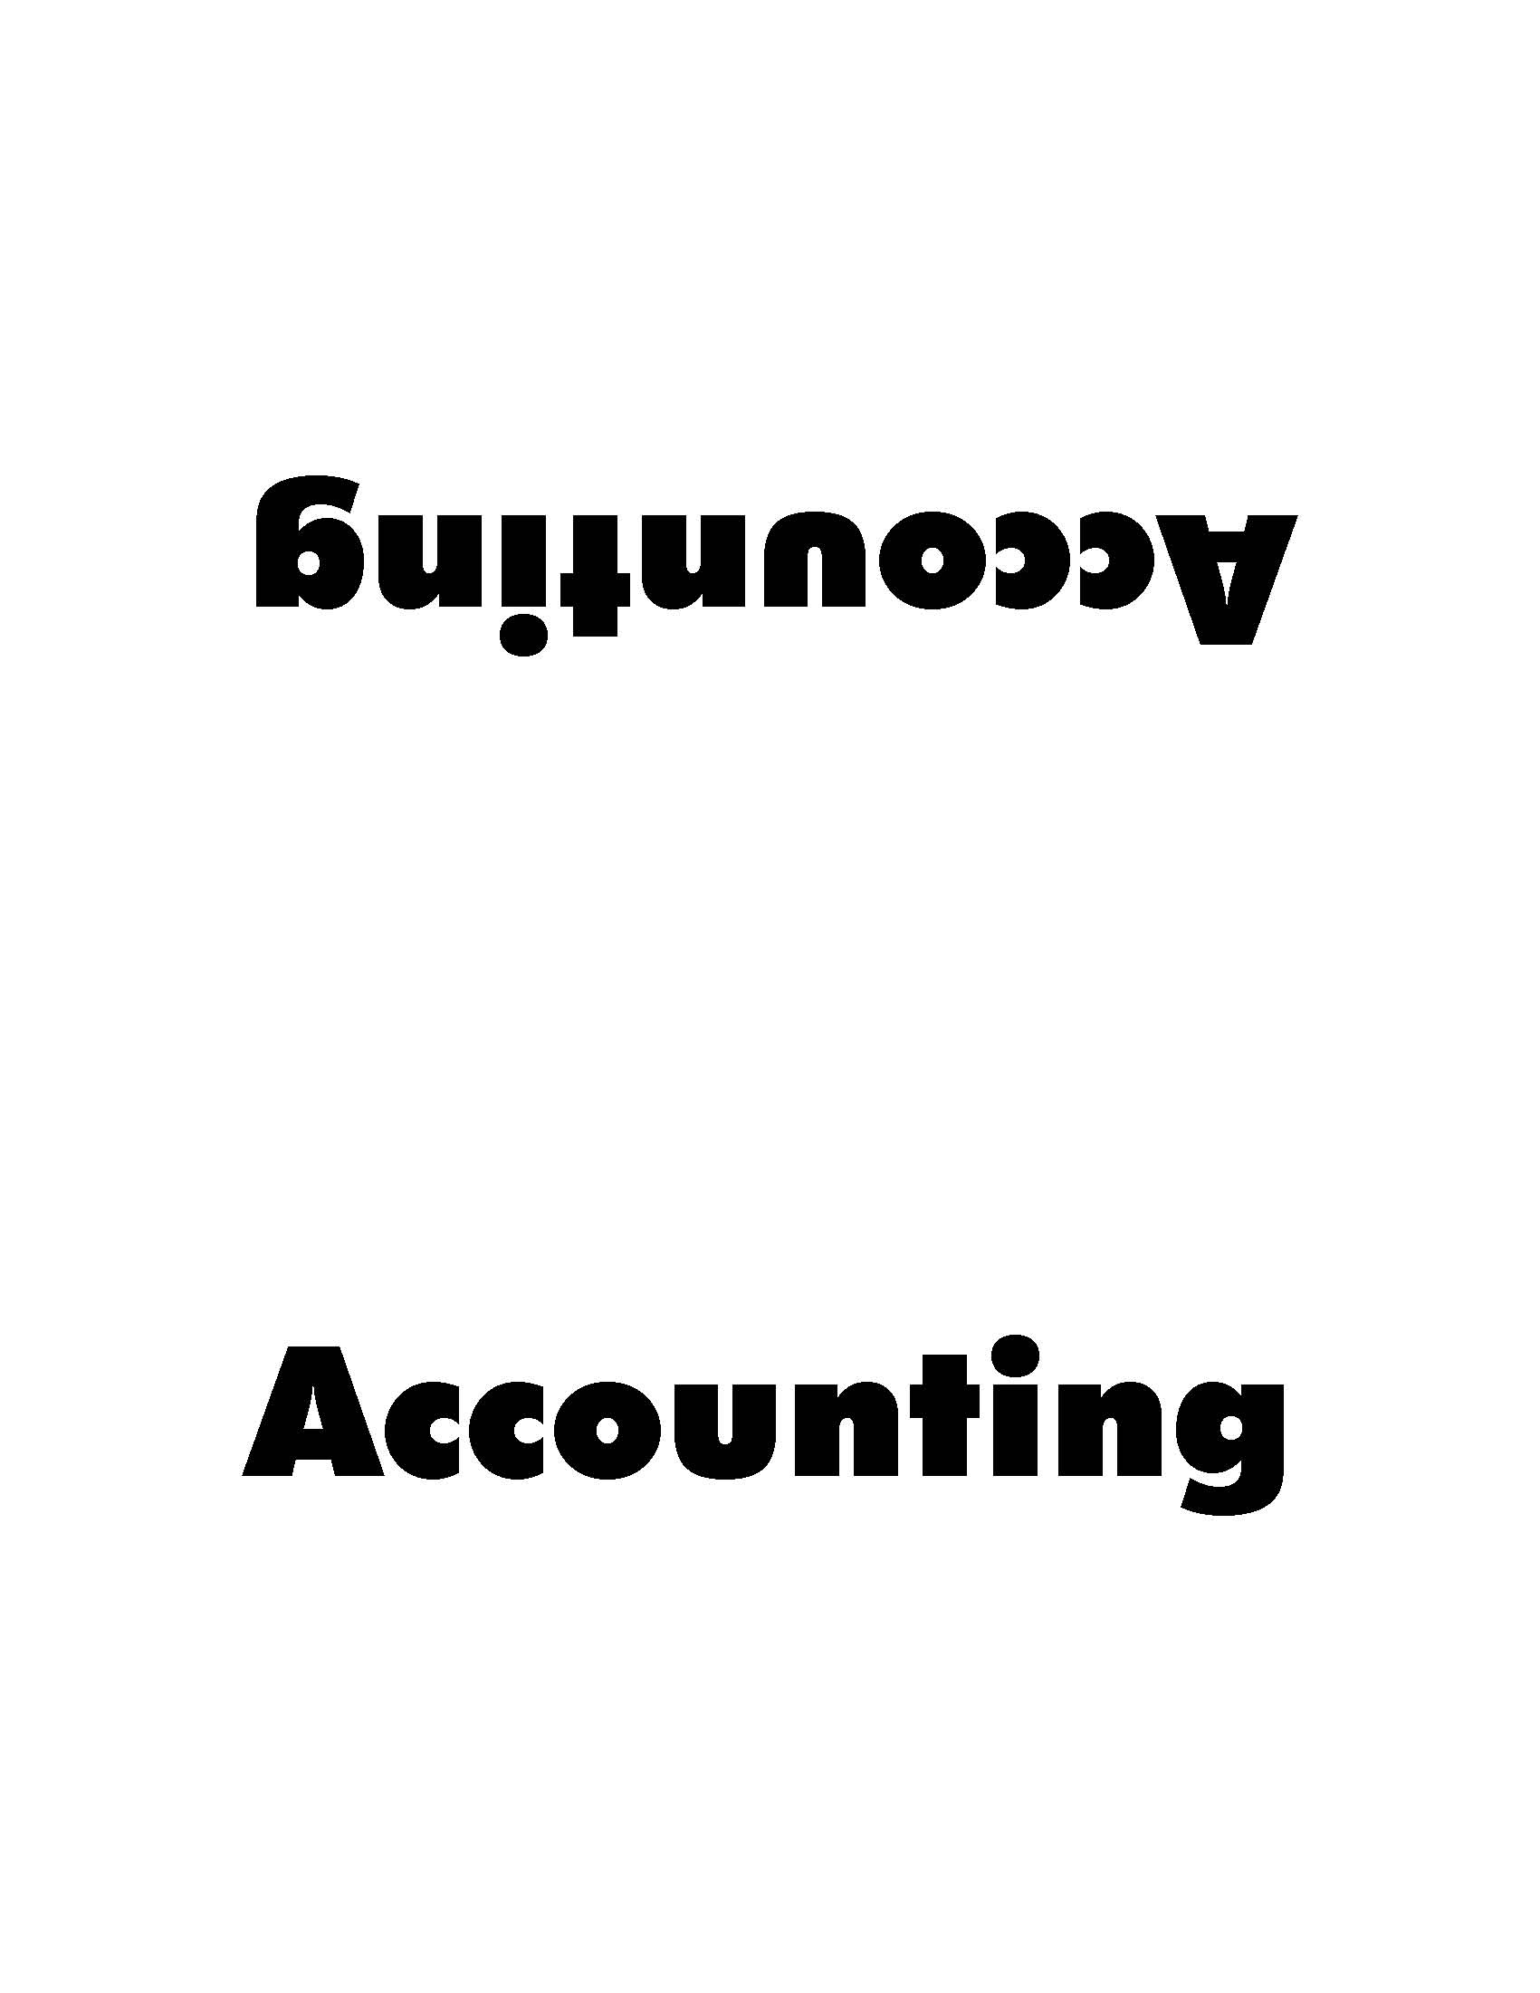

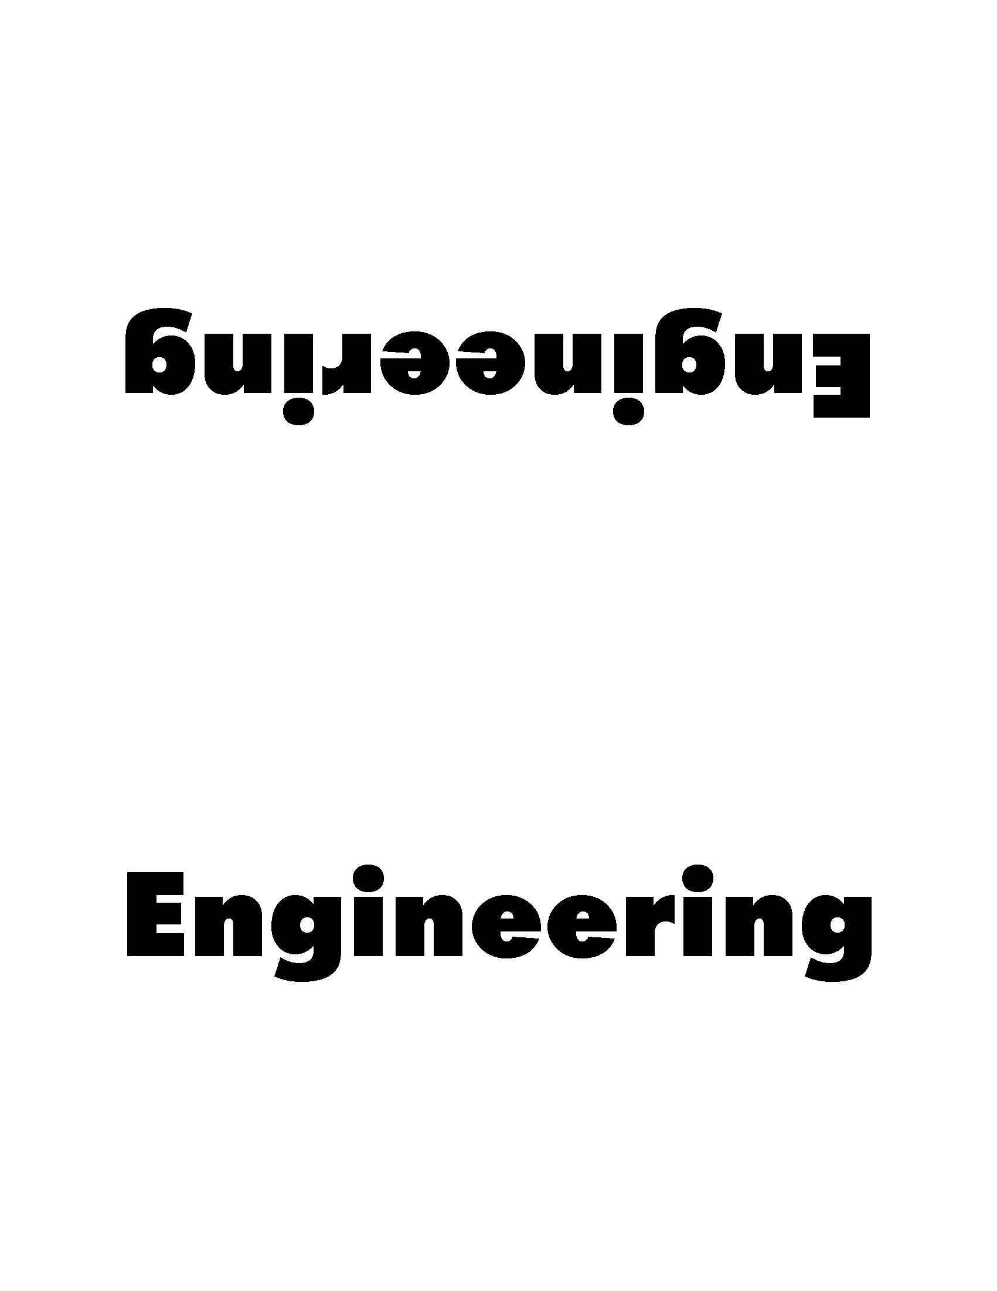

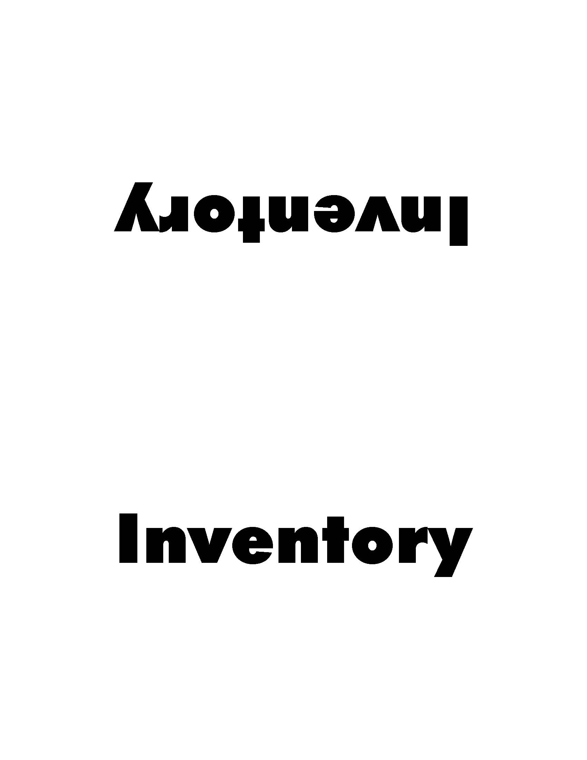

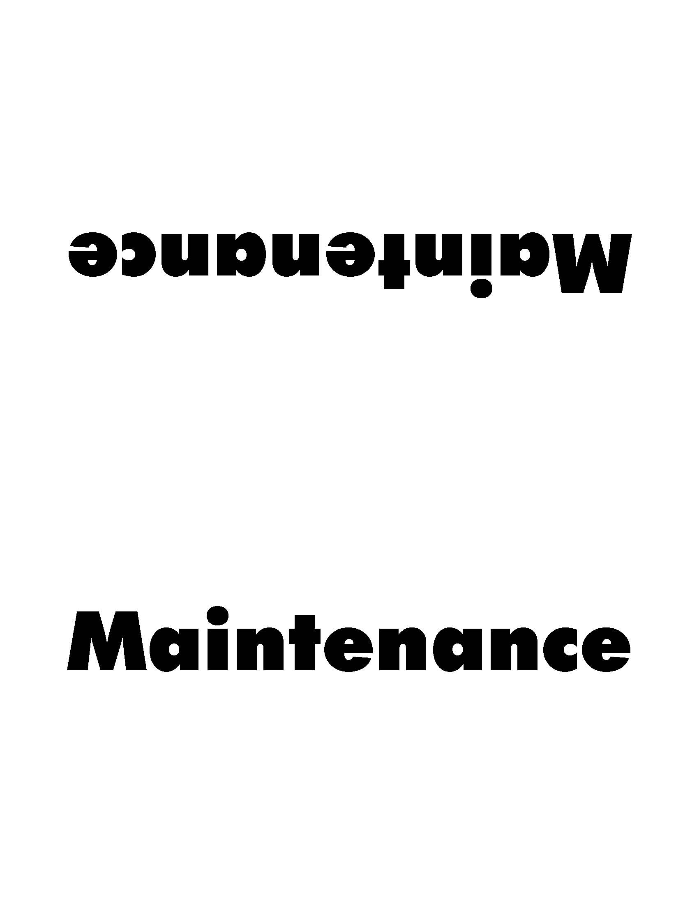

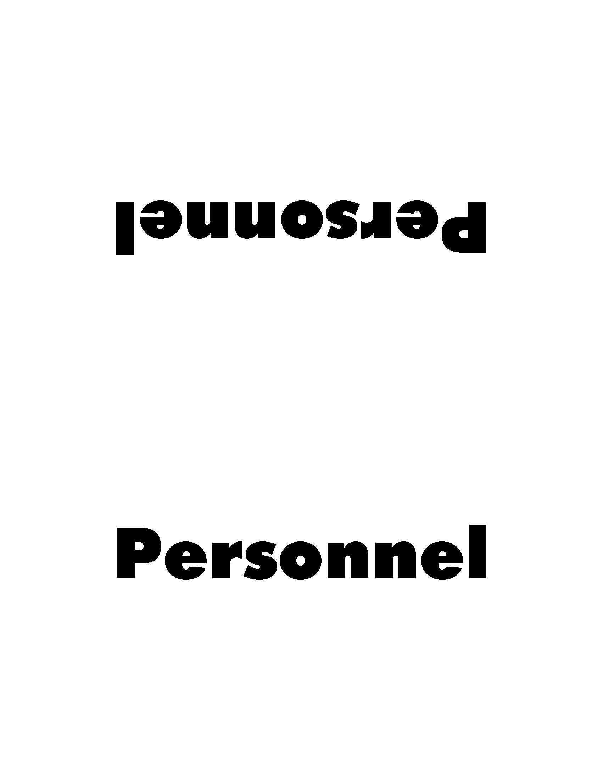









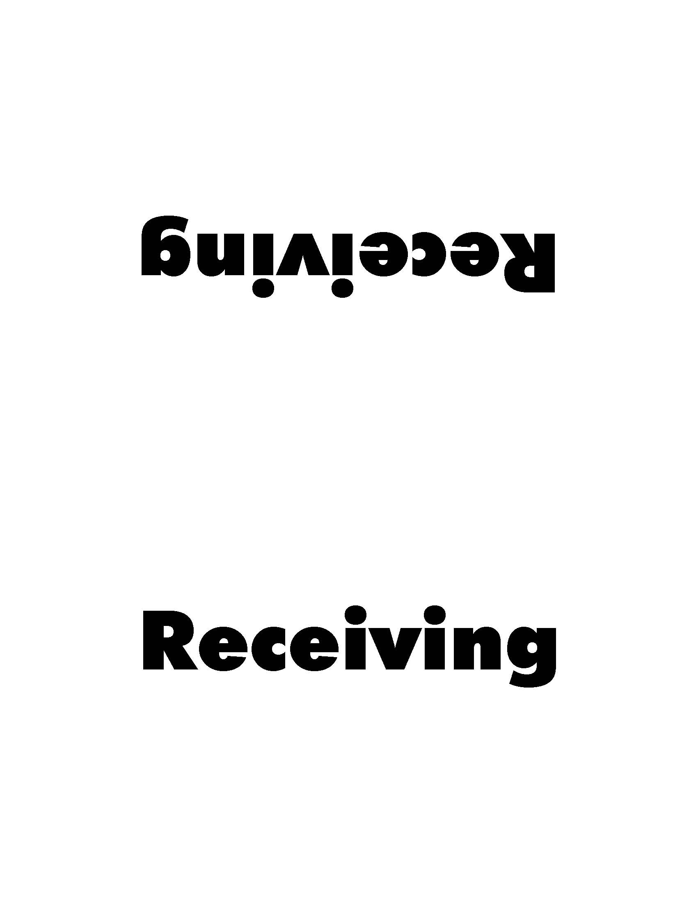





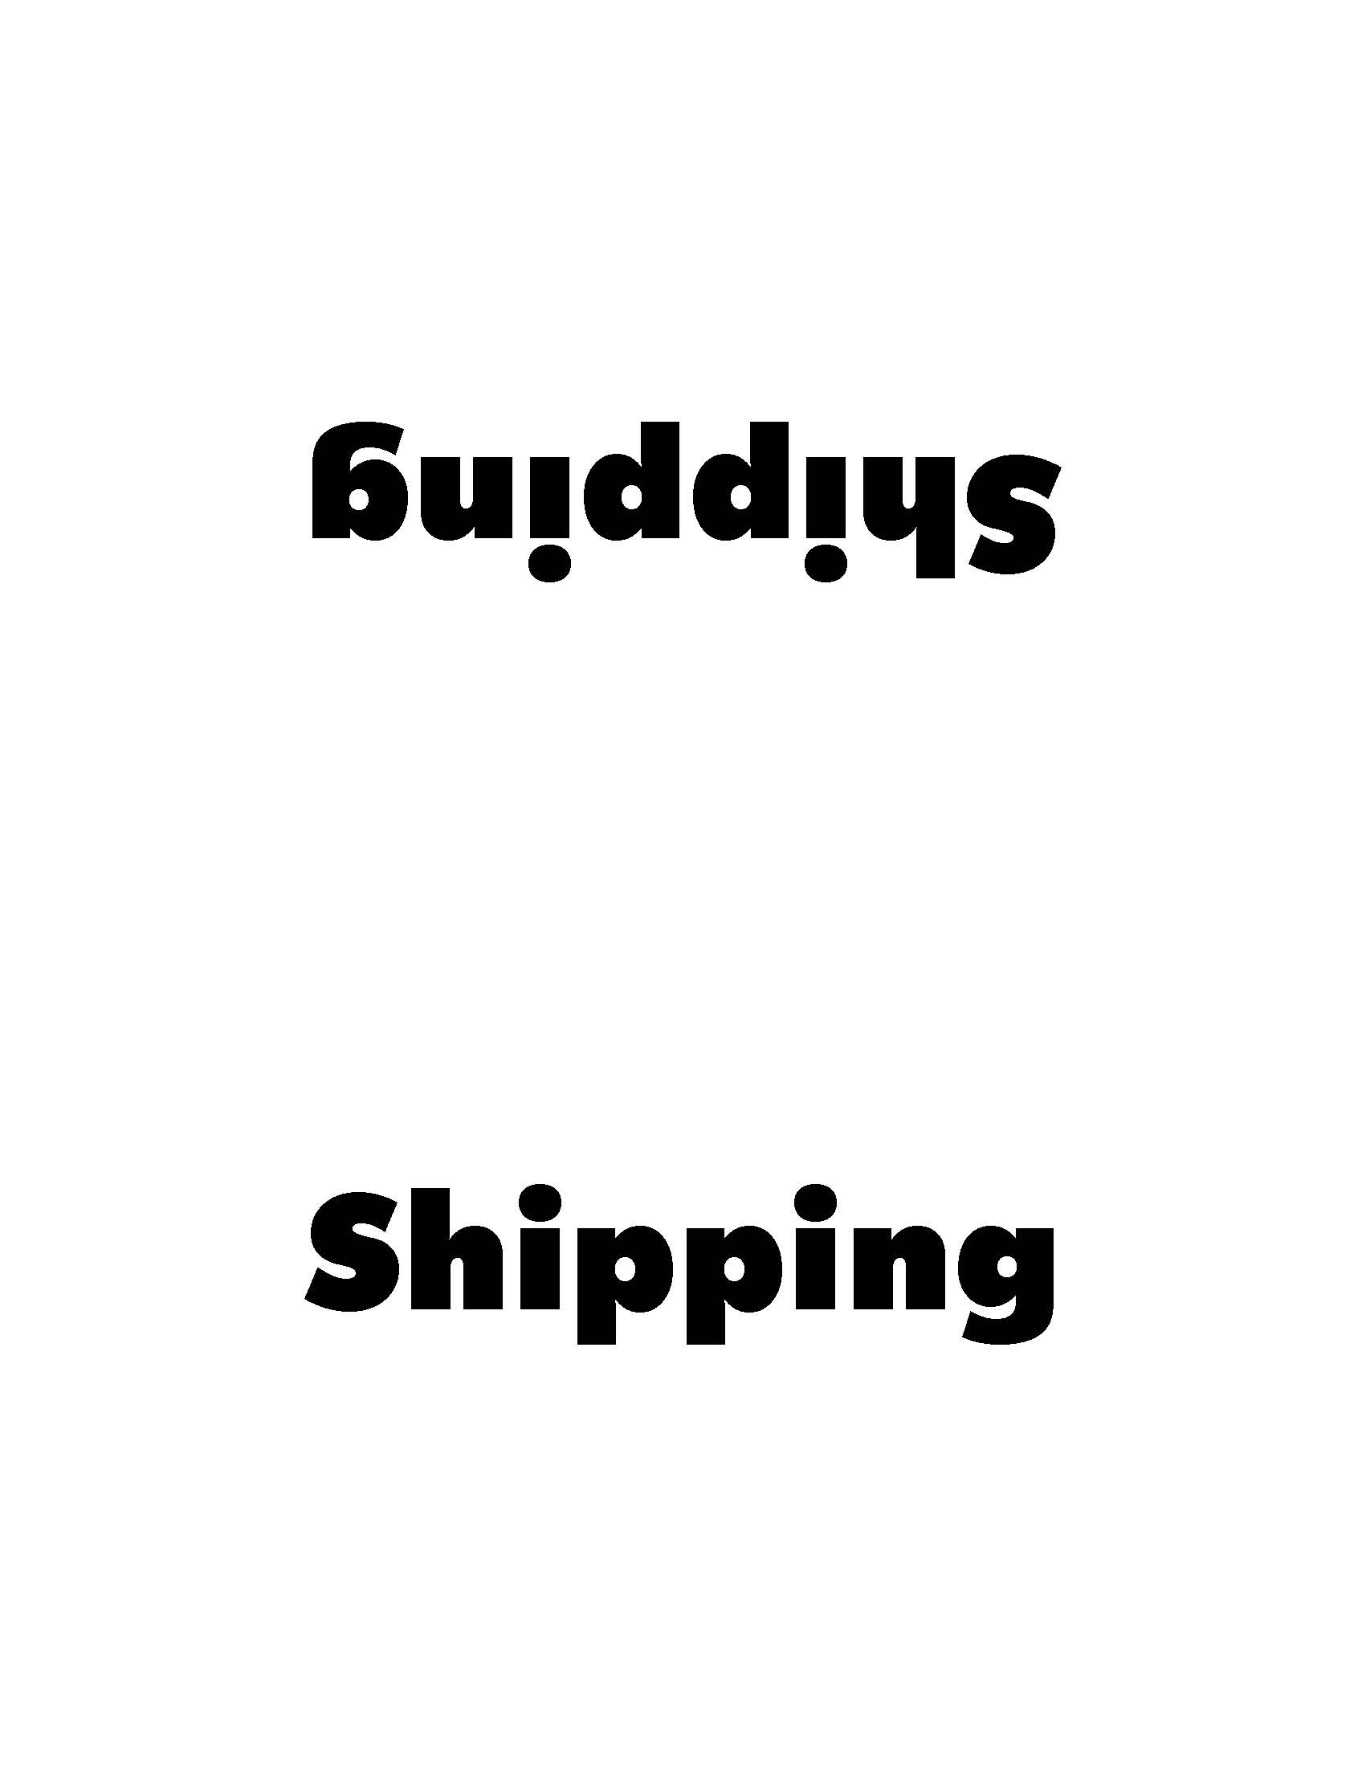
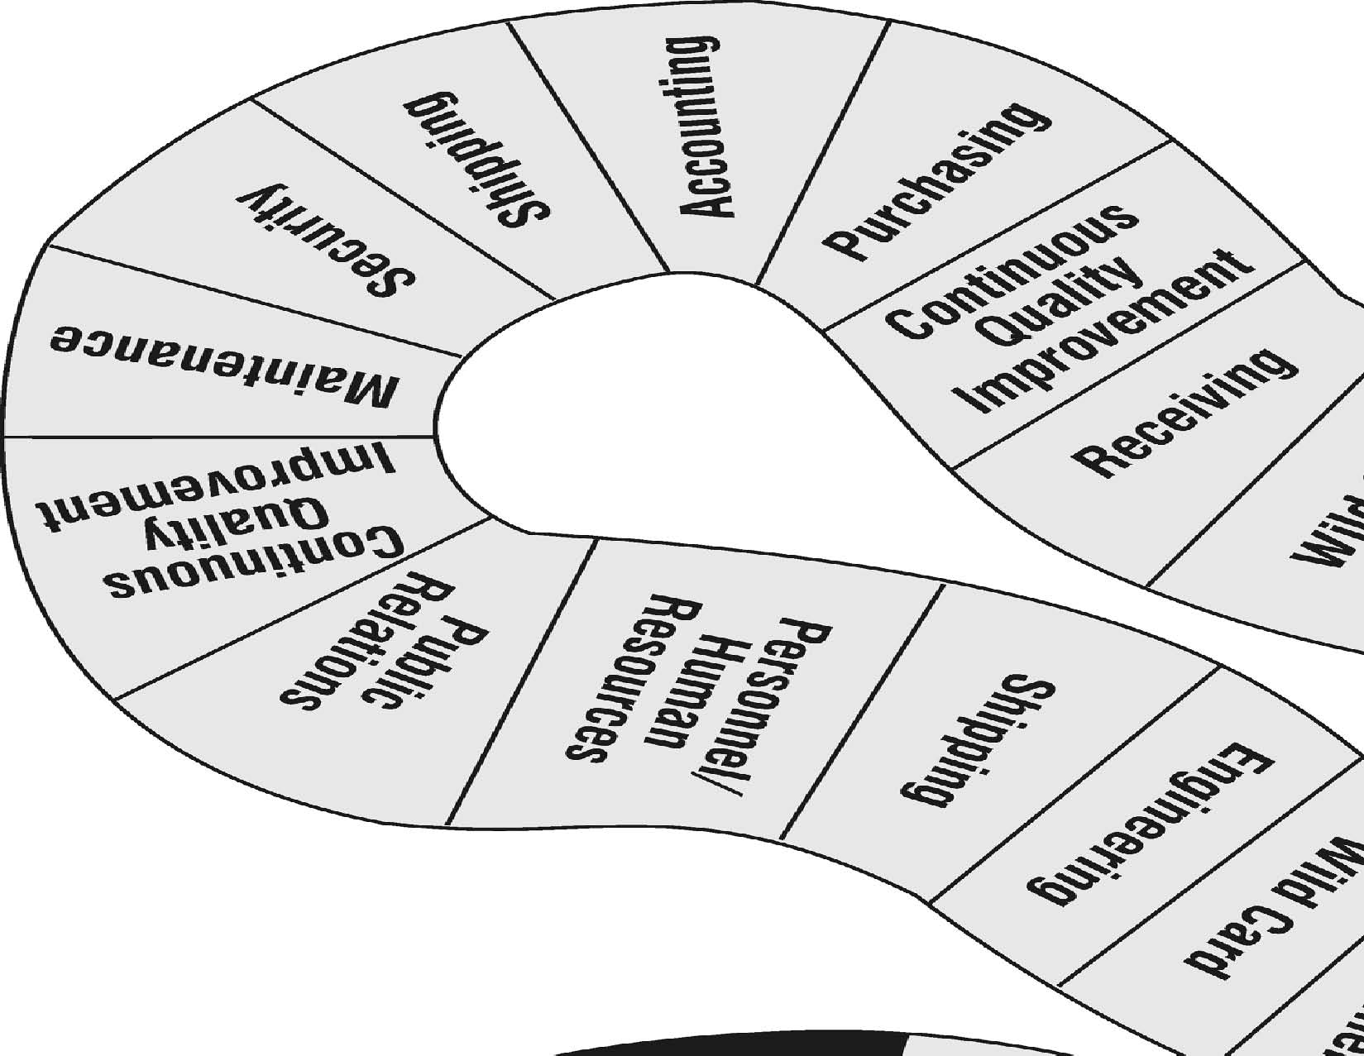
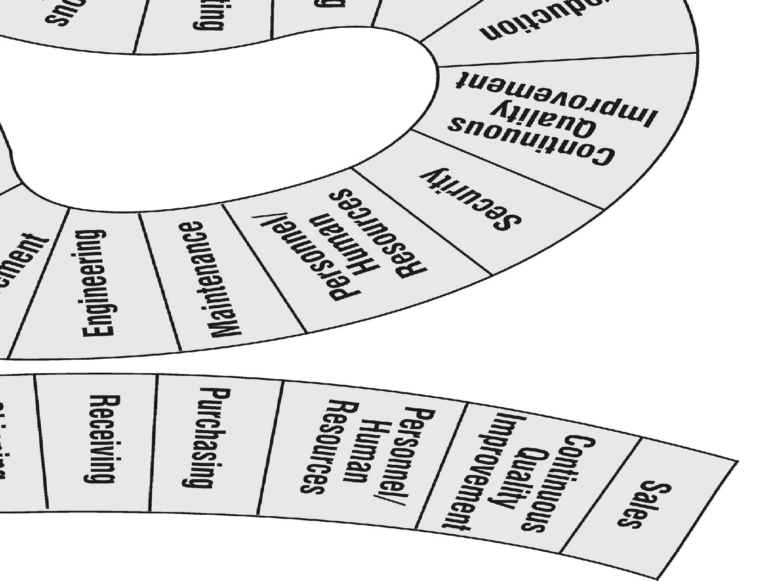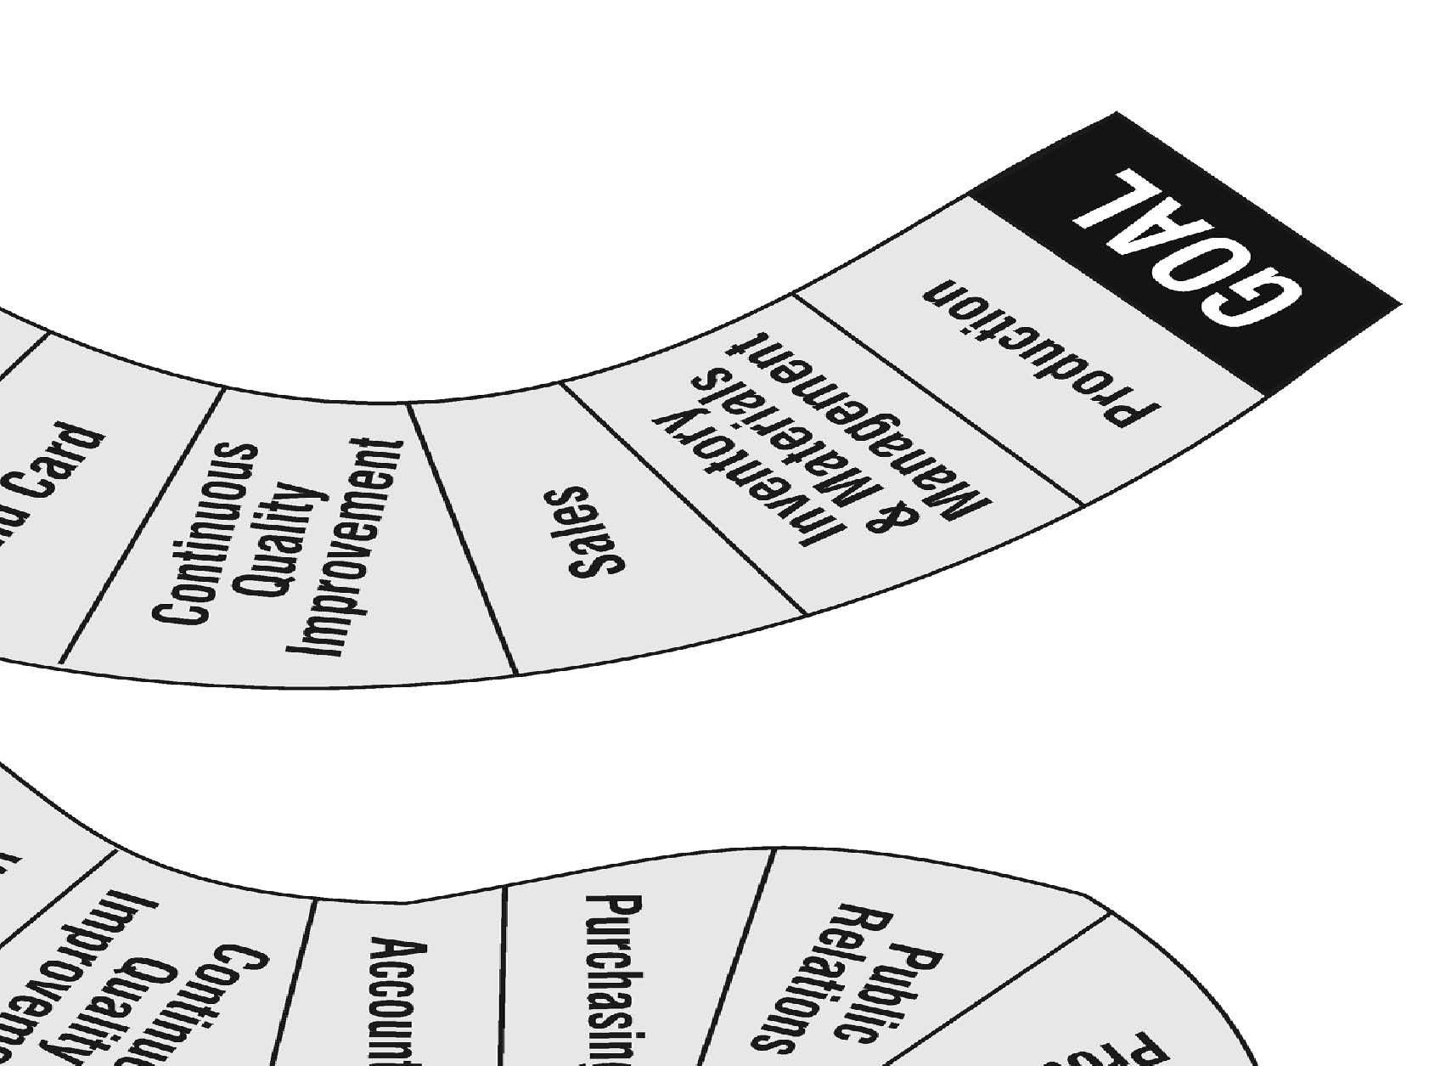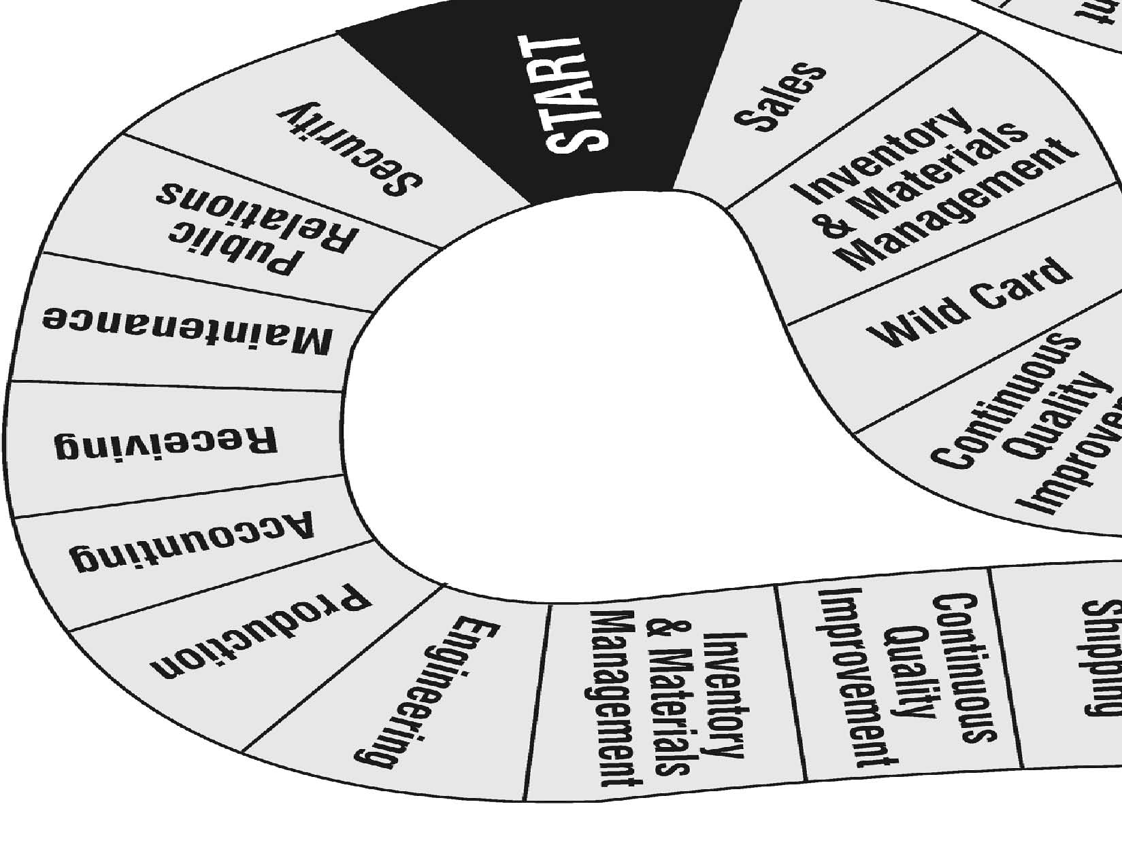
Assessment Tools/Strategies
This section includes specific strategies and instruments for assessing students’ knowledge, skills, and attitudes in regards to initiative and dependability skills.
Rubrics
Rubrics are valuable assessment tools. Students should be provided with the rubric by which they will be assessed before an activity begins so they will understand the performance expectations. When time permits, students can contribute to the rubrics by brainstorming with the instructor about what a quality behavior or product looks like. For example, before assigning a project, ask students to describe how the ideal should look when completed successfully. Prompt students with specific components. Then have them describe a poor performance. These will be the descriptions of the characteristics for the highest and lowest ends of the Likert scale for each performance criterion. Instructors should add any required attributes to the rubric if the students do not come up with them on their own. Several Initiative and Dependability evaluation rubrics have been provided as examples.
- The first type of rubric lists attributes that can be observed. These include spaces where the instructor can adapt the rubric for a specific project or activity by inserting additional criteria. There are two of these rubrics dealing with different aspects of initiative and dependability in this section: Scheduling and Housekeeping.
- Another type of rubric is more complex as it requires a comparison between a student’s view of his/her performance and a peer and instructor review. It is exemplified by the rubrics: Positive Attitudes Personally and Professionally; Role of Awareness of Abilities and Skills; Successful Job Performance; Job-Keeping Skills; Work Ethic; and Self-Management. The student completes a rubric by providing examples of satisfactory or exemplary performance of the tasks/behaviors listed. Then the student meets with the instructor or peer observer and compares his/her reflections with their instructor’s or peers’ observations and formulates an action plan for improving attitudes, behaviors, or skills.
This type of rubric most resembles the type of assessment an employee might receive on the job. It is also the most time-consuming. Ideally, this rubric would be used at least three times during a course:
- At the beginning of the course, to get a baseline and to give students suggestions for specific actions they might take to improve their performance;
- At the midpoint of the course, to check progress and refine the recommendations for improvement; and
      - At the end of the course, to assess the progress made over the duration of the course. Additional suggestions can be made for students’ continued growth beyond the end of the course.

Rubric for Scheduling
Outcome: Scheduling – Develop, communicate, and implement schedules, either electronically or on paper; read and follow schedules so that jobs are completed by the respective due date in accordance with user requests.

Determines when to use paper-based or electronic scheduling tools. | 1 2 3 4 5
Selects and uses software to track and manage schedules. | 1 2 3 4 5
Monitors and adjusts schedules to complete projects on time. | 1 2 3 4 5
Works with others involved in the project to develop appropriate timelines and schedules. | 1 2 3 4 5
Keeps everyone involved in the project informed of project progress. | 1 2 3 4 5

5 | Always | Excellent
4 | Most of the Time | Good
3 | Sometimes | Adequate
2 | Occasionally | Fair
1 | Never | Poor or None

Rubric for General Housekeeping
Outcome: General Housekeeping – Implement general housekeeping practices to maintain a neat and orderly work area while recognizing the connection to successful job performance.

Cleans work area and equipment according to acceptable standards. | 1 2 3 4 5
Uses techniques that preserve the safety of self and others. | 1 2 3 4 5
Keeps work area free from clutter. | 1 2 3 4 5
Properly stores equipment and supplies. | 1 2 3 4 5
Exhibits a sense of pride in the work area, which is a reflection on the person and their work. | 1 2 3 4 5

5 | Always | Excellent
4 | Most of the Time | Good
3 | Sometimes | Adequate
2 | Occasionally | Fair
1 | Never | Poor or None

Rubric for Positive Attitudes Personally and Professionally
Outcome: Positive Attitudes Personally and Professionally – Model effective work attitudes and behaviors in both personal and professional settings.

Performance Criteria
Reflection  Reflect on your actions during class or at a workplace and identify examples of when you: |  | Personal Plan  Based on your examples and the feedback of your peers or instructor, describe the steps you might take to continue or improve your positive attitude personally and professionally.
Demonstrated a positive view of yourself. | Example:  Peer / instructor review: | Steps:
Recognized that your behavior may have a positive or negative impact on others in your group. | Example:  Peer / instructor review: | Steps:
Experienced a sense of personal pride and responsibility. | Example:  Peer / instructor review: | Steps:
Recognized that your words and actions reveal what you personally value or believe. | Example:  Peer / instructor review: | Steps:
Were aware of your beliefs, feelings, and opinions that affected your attitude toward others and the task. | Example:  Peer / instructor review: | Steps:
Experienced a positive attitude toward learning something new. | Example:  Peer / instructor review: | Steps:

Peer comments and suggestions:
Instructor comments:

Rubric for Role of Awareness of Abilities and Skills
Outcome: Role of Awareness of Abilities and Skills – Demonstrate an understanding of personal abilities and skills with an awareness of the impact on career development and achievement in academic and occupational skills. Discuss the impact of abilities and skills on colleagues and clients.

Performance Criteria
Reflection  Reflect on your actions during class or at a workplace and identify examples of when you: |  | Personal Plan  Based on your examples and the feedback of your peers or instructor, describe the steps you might take to continue or improve awareness of your own abilities and skills in your career development.
Demonstrated an appreciation of your personal abilities and skills. | Example:  Peer / instructor review: | Steps:
Identified one of your weaknesses. | Example:  Peer / instructor review: | Steps:
Matched one of your abilities or skills with one of your educational or career goals. | Example:  Peer / instructor review: | Steps:
Discovered or continued practicing techniques you use that help you accomplish a goal or task. | Example:  Peer / instructor review: | Steps:
Recognized the influence of your abilities and skills on others. | Example:  Peer / instructor review: | Steps:

Peer comments and suggestions:
Instructor comments:
Rubric for Successful Job Performance
Outcome: Successful Job Performance – Recognize and value effective work ethic attitudes and behaviors that support the ability to be successful in job performance, such as acceptance of the requirements of the job, a willingness to take initiative with new challenges; taking responsibility for decisions and actions; and recognizing the necessity of being prompt, accurate, and reliable in completing tasks.

Performance Criteria
Reflection  Reflect on your actions during class or at a workplace and identify examples of when you: |  | Personal Plan  Based on your examples and the feedback of your peers or instructor, describe the steps you might take to continue or improve your attitudes and behaviors for successful job performance.
Demonstrated a positive and responsible attitude while fulfilling the requirements of the job. | Example:  Peer / instructor review: | Steps:
Took initiative and sought new challenges. | Example:  Peer / supervisor review: | Steps:
Took responsibility for your own decisions and actions. | Example:  Peer / instructor review: | Steps:
Demonstrated promptness, accuracy, and reliability in completing a task. | Example:  Peer / instructor review: | Steps:
Consistently demonstrated a good attendance record and/or demonstrated punctuality and enthusiasm in completing a task. | Example:  Peer / instructor review: | Steps:
Demonstrated pride in your work. | Example:  Peer / instructor review: | Steps:
Accepted directions, accepted constructive criticism, and/or adjusted your behavior to the situation. | Example:  Peer / instructor review: | Steps:

Peer comments and suggestions:
Instructor comments:

Rubric for Job-Keeping Skills
Outcome: Job-Keeping Skills – Recognize and implement employer expectations for maintaining a job. Basic employability skills include communication skills, thinking skills, and interpersonal skills. Recognize the importance of a personal work ethic.

Performance Criteria
Reflection  Reflect on your actions during class or at a workplace and identify examples of when you: |  | Personal Plan  Based on your examples and the feedback of your peers or instructor, describe the steps you might take to continue or improve your job-keeping skills.
Orally communicated with others in a clear and organized manner. | Example:  Peer / supervisor review: | Steps:
Clearly communicated information in writing. | Example:  Peer / supervisor review: | Steps:
Listened attentively to others. | Example:  Peer / supervisor review: | Steps:
Used creative thinking to explore options and consider consequences. | Example:  Peer / instructor review: | Steps:
Used decision-making skills. | Example:  Peer / instructor review: | Steps:
Used reasoning skills. | Example:  Peer / instructor review: | Steps:
Used problem-solving skills. | Example:  Peer / instructor review: | Steps:
Gathered, evaluated, and organized information for successful job performance. | Example:  Peer / instructor review: | Steps:
Prioritized work to complete the task on time and with accuracy. | Example:  Peer / instructor review: | Steps:
Demonstrated responsibility for the safety of yourself and others. | Example:  Peer / instructor review: | Steps:
Demonstrated effective interpersonal skills with supervisors, colleagues, and/or clients. | Example:  Peer / instructor review: | Steps:

Peer comments and suggestions:
Instructor comments:

Rubric for Work Ethic
Outcome: Work Ethic – Display conscientious personal and professional work habits, seek ongoing professional development, improve performance for the benefit of self and the employer, and display a sense of personal responsibility for the welfare of the company and colleagues. Elaboration: The workforce requires workers with a strong work ethic in which the worker demonstrates conscientious personal and professional work habits and behaviors. It includes a willingness to engage in professional development leading to improved performance that benefits self and the employer. The worker must display a sense of personal responsibility for the welfare of the company and colleagues.

Performance Criteria
Reflection  Reflect on your actions during class or at a workplace and identify examples of when you: |  | Personal Plan  Based on your examples and the feedback of your peers or instructor, describe the steps you might take to continue or improve your work ethic.
Demonstrated consistent ability to be punctual, maintained regular attendance, performed at a high level of quality meeting or exceeding job expectations, motivated self, and behaved honestly. | Example:  Peer / instructor review: | Steps:
Participated in a professional development opportunity that resulted in improved performance and benefited both yourself and your employer. | Example:  Peer / instructor review: | Steps:
Documented and reported professional development. | Example:  Peer / instructor review: | Steps:
Demonstrated personal responsibility for the welfare of the company and your colleagues. | Example:  Peer / instructor review: | Steps:

Peer comments and suggestions:
Instructor comments:

Rubric for Self-Management
Outcome: Self-Management in the Workplace – Display skills of organization and time management.

Performance Criteria
Reflection  Reflect on your actions during class or at a workplace and identify examples of when you: |  | Personal Plan  Based on your examples and the feedback of your peers or instructor, describe the steps you might take to continue or improve your self-management skills.
Demonstrated the ability to plan workloads. | Example:  Peer / instructor review: | Steps:
Demonstrated the ability to maintain your work area. | Example:  Peer / instructor review: | Steps:
Used technology according to purpose. | Example:  Peer / instructor review: | Steps:
Accomplished strategic goals. | Example:  Peer / instructor review: | Steps:
Used visual display of information such as Gantt charts. | Example:  Peer / instructor review: | Steps:
Organized resources for easy access. | Example:  Peer / instructor review: | Steps:
Managed work, family, and leisure-time demands. | Example:  Peer / instructor review: | Steps:
Developed a time-management plan that monitored your progress toward goals. | Example:  Peer / instructor review: | Steps:
Developed and followed a work schedule. | Example:  Peer / instructor review: | Steps:
Conducted a time-management analysis with an awareness of poor time management and its consequences. | Example:  Peer / instructor review: | Steps:

Peer comments and suggestions:
Instructor comments:
Videos and Weblinks
Videos
http://www.youtube.com/watch?v=blaK_tB_KQA (low res)
http://archive.org/details/GabrielRobins-TimeManagementByRandyPauschNovember2007187 (hi res)
Excellent “Time Management” lecture by the late Randy Pausch, University of Virginia, Nov 2007. (1h 26m)
http://www.youtube.com/watch?v=Ae-VJ_lauCw (part 1 of 3, 5:09)
http://www.youtube.com/watch?v=kiQV0oTyd98 (part 2 of 3, 4:22)
http://www.youtube.com/watch?v=su2UuP3aqZg (part 3 of 3, 4:45)
“Setting Goals” by Zig Ziglar, renowned motivational speaker. Lo-def video, but a high-quality message.
Weblinks
There are free programs and templates available online that students can use to create their Gantt charts. (See https://www.capterra.com/sem-compare/project-management-software. Free trial use available.) Google Sheets provides a Gantt chart template, and several are available for Microsoft Excel. These can be accessed through Excel by clicking New and then entering “Gantt” in the search window. See also https://www.smartsheet.com/s/gantt-chart-excel. Several Gantt chart apps are also available.
Articles on time management (https://hbr.org/2020/01/time-management-is-about-more-than-life-hacks; https://corporatefinanceinstitute.com/resources/careers/soft-skills/time-management-list-tips/; https://www.skillsyouneed.com/ps/time-management.html)
http://www.rightattitudes.com/2008/10/21/log-where-time-actually-goes/
Online guide to logging one’s daily time, including blank forms: 24 hours in 10-minute intervals (4 pages) and 11 hours in 15-minute intervals (1 page).
http://www.stevepavlina.com/articles/triple-your-personal-productivity.htm
Guidelines from a Time Management consultant for logging your time and eliminating waste.
https://www.capterra.com/sem-compare/time-tracking-software
Top time-tracking applications, for those who dislike paper logs. Free trial use available.
https://www.google.com/search?q=messy%20desk&num=50&safe=on&hl=en&um=1&ie=UTF-8&tbm=isch
Google can provide hundreds of photos of “messy desks” for the activity “Maintaining Your Workspace and Equipment.”

