NC-NET Employability Skills Resource Toolkit
Module 2: Communication
Overview 2
Presentation Materials 3
Teaching Resources 7
Activity: Communicating on the Job 8
Activity: Giving and Receiving Instructions 11
Activity: Adapting Communication Style 17
Activity: Conflict Resolution in the Workplace 21
Activity: Listening Accuracy for Tech Support 24
Activity: Preparing Presentations 30
Activity: English for Business 33
Assessment Tools/Strategies 37
Rubrics for Instructor Assessment 38
Rubric for Self-Assessment of Communication Skills 42
Rubric for Assessing Interpersonal Skills 44
Videos and Weblinks 50
Videos 50
Weblinks 50


Overview
Effective communication is essential for a motivated and productive workplace. Communication—spoken and written, on paper and in electronic form—is the lifeblood of every workplace. It is impossible to prepare workers for successful careers without preparing them to communicate effectively and successfully. In this module, while we cannot address all the years of language skills training (or lack of training) that students bring to the classroom, we can pause to emphasize the importance of this area to their overall career preparation, and highlight room for improvement. Whether their future employment includes working in quality control teams in factories, at construction sites involving multiple crafts, in laboratories staffed with multi-skilled technicians, or around conference room tables, their success will largely be tied to their abilities to communicate with their fellow workers and with management.
In this module, you will find:
- Instructor Presentation Materials—The presentation materials for this topic provide students with an overview of positive communication strategies. The slides offer talking points introducing the concepts addressed in the activities.
- Classroom Activities—The student activities allow students to practice many facets of effective oral and written communications.
- Assessment Tools—There are a variety of rubrics following the classroom activities section. These can be used as observation checklists, peer evaluations, or student self-evaluations. In addition, there are personal performance plans designed to help students reflect on their individual achievements, compare their reflections with their instructors’ or peers’ observations, and formulate action plans for improving attitudes, behaviors or skills.
- Videos and Links—This collection of resources can be used to encourage further exploration of the topic.
Presentation Materials
 | SLIDE | TEACHER NOTES
1
2 | 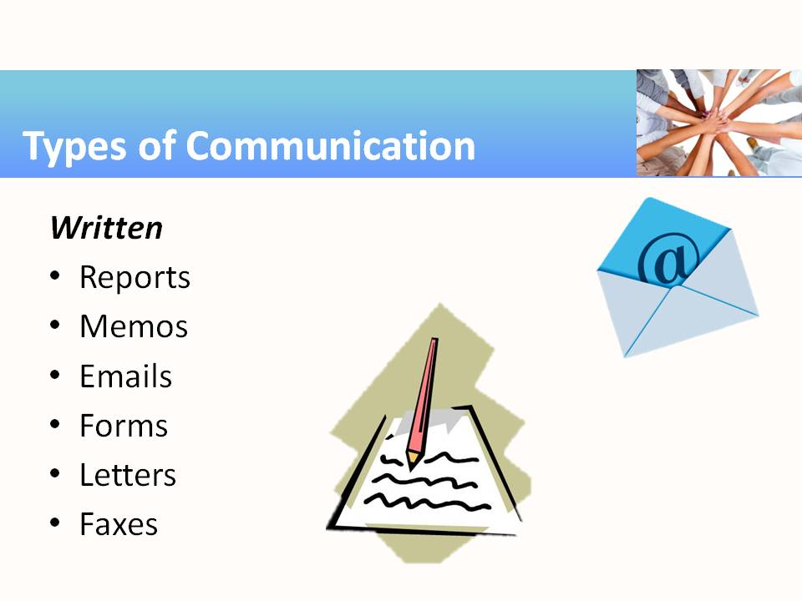
3 | 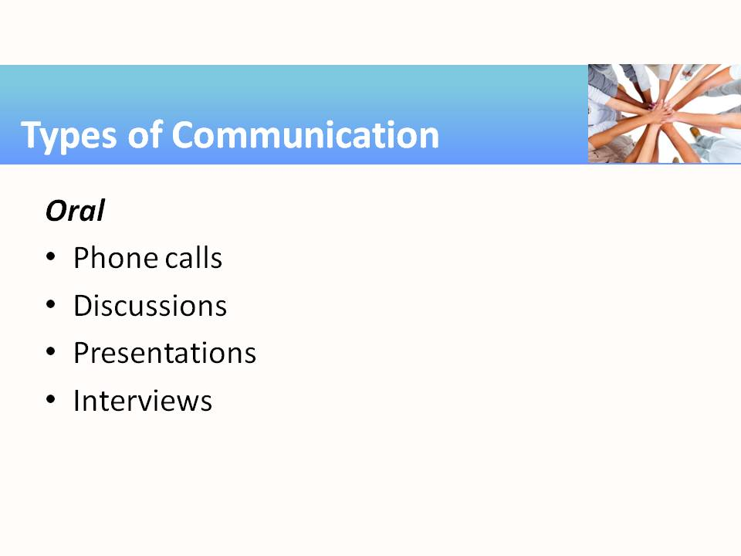
4 | 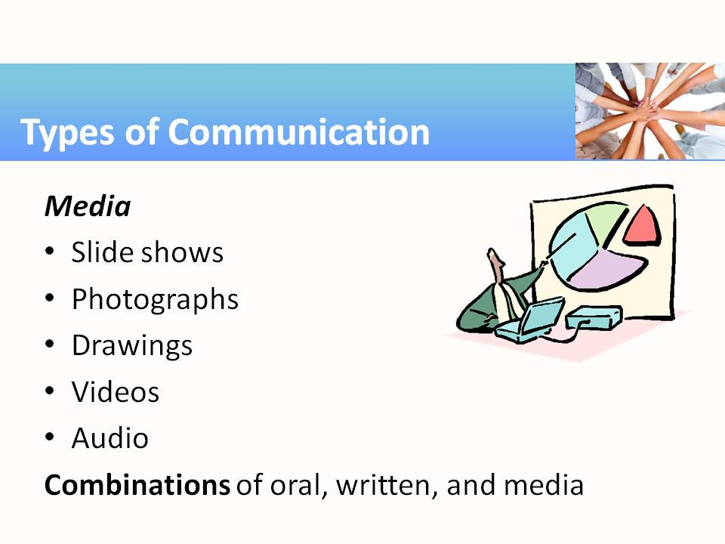
5 | 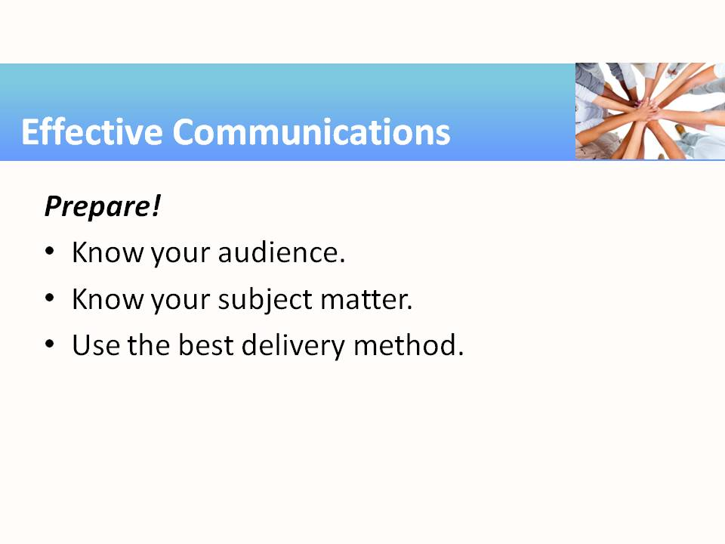 | - Your audience: One person, a small group, or an auditorium filled with people?  - Your subject: What are you going to cover? What are you NOT going to cover?  - The delivery medium: Oral presentation? Written document(s) and handouts? Multimedia?
6 | 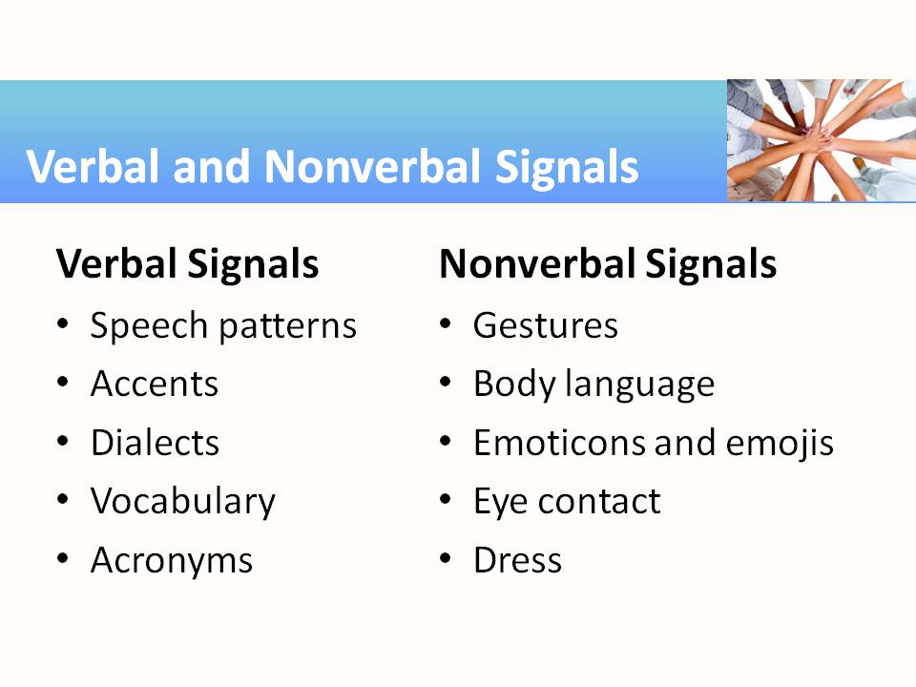 | - Communicators should be aware of the signals they are sending. Non-verbal cues such as body language can reveal true feelings and attitudes more readily than polite conversation. What do slumped shoulders and lack of eye contact convey?
7 | 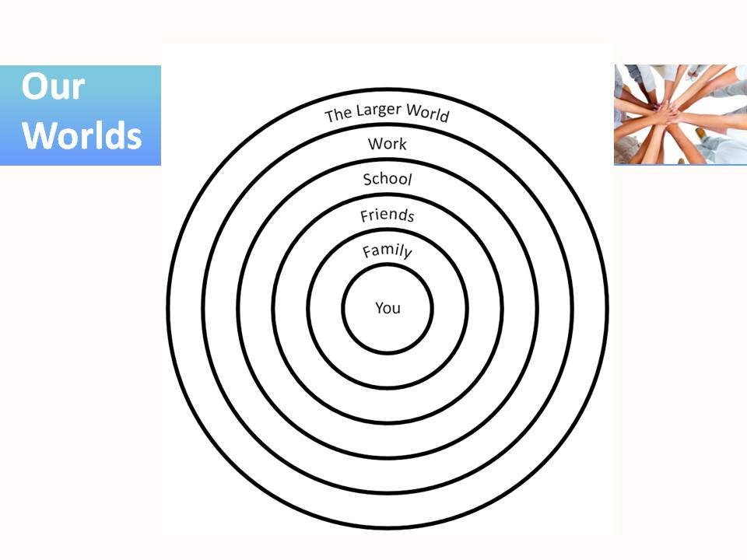 | - It’s perfectly appropriate to use different styles of communication in different circles. We generally speak much less formally with family members and friends (small circles) than we do at work and in the larger world (larger population; less “known” to us; reactions not entirely predictable; may expect greater formality).
8 | 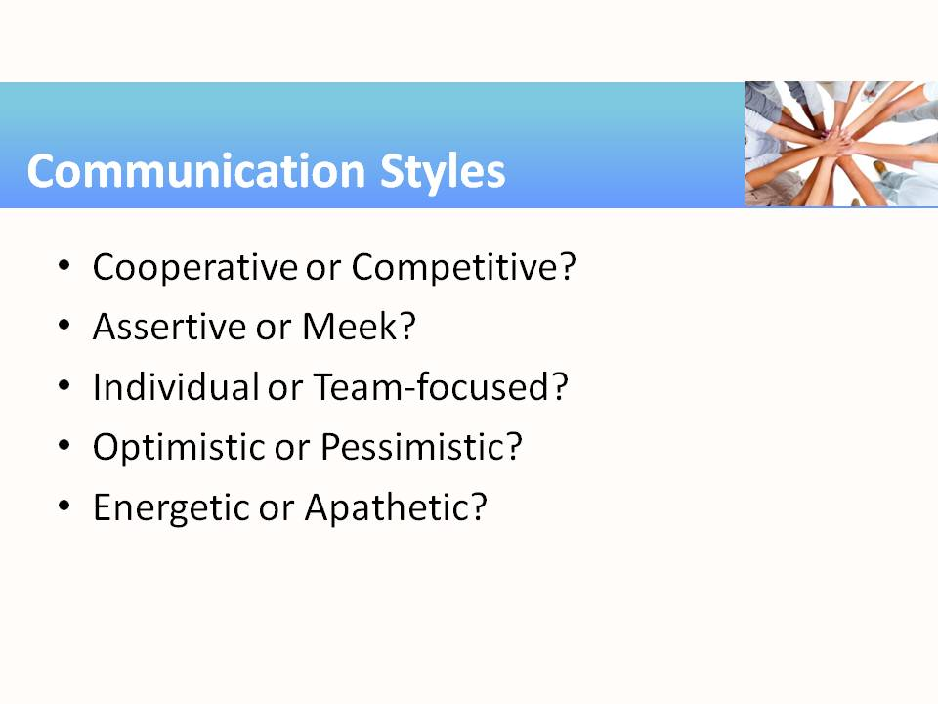 | - The attitudes behind how we communicate add either positive or negative value to our message. In this case, opposites do not attract. Conflict may be a natural outcome when people with divergent communication styles interact.
9 | 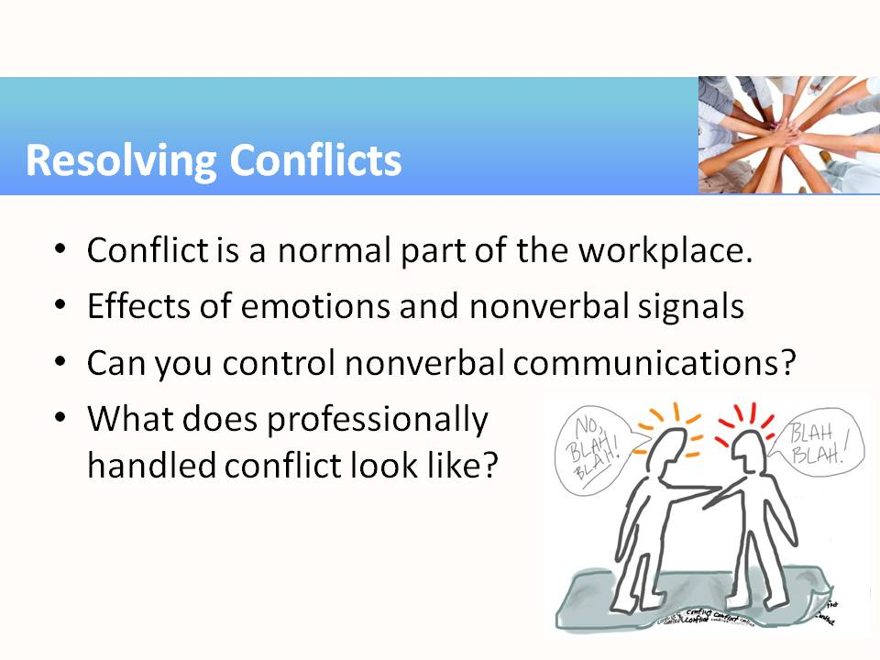 | - For most people, the word conflict is scary because of the emotional baggage it carries. Since no two people view the world exactly the same way, disagreement is normal. One way of avoiding or resolving conflict is to listen carefully to the other speakers and calmly rephrase what they are saying, e.g. “So, I think what I hear you saying is that we should alternate days off. Is this correct?” This active listening technique can help get disagreeing parties “on the same page.”
10 | 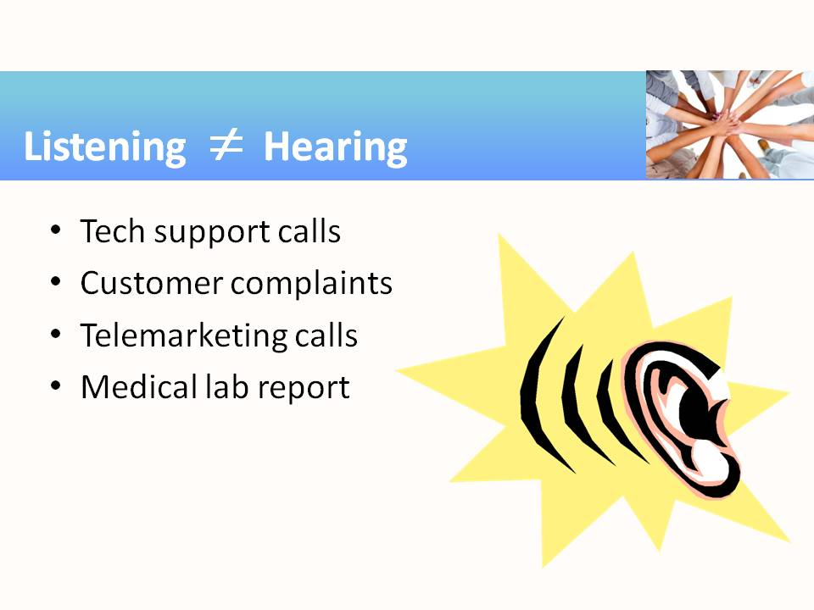 | - Listening requires focus, remembering, and responding. How is listening critical in the situations listed on this slide?
11 | 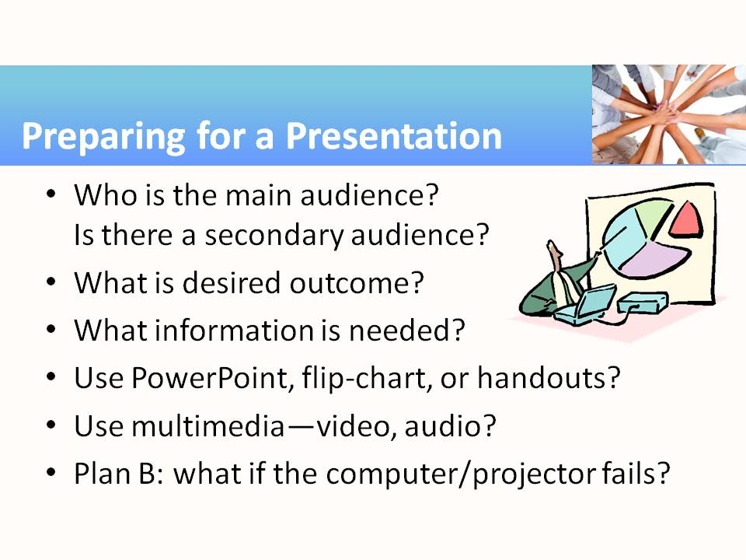 | - Preparing for a presentation involves putting all the pieces of the communication puzzle together: appropriate word choices, delivery speed, body language, clothing, and delivery tools to suit the audience and occasion.
12 | 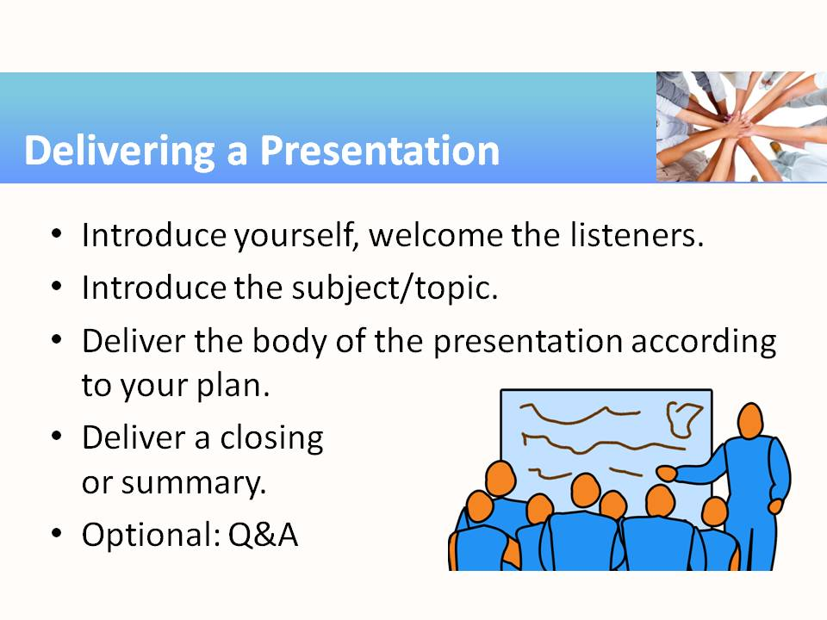 | - The introduction explains who the speaker is and why he or she is qualified to address the subject. The body should follow a plan that presents the main points in a logical order. Speakers should stick to the plan so that listeners can easily follow the flow of ideas and remember them. The closing briefly ties everything together.
Teaching Resources
Activities
The following activities can be completed in class to emphasize specific aspects of effective communication and positive interpersonal skills. The activities found in this resource can be used “as-is” or they can be tailored to fit a specific course. Suggestions for adaptation precede each activity, with examples from several different subject areas/career pathways. The suggested modifications provide instructors with ideas for adapting the activity to fit content they are already teaching. Modifying the activities allows employability skills to be infused into subject area content more easily.

Activity: Communicating on the Job
Instructor Preparation
Communicating on the Job is one of a set of activities for increasing student awareness of the types of communication needed on many jobs, including some that could be stressful. On the job, the transmission of information or idea may be accomplished using any of the following:
- Written communication (reports, memos, e-mails, faxes, forms, letters)
- Oral communication (phone calls, personal communication, presentations, interviews)
- Media presentations (PowerPoint slides, printed or electronic photographs, graphics, drawings, video, audio recordings)
- A combination of written, oral, and media communication, as might be used for accident investigations, training workshops, or inspections
These communication methods are useful in every career. In addition to the following examples, career-specific vignettes are provided at the end of this activity.
- In a Theater Arts program, extensive planning and discussion are required for every production. The teams designing the costumes, props, backgrounds, music, sound, and lighting effects rely on multiple communication methods to achieve the end result. Students could be asked to focus their attention on one set of such communications and analyze its clarity and effectiveness.
- Ask students to consider how government administrators explain programs and bureaucracies to the public. Printed materials sometimes suffice, but often multimedia presentations and colorful artwork are most effective. Students could be tasked with preparing a presentation on a particular new law or regulation.
- All Manufacturing programs rely on accurate recordkeeping associated with storage of raw and finished goods. Many different forms are used to initiate, verify, and record transactions. As students encounter business forms—both paper and electronic—in their courses and employment, ask them to notice the multitude of facts and data values included on the forms.
Not only does communication play a vital role in the workplace, but it is also essential in the classroom. It should be relatively easy to build the case for the following activity by eliciting examples from students’ own experiences. Examples of classroom communication vehicles include items such as a class assignment distributed with a handout, a list of items needed for a project, a discussion among students about a misunderstood assignment, or a returned test paper with red ink denoting errors. These items help introduce the importance of oral and written communication to success as students, employees, or even as entrepreneurs.
Objectives
Students will:
- Identify the communication process needed for effective communication.
- Compare communication methods.
- Evaluate each method’s effectiveness for the situation.
Materials
- Whiteboard with markers (or other classroom writing surface)
- Paper, pens, pencils
- Projector (optional)
Activity Guidelines
1. Assign a scribe to write on the board. Lead students in a discussion of points needed for effective communication. The following list is not meant to be definitive, just some ideas to elicit discussion.
- Know your audience. Is it one person or an auditorium filled with people?
- Know your subject. What are you going to talk about? What are you NOT going to talk about?
- Identify the best communication vehicle for your audience—oral, written, multimedia, or a combination—and allow adequate time to prepare it.
- Introduce yourself to your audience. Who are you and what is your knowledge of or experience with the subject? Tell your audience what you know about the subject. This part—the body of the presentation or paper—should be the longest part of the communication. Summarize. This is called the closing. Depending on the medium selected, ask for feedback.
2. Form three student groups (one for each type of communication listed below). Briefly present the situation to be discussed in today’s activity.
A company has committed a safety violation. Playing the role of the regional safety officers, student groups will warn the company of the infraction and advise them of the proper course of action. Ask each group to compose and deliver a response to the violation using one of the following types of communication.
- Memo or e-mail
- Personal conversation with a manager
- Presentation with demonstration and handouts
Each group should present their response. It would be helpful if the written responses could be projected for all to see. The oral and media responses should be delivered by a representative from the group.
Group Reflection Questions
Following the deliveries, engage the students in a discussion of the three modes of communication demonstrated by the groups.
- Compare the three methods and evaluate their effectiveness at addressing the situation.
- Consider the different communication styles observed during the exchange. Did any work better than others? How did the situation define the style that was employed?
- Was there a particular style that was most evident in this situation? Cooperative or competitive? Assertive or meek? Direct or indirect? Individual or team-focused? Optimistic or pessimistic?
Individual Reflection on the Process (Homework)
Have students identify the types of communication involved in the following scenarios:
- Marcus is part of the team preparing for a new four-act play to be presented at the Munson Theater next month. Following the planning meeting, Marcus uses his notes and the meeting minutes recorded by the team secretary to draft a purchase order for the needed supplies. The purchase order will require approval by the theater owner. Marcus also makes a few phone calls to the theater craftsmen to discuss the materials that will be required.
- Sharon and Richard conduct annual storm spotting seminars at several locations around the state. For each seminar they prepare handouts explaining the proper procedures for storm spotters and a presentation illustrating how to recognize storm formations and threatening weather. The four-hour seminar is presented in an entertaining manner.
- Eunice gave explicit instructions to her two fork-lift drivers about the need to reposition the three stacks of pallets over to aisle K. She told them she wanted that done before the morning break, which normally occurs about 9:30. It’s now 10:00 a.m. and the stack of pallets has not been touched. She will need to file a grievance against the drivers.
Activity: Giving and Receiving Instructions
Instructor Preparation
Briefly draw the class’s attention to two facets of good communication: giving and receiving. The link between the “giving” and the “receiving” can be words, pictures, sounds, etc. In this activity, ask students to join pictures and words, with the students themselves being the link.
This activity requires giver-receiver communication using simple drawings provided for that purpose. However, relevant objects or artwork can be substituted. The activity might take a different form in other courses. For example:
- In a Public Safety course, a 9-1-1 dispatcher must listen carefully to the situation described by the frantic caller and then give carefully worded instructions. Can they do it using only words over the telephone? Will the frantic caller be able to receive, interpret, and follow the instructions?
- In an Agriculture or Construction program, the work plan for the day is articulated and the workers are expected to carry it out. This requires accurate instructions about the day’s plan, as well as an accurate interpretation of the plan.
- An Education and Training program requires detailed processes in words and pictures for Training Manuals. Master operators will describe or demonstrate the steps for a certain procedure and others will accurately document the procedure.
Ask students to rate themselves, answering this simple question on a scale of 1–10: Am I a good communicator? In this activity, they will get a chance to measure that skill as both a speaker and a listener.
Objectives
Students will:
- Assess their ability to be an effective communicator.
- Practice using words to effectively describe simple objects and processes.
- Practice giving and receiving instructions to accomplish a task.
Materials
- Copies of the handouts
- Blank paper and pens or pencils
Activity Guidelines
- Assign students to a role, Giver or Receiver, and form pairs—one Giver with one Receiver.
- Each pair of students should sit back-to-back.
- Give each Receiver a blank sheet of paper and a pencil. Give each Giver a copy of Handout 1, shielding it from the view of the Receiver.
- Instructions to Givers: Communicate to the Receiver—with words only—what is drawn on Handout 1.
Instructions to Receivers: Listen to the Giver’s words and attempt to replicate the drawing on the blank paper. Neither the Giver nor Receiver is allowed to ask or answer questions.
- After three or four minutes, have students switch roles and repeat the exercise with Handout 2.
- After three or four minutes, allow students to compare their drawings to see how effectively they communicated to each other.
- Encourage a brief class discussion to achieve consensus that feedback and interaction are essential to effective communication.
- Repeat the preceding activity with Handouts 3 and 4. This time students are permitted to ask and answer questions.
Group Reflection Questions
Use the following ideas as discussion starters.
- Compared to the one-way process at the beginning, how important was two-way communication?
- Which was a more important role, the Giver or the Receiver?
- What were some limitations to the successful communication of the drawings? (Answers should include things like language, vocabulary, mutual understanding of terminology, and a quiet environment.)

Handout 1—Communication Drawing 1

Handout 2—Communication Drawing 2

Handout 3—Communication Drawing 3

Handout 4—Communication Drawing 4

Activity: Adapting Communication Style
Instructor Preparation
As business professionals, we know that communication happens on both verbal and nonverbal levels. This activity is designed to increase student awareness of the many ways they communicate and accidentally “miscommunicate” to those around them.
Since each career area includes specialized vocabulary, personnel interactions, and customer relations, this activity applies in almost every course. Here are examples:
- In the Hospitality and Tourism industry, style of dress and tone of voice are clearly important to the clientele. So, in a Food Service course, one would expect the staff in a hotel on an island resort to dress and speak differently than the staff at a mountain ski lodge. Is this being deceptive to the customer?
- The concepts taught in a Marketing course are geared towards attaining profitable sales margins, so the vocabulary used will include language and behavior that might be considered aggressive and greedy in any other setting. How far outside the workplace is this type of communication acceptable?
Objectives
Students will:
- Recognize the consequences of poor communication skills.
- Give examples of communication signals, both verbal and nonverbal.
- Demonstrate a change in behavior appropriate for a particular career area.
Materials
- Verbal and Nonverbal Communications (See Handout 1)
- “Our Worlds” handout (See Handout 2)
Activity Guidelines
Break the ice by sharing an anecdote about terms from your personal experience that have changed meanings over the course of your life (e.g., “bad” meaning great). Relate how older adults may have a difficult time understanding young people because slang terms change with each generation.
- Ask the class: Can you give examples of current phrases that are popular but confusing?
- Project (as a slide) or distribute (as a handout) Handout 1—Verbal Signals. Engage students in a discussion of how each of these types of verbal signals might operate between:
- A student and a younger sibling
- A police officer and a lawbreaker
- Two strangers in the grocery store
- Two best friends meeting on the street
- A minister or parish priest visiting with a church member
- An employee and a supervisor
- Two strangers meeting via social media
- Project (as a slide) or distribute (as a handout) the second half of Handout 1—Nonverbal Signals. Review the list of signals, asking students what sorts of nonverbal signals might be witnessed during each exchange.
- Distribute Handout 2—“Our Worlds.” Have students review this handout and explain what the concentric circles represent regarding communications. Questions to stimulate discussion include:
- How do people at each level perceive you?
- How do you adapt your communication as you move from one circle to another?
- What is the effect of using a communication style appropriate for one circle when operating in a different circle? (For example, suggest the incongruity of using texting abbreviations in formal speech.)
- Think back to your transition from high school to college or the workplace. What changes in behavior did you have to make (regarding communication) to adjust to your new environment? What problems did you face? How did you cope?
- How might you describe the communication style used in a workplace setting? (For example, students might mention the degrees of formality in communication between workers and supervisors.) Do different settings call for different communication styles?
Group Reflection Questions
- Why are multiple communication styles similar to speaking more than one language?
- Reflect on your own verbal and nonverbal communication skills. Identify three areas that, as a result of today’s discussions, you might change to be more appropriate for a workplace in your career field.

Handout 1—Verbal and Nonverbal Signals
Verbal Signals
- Speech patterns
- Accents
- Dialects
- Vocabulary
- Acronyms

Nonverbal Signals
- Gestures
- Body language
- Emoticons and emojis
- Eye contact
- Dress

Handout 2—“Our Worlds”
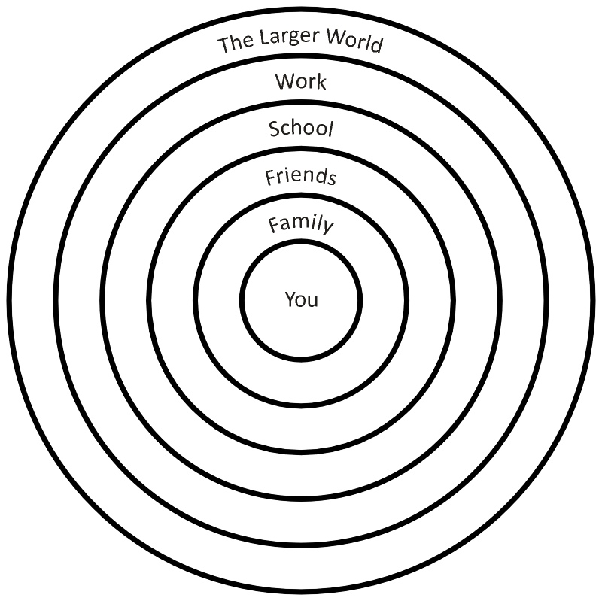

Activity: Conflict Resolution in the Workplace
Instructor Preparation
Conflict is a natural occurrence when two or more people work toward a common purpose and have the opportunity to express different viewpoints. Resolving conflicts allows movement toward achieving the desired purpose. A short activity cannot teach us how to resolve every conflict, but it is important to recognize the communication that does (or does not) occur in the midst of conflicts.
For most people even the word conflict is scary because of the emotional baggage that usually accompanies it. However, not all conflict is bad. Since no two people view the world exactly the same way, disagreement is normal. In fact, anyone who agrees with you all of the time is probably telling you what you want to hear, not what he or she actually believes.
This activity provides an opportunity to evaluate ways to approach conflicts and disagreements. Students will learn (and have fun) by role-playing the scenarios described on the handout.
Alternately, create scenarios from your career area involving fictional characters in typical disputes or miscommunications. Example: Coworkers disagree over who will get to take additional vacation days near a holiday. The scenario could provide relevant background information, such as which coworkers had already taken the most days off.
Objectives
Students will:
- Recognize conflict as a normal part of the workplace.
- Practice different styles of handling workplace conflicts.
- Identify forms of communication involved in conflicts.
Materials
- Scenario descriptions (see Handouts)
- Copy of one situation for all members of each group
Activity Guidelines
Divide the students into groups. Assign each group one handout (or instructor-created) scenario. The activity has three phases: 1) role-playing behaving badly, 2) role-playing behaving nicely (or professionally), and 3) post-game class discussion. One student in each group will be an outside observer and notetaker, but not a mediator. Ask the students to come up with their own resolutions to each scenario, without instructor hints.
- Each scenario should first be handled badly, where tensions and emotions escalate and the outcome is not productive.
- After a brief cool-down period, ask students to re-play the scenario, with the players having a more congenial and constructive attitude and, likewise, a more productive outcome.
- Each group should be prepared to discuss their outcomes and observations with the class afterwards, with an eye toward noting subtle forms of communication in each exchange.
Conflicts usually result from differences in personality, values, or perceptions. Watch for those in the scenarios that play out here. Acknowledge that there are no right answers, just better ones. Communication between the players, in all its aspects, is the key.
Group Reflection Questions
Vital to this activity is the discussion that occurs after the role-playing. Remember the objectives. Students need to 1) recognize conflict as a normal part of the workplace, 2) practice different styles of handling workplace conflicts, and 3) identify forms of communication that help resolve conflicts. For the last objective, in particular, students should be able to identify the subtle communications that occurred during each scenario—both spoken and unspoken.
- How do emotions and nonverbal communication (facial expressions, tone of voice, and gestures) affect conflict?
- Can nonverbal communications be controlled (i.e., can you fake it)?
- What does handling conflict in a professional manner look like?
Handout
Situation 1
Eric is a new stock clerk in a consumer electronics store and his job is to stock shelves. He has been on the job for only two weeks. Frances, who has been with the store for five years, works in the stockroom. Eric lets Frances know which items he needs to fill the shelves. However, Frances spends most of her time talking on the phone with her boyfriend rather than helping Eric find the cases he needs. This has happened repeatedly. What can Eric do?
Situation 2
Michelle has just been hired as the chief executive assistant at a bank. During her first week, Michelle noticed that the office assistants are very cool toward her. Shane, the office assistant assigned to orient her to the workplace, is almost hostile. Michelle learns that Shane had her job temporarily, while the bank interviewed prospective replacements. He even interviewed for the position, but Michelle landed the job. Michelle is on the verge of tears every day because of the constant hostility in the office. What can she do?
Situation 3
Harley’s supervisor continually asks him to prepare her coffee and to run personal errands for her during his lunch hour. She doesn’t mind if Harley returns late from lunch, as long as her personal errands are completed. What can Harley do?
Situation 4
Terra is a courier for a law firm. Because of heavy downtown traffic one day, she comes in late to work. Terra has been late to work three times this month for the same reason. Today her boss yells at her in front of all the paralegals, calling her lazy and saying her pay will be docked a full hour if she is even a minute late. Terra is embarrassed and angry. How can she respond?
Activity: Listening Accuracy for Tech Support
Instructor Preparation
It’s been said: “Listening is not the same thing as hearing.” Of course, listening requires focus, remembering, and, often, responding. One study reported that average adults spend almost 50% of their daily communication time listening. Most of the time it’s in casual conversation. But when it is workplace related, it can involve an important, even critical, exchange of information.
Phone calls to technical support or customer service require an accurate exchange of information between the customer and the service representative. For the communication to be reliable, both parties must listen attentively, record information accurately, and then interpret and act precisely to obtain the desired results. In this activity, students will respond to simulated telephone conversations containing important information, notice how well they listen, and consider ways to improve their skills.
Before the class meeting, duplicate and cut apart the telephone scripts in the handouts. Place sets of scripts in envelopes—one envelope per group. The scripts are to remain hidden from the group members until selected, one at a time, and read. The phone call transcripts cover a few representative career areas but could easily be supplemented with calls from other fields. Examples: In a finance program, a call to a credit card validation service; in human services, an inquiry to an employment agency about an advertised job opening; or for a law program, a call to a jury service clerk seeking a written excuse from jury duty
Objectives
Students will:
- Practice their listening skills.
- Evaluate their listening skills.
Materials
- Scripts of phone calls (cut from the handouts)—one of each per group, in a folder or envelope
- Answer sheets (cut from the handouts)—enough for each group member to have an answer sheet corresponding to each script
Activity Guidelines
Introduce this activity with a quick story. Suppose that, when you arrive home today, your brother says,
Oh, your friend Mary called. I think she said she will meet you at the corner of 4th Street and 3rd Avenue at 2 PM. Or maybe it was 2nd Street and 4th Avenue at 3 PM. I’m not really sure. Sorry. I didn’t write it down. In any case, she didn’t say what phone she had today.
The facts in this story make a big difference in whether you’ll ever meet Mary or not!
Hopefully students will do a better job of listening in this activity. Form groups of three or four students and distribute a packet of scripts to each group, with instructions not to open them yet.
Explain that scripts and answer sheets have been provided so that each group member can have a turn being the speaker. The speaker will select a script and read it while the others listen. After each listening session, the speaker should distribute the corresponding question slips. Students should then take a few minutes individually to complete the slips. Finally, the speaker can provide the correct answers and students can score themselves and write their number of correct answers on their question slip. The next student should then take a turn at being a speaker, repeating the process with a different script. When all the scripts have been read, reconvene the class for reflection and discussion. If needed, revisit each of the scripts until everyone is convinced of the correct answers.
Group Reflection Questions
- If you worked in a call center, what could you do to improve your listening skills? What could you do to help your customers improve their listening skills?
- Are there some parts of a conversation which should be considered essential? Nonessential?
- What message do you send when you have to ask the speaker to repeat the information? Is this bad or good?
- What role, if any, do emotions play in listening?
- Is it possible that your listening skills changed a little during this brief activity? In what way?
Handouts
Script 1: Customer Tech Support Call
Hello, my name is Chambers. That’s spelled with C-H. I purchased an Innova tablet two months ago, and now the screen is blank. It’s a model AirMax2. It has worked fine until yesterday. I have tried removing and reconnecting the battery, and I even replaced the battery with a new one. I have also tried all the troubleshooting tricks I can find on the web—with no results. I need the tablet to write and submit a research paper that is due in two days. What do I need to do?
The caller’s name:  __________________________  With what kind of device is there a problem?  __________________________  What model?  __________________________  What’s the problem?  __________________________  What did the customer do to try to fix it?  __________________________  Why the urgency?  __________________________  SCORE: | The caller’s name:  __________________________  With what kind of device is there a problem?  __________________________  What model?  __________________________  What’s the problem?  __________________________  What did the customer do to try to fix it?  __________________________  Why the urgency?  __________________________  SCORE: | The caller’s name:  __________________________  With what kind of device is there a problem?  __________________________  What model?  __________________________  What’s the problem?  __________________________  What did the customer do to try to fix it?  __________________________  Why the urgency?  __________________________  SCORE:

Script 2: Customer Complaint
Hello, is this the Rapid Transit Office? I have a problem. I think I need to speak with customer service. Last week when I tried to ride the number 6 bus from 42nd and Main to downtown, there was no place to insert my card. I complained to the driver. His name was Ricky, I think. He said they changed the system. Now I would have to download an app to my phone and pay by swiping the phone. My phone plan doesn’t give me data, just calling. So I had to walk 12 blocks in the rain. I called City Hall yesterday and spoke with someone named Ramona and she said I needed to call you. This is discrimination! What are you going to do take care of poor people who can’t afford fancy phones?
The caller’s name:  __________________________  What department was being sought?  __________________________  What was the complaint?  __________________________  What did the customer have to do?  __________________________  With whom has the customer already spoken?  __________________________  Who is Ricky?  __________________________  SCORE: | The caller’s name:  __________________________  What department was being sought?  __________________________  What was the complaint?  __________________________  What did the customer have to do?  __________________________  With whom has the customer already spoken?  __________________________  Who is Ricky?  __________________________  SCORE: | The caller’s name:  __________________________  What department was being sought?  __________________________  What was the complaint?  __________________________  What did the customer have to do?  __________________________  With whom has the customer already spoken?  __________________________  Who is Ricky?  __________________________  SCORE:

Script 3: Telemarketing Call
Good morning. Am I speaking with master of the house? Excellent! My name is Mario and I am happy to tell you that you have been selected to receive a free rug shampoo in one room of your home just for answering three quick survey questions today. Are you interested? Great! OK. Let’s get started! Did you know that the carpets in the average American household have not been cleaned in over 10 years? That’s right! So, how long has it been since you’ve had your carpet’s cleaned? What?! Never?! <laughing> Ha! Ha! Well, then this is your lucky day, because we’re going to clean one of your rooms absolutely free! We will do this with the Power-Vac seven-thousand, made by And-How Industries, one of the leading manufacturers of carpet cleaning machinery in the world. And-How Industries produces twelve different models of cleaners and has a complete line of detergent products guaranteed to leave your carpet looking like new.
The caller’s name:  __________________________  What free offer was made?  __________________________  What must you do in exchange?  __________________________  What did the caller claim?  __________________________  What device is being promoted?  __________________________  What is the model number?  __________________________  SCORE: | The caller’s name:  __________________________  What free offer was made?  __________________________  What must you do in exchange?  __________________________  What did the caller claim?  __________________________  What device is being promoted?  __________________________  What is the model number?  __________________________  SCORE: | The caller’s name:  __________________________  What free offer was made?  __________________________  What must you do in exchange?  __________________________  What did the caller claim?  __________________________  What device is being promoted?  __________________________  What is the model number?  __________________________  SCORE:

Script 4: Medical Lab Report
Hello, Mrs. Sicker? This is Rosa from Doctor Weller’s office. I have the results of your lab work from yesterday’s office visit. Everything looked pretty good, but Doctor Weller has a few concerns. Your red blood cell count was normal, but your white cell count was a little elevated. That suggests that you might have an infection. Since you just recovered from that bad cold last week that could explain it, so the doctor will not prescribe any new medications at this time. However, he is more concerned about the fat count. Although the normal range is between 120 and 140, your reading of 160 is too high. He wants you to start taking two doses of the red and white pills each day, starting tomorrow. And be sure to drink a whole glass of water with those pills.
The caller’s name:  __________________________  From what company?  __________________________  When was the office visit?  __________________________  What was wrong with the white cell count?  __________________________  What was your fat count?  __________________________  What did the doctor change?  __________________________  SCORE: | The caller’s name:  __________________________  From what company?  __________________________  When was the office visit?  __________________________  What was wrong with the white cell count?  __________________________  What was your fat count?  __________________________  What did the doctor change?  __________________________  SCORE: | The caller’s name:  __________________________  From what company?  __________________________  When was the office visit?  __________________________  What was wrong with the white cell count?  __________________________  What was your fat count?  __________________________  What did the doctor change?  __________________________  SCORE:

Activity: Preparing Presentations
Instructor Preparation
Almost anyone involved in business or education will make presentations. It might be a five-minute summary to a few people sitting around a table, or a one-hour delivery to a large, full auditorium. In any case, preparation is the essential ingredient for a successful presentation. This activity outlines one strategy for being prepared. It is beyond the scope of one activity to actually assemble and polish the presentation, so this activity is confined to the planning phase.
We’ve offered a typical scenario that students can appreciate, but it can be adapted for a specific career field. For example:
- In Health Sciences, a CPR instructor is notified of a new set of protocols for the corporate training program. A 15-minute presentation will be delivered to summarize the changes to the executive staff of several client companies.
- A Quality Circle Team is ready to unveil their new process for assembling the T-Frame. The team is scheduled to make their presentation at the next weekly meeting of Manufacturing Management.
- The Starry Skies Travel Agency has been invited to present their Summer Cruise programs to the Ladies Guild as part of Tourism Week.
Objectives
Students will prepare for a presentation by:
- Analyzing the audience characteristics
- Listing the desired outcomes
- Evaluating the delivery options, based on various circumstances
Materials
- Handout−Presentation Planning Checklist
Activity Guidelines
Prepare the class by first working together through this sample scenario. Read the scenario to the class:
Imagine that you are employed as an information technology (IT) specialist. Your company’s chief financial officer (CFO) asks you to research collaboration software that will enable your company to improve in-house communication, file sharing, video meetings, and data storage. After you research functionality, cost, and ease of use, you report to the CFO that the best solution is Program X, even it is more expensive than comparable programs.
Referring to the sample scenario, pose the following questions to the class. See the suggested answers following each question.
- Thinking about the presentation to be prepared for this assignment, who is the audience? (The CFO who requested the research.)
- Might the presentation also be used for a secondary audience? How would that audience differ from the primary audience? (Yes, the information probably will be shown to others and administrative staff who will need more supporting background information than the CFO.)
- Thinking about the delivery medium, will a PowerPoint presentation be appropriate for this audience, or must it be “low-tech” (flip charts and handouts)? (A computer presentation is appropriate for almost any audience, if technology is available.)
- Are there any limitations on media, such as colors, sounds, and animations? (Probably not in this case, but the subject matter may not call for video and audio.)
- What is the desired outcome of this presentation? (The presentation will convey the research findings about the pros and cons of available programs and the justification for recommending Program X. Ideally, the listeners will agree with the selection.)
- What kinds of information do you need to achieve the desired outcome? (The presentation needs to contain the most relevant facts from the research, but not every detail of the research, i.e., no details of unproductive research.)
- How can you communicate the information? (Side-by-side lists provide good comparisons of features, as long as they are not too text dense. These could be bulleted lists. Bar charts are good for comparing relative magnitudes. Pie charts are good for comparing percentages, like the market share or customer loyalty of different brands. Short marketing video clips may serve to show the attractiveness of a product.)
- Should the presentation run automatically or with user intervention? (Since there will likely be questions along the way, the presentation will be best if slides are advanced manually. Later, a repackaged version that runs automatically could be created to present the new system.)
- How could the presentation be salvaged if the electronic delivery fails? (The PowerPoint slides can be printed as handouts.)
Develop one or more new career-specific scenarios comparable to the example in the Instructor Preparation notes above. Now, distribute copies of the Presentation Planning Checklist and describe a scenario for students to use in completing the checklist.
Group Reflection and Application
Ask students to discuss and compare the results of their checklists in small groups or as a class. If time and relevancy permit, students can take the assignment to the next level and outline or storyboard (frame-by-frame rough sketch) their presentation.
Handout—Presentation Planning Checklist
Primary Audience  Age bracket ___________ Gender  Occupation  Experience  Other  Other  Style of learning  Visual Other  Auditory Mixed  Hands-on Impaired  Secondary Audience(s)  Age bracket  Gender  Occupation  Experience  Other  Other  Style of learning  Visual Other  Auditory Mixed  Hands-on Impaired  Miscellaneous  Yes – No Incorporate all audiences into one presentation?  Number of presentations required  Single delivery _____ Multiple deliveries  If you need to create separate presentations for different audiences, what styles will be used? | Elements  Bulleted lists Hyperlinks  Tables Photos  Quotations Videos  Graphs/Charts Sounds  Presentation Conditions  Primary Audience, Single Delivery  Room size: Large – Medium – Small  Computer w/ projector  Overhead  Web/Kiosk  Primary Audience, Multiple Delivery  Room size: Large – Medium – Small  Computer w/ projector  Overhead projector  Kiosk displaying website  Secondary Audience, Single Delivery  Room size: Large – Medium – Small  Computer w/ projector  Overhead projector  Kiosk displaying website  Secondary Audience, Multiple Delivery  Room size: Large – Medium – Small  Computer w/ projector  Overhead projector  Kiosk displaying website  Media Types for Primary Audience  PowerPoint presentation with facilitator  Automated slide show/Kiosk  Handouts ______ Notes  Website ______ Mixed  Other:
Activity: English for Business
Instructor Preparation
People who interview prospective employees will tell you that relatively few applicants are adequately prepared to use standard business English in the workplace. Errors in grammar, spelling, usage, and punctuation on job applications and résumés often disqualify job applicants. Many students seeking employment do not have the language skills required by employers. Students need to understand that competence in oral and written English is vital to their success.
One activity cannot remedy a lifetime of poor language use, but it can make students more aware of the types of errors that creep into oral and written communication, as well as the word processing tools that can help smooth out some of the rough edges.
Duplicate the two sample letters included as handouts for this activity.
Depending on the demands of a particular course or career field, this activity can be taken to different levels, as described in the following options:
- Option 1: Have students proof the letters in the handouts. They could practice drafting a letter of inquiry to a prospective employer, seeking a job and introducing their qualifications and prior job experience. They could also prepare for a face-to-face job interview by creating an outline of relevant facts likely to be required during an interview.
- Option 2: In addition to proofing the handout letters, students should draft a letter of application to a prospective employer in response to an advertised job opening. They should include a brief description of their qualifications and prior job experience, and should create and attach a résumé.
- Option 3: For English, office systems technology (OST), or business writing courses, in addition to proofing the handout letters in class, students should correct the letters and rewrite them. They should also draft a letter of application, similar to that described above.
Remind students to use their software’s spelling and grammar checkers, keeping in mind that those tools do not guaranty error-free writing. They will still need to proof carefully.
Objectives
Students will:
- Analyze and reword written communications according to accepted business English standards.
- Demonstrate proficiency in proofreading their own work and using a spelling and grammar checker.
Materials
- Handouts 1 and 2: Sample letters for proofing
Activity Guidelines
Although this activity addresses spelling and grammar, students will not be graded as if they were in an English language classroom—unless it is an English language classroom. The message to be conveyed here is that using correct business English is essential for a successful career.
Use Handout 1 in a class discussion as an ice-breaker. This letter is so obviously poor that everyone will have a good laugh before tackling Handout 2—the more serious attempt. Nevertheless, Handout 1 provides many opportunities to discuss practices to avoid.
Students should examine Handout 2 individually or in small groups before discussing it as a class. Ask students to circle the problem words or phrases and indicate in the margins the changes they would recommend.
After a few minutes of small group discussion, bring everyone back together and compare the findings to see if anyone has found an error that others have overlooked.
Clearly, the chances of the two sample letters being well received are slim. Reinforce that good English, both oral and written, is essential to workplace success.
Optional Extension: As time and resources permit, have students compose a letter introducing themselves to a prospective employer and seeking an advertised job position—similar to the handouts of this activity. Online or classified job listings can be used as writing prompts. Here are suggested minimal requirements for the letter:
- Biographical information: name, age, and contact information
- Relevant educational background
- Employment experience
- Awards and recognition for outstanding achievements, both job-related and personal
- Aspirations and goals
The best letters will demonstrate careful selection of relevant facts and meaningful aspirations but will not include a complete autobiography. Students should also spell-check and grammar-check their finished letter and document examples of how the word processor corrected typos, misspellings, grammar mistakes, punctuation errors, and so on. Are the results reliable or did the computer spelling and grammar checkers incorrectly suggest changing something? Be sure students realize that there is no shame in finding mistakes. It’s the final version that counts!
Group Reflection Questions
Is it acceptable to speak and write differently in the business environment than at home or with friends?
(Answer: Yes. Just as we dress and behave differently for solemn occasions and casual events, we also use speech and written communication styles in the workplace that are different from our natural, informal speaking and writing styles.)
Handout 1—Memo to Mr. Taylor
M E M O R A N D U M
DATE: March 10
TO: Mr. Taylor
FROM: Mr. Winters
RE: Update?
Dude, some update. Your department are always to little to late. I’m sick and tired of the slow service. It stinks. Those sound card shoulda been installed months ago. And only 5 laptops, that,ll do a whole lotta good for 100 people. Get a bigger server for crying out loud!!!!!!!! Everytime I turn around your asking me to clean files. I feel ilke a stupid maid. Your the dingbat.

Handout 2—Letter with Application
January 28, 2021
Workplace, Inc.
123 Park Avenue, 7th Floor
York, NY 12345
Attn: Personnel
Dear Sir or Madam:
I am a graduated from Taco College, minor computer science. I have enclosed my resume for your perusal.
During my job search and reviewing information about computer businesses, I have locate your address from a website and took the liberty of forwarding my resume. The experience that I need to enhance my career in the field of computer science has been comprehensive. Considering my self-esteem, self motivation, and self-reliance, I will be glad to discuss in detailing with you.
If you should have any available opportunities or should no of any lending opportunities plaese call me at 987-654-3210 or send brochures to my address.
Thank you for your time and consideration, and look forward of hearing from you soon.
Sincerely,


Assessment Tools/Strategies
This section includes specific strategies and instruments for assessing students’ communication knowledge, skills, and attitudes.
Rubrics
Rubrics are valuable assessment tools. Students should be provided with the rubric by which they will be assessed before an activity begins so they will understand the performance expectations. When time permits, students can contribute to the rubrics by brainstorming with the instructor about what a quality behavior or product looks like. For example, before assigning a team project to research a topic and prepare a group presentation, ask students to describe how the ideal team would handle the assignment, i.e., how they would assign roles, divide the work, and create and deliver the presentation. Prompt students with specific components. Then have them describe a poor performance. These will be the descriptions of the characteristics for the highest and lowest ends of the Likert scale for each performance criterion. Instructors should add any required attributes to the rubric if the students do not come up with them on their own. Several communication evaluation rubrics have been provided as examples.
- The first four communication rubrics cover communication content, oral and written communication, and listening skills and include spaces where the instructor can insert additional attributes to tailor the rubric to a specific project or activity. It was developed to be used by the instructor or other observer who will be assessing a student.
- The next two communication rubrics are self-ratings for use by students. The students indicate the degree to which they think they are performing each attribute. They can periodically return to the rubric to reassess and determine whether they are improving those skills.
- The final rubrics are the most complex. The student completes a self-rating rubric as in the second type, but is asked to provide examples to support his/her ratings. Then the student meets with the instructor or peer observer and compares his/her reflections with the instructor’s or peers’ observations and formulates an action plan for improving attitudes, behaviors, or skills. This type of rubric most resembles the type of assessment an employee might receive on the job. It is also the most time-consuming. Ideally, this rubric would be used at least three times during a course:
- At the beginning of the course, to get a baseline and to give students suggestions for specific actions they might take to improve their performance,
- At the midpoint of the course, to check progress and refine the recommendations for improvement, and
      - At the end of the course, to assess the progress made over the duration of the course. Additional suggestions can be made for students’ continued growth beyond the end of the course.
Rubrics for Instructor Assessment
Outcome: Communication Content – Determine content of communication based on purpose and audience. Select and interpret appropriate references. Identify the appropriate format for communication. Convey information to audience according to accepted practices.

Assesses audience and matches topic to audience needs. | 1 2 3 4 5
Displays sensitivity to cultural differences of a diverse audience. | 1 2 3 4 5
Speaks and understands audience-appropriate terminology. | 1 2 3 4 5
Chooses relevant and current information. | 1 2 3 4 5
Documents print and electronic sources. | 1 2 3 4 5
Organizes and maintains information. | 1 2 3 4 5
Matches information to usable data. | 1 2 3 4 5
Converts information into the appropriate format. | 1 2 3 4 5
Conveys information in a clear, courteous, concise, and correct manner. | 1 2 3 4 5
Delivers information from key ideas connecting relationships between and among elements of a topic. | 1 2 3 4 5
 | 1 2 3 4 5
 | 1 2 3 4 5
 | 1 2 3 4 5

5 | Always | Excellent
4 | Most of the Time | Good
3 | Sometimes | Adequate
2 | Occasionally | Fair
1 | Never | Poor or None
Outcome: Oral Communication – Demonstrate knowledge of the topic, organized in a logical manner and delivered with confidence using effective verbal and nonverbal techniques. Monitor and adjust delivery according to perceived reception, providing response to feedback from the audience as appropriate. Use equipment that supports the purpose of the presentation.

Demonstrates knowledge of the topic. | 1 2 3 4 5
Organizes topic in format suitable to the audience and situation. | 1 2 3 4 5
Organizes topic to convey the central idea or theme with critical points emphasized. | 1 2 3 4 5
Demonstrates interpersonal skills with sensitivity to cultural differences. | 1 2 3 4 5
Presents a confident, professional image through diction, voice quality, vocabulary selection, and style of delivery. | 1 2 3 4 5
Identifies point of view of the audience. | 1 2 3 4 5
Provides opportunities for an audience to gather information by inviting questions and listening to praise or constructive criticism. | 1 2 3 4 5
Observes audience’s nonverbal messages. | 1 2 3 4 5
Responds in an objective, appropriate, and courteous manner to resolve differences of opinion. | 1 2 3 4 5
Reflects on and evaluates the delivery of communication. | 1 2 3 4 5
Uses equipment and software programs to generate visuals and handouts to support the oral communication when appropriate. | 1 2 3 4 5
 | 1 2 3 4 5
 | 1 2 3 4 5
 | 1 2 3 4 5

5 | Always | Excellent
4 | Most of the Time | Good
3 | Sometimes | Adequate
2 | Occasionally | Fair
1 | Never | Poor or None
Outcome: Written Communication – Use standard practices for written communication to organize information in the necessary format to achieve a clear objective. When appropriate, use the writing process: prewriting, drafting, proofreading, editing, and revising.

Selects a format based on the target audience and the information to be communicated. | 1 2 3 4 5
Uses an outline to organize ideas into a cohesive presentation pertinent to the stated objective. | 1 2 3 4 5
Exercises brainstorming techniques in the prewriting stage to accumulate ideas that should be communicated. | 1 2 3 4 5
Discards ideas and content deemed unnecessary or not supportive of the objective. | 1 2 3 4 5
Writes a rough draft from the outline. | 1 2 3 4 5
Proofreads the draft to correct spelling and grammar errors. | 1 2 3 4 5
Edits and revises the proofed text to refine the expression of the ideas. | 1 2 3 4 5
Uses word processing to produce a formatted document. | 1 2 3 4 5
Uses word processing tools to yield an error-free document. | 1 2 3 4 5
 | 1 2 3 4 5
 | 1 2 3 4 5
 | 1 2 3 4 5

5 | Always | Excellent
4 | Most of the Time | Good
3 | Sometimes | Adequate
2 | Occasionally | Fair
1 | Never | Poor or None
Outcome: Listening – Develop and practice active listening skills including identification of speaker’s major points, focusing on speaker’s message rather than listener’s response, and discrimination between fact and opinion. Use appropriate note-taking techniques. Overcome communication barriers by treating the speaker with courtesy and respect. Seek clarity of communication by rephrasing statements and asking questions.

Assesses an audience or speaker in a social situation. | 1 2 3 4 5
Selects conversation and behavior style according to the situation. | 1 2 3 4 5
Pays attention to given information, directions, and specific details. | 1 2 3 4 5
Interprets and evaluates content to identify facts and opinions. | 1 2 3 4 5
Checks to verify interpretation of message rather than making assumptions about understanding. | 1 2 3 4 5
Takes notes or completes forms based on listening and reading information relevant to the situation. | 1 2 3 4 5
Records major points and specific details. | 1 2 3 4 5
Supports the speaker by practicing attentive listening and adapting behavior accordingly. | 1 2 3 4 5
Seeks clarity of communication by rephrasing concepts and asking questions. | 1 2 3 4 5
Makes use of verbal and nonverbal information. | 1 2 3 4 5
 | 1 2 3 4 5
 | 1 2 3 4 5
 | 1 2 3 4 5

5 | Always | Excellent
4 | Most of the Time | Good
3 | Sometimes | Adequate
2 | Occasionally | Fair
1 | Never | Poor or None
Rubric for Self-Assessment of Communication Skills
Use this instrument throughout the course to self-monitor your communication skills. Note: It is fairly common to overrate your skills during the initial assessment. You may rate yourself a bit lower as you get feedback from others and discover the complexities of each attribute. By the end of the course you should see improvements in your ratings if you focus on improving the quality of your oral and written communication and interpersonal behaviors.
Objective: Communicate effectively with others in conversation.
Essential Attribute | I | II | III | IV
I maintain eye contact with the other person(s) while speaking and listening. | Seldom | Sometimes | Usually | Consistently
I use appropriate gestures and body language to communicate my interest and engagement in the conversation. | Seldom | Sometimes | Usually | Consistently
I convey constructive attitudes and beliefs to further the conversation. | Seldom | Occasionally | Often | Consistently
I speak clearly and professionally, using vocabulary appropriate to the occasion. | Seldom | Sometimes | Usually | Consistently
I listen to and respect others’ points of view and positions. | Seldom | Sometimes | Usually | Consistently
I avoid interrupting others. | Seldom | Sometimes | Usually | Consistently
I pause a moment after others finish speaking. | Seldom | Sometimes | Usually | Consistently
I can briefly rephrase in my own words what others have said, as evidence that I have understood their point(s). | Seldom | Sometimes | Usually | Consistently

Objective: Communicate effectively with others in writing.
Essential Attribute | I | II | III | IV
I write with a clear purpose, not straying off topic. | Seldom | Sometimes | Usually | Consistently
I use a word processor including the spell-checker and grammar-checker. | Seldom | Sometimes | Usually | Consistently
I avoid the use of jargon and unnecessarily long sentences. | Seldom | Sometimes | Usually | Consistently
I use numbering and bulleted points rather than very long paragraphs. | Seldom | Sometimes | Usually | Consistently
I observe professional business etiquette and manners in my work-related communications. | Seldom | Sometimes | Usually | Consistently
I proofread my writing before any final action to avoid obvious mistakes. | Seldom | Sometimes | Usually | Consistently
Rubric for Assessing Interpersonal Skills
Plan for Developing Appropriate Self-Expression Skills – Demonstrate self-expression skills appropriate to a variety of situations. This includes the ability to express feelings, reactions, ideas, and opinions while also demonstrating active listening skills.

Performance Criteria
Reflection  Reflect on your actions during class or at a workplace and identify examples of when you: |  | Personal Plan  Based on your examples and the feedback of your peers or instructor, describe the steps you might take to continue or improve your self-expression.
Used interpersonal skills assertively and appropriately to express your feelings, reactions, ideas, opinions, wants, and needs. | Example:  Peer / instructor review: | Steps:
Used active listening skills as a way to show positive self-expression. | Example:  Peer / instructor review: | Steps:
Recognized the requirements of the situation and tailored your expressions accordingly. | Example:  Peer / s instructor review: | Steps:
Orally communicated with others in a clear and organized manner. | Example:  Peer / instructor review: | Steps:
Communicated information clearly in writing. | Example:  Peer / instructor review: | Steps:
Listened attentively to others. | Example:  Peer / instructor review: | Steps:

Peer comments and suggestions:
Instructor comments:
Plan for Developing Conflict Management Skills – Negotiate work and personal demands in such a way that promotes effective time and stress management techniques. Demonstrate techniques in conflict prevention and conflict resolution. This includes demonstrating communication skills that comprise negotiation, group decision-making, and consensus-building.
Performance Criteria
Reflection  Reflect on your actions during class or at a workplace and identify examples of when you: |  | Personal Plan  Based on your examples and the feedback of your peers or instructor, describe the steps you might take to continue or improve your intrapersonal and interpersonal management skills.
Used your communication skills to avoid, minimize, prevent, or solve conflicts. | Example:  Peer / instructor review: | Steps:
Used problem-solving skills to avoid, minimize, prevent, or solve conflicts. | Example:  Peer / instructor review: | Steps:
Used negotiation skills to solve a conflict or problem. | Example:  Peer / instructor review: | Steps:
Participated in a decision process that led to a reasonable compromise and consensus. | Example:  Peer / instructor review: | Steps:

Peer comments and suggestions:
Instructor comments:

Plan for Adapting Interpersonal Skills – Display the ability to adjust behavior as appropriate to the dynamics of the situation, listening and responding with empathy and respect for the rights of others. This includes making judgments about the appropriate behavior in a working environment that includes customer and staff relationships. It also includes the ability to listen to colleagues, supervisors, and customers and respond appropriately and empathetically.
Performance Criteria
Reflection  Reflect on your actions during class or at a workplace and identify examples of when you: |  | Personal Plan  Based on your examples and the feedback of your peers or instructor, describe the steps you might take to continue or improve your workplace interpersonal skills.
Adjusted your behavior to fit the situation. | Example:  Peer / instructor review: | Steps:
Recognized, felt, or acted with empathy for others. | Example:  Peer / instructor review: | Steps:
Recognized and evaluated the appropriateness of your behavior in the presence of a customer. | Example:  Peer / instructor review: | Steps:
Gave or received peer feedback. | Example:  Peer / instructor review: | Steps:
Worked as a member of a productive team. | Example:  Peer / supervisor review: | Steps:

Peer comments and suggestions:
Instructor comments:
Videos and Weblinks
Videos
The following is an annotated list of videos that are available at the links provided. You may choose to use these in class to give additional background on communication skills, as scenarios to kick off a discussion, as examples of effective or ineffective communications, and so forth.
http://youtu.be/K15ca0n0ois
10 tips for Effective Communication by Integration Training
Weblinks
Here are some links relevant to this module that may be useful.
http://www.mindtools.com/pages/article/newCS_99.htm
“How Good Are Your Communication Skills?” A 15-question test, immediately scored with good feedback provided.
http://www.wikihow.com/Develop-Good-Communication-Skills
A comprehensive list of tips for good communication, such as appropriate eye contact, gestures, body language, and so forth.
http://stress.about.com/od/relationships/ht/healthycomm.htm
Improving your chances for a positive outcome when conflict arises.
http://www.optimalthinking.com/quiz-communication-skills.php
Communication Skills Assessment Quiz

