NC-NET Employability Skills Resource Toolkit
Module 1: Interpersonal Skills and Teamwork
Overview of Teamwork in the Classroom 2
Presentation Materials 3
Teaching Resources 13
Activity: How Groups Work 14
Activity: Planning Group Research 20
Activity: Presenting a Group Report 22
Introduction to Team Development and Function 25
Activity: Team Development and Function—Forming, Part 1 27
Activity: Team Development and Function—Forming, Part 2 29
Activity: Team Development and Function—Storming, Think-Pair-Share 30
Activity: Team Development and Function—Norming and Performing 32
Activity: When Your Team Breaks Down 33
Assessment Tools/Strategies 42
Rubrics for Assessing Teamwork 43
Rubrics for Self-Assessment of Teamwork Skills 49
Rubrics for Improving Teamwork 51
Videos and Weblinks 56
Videos 56
Weblinks 56

Overview of Teamwork in the Classroom
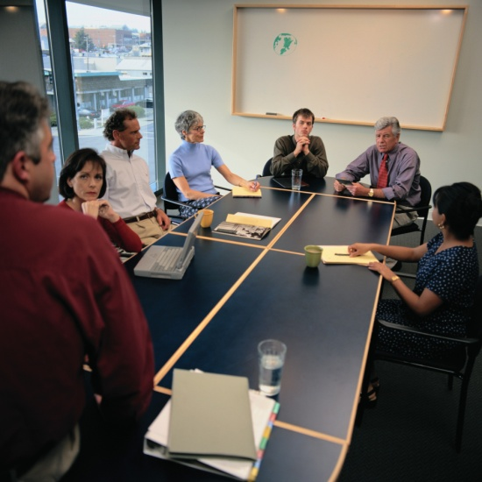
Many students (and their instructors) worry when they hear the word teamwork. Their experience with working in groups may have been a negative one in which team members shirked responsibility and left others to do the work. This can be remedied through careful structuring of collaborative learning assignments. Collaborative learning is essentially teamwork, the topic of this module. The skills necessary for successful teamwork are not innate; they must be taught and modeled. Instructors should not assume that students come to class equipped with these skills.
The presentation materials for this topic provide students with an overview of the behaviors expected of team members and of the normal stages of team development. Some students may be surprised to learn that conflict is an expected part of the process. Others may be unaware that they dominate discussions and interrupt when colleagues are speaking. Before beginning team assignments, instructors may wish to conduct student role-play of conflict resolution, respectful speaking and listening, or other behaviors essential to positive group dynamics.
In addition to expectations for positive interpersonal communication, students must clearly understand the outcomes (products) they are expected to generate. Instructors should be very specific, particularly with novice team members who are unaccustomed to selecting their own accountability measures. As students become used to team processes, more responsibility for decision-making should be assigned to them.
There are assessment tools following the classroom activities on teamwork. The rubrics can be used as observation checklists, peer evaluations, or student self-evaluations. In addition, there are “Team Member Performance Plans” designed to help students reflect on their individual contributions as team members, compare their reflections with their instructors’ or peers’ observations, and formulate action plans for improving attitudes, behaviors, or skills.
Presentation Materials
 | SLIDE | TEACHER NOTES
1
2 | 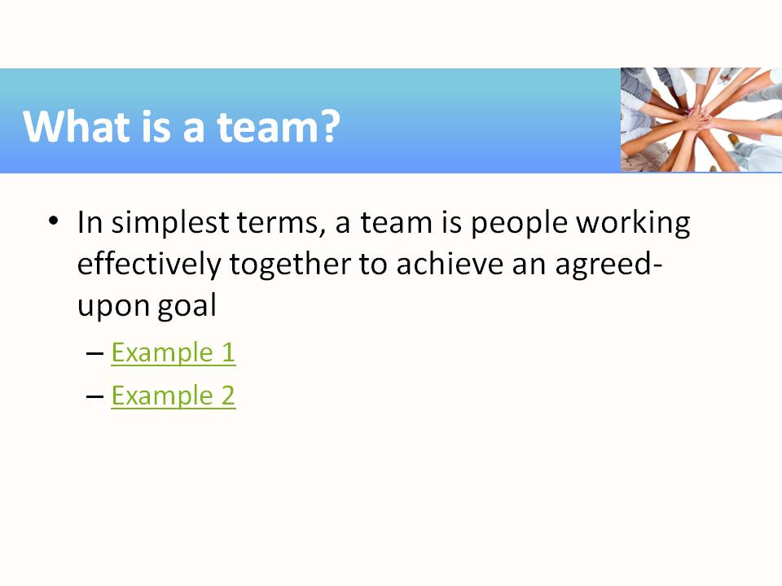 | Note the important components of this simple definition: together, effectively, agreed-upon, and goal.  Example 1 is a link to a YouTube video of an advertisement for public transportation. In it, penguins work together to defeat a predator. Ask students to name the components of teamwork illustrated by the video.  Example 2 is a link to a YouTube video of the Pilobolus dance troupe. In it, members of the troupe work together to create amazing shadow images. Again, ask students to name the components of teamwork illustrated by the video.
3 | 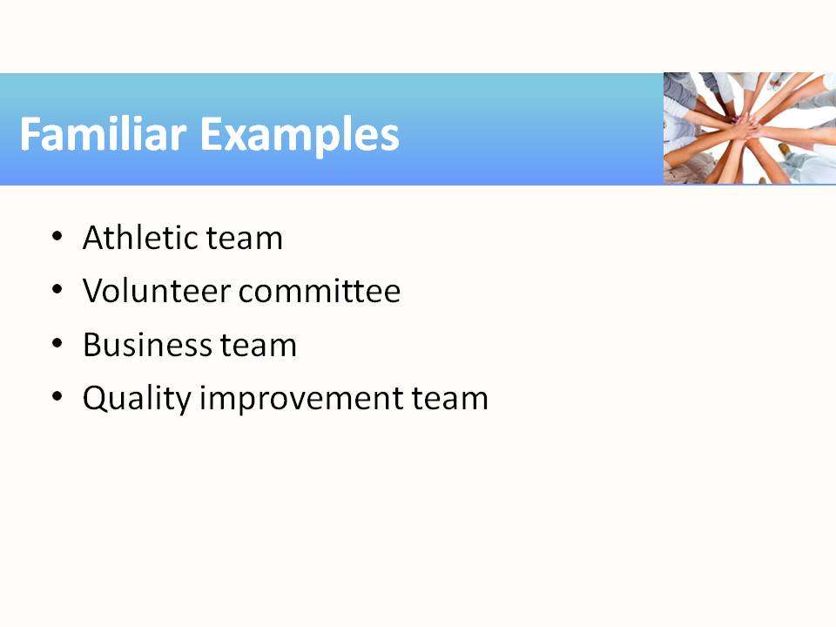 | Discuss the formal/informal nature of these types of teams—some may be both. What are the goals of these example teams?
4 | 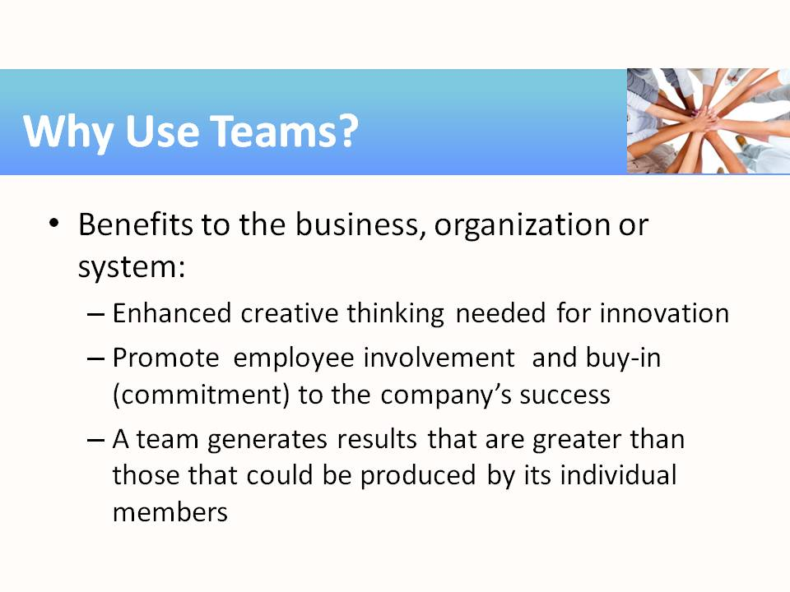 | Employee involvement leads to employee commitment to the success of the project (emotional and intellectual investment in the success of the business and potentially greater employee job satisfaction and less employee turnover).
5 | 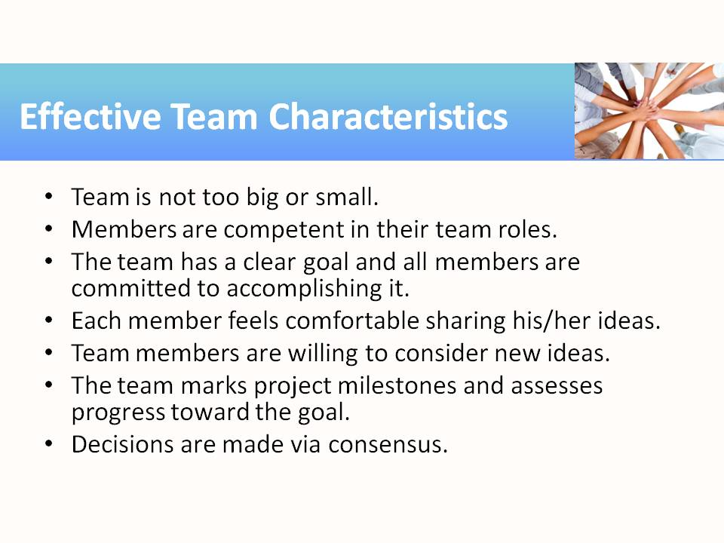
6 | 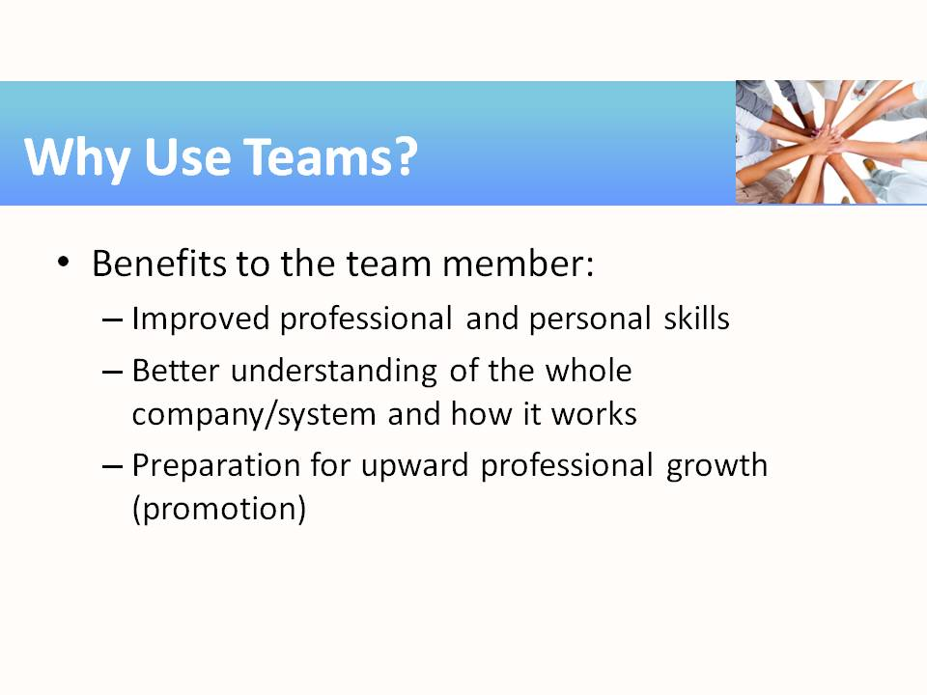 | Team member = employee  Learning how to be an effective team member (and leader) allows employees to practice and demonstrate some of the skills needed for success in the workplace. There are very few jobs that allow employees to work individually with input from only a supervisor or client.  On a personal level, communicating and negotiating with team members from other units in the company (or other academic disciplines) allows employees to practice not only their verbal communication skills but also listening and critical thinking.
7 | 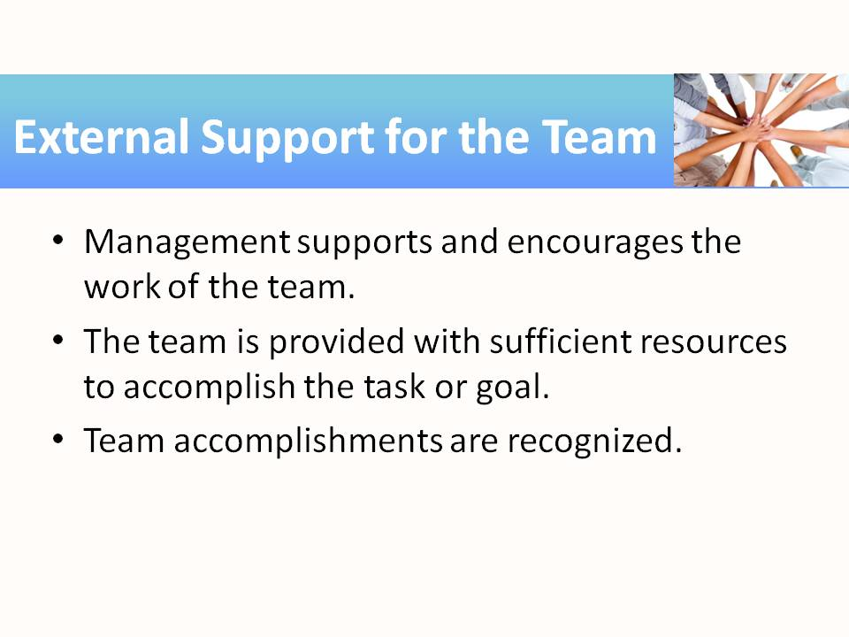
8 | 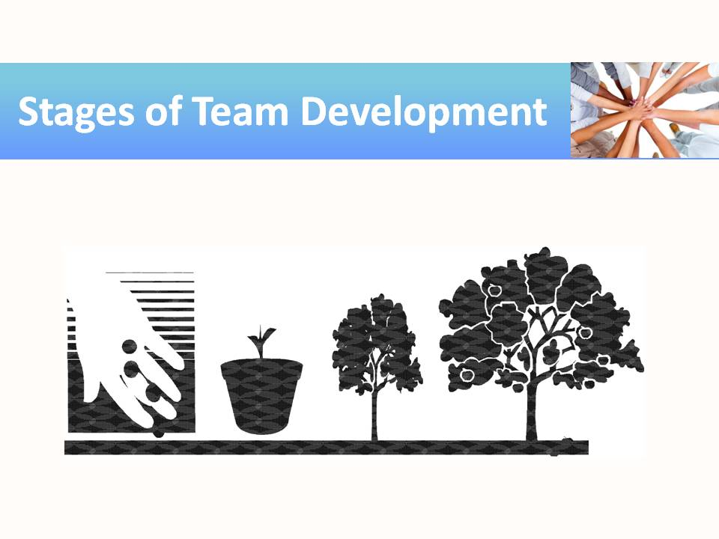
9 | 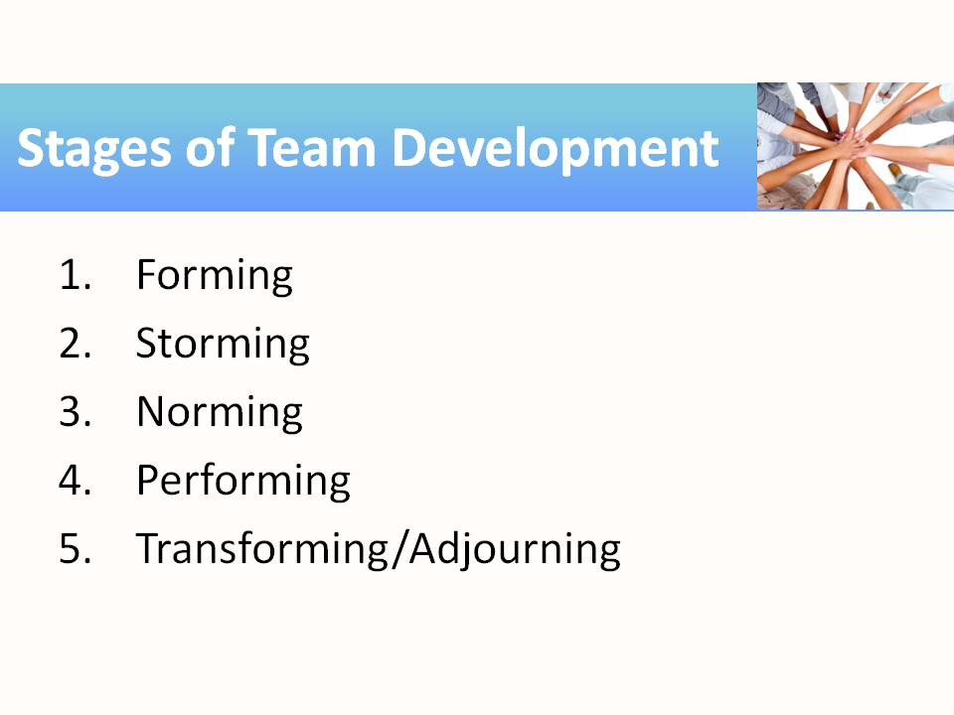
10 | 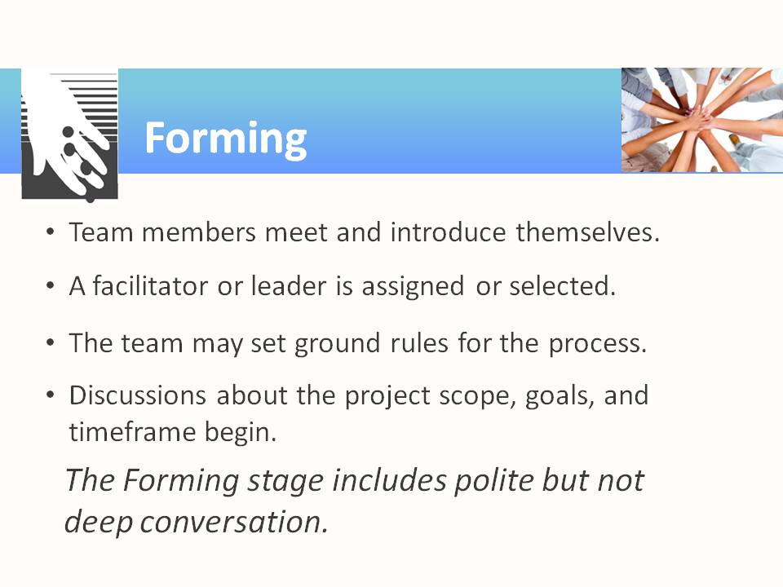
11 | 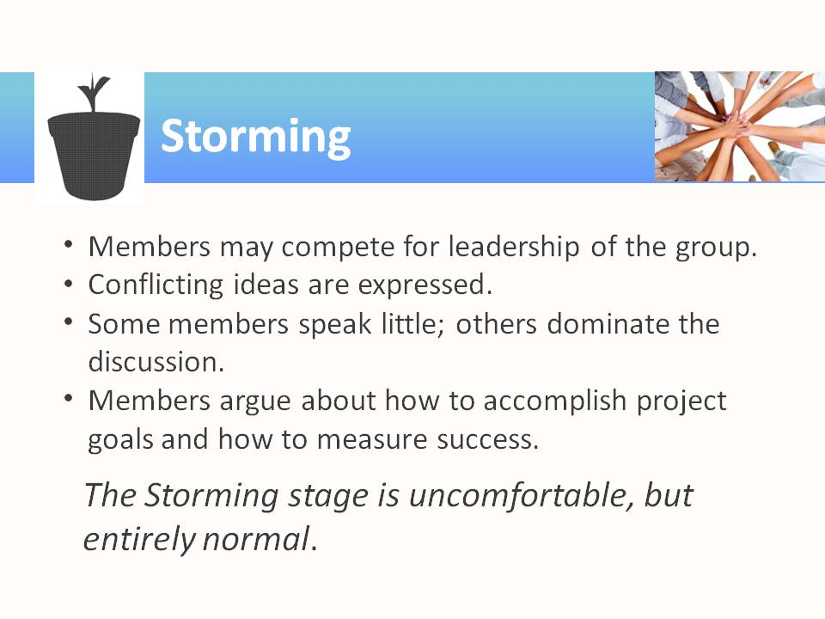
12 | 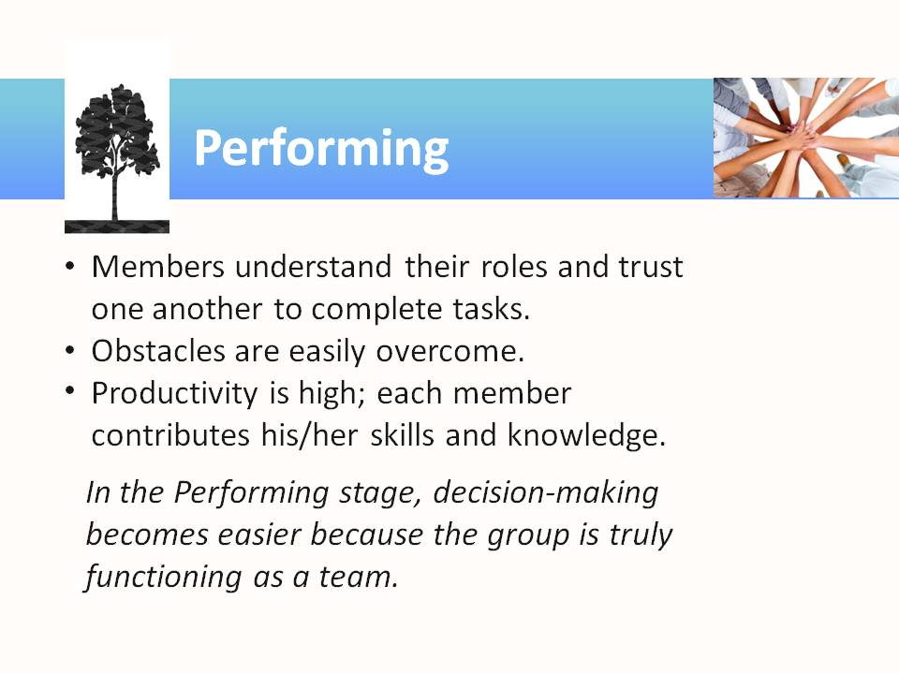
13 | 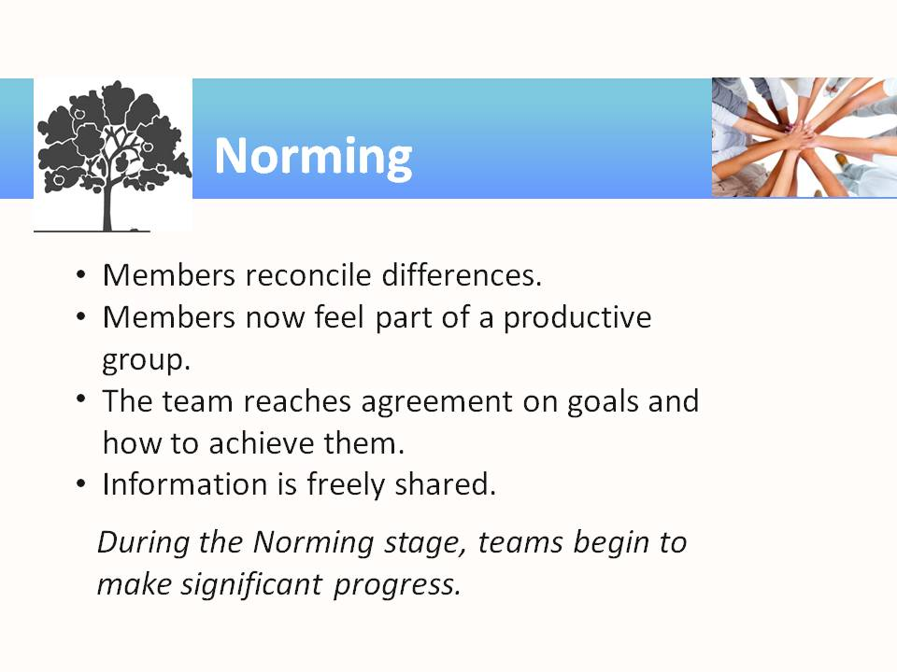
14 | 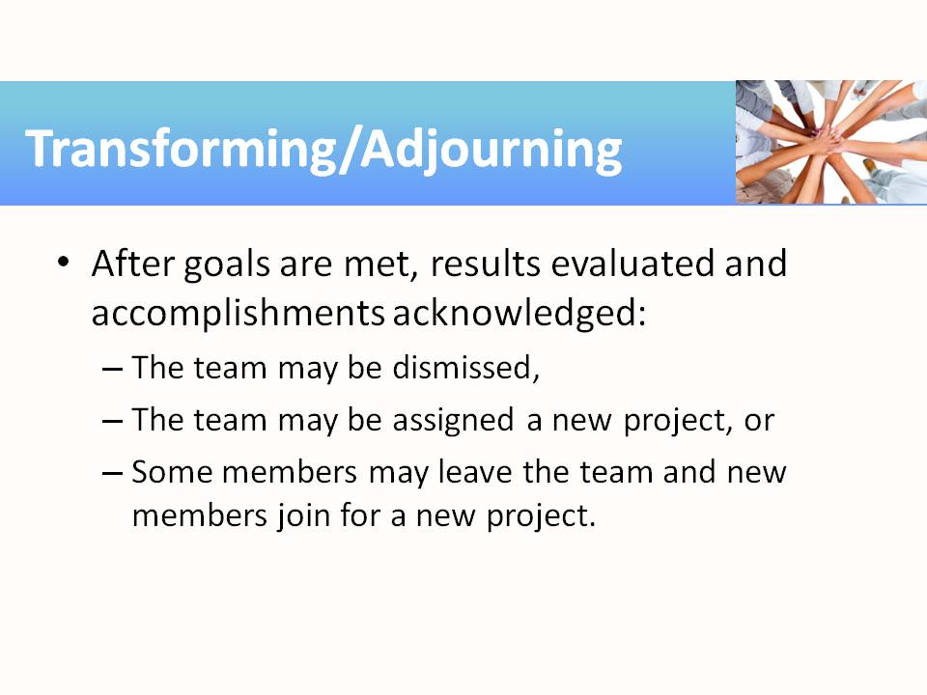
15 | 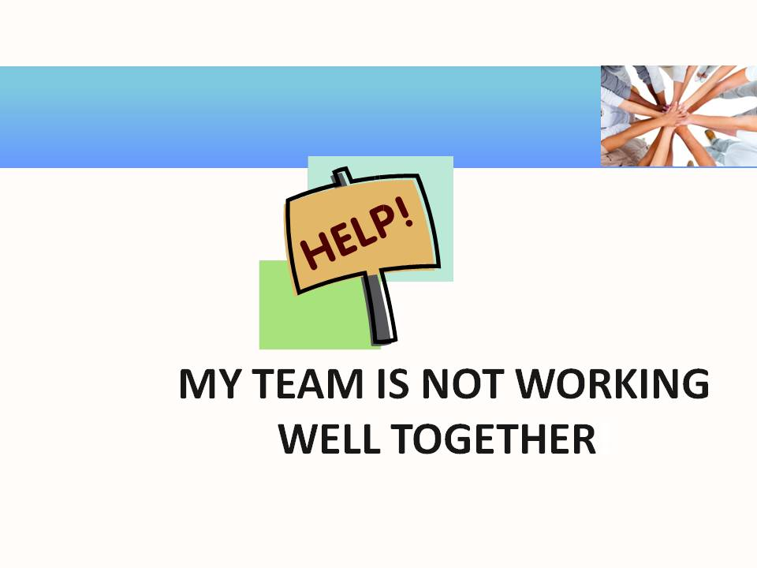
16 | 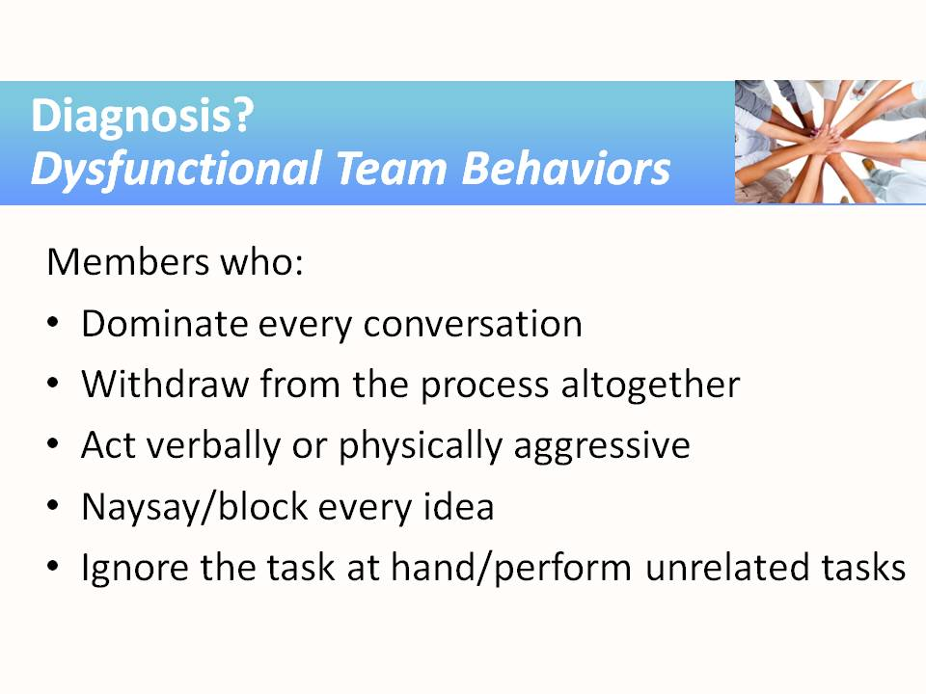
17 | 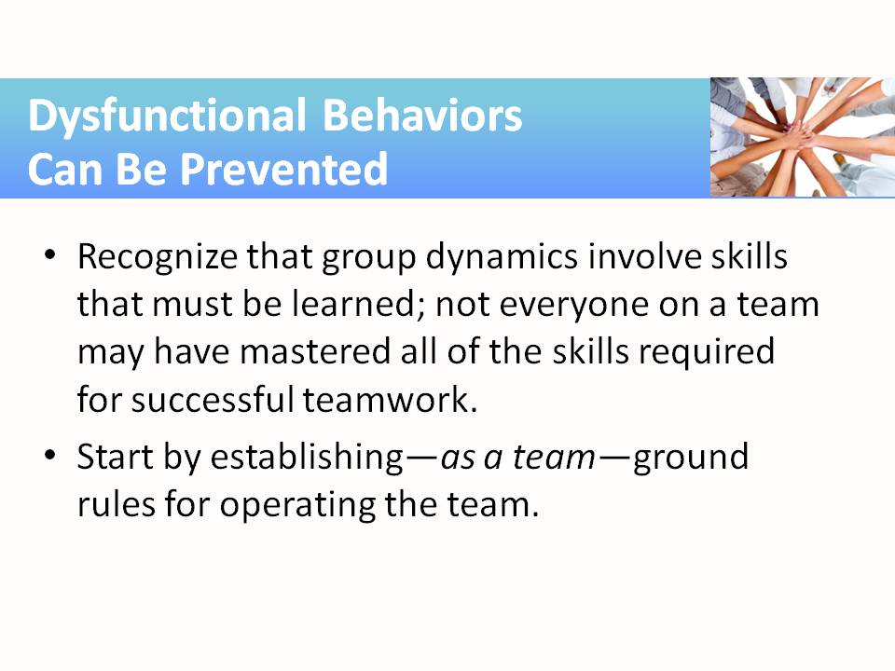 | Instructors may need to lead students through a step-by-step process of team-building. Most students will have experienced group work; this does not mean that they possess good group interaction skills or attitudes or that they have been part of successful teams. Instructors should not assume that adult students already know how to work in teams. Group dynamics are a set of skills that cannot be taken for granted and must be taught.
18 | 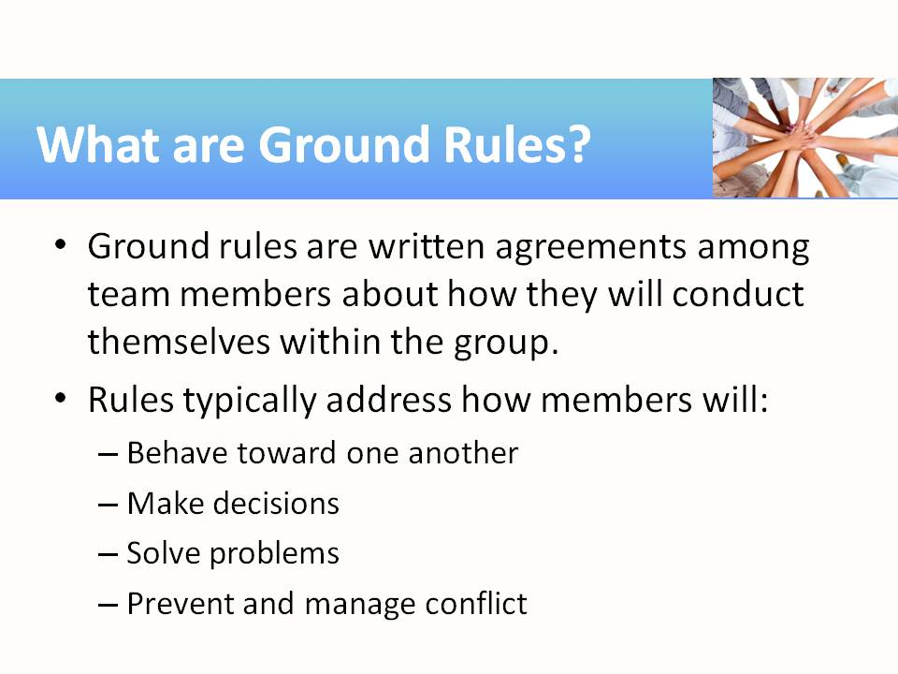
19 | 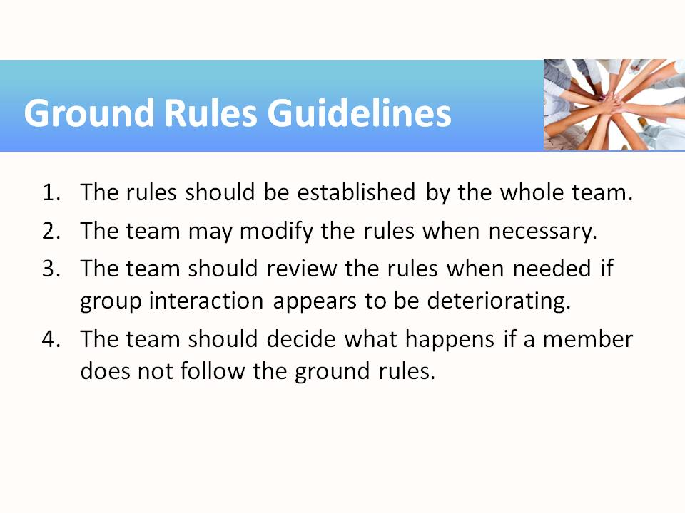
20 | 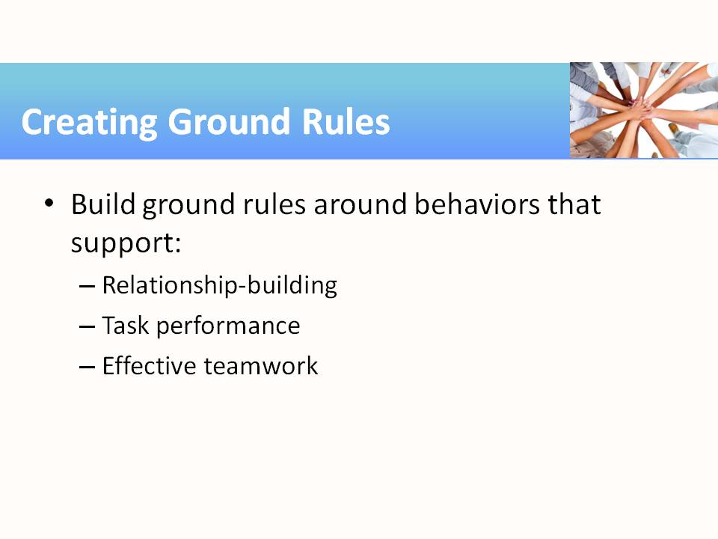
21 | 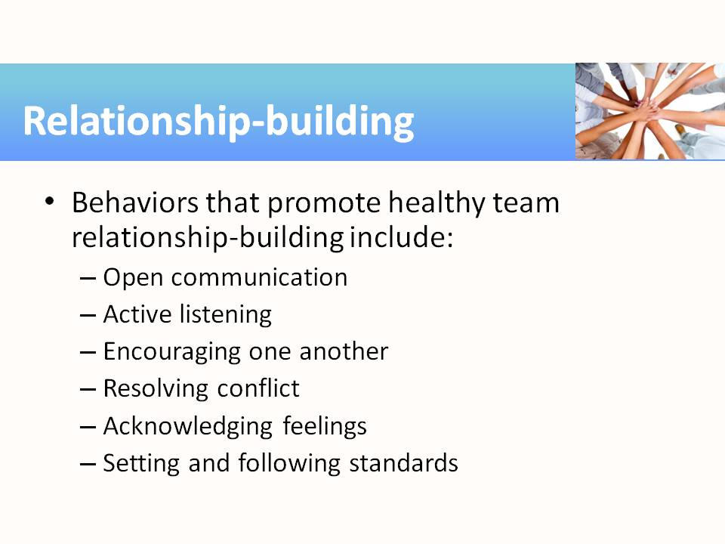
22 | 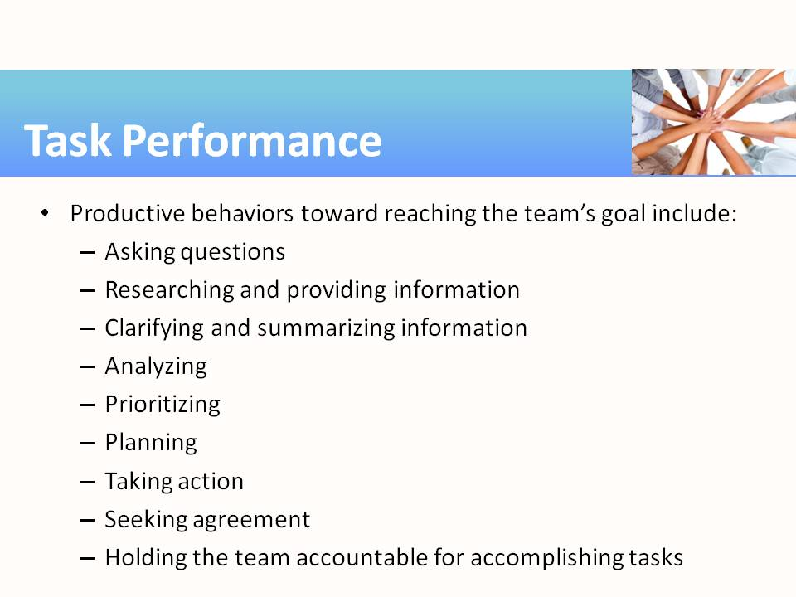
23 | 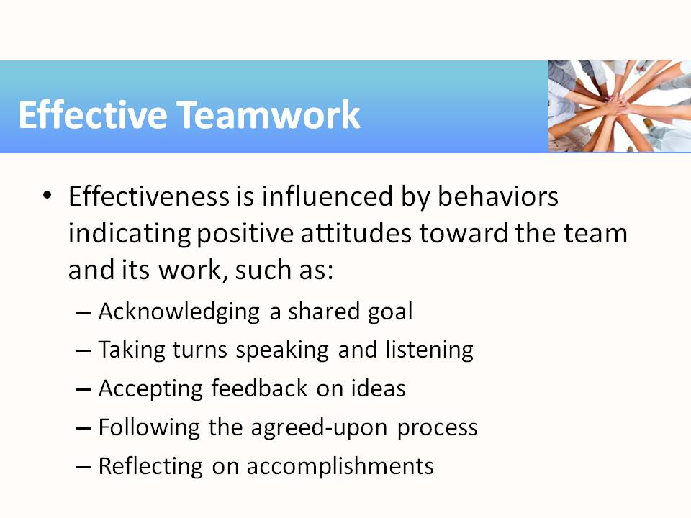
24 | 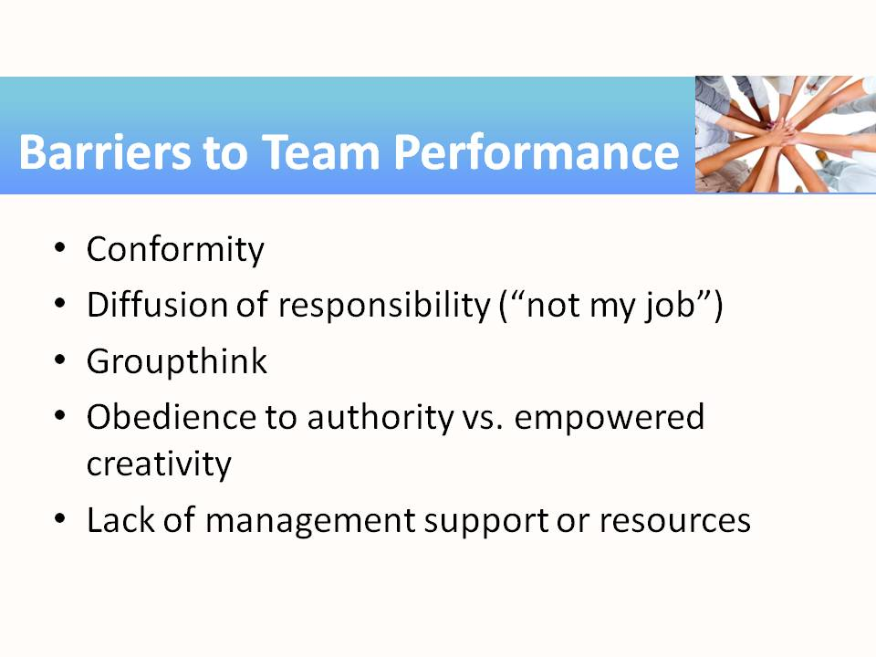 | Ask students how each of these barriers affects the potential team outcomes. Their answers may be something like the following:  “Conformity means that the team will do what has always been done in the company. Nothing new will come out of the process.”  “Diffusion of responsibility means that no one takes ownership for specific tasks needed to accomplish the team goals, so nothing gets done.”  “Groupthink? Is that a bad thing?” [groupthink occurs when the team is so conflict-avoidant that the members don’t consider all possible solutions to a problem; harmony is more important than achieving the best outcome]  “Obedience to authority implies that team members are afraid to think outside the box, unlike empowered creativity.”  “If there is a lack of support, the team may have wonderful ideas that can never be carried out. This will lead to bad morale in the future and employees not wanting to serve on teams in the future.”
25 | 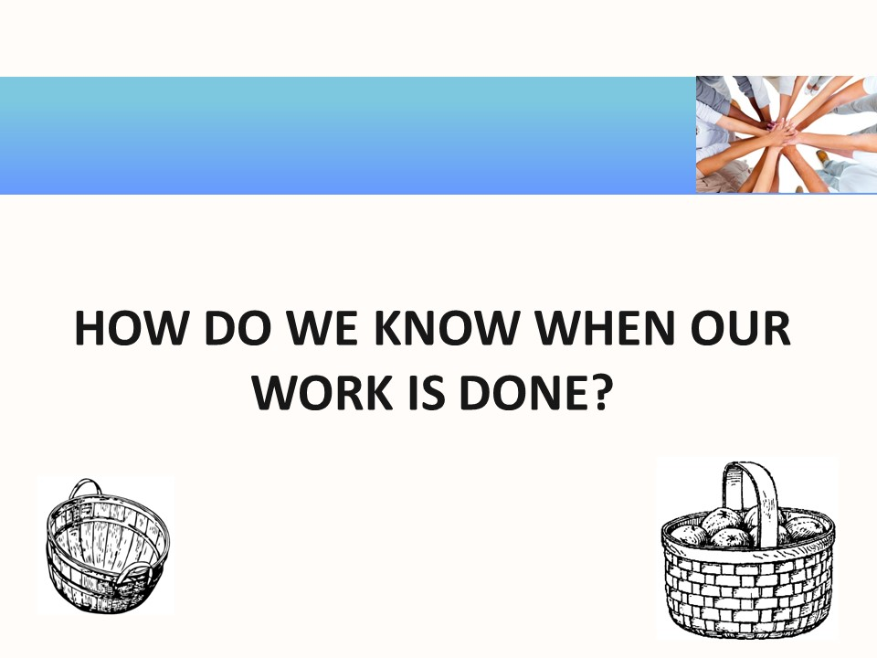
26 | 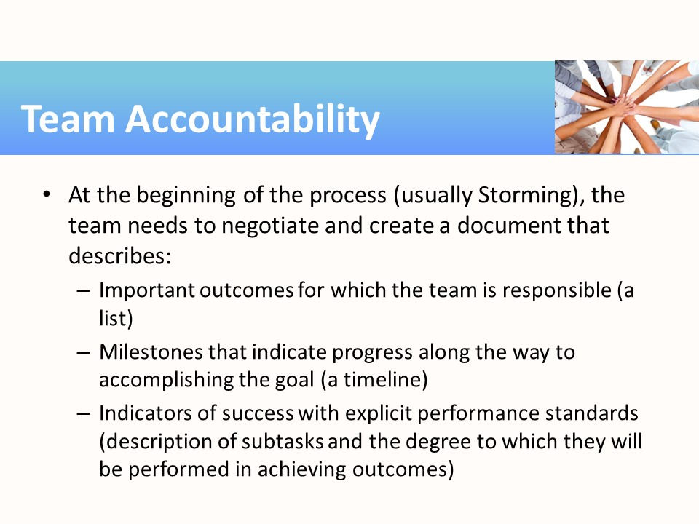 | As with instructional design, team accountability “begins with the end in mind.” In other words, the team decides what their end goal is and then decides what accomplishment of that goal looks like—the end product. To keep the team moving toward the goal, the members decide upon milestones of progress that demonstrate they are working productively.
27 | 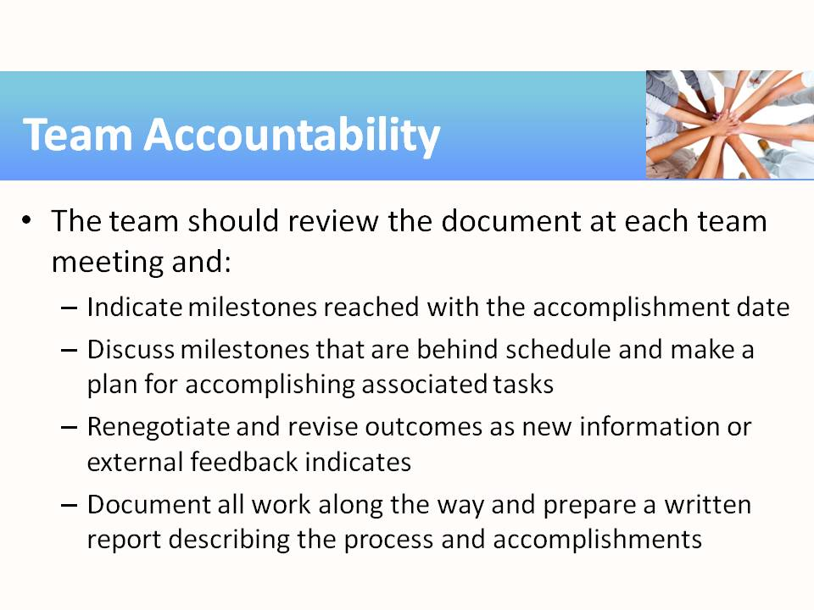 | Note that documentation of both the process and products will be required by the organization’s management. Team members may find their participation and success included in their annual performance reviews.
28 | 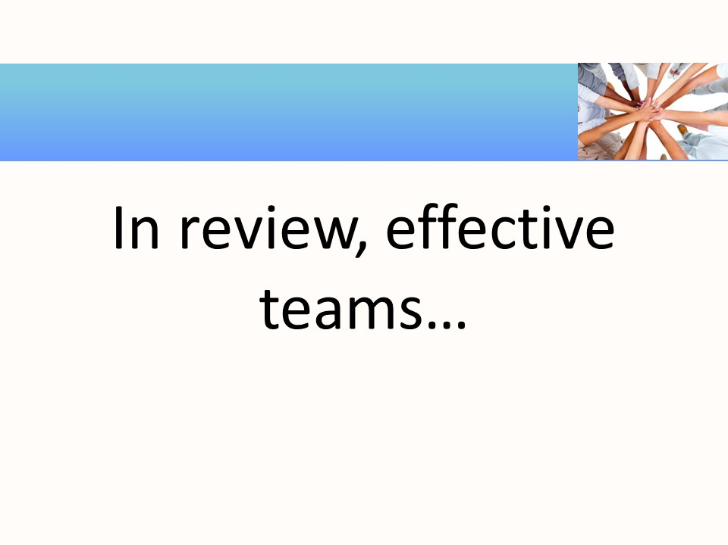
29 | 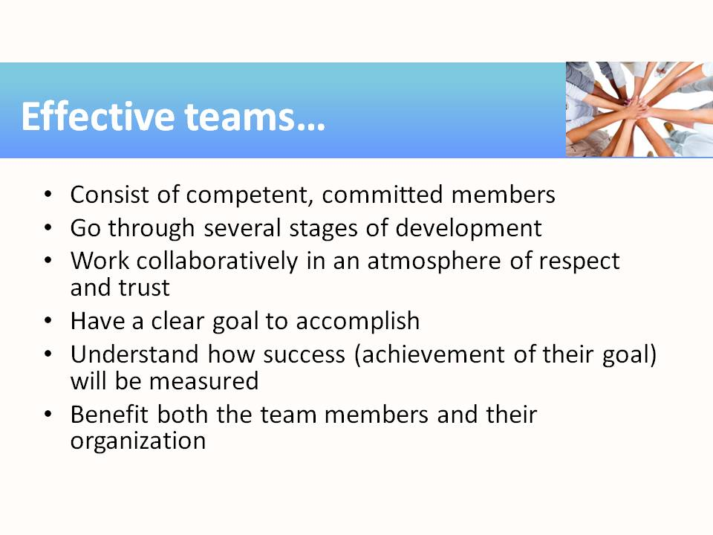 | The NC-NET Employability Skills Resource Toolkit contains many lessons on teamwork that can be adapted for use in both academic and career-technical courses.

Teaching Resources
Activities
The following activities can be completed in class to emphasize specific aspects of teamwork and interpersonal skills. The activities found in this resource can be used “as is,” or they can be tailored to fit a specific course. Suggestions for adaptation precede each activity, with examples from several different subject areas/career pathways. The suggested modifications provide instructors with ideas for adapting the activity to fit content they are already teaching. Modifying the activities allows employability skills to be infused in subject area content more easily.
Activity: How Groups Work
Instructor Preparation
How Groups Work is one of a series of three activities aimed at building teamwork skills. Planning Group Research and Presenting a Group Report are the other activities in the series. These activities should be conducted early on when teaching students about teamwork. This activity as written is generic and can be used in any course or easily tailored to relate to specific course content. In this version, students imagine a family trip and then write and perform a group skit. Alternate topics for various courses might include:
- Construction: Group is discussing various flooring for a home remodel. Possible roles might include homeowner/customer, contractor, flooring salesperson, interior designer, and so forth.
- Government/History: Pick a current event, historical topic, case study, or other topic previously covered in class. Have students create a skit about how the topic affects the general populace at the time.
- Science: The group could be tasked with creating an experimental design for a research topic.
- Early Childhood Education: Childcare worker/instructor meeting with family to discuss issues related to a child’s behavior problems in class and to create a plan for dealing with them.
If an alternate scenario is used, the instructor will need to adapt Handout 3 to the situation assigned.
The dynamics of group interaction are at the heart of developing working relationships. This lesson will focus on these dynamics by providing students with a task to complete as a group and by asking them after the task about their perceptions of their behavior and others in the group as they worked on the task. The role of the group observer is a very important one in this activity. Try to assign this role to alert and perceptive students. Give the group observer a copy of Handout 1. Direct them to read through the questionnaire and take notes discreetly as their group works on its task. During the activity, the instructor’s role is essentially that of silent observer. Take note of any pitfalls or obstacles students encounter and suggest strategies for overcoming such group problems after the activity.
Objectives
Students will:
- Compare the roles and contributions of individuals in a group.
- Assess the effectiveness of a group at accomplishing a task.
- Differentiate factors that help and hinder effective group processes.
Materials
- Handout 1—Group Observer Questionnaire
- Handout 2—Group Participant Questionnaire
- Handout 3—A Family Vacation
- Timer for each group (stopwatch, kitchen timer, timer app, watch, etc.)
Activity Guidelines
The instructor should provide the following general instructions and distribute Handout 3—A Family Vacation.
- Your group of four to five members needs to envision itself as a family going on a trip. You will have twelve minutes to develop an entertaining, three-minute skit that you will perform for the whole class at the end of this activity. One member of your group will serve as an observer and will take notes but not contribute to writing or acting in the skit. One member of your group will introduce your skit, giving any background information the audience may need. All members except the observer must have a speaking part. Provide the observer with Handout 1—Group Observer Questionnaire.
- After each skit is performed, ask for a brief class evaluation of the skit.
- Did it stick to the time limit? Was it entertaining? Did it make sense?
- Did the groups follow the assignment?
Group Reflection Questions
- How effectively did your group deal with this task? What was difficult about the task? What were some of your group’s strengths and weaknesses?
- What factors contributed to or hindered your ability to complete the task well? Record the factors on the board or flip chart. Elicit: Time management; division of labor; respect for others’ ideas; ability to reach consensus, stay on task, draw on individual strengths, and encourage participation.
- How could your group members have helped overcome these problems?
Individual Reflection on the Process (Homework)
Distribute Handout 2, Group Participant Questionnaire. Have students (except the group observers) complete the handout and bring it to the next class. Group observers should bring their completed Handout 1 to the next class. Lead a follow-up discussion on this introductory teamwork activity.

Handout 1—Group Observer Questionnaire (2 pages)
Your job is to watch and listen as the group works. Pay close attention to how the group operates and how different students help the group accomplish its task. Jot down notes to answer the questions while the group works.
As an observer, it is important that you not join in the task (not even to make comments aloud!) so that you do not influence how the other group members act or how they complete their tasks.
Name of Group Member | Actions/Behaviors That Supported Group Progress

- How were parts assigned? Did everyone have a speaking part?

2. How did the group decide what the plot was going to be?

- How did the script get written? Did the whole group discuss every line?

- How were disagreements resolved?

- Did anyone keep track of the time for the group (e.g., “Only five more minutes left to work, guys”)?

- Did anyone try to keep the group on task when others’ attention started to wander? How did the group react to that person?

- Did every group member participate in the task? If so, what helped to get members involved? If not, were there any obvious reasons why someone did not participate?

- What types of comments did group members have for each other (constructive criticism, positive reinforcement, sarcastic criticism)?

Handout 2—Group Participant Questionnaire
- Did you enjoy working on this activity with your group? Explain why or why not.

- Did you feel that what you contributed helped to complete the task? Explain why or why not.

- Did the rest of the group welcome your ideas? Did you welcome the ideas of others? How did the way the group responded to suggestions influence the making of additional suggestions?

- a) Who gave others the most directions?
b) Do you think that person’s direction helped or hindered the group’s progress?

- How satisfied are you with the skit your group performed? Could you have written a better skit in the same amount of time if you’d completed the task by yourself?

- If you were with the same group and were given a different task, what changes would you suggest with respect to how the group members should work together?

- What did you learn that will help you to be more effective in future group projects?

Handout 3—A Family Vacation
Your group is assigned to prepare a skit to be performed before the class.
You have only 12 minutes to prepare this skit.
The information you need is listed below:
Topic: A family vacation
Length of finished skit: 3 minutes
Essential elements of your skit: Destination, plot, action, and dialogue by each team member
You also need a narrator, to introduce your skit to the class, and an observer who will take notes on the process but will not participate in developing or acting in the skit.
Activity: Planning Group Research
Instructor Preparation
This activity and the next activity (Presenting Group Research) are most useful when completed early in the course so that students learn how to operate in teams and can practice and strengthen teamwork skills. In addition to teamwork, this activity teaches students to work on initiative and dependability skills such as creating and adhering to a schedule. For this activity choose a group research project/presentation that you would normally assign in class. Hands-on group projects such as labs, field work, and construction projects will also work provided they include a group presentation at the end for the follow-up activity, Presenting a Group Report.
Objectives
Students will:
- Analyze contributions of group members.
- Suggest ways to deploy group members to best accomplish a task.
- Develop a group action plan for researching an assigned topic.
Materials
- Handout—Action Sheet
- Topic or list of topics for students to research
Activity Guidelines
If all student groups are to research the same topic, the instructor might want to provide an introduction to the topic, an interesting article, or statistics that will help students think about the topic. If student groups are allowed to choose their topic, a more generic introduction to the project and topic can be given. Instructors should provide specific expectations in terms of quality and content. They should also emphasize that teamwork skills will be assessed during the activity in addition to technical content knowledge.
Give students a copy of Handout 1—Action Sheet. They should use it to plan their research and to divide up tasks. Indicate that they may want to revise their Action Sheet during the course of the project and make revisions as needed to ensure they meet the final deadline. Allow students time in class to do their planning; actual research could be completed individually outside of class. For this assignment, research strategies will include using the Internet, going to the library, phoning organizations, etc. Presentation format means written paper, PowerPoint presentation, poster sessions, oral presentation, or some combination of these. Let students know if they are expected to complete the assignment outside of class time. The wrap-up and evaluation of teamwork will occur after the groups present their group reports.
Handout—Action Sheet
Research topic
Research strategies
Final presentation format(s)
Presentation date
WHAT will we do? | WHO will do it? | WHEN is it due?
1.
2.
3.
4.
5.
6.
7.
8.
9.
10.

Activity: Presenting a Group Report
Instructor Preparation
This is the final activity in the trio of activities on working in groups. The first activity helped students identify how groups work together. The second activity had students develop a plan and timeline for completing the research required to prepare and deliver the group report. At this point, each group should reconvene to share its data and consolidate its information into a written report. This lesson continues the development of skills needed in the workplace as companies rely on the cooperative efforts of employees to accomplish tasks in a short period of time.
The evaluation criteria for this activity are listed on the Evaluation Form. The student groups need to understand these criteria thoroughly before beginning their reports. Each student will use the criteria to rate every group’s presentation. The results will not be discussed in class, but the ratings will be collected and given to the appropriate groups for review and discussion. Each group should write a response and describe how they would change their work process in future projects.
Objectives
Students will:
- Share individually collected information with group members and organize it for a written group report and class presentation.
- Plan the format for presenting the information.
- Use review and editing skills to create a final report.
- Evaluate written reports/presentations using specified criteria.
- Demonstrate the ability to use presentation software.
Materials
- Computers with Internet access, word processor, and presentation software
- Handout—Evaluation of Group Presentation (There are two forms per sheet; each student needs enough forms to evaluate each group presentation.)
- Scissors or paper cutter to separate the two forms
Activity Guidelines
Begin by explaining the criteria on the Evaluation Form so that students understand performance expectations for the activity. If students were not required to complete all work on the project outside of class, allow student groups time to combine, format, and finalize their written reports and presentation materials. If time permits, begin group presentations.
Prior to the presentations, distribute enough copies of the Evaluation of Group Presentation form to enable each student to evaluate every group report. Direct students to judge each report using the listed categories, and to award 1–5 points per category (5 being the highest rating). Additionally, instruct students to write a description of the best features of the report and areas for improvement. Collect the completed evaluations and distribute them to the appropriate report group for its review.
During the group presentations the students in each of the other groups should complete the evaluation of the written report and presentation form. Ask them to give constructive feedback instead of comments such as, “I did not like the presentation slides.” Instead have them suggest possible solutions by saying something like, “The presentation slides were distracting to me because they used too many different transitions, and the font was too small for me to read because too many words were on the slides.”
After all of the class presentations are complete, distribute the reviews to the appropriate groups. Have the groups work together to do the following and discuss their team processes.
Group Reflection Questions
- How effectively did your group deal with this task? What was difficult about the task? What were some of your group’s strengths and weaknesses?
- Did you agree with the reviewer comments you received? Were there any comments that surprised you? Were there suggestions or criticisms that you can work on to improve future projects?
- Did anything stand out from the presentations of the other groups that you might want to include in future work?
Handout—Evaluation of Group Presentation
These are the five criteria on which your presentation will be judged and that you will use to rate other groups’ presentations. Use these evaluation forms to assign a rating of 1–5 for each group presentation. Rate the reports on each category listed, using 5 as the highest mark.
Report title
Quality of technical information
Organization of information
Visual presentation (use of tables, charts, etc.)
Clarity and flow of presentation
Team division of labor
Total points
Best features of this presentation

Areas for improvement

****Cut Here****
Report title
Quality of technical information
Organization of information
Visual presentation (use of tables, charts, etc.)
Clarity and flow of presentation
Team division of labor
Total points
Best features of this presentation

Areas for improvement

Introduction to Team Development and Function
The following activities should be built around a group-created product. The students will complete the activity twice. The object will be for groups to create/assemble at least two of the same (or similar with slight variations) product and to improve their process for creating the second edition. They will be interrupted several times along the way to discuss their group process and to identify the stage of team development at which they are operating—forming, storming, norming, or performing. (The instructor presentation provided at the beginning of this Teamwork module explains these stages briefly.)
Example group-created products:
- Building a couple of models from kits of Legos, Erector Sets, K-Nex, or other type of building toy
- Completing jigsaw puzzles. Either use standard puzzles of about 100 pieces or smaller puzzles with a catch such as the nine-piece Scramble Squares puzzles.
- Give teams collections of random items and have them “invent” a product from the materials and write an advertising piece that describes what their invention does. They should also be able to demonstrate a working model.
Example course-specific products:
- For a robotics class: Have student groups build a robot from a kit. If the class is more advanced, have them program a robot to complete a maze.
- For a culinary arts class: Give groups raw materials (flowers, fruits, veggies, or other materials) and have them build two centerpieces for a banquet. For a more advanced class, ask groups to create a plan (menu, food order, preparation schedule) for catering a specific function.
- For a horticulture class: Have student groups plan 4′ x 4′ gardens to meet specific growing goals—an herb garden, the most productive food garden that could provide fresh produce to a food bank, or a flower garden. Specify a season of the year and for the second round have them describe what should be changed for the next season.
- For a basic biology class: Ask student groups to create a model of a cell at a specific stage of mitosis, clearly labeling the parts from random materials such as modeling clay, resealable plastic bags, plastic drink bottles, pipe cleaners, string, tape, stapler, and glue. A different stage can be used for the second model.
The activity should be complex enough to require a group of 4–6 students, but not so complex that it takes hours to complete.
Objectives
- Participate in the setting of effective ground rules.
- Demonstrate a willingness to participate in group work.
- Gain an awareness of the purpose and goals of a team.
- Coordinate assigned tasks with other members.
- Identify issues and problems to be addressed.
- Demonstrate the ability to focus in team meetings.
- Identify and use the abilities and skills of other team members.
Materials
In addition to the materials needed to complete the project selected for your class (see the examples on the previous page), you will need a way to display information for the class as a whole (e.g., projector screen, whiteboard).
Activity: Team Development and Function—Forming, Part 1
Instructor Preparation
The activities described in the Team Development and Function introduction simulate the forming of a team around a manufacturing or other multi-part process. Teams should consist of four to six students, and these groups should remain the same through all of the Team Development and Function activities. You will need materials for each group to create their products twice. Divide the classroom into two areas: a discussion area and a work area. Arrange the discussion area in a U-shape, square, or circle so everyone can see each other and the projector screen or whiteboard. Arrange the work area with one long table or large round table where each group can surround it for an assembly-type configuration. (Adapt the assembly area to the project being completed.)
Objectives
- Participate in setting effective ground rules.
- Demonstrate a willingness to participate in group work.
- Gain an awareness of the purpose and goals of a team.
- Coordinate assigned tasks with other members.
- Perform roles and complete responsibilities appropriately.
Materials
In addition to whatever materials will be needed for students to build their products, you may want to provide containers such as small paper plates, cupcake forms, small cups, sealable sandwich bags, flat trays, and box lids for the teams to use to organize the parts.
Activity Guidelines
- Assign the teams and explain that the purpose of the simulation is for students to experience the stages of team development.
- Have students move to the work area of the room and give them the instructions for the activity.
- Have each team discuss the instructions and the task.
- Distribute the materials for one product to each team. They will get the remaining materials once the first product is completed.
- Ask each team to become familiar with the materials and organize them to best accomplish the task. Tell team members that they will need to organize themselves to complete the task. Let them know they can work for 20 minutes to accomplish these goals.
- After 20 minutes, stop the team and tell them that they will have several opportunities to work on the plan and assemble their products later. Explain that you would like to discuss the team-member roles and set ground rules to help team meetings run efficiently and effectively.
- Have groups move back to the discussion area of the room. Teams should sit together as they construct team ground rules. The instructor might want to review the PowerPoint slides 18–20 if they have not already been presented.
Discussion Notes: In society, we have rules to maintain order and to spell out acceptable behaviors. For teams, ground rules perform this function. With many different personalities, temperaments, and preferred work styles, it is critical that team members agree on the acceptable norm for the team. Established ground rules enable the team to address deviations from the preferred behaviors without personally offending any member—since that member did help establish the rules and agreed to them. Ground rules identify how members will be treated, how problems will be solved, how decisions will be made, and how conflict will be managed. It is important to have these rules written down and in plain view.
- Ask students to describe a situation in which having ground rules would have been helpful.
- Explain that setting ground rules is a preventive technique for avoiding team breakdowns.
- Explain that students will have two tasks to accomplish in the next 20 minutes.
1. They will decide which team members will assume specific functional roles for the team activity such as timekeeper, recorder, and gatekeeper (who is responsible for bringing the team’s attention back to the task if it wanders). All team members are expected to participate and work toward building consensus.
2. They will write 3–5 ground rules for their team and display them prominently for reference throughout the activity. At this point, each team should keep their ground rules to themselves and share them only with the instructor, who will be able to monitor which rules were valued and observed and which rules were ignored. There will be time later in the activity to revise the ground rules if needed.
- Allow students to return to the work area if time permits or continue at the next class period. Their task will be to develop a plan for team accountability. They will need to address three points in their plan: a clear list of outcomes for which the team is responsible (restating the assignment in terms of team responsibilities), a list of milestones for measuring their progress, and a description of how the team will measure success for each of the outcomes identified.
Activity: Team Development and Function—Forming, Part 2
Instructor Preparation
Teams will be working on their team accountability plan to determine the outcomes for the activity, milestones they must meet to stay on track, and the criteria by which they will measure their success. The preparation is the same as for Part 1.
While the teams begin working on their products and their accountability plans, the instructor should be observing the teams as they work. Watch for appropriate and inappropriate behaviors and notice whether any storming occurs.
Objectives
- Participate in setting effective ground rules.
- Demonstrate a willingness to participate in group work.
- Gain an awareness of the purpose and goals of a team.
- Coordinate assigned tasks with other members.
- Perform roles and responsibilities appropriately.
Activity Guidelines
- Allow the teams to have time to construct their product and to work on their team accountability plans. Remind them of their ground rules and observe whether the ground rules are enforced and followed.
- Allow student groups time to work on their products until at least one group completes their first product. Then have the groups come together for a debriefing on their team’s behavior.
Group Reflection Questions
- The instructor should bring the groups back together for a quick debriefing, asking the following questions.
- Did your team select a facilitator, or did someone assume the group leader role?
- Did your team do any planning, or did everyone jump into construction?
- Did you discuss how to proceed as a group?
- Did you assign roles to the team members? What were they?
- Did everyone contribute their ideas about the process? If not, why?
- How did you coordinate doing the task with your team?
- Did everyone participate in the actual construction of the product?
- Did any conflict occur? If yes, what happened? Are there any thoughts about why it happened?
- What worked well?
- What difficulties or obstacles affected the process?
- What guidelines or practices would help the team communicate or work together better?
Activity: Team Development and Function—Storming, Think-Pair-Share
Instructor Preparation
Think-Pair-Share is a creative thinking strategy for brainstorming. Developed by Arthur Whimbey, Think-Pair-Share encourages students to think on their own first, then collaborate with partners, and finally express as many ideas as possible from the group in a short period of time. This process may help expose problems during team processes and identify issues that can cause stress and conflict within the team. Sometimes the blame is shifted unfairly to an individual when there may be a materials, supply, or process problem that needs to be solved. The instructor should point out that work conditions such as poor tools and difficult work environments happen in real life and can cause stress and storming on a team.
Objectives
- Identify issues and problems to be addressed.
- Demonstrate ability to focus in team meetings.
- Identify and employ the abilities and skills of other team members.
Materials
- Copy of Think-Pair-Share handout
- You will need a way (projector, whiteboard) to display student responses for the class.)
Activity Guidelines
- Have the students return to assembling or creating their product and working out the steps to their process. Tell them to use the procedure they drafted earlier and note where changes might be needed.
- Observe each team and how it is functioning. If you observe problems and issues that are surfacing, then have students take a break from the project to come together while you explain the think-pair-share strategy for identifying issues and problems.
- Distribute a Think-Pair-Share handout to each student and have teams follow the procedure below.
- Ask each team member to write down the problems and issues that surfaced during the activity they were just performing under the “Think” column of the handout. Each student should come up with at least three items. NOTE: Not all problems and issues will be related to team behaviors. They could include not having the materials they would like to have, insufficient light or room, and so forth. All issues and problems should be recorded.
- Next, ask the students to pair up with another student and compare ideas and add other ideas. These new ideas are recorded in the “Pair” column of the handout.
- Finally, ask each group to present one idea aloud and display these on the screen or whiteboard. Students can record new issues in the “Share” column.
- Point out that this activity allowed teams to verbalize issues and problems—a first step toward solving them. Intervention techniques will be introduced in a later activity.
Handout—Think-Pair-Share
Product Creation/Assembly Issues and Problems
Think | Pair | Share
Activity: Team Development and Function—Norming and Performing
Instructor Preparation
In this final Team Development and Function activity, students will complete their products, prepare a final presentation of their product, and reflect on their team experiences.
Activity Guidelines
- Allow students time to complete their projects unless this would cause a major delay.
- Continue to observe and gather examples of team member conflicts to use as discussion points during the wrap-up. For example, you might ask, “What was happening when…?”
- Have each group finalize its process plan and present it to the class.
Group Reflection Questions
- How well is your team working together now? Did you get past the storming and begin to work together more effectively?
- How does each of you feel about the process your team has created? Have your ideas been heard and your personal issues resolved by the team’s plan?
- Did your team move into the norming stage or are you still stuck in storming? Why?
- Did your team get to the performing stage?
- Have each team member tell what they appreciated about other members of the team and what they brought to the team effort. You might want to record this positive feedback and give it to each student to encourage them.
Activity: When Your Team Breaks Down
Instructor Preparation
This activity involves role playing intervention techniques to help students identify team problems and possible ways of dealing with them. Before working through the role play activities, you should discuss the probability of team conflicts and means for resolving these conflicts. Many team problems can be quite formidable. In the role-play scenarios that follow, students need to be prepared to act out difficult, real-world interpersonal communication arising from miscues in vocal tone, sending negative messages with body language, or misunderstanding a co-worker’s intentions. Co-worker “Bob” bears the brunt of the miscommunication when his colleagues inquire about his home life.
A key to resolving problems with the least disruption or risk lies in focusing on prevention or being proactive and not letting small problems develop into major conflicts. This requires the recognition of symptoms that may include backbiting and complaining, warring between cliques, displaying combative behavior, avoidance of differences or potential conflicts, dysfunctional group norms, unequal participation, delaying or changing decisions, a climate of defensiveness or fear of speaking, and/or domination by an individual. Team members should step in at the appropriate time and with the appropriate approach to address the root cause of the problem.
There are various intervention techniques that can be used to handle conflicts, including:
- Refocus on prevention—This may simply involve revisiting the goals/objectives, individual roles, and ground rules for the team as a reminder to everyone about how things are supposed to be done. A team member or leader might ask the team: “Do we need to add any ground rules to be an effective team?” “Do we need to modify any ground rules because they are not effective?” Ask students who might have misplaced their ground rules to make a new copy to keep with them.
- Coaching one-on-one—Perhaps taking an individual aside and working with him/her privately on weaknesses as a team member would be the most effective and efficient way to resolve the issue. This will also protect the dignity of the person.
- Structural intervention—At times the way the team is organized (members, roles, expertise, mission) may need to be addressed.
- Introduce information—This technique is similar to going back to school—assuming the team has had the proper team training—and serves as a refresher to make members aware of the dynamics that occur at each state of team development as well as other group dynamics
- Observe/report group dynamics—This technique requires one team member to critique the group on what is actually occurring (based on observation). The risk of conflict increases here as people may feel singled out and become defensive. If effective ground rules are in place, the problems should be addressed as indicating a lack of respect for them.
- Team problem-solving of breakdowns—This involves getting the team to apply its problem-solving methods. The positive side is the members will have ownership of the solution. The negative is that it is time consuming.
- One-on-one confrontation—This technique, which requires direct confrontation of the person unable to fulfill his/her role, may be used if all else fails. Before matters get to this point, make sure all risks to the team’s ability to function and achieve its objective justify using this technique.
Materials
- Copies of the seven Intervention Role Plays for each student
Activity Guidelines
- Ask for two or three volunteers (depending on the individual role play) who are willing to play people involved in conflict to illustrate the use of various intervention techniques. Explain that they will model how others on the team can help work through any breakdown.
- Give the students a minute or two to read through their parts and consult with the other volunteers before presenting the role play to the class.
- The instructor should read the setting information to the class, and have the volunteers to act out their parts. The instructor will participate in the role plays as well.
- After each role play, use the reflection questions below to discuss the situation and alternate behaviors that could have been tried.
Group Reflection Questions
- Which workplace behaviors (interpersonal communication) were appropriate? Which were not?
- Can you think of any other resolutions to the conflict?
- Was there a time in your team production activity when this conflict-resolution technique was needed?
- What could have been said then to avoid a breakdown?
- Referring back to the Think-Pair-Share exercise, discuss which intervention technique would have worked with the listed issues and problems.
Intervention Role-Play 1:
Refocus on Prevention
Setting: Outside the meeting room where the team has just finished a team meeting.
Four of the team members are discussing the meeting.
Volunteer 1: Our team meeting was late finishing up again.
Volunteer 2: I know. It seems that we get out later and later every week.
Volunteer 3: Well, I know I was late getting to the meeting today, but I had a good reason. Besides, Bob always wanders way off the important topics.
Volunteer 1: I think we should just stop the meeting one hour after we start, no matter what.
Volunteer 3: I think we should not let anyone in after the meeting starts.
Instructor: Let’s think about how we can prevent this from happening again. I propose we take another look at our team’s ground rules. We might need to add “starting and stopping meetings on time” as well as “staying on the topic.”
Note: Can you think of other answers that might have been given?
Intervention Role-Play 2:
Coaching One-on-One
Setting: Two members of the team are talking in the break room about an incident that occurred that morning.
Volunteer 1: I don’t think Bob should have told his daughter to move out of the house by the end of the day. After all, she is only 15. I told him I thought that he ought to be ashamed. Brittany is his only daughter.
Instructor: You did? How did he react?
Volunteer 1: He told me to mind my own business. We both got a little hot. But can you imagine telling your daughter to hit the road?
Instructor: No, but I’m not Bob. I don’t know the problems he has had. Did you ask him about his problems with Brittany?
Volunteer 1: No, he was so hot that I just walked off. It’s funny, but we have not spoken since then. That makes it hard for me to pass the work I’ve completed on to him to finish the next phase in production.
Instructor: That certainly doesn’t help the team. I wondered why we seemed to be running slow. You know, you might think about going back to Bob and letting him know you really are concerned about him and Brittany. He probably needs someone to listen to him. You might not agree with him, but you can certainly listen.
Note: Can you think of other answers that might have been given:
Intervention Role-Play 3:
Structural Intervention
Setting: A team meeting. Team members are sitting around a table.
Volunteer 1: I am concerned about the way I am doing things since we added three new color combinations to our product.
Volunteer 2: So that’s what’s been slowing me down! I was planning on discussing it at this meeting. Bob said he was having problems, too.
Volunteer 1: I took a look at last week’s reports and saw that we had fallen short of our quota. I think our team has a problem.
Volunteer 2: Our team has a problem? I think you are the one with the problem. After all, it’s your work that is slowing us down.
Volunteer 1: Me? I don’t think you can blame this one on me. After all, you are the one who just last week….
Instructor: Hold it. Hold it. It seems to me we have a system problem, not a people problem. If adding more color combinations has slowed our process, then we need to work together, as a team, to solve this process problem. Why don’t we try analyzing our process to see if we can come up with another way to organize our work?
Volunteer 2: You’re right. I’m sorry I lashed out. The problem really is in our process, not our people.
Volunteer 1: (to the side) Bob, let’s consider the work you are doing. You might be able to do things differently and help me out. What do you think?
Note: Can you think of other answers that might have been given?
Intervention Role-Play 4:
Introduce Information
Setting: Team receives a memo from the human resources department announcing a team-building session.
Volunteer 1: I’m surprised that Human Resources is still putting money into building teams. We have been working as a team for six months. What else is there to know?
Volunteer 2: I don’t know, except that Bob sure could use some help in relationships. If he has had trouble at home, he is a bear here at work. I can’t get along with him at all during those times. Did you see what happened Monday morning? Bob came in with a troubled look on his face, so I knew better than to say anything, but I did. Just to lighten him up, I said, “Bob, you look like you just lost your best friend.” Bob twirled around and said, “Mind your own business.” Well, he didn’t speak to me the rest of the day. Later I needed to ask him to redo some of the work he did. I walked up to him and he let me know with one look that I was not welcome in his area.
Volunteer 1: I guess we should recommend that Bob attend the HR training and let us get on with our work. However, we really can’t do our work efficiently without Bob.
Instructor: Do you remember when our team first went through team-building sessions? Do you remember during the session when we were building those miniature vehicles and two of you guys got mad at each other but then the trainers showed us how to work through those problems?
Volunteer 2: Yeah, I remember Bob and I were the ones who got mad. But, if you remember, we worked it out just great. You know that situation really isn’t too different from this one. Maybe all of us going through a refresher course would be valuable. I’m sure I didn’t react to Bob on Monday the way I should have.
Volunteer 1: Let’s talk to the other members and sign up for the session. It will be good for all of us.
Note: Can you think of other answers that might have been given?
Intervention Role-Play 5: Observe/Report Group Dynamics
Setting: Manufacturing floor during production.
Volunteer 1: Hand me another box of parts, will ya?
Volunteer 2: What do you mean, hand you another box of parts? Why can’t you get your own parts? I just handed you a box of parts 30 minutes ago. What are you doing with them, having them for lunch?
Volunteer 1: Very funny. You’re closer to them than I am. The least you could do is help me out here. After all, you don’t do enough of the work around here to be a real member of the team. Besides, there were a bunch of defective parts in the last box you gave me that I can’t use. I think you must have given me old scrap materials.
Volunteer 2: I did not. Besides, I don’t think it is my job to keep you supplied with parts. You must be doing something wrong…AGAIN.
Volunteer 1: Hey, I do my job. It is hard to tell if the whole box is defective or if my parts are not fitting right. Occasionally, the parts fit fine, but most of the time they don’t. They did just redesign this part of the vehicle, but I thought things were going to be adjusted. All I know is that I don’t have what I need to do the work.
Volunteer 2: Well, this is important because we’ve been getting complaints from up the line that our parts seem not to fit as well as they have in the past, so it must be your work that is making the whole team look bad.
Instructor: Hold it, folks. There is something more wrong here than just defective parts. You two are going at each other like wildcats. I think maybe just an observation period of our team’s work is in order here. We can get the report and find out what problems our team is having. I’ll arrange for it right away. It should happen sometime this week. Then we can fix the problems and get on with our work.
Instructor: (at the end of the week) OK. The observation report is back. It seems that we do have several problems that should be addressed. First, we need to adjust the machine that makes your parts (pointing to Volunteer 1). Second, we need to adjust our process. You two do not need to be handing each other boxes of parts (pointing to Volunteers 1 and 2). Third, there is a procedure that you (Volunteer 1) are not doing quite right. An engineer will be here soon to show you the procedure.
Volunteer 1: I think I know what you are talking about. Does it have to do with the three steps in the middle of my process?
Instructor: Yes, I think so.
Note: Can you think of other answers that might have been given?
Intervention Role-Play 6:
Team Problem-Solving of Breakdown
Setting: Team meeting
Instructor: There have been indications that we are not doing well in our area. The problems don’t seem to be linked to any one thing, so I thought we might meet to discuss some of the problems. I have printed the agenda each of you suggested.
Volunteer 1: A couple of the items on our agenda relate to my area and I would like to address them. The first one is material. I think the quality of the material we have received from our supplier lately is not good. I have also noticed that my machine has had numerous breakdowns within the last week. I do not know if that has to do with the material quality or another major problem with the machine.
Volunteer 2: My machine has had problems, too. The control charts are indicating some type of problem today. During the rain yesterday, Bob had a leak right over his area. He got so upset because the leaky roof is also rusted. The rusty water dripped down his back and stained the new shirt his daughter Brittany gave him for Father’s Day.
Instructor: Well, I know we had two people out a couple of days last week, which affected production. That really changes our process even when we have temporary help. It sounds like we have several problems that should be addressed. Let’s think about using a fishbone diagram to help us sort out all the problems. (Instructor draws out a fishbone similar to the following.)
Instructor: These are the six areas that I hear you identifying as having problems. Let’s think about these and others that are possible causes of a drop in our work quality.
Note: Can you think of other answers that might have been given?
Intervention Role-Play 7:
One-on-One Confrontation
Setting: During lunch at an outside table.
Instructor: Bob, I understand that you have had some recent problems with different members of the team. What is your point of view of the problem?
Volunteer: I don’t know what you are talking about. It is not my problem; they’re the ones who have the problem. They’re always making me hurry my work. They are always prying into my personal business. And when there is a problem, they always come over and try to “help” me. They just need to leave me alone and let me do my work.
Instructor: Bob, has it occurred to you that when they ask you to hurry, maybe it’s only because they need a piece that helps them meet their quota?
Volunteer: No, I just thought they don’t like me.
Instructor: Doesn’t it seem possible that, when they ask about your personal problems, it’s because they care about you? And don’t you see that, when you are upset, your work, and eventually theirs, is affected?
Volunteer: No, I don’t think my work is affected by my personal problems. And what does what happens to me personally have to do with their work?
Instructor Bob, when your daughter left home last month, you were obviously upset. Some of the team members asked you about it and you became even more upset. That has to be affecting your work and theirs.
Volunteer: You may be right. I know I didn’t work well that day. I was so upset I never thought about any of the other team members.
Instructor: Just realize we’re all in this together.
Note: Can you think of other answers that might have been given?

Assessment Tools/Strategies
This section includes specific strategies and instruments for assessing students’ teamwork knowledge, skills, and attitudes.
Rubrics
Rubrics are valuable assessment tools. Students should be provided with the rubric by which they will be assessed before an activity begins so they will understand the performance expectations. When time permits, students can contribute to the rubrics by brainstorming with the instructor about what a quality behavior or product looks like. For example, before assigning a team project to research a topic and prepare a group presentation, ask students to describe how the ideal team would handle the assignment and how they would assign roles, divide the work, and create and make the presentation. Prompt students with specific components. Then have them describe a poor performance. These will be the descriptions of the characteristics for the highest and lowest ends of the Likert scale for each performance criterion. Instructors should add any required attributes to the rubric if the students do not come up with them on their own. Several teamwork evaluation rubrics have been provided as examples.
- The first type of rubric lists attributes that can be observed and includes spaces where the instructor can adapt the rubric for a specific activity, project, or career field by inserting additional criteria. There are six of these rubrics dealing with different aspects of teamwork in this section: Teamwork, Listening, Leadership Skills, Planning, Problem-Solving and Decision-Making, Record-Keeping, and documentation.
- The second type is exemplified by the Rubric for Self-Assessment of Teamwork Skills. This rubric is a self-rating rubric for use by students. The students indicate the degree to which they think they are performing each attribute. They can periodically return to the rubric to reassess and determine whether they are improving those skills.
- The final type of rubric is the most complex. It is exemplified by the rubrics: Team Member Plan for Developing Interpersonal Skills and Team Member Plan for Contributing to the Team’s Success. The student completes a rubric by providing examples of satisfactory or exemplary performance of the tasks/behaviors listed. Then the student meets with the instructor or peer observer and compares his/her reflections with their instructor’s or peers’ observations and formulates an action plan for improving attitudes, behaviors, or skills.
This type of rubric most resembles the type of assessment an employee might receive on the job. It is also the most time consuming. Ideally, this rubric would be used at least three times during a course:
- At the beginning of the course, to get a baseline and to give students suggestions for specific actions they might take to improve their performance,
- At the midpoint of the course, to check progress and refine the recommendations for improvement, and
      - At the end of the course, to assess the progress made over the duration of the course. Additional suggestions can be made for students’ continued growth beyond the end of the course.
Rubrics for Assessing Teamwork
Outcome: Teamwork – Participate as an effective member of a team by contributing to the group effort for accomplishing goals. Identify and employ the appropriate role within the group. Use effective interpersonal skills while working with others. Participate in group decision-making processes. Evaluate the team’s efforts.
Exhibits concern and encouragement for each team member and team goals. | 1 2 3 4 5
Accepts tasks set according to team-established procedures. | 1 2 3 4 5
Cooperates with team members to reach realistic, attainable goals. | 1 2 3 4 5
Works toward resolving conflict, constructing compromises, and building consensus. | 1 2 3 4 5
Participates in observing team’s efforts and completing follow-up activities to evaluate team’s goals. | 1 2 3 4 5

5 | Always | Excellent
4 | Most of the Time | Good
3 | Sometimes | Adequate
2 | Occasionally | Fair
1 | Never | Poor or None

Outcome: Listening – Develop and practice active listening skills including identification of speaker’s major points, focusing on speaker’s message rather than listener’s response, and discrimination between fact and opinion. Use appropriate note-taking techniques. Overcome communication barriers by treating the speaker with courtesy and respect. Seek clarity of communication by rephrasing statements and asking questions.
Selects conversation and behavior style appropriate for the situation. | 1 2 3 4 5
Pays attention to given information, directions, and specific details. | 1 2 3 4 5
Interprets and evaluates content to identify facts and opinions. | 1 2 3 4 5
Checks to verify interpretation of message rather than making assumptions about understanding. | 1 2 3 4 5
Takes notes relevant to the situation. | 1 2 3 4 5
Documents major points and specific details in writing. | 1 2 3 4 5
Demonstrates attentive listening. | 1 2 3 4 5
Seeks clarity of communication by rephrasing concepts and asking questions. | 1 2 3 4 5

5 | Always | Excellent
4 | Most of the Time | Good
3 | Sometimes | Adequate
2 | Occasionally | Fair
1 | Never | Poor or None

Outcome: Leadership Skills – Demonstrate leadership techniques and qualities to accomplish team goals.
Practices problem-solving and decision-making techniques by recognizing that a problem exists and identifying possible reasons for the problem. | 1 2 3 4 5
Identifies goals and challenges that may require alternative solutions. | 1 2 3 4 5
Implements, evaluates, monitors, and revises action plan on a continuing basis. | 1 2 3 4 5
Values and appreciates the ideas of team members. | 1 2 3 4 5
Uses good interpersonal skills to encourage effective, productive team relationships. | 1 2 3 4 5
Models high standards with attendance, punctuality, and enthusiasm. | 1 2 3 4 5
Builds trust and behaves in an ethical, courteous manner. | 1 2 3 4 5

5 | Always | Excellent
4 | Most of the Time | Good
3 | Sometimes | Adequate
2 | Occasionally | Fair
1 | Never | Poor or None

Outcome: Planning – Define a goal and gather background information to determine the feasibility of the goal. Take into consideration variables such as timing, budgetary constraints, and staffing concerns. Logically sequence activities to support a plan of action that can be implemented and will support the project goal. Implement the plan, monitor progress toward the goal, and make adjustments to the plan as necessary.
Gather and evaluate information. | 1 2 3 4 5
Set a realistic goal. | 1 2 3 4 5
Assess variables that will affect the plan of action. | 1 2 3 4 5
Create a plan of action to reach the goal. | 1 2 3 4 5
Implement the plan. | 1 2 3 4 5
Monitor progress. | 1 2 3 4 5
Make adjustments to plan as needed. | 1 2 3 4 5
Evaluate process and final outcome. | 1 2 3 4 5

5 | Always | Excellent
4 | Most of the Time | Good
3 | Sometimes | Adequate
2 | Occasionally | Fair
1 | Never | Poor or None

Outcome: Problem-Solving and Decision-Making – Understand problem-solving and decision-making processes and apply these processes to team projects. Identify root causes. Understand the factors that influence solving problems and making decisions and use this to formulate and implement action plans. Monitor action plans and make adjustments as needed.
Uses problem-solving and decision-making strategies that fit the given set of circumstances and variables. | 1 2 3 4 5
Analyzes the source of the problem. | 1 2 3 4 5
Applies problem-solving and decision-making strategies. | 1 2 3 4 5
Uses the processes of:  - identifying, clarifying, and validating the problem or reason for a decision;  - exploring options;  - considering consequences;  - clarifying values related to consequences; and  - formulating action plans to follow through on the reasoned-out conclusion of the process. | 1 2 3 4 5
Checks status of action plans by monitoring progress of self and others through keeping accurate records, asking pertinent questions of self and others, verifying evidence of progress, and reflecting on relevant consequences. | 1 2 3 4 5
Modifies action plans on the basis of information gathered in the problem-solving and decision-making process. | 1 2 3 4 5

5 | Always | Excellent
4 | Most of the Time | Good
3 | Sometimes | Adequate
2 | Occasionally | Fair
1 | Never | Poor or None

Outcome: Record Keeping and Documentation – Accurately record information that supports data related to the team’s process and progress.
Explains the need for accurate record keeping and documentation. | 1 2 3 4 5
Follows team’s established policies and procedures for record keeping and documentation. | 1 2 3 4 5
Creates a system for tracking team assignments and completion of work. | 1 2 3 4 5
Creates a written report documenting the team’s activities and accomplishments. | 1 2 3 4 5

5 | Always | Excellent
4 | Most of the Time | Good
3 | Sometimes | Adequate
2 | Occasionally | Fair
1 | Never | Poor or None

Rubrics for Self-Assessment of Teamwork Skills
Use this instrument throughout the course to self monitor your teamwork skills. Note: It is fairly common to overrate your skills during the initial assessment. You may rate yourself a bit lower as you get feedback from others and discover the complexities of each attribute. By the end of the course you should see improvements in your ratings if you focus on improving the quality of your participation in the team’s process rather than primarily on getting the assigned group work completed.
Component: Participates as a member of a team.
Essential Attribute | I | II | III | IV
I am aware of the purpose and goals of the team. | Barely | Partially | Mostly | Fully
I provide ideas when the team creates ground rules. | Seldom | Occasionally | Usually | Consistently
I identify issues as the team works. | Seldom | Occasionally | Usually | Consistently
I stay focused in team meetings. | Seldom | Occasionally | Usually | Consistently
I am willing to participate in group work. | Unwilling | Reluctant | Moderately | Completely
I help coordinate assigned tasks with other members. | Rarely, if ever | Sometimes | Often | Always
Component: Identifies and employs various roles within the group.
Essential Attribute | I | II | III | IV
I recognize the necessity of being an active team member. | Rarely, if ever | Occasionally | Usually | Always
I know the various team-member roles and responsibilities of each role. | Seldom | Sometimes | Usually | Consistently
I perform the roles and responsibilities appropriately. | Seldom | Occasionally | Often | Consistently
I identify and utilize the abilities and skills of other team members. | Rarely, if ever | Occasionally | Usually | Consistently

Rubrics for Improving Teamwork
Team Member Plan for Developing Interpersonal Skills – Demonstrate interpersonal skills for working with others that include the ability to adjust one’s own behavior to fit the dynamics of the situation. This covers appropriate expression of feelings and ideas in a working environment that includes teams. It also includes the ability to listen to colleagues and respond appropriately.
Performance Criteria
Reflection  Reflect on your actions during class or at a workplace and identify examples of when you: |  | Personal Plan  Based on your examples and the feedback of your team or instructor, describe the steps you might take to continue or improve your interpersonal skills.
Adjusted your behavior appropriate to the situation to express your feelings, communicate your ideas and opinions, or to listen to others’ feelings, ideas, and opinions. | Example:  Peer / Instructor review: | Steps:
Recognized and evaluated the appropriateness of your behavior as a team member. | Example:  Peer / Instructor review: | Steps:
Gave or received team feedback. | Example:  Peer / Instructor review: | Steps:
Worked as a member of a productive team. | Example:  Peer / Instructor review: | Steps:

Peer comments and suggestions:
Instructor comments:

Team Member Plan for Contributing to the Team’s Success – Recognize and value effective work ethic and attitudes and behaviors that support the ability of the team to meet its goals. These include acceptance of the requirements of the job, a willingness to take initiative with new challenges; taking responsibility for decisions and actions; and recognizing the necessity of being prompt, accurate, and reliable in completing tasks.
Performance Criteria
Reflection  Reflect on your actions during class or at a workplace and identify examples of when you: |  | Personal Plan  Based on your examples and the feedback of your team or instructor, describe the steps you might take to continue or improve your attitudes and behaviors for successful team participation.
Demonstrated a positive and responsible attitude while fulfilling the requirements of a task. | Example:  Peer/instructor review: | Steps:
Took initiative and sought new challenges. | Example:  Peer / Instructor review: | Steps:
Took responsibility for your own decisions and actions. | Example:  Peer / Instructor review: | Steps:
Demonstrated promptness, accuracy, and reliability in completing a task. | Example:  Peer / Instructor review: | Steps:
Consistently demonstrated a good attendance record and/or demonstrated punctuality and enthusiasm in completing a task. | Example:  Peer / Instructor review: | Steps:
Demonstrated appropriate interpersonal communication when contributing to the team’s decision-making process. | Example:  Peer / Instructor review: | Steps:
Accepted directions or accepted constructive criticism and adjusted your actions to the situation. | Example:  Peer / Instructor review: | Steps:
Peer comments and suggestions:
Instructor comments:

Videos and Weblinks
Videos
The following is an annotated list of videos and websites that are available at the links provided. You may choose to use these in class to give additional background on the subject of teamwork, as scenarios to kick off a discussion, or as tutorials on a particular aspect of the subject.
http://youtu.be/SLqDm0Cg7Sw (2:06)
Inspirational Teamwork quotes (2:06), good for starting (or ending) this module.
http://www.youtube.com/watch?v=OpzH1hPvf38 (3:52)
Inspirational video “TEAM: Together Everyone Achieves More” and available PPT file (see “Show More”).
https://vimeo.com/99080962 (3:10)
Inspirational video that considers the teamwork accomplished by a flock of geese.
Weblinks
https://www.thebalance.com/tips-for-team-building-1918512
12 Tips for Team Building (Clear Expectations, Context, Commitment, Competence, Charter, Control, Collaboration, Communication, Creative Innovation, Consequences, Coordination, Cultural Change): short paragraphs for each tip to ensure work teams contribute most effectively to your business success.
http://www.career-success-for-newbies.com/behaviors-for-teamwork.html
“Successful Behaviors for Teamwork” (collaborate, constructive criticism, park ego outside, energetic and enthusiastic, empathy, integrity, balanced roles of leading and following); this site provides a short paragraph about each recommended behavior.
http://www.nwlink.com/~donclark/leader/teamsuv.html
Online “Teamwork Survey” will help your team identify its current stage within the teamwork model (i.e., Forming, Storming, Norming, or Performing).
http://www.huddle.com/blog/team-building-activities/ (Part 1)
http://www.huddle.com/blog/team-building-exercises/ (Part 2)
“10 Quick and Easy Team Building Activities and Exercises” includes activities designed to improve communication and problem-solving skills and improve employee planning skills while building trust within a team of peers.

